Wi-Fi CSI Sensing — Model Comparison
How different model families perform on the same task
July 13, 2026
What was tested and how
We compared ten model families on the occupancy/activity task, from simple classifiers to deep neural networks (a 1-D convolutional network and a recurrent GRU network). To make the comparison fair, everything except the model was held fixed: the same recordings, the same per-configuration empty-baseline calibration, and the same leave-one-configuration-out evaluation (train on all placements but one, test on the held-out placement). Any difference in the numbers is therefore due to the model itself, not the setup. Dataset: 14 strong-link configurations, 4,971 labeled 2-second windows.
Two input representations were compared. The eight classical models receive the same 160 hand-crafted features per window used by the current pipeline. The two deep networks instead receive the raw calibrated window (52 subcarriers x 200 samples) and learn their own features end-to-end — this is the fairest test of whether deep learning helps here.
Results (balanced accuracy, held-out unless noted)
Model | Input | Presence  (cross-placement) | Activity 5-class  (cross-placement) | Activity 5-class  (per-install)
1D-CNN (raw) | Raw window | 0.59 | 0.46 | —
NaiveBayes | 160-D features | 0.82 | 0.45 | 0.64
GradientBoosting | 160-D features | 0.83 | 0.44 | 0.79
SVM (RBF) | 160-D features | 0.82 | 0.42 | 0.83
RandomForest (baseline) | 160-D features | 0.84 | 0.42 | 0.79
ExtraTrees | 160-D features | 0.82 | 0.42 | 0.80
MLP neural net | 160-D features | 0.81 | 0.42 | 0.67
LogisticRegression | 160-D features | 0.79 | 0.40 | 0.85
k-NN (k=15) | 160-D features | 0.75 | 0.37 | 0.66
GRU (raw) | Raw window | 0.64 | 0.37 | —

RandomForest is the current pipeline's model (bold). “Cross-placement” is the honest generalization number (unseen placement); “per-install” is the deployable ceiling when the model is calibrated at the location it runs. Deep networks were not run per-install (they need far more data to be worth it). Chance for 5-class is 0.20; for presence 0.50.
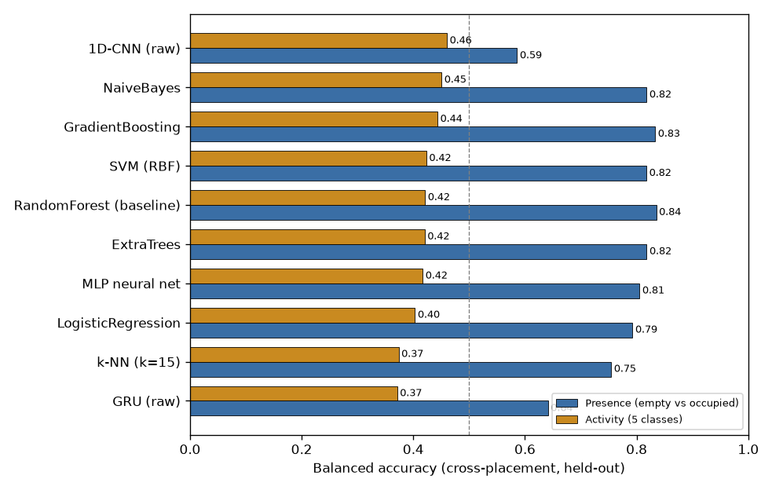
Figure 7. Cross-placement balanced accuracy for every model, sorted by activity score. Presence (blue) and 5-class activity (orange). The dashed line marks presence chance (0.50).
What the comparison shows
- Model choice barely changes cross-placement activity. Every model lands between 0.37 and 0.46 balanced accuracy on an unseen placement — the 1-D CNN is nominally best (0.46), naive Bayes and gradient boosting next (0.45, 0.44), the random forest 0.42 — but the spread is within noise. No algorithm breaks out. The ceiling here is set by the single-antenna viewpoint and the amount of data, not by the model. A fancier model does not fix cross-placement activity; a second receiver is the lever.
- For presence, engineered features beat raw deep learning decisively. The calibrated hand-crafted features give 0.79–0.84 presence with essentially any classifier, while the raw-window CNN and GRU reach only 0.59 and 0.64. The empty-baseline calibration already encodes “is the room different from empty?”; a deep net trained from scratch on this much data does not rediscover it as well.
- The deep networks captured motion but missed stillness. The CNN had the best walk and run recall of any model (0.67 and 0.54) yet the worst empty and sit recall — it learns movement dynamics from the raw signal but confuses an empty room with a still person. The feature-based models are the opposite: they nail empty. This is a useful pointer for combining them later.
- Once calibrated on-site, the simplest models win. Per-install, logistic regression (0.85) and the RBF-SVM (0.83) actually beat the tree ensembles (0.79–0.80). With an on-site empty baseline the features become cleanly separable, so a light linear model is enough — no heavy model needed for the realistic deployment mode.
- Deep learning does not beat the random forest at this data scale. With ~5,000 windows from one subject, the CNN and GRU do not outperform the random forest overall (they trade a hair of activity accuracy for a large loss on presence) and cost far more compute. Deep models become worth revisiting once multi-receiver collection scales the dataset up by an order of magnitude.
Recommendation
Keep the random forest as the default model: it is at or near the top for presence (0.84), competitive on activity, needs no feature scaling or tuning, trains in seconds, and is interpretable. The result to take away is that the current limitations are a sensing limitation, not a modeling one — no model in this sweep, including deep networks, removes the cross-placement activity wall. That is the direct argument for adding a second and third receiver rather than investing in a heavier model on a single link.

Reproducibility: run “python model_comparison.py” (classical + deep) to regenerate the table, Figure 7, and model_comparison.json. The random-forest row reproduces the main report's numbers exactly, which anchors the comparison.

