CSI Presence & Activity Sensing
Progress Update
July 13, 2026
Summary
Over the past two weeks I have pooled all the strong link recordings into a single model and evaluated it using cross validation. Overall, I have a much better understanding of the single transmitter to receiver link as far as what it can do, what it cannot, and the hardware limits. The biggest and clearest results are that occupancy detection is transferable across placements, fine activity recognition is strong on site but does not at the moment transfer to a new placement without a short calibration (90 second baseline of the empty environment), and the usable range of a single link is a hard limit at roughly 120 inches.
Dataset
All results below use one subject across Library Study Room 3202, 3203 and 3225 (Miller Branch Library) spanning various node placements.
- 14 configurations (placement x orientation), 29 recording sessions.
- 910,071 CSI packets logged.
- 4,971 labeled 2 second analysis windows.
- Classes: empty, stand, sit, walk, run.
There were a number of weak link configurations, low RSSI and high packet loss, which were excluded because the link had degraded past its usable range (see Figure 5).
Key Discoveries
- Occupancy detection is transferable. Presence (empty vs. occupied) is decent when the model is placed into a new environment it never trained on (0.79 balanced¹ accuracy held out, 0.97 when calibrated on site).
- Fine activity needs on site calibration. Activity classification is good when calibrated at the location it runs (0.78 balanced) but falls to 0.42 across unseen environments/placements. A short empty room baseline recovers it.
- Link quality drives generalization. Strong links (RSSI > ~52 dBm) generalize across placements. This explained failures in a large open room where signal strength was very weak.
- A single link has a hard range limit of ~120 inches. Beyond that, signal strength falls below ~60 dBm and packets drop heavily.
- The new long block recording protocol fixed the weak classes. Recording each activity as one continuous 2 minute block gives balanced, clean data and raises stand, sit, and run recall.

Results
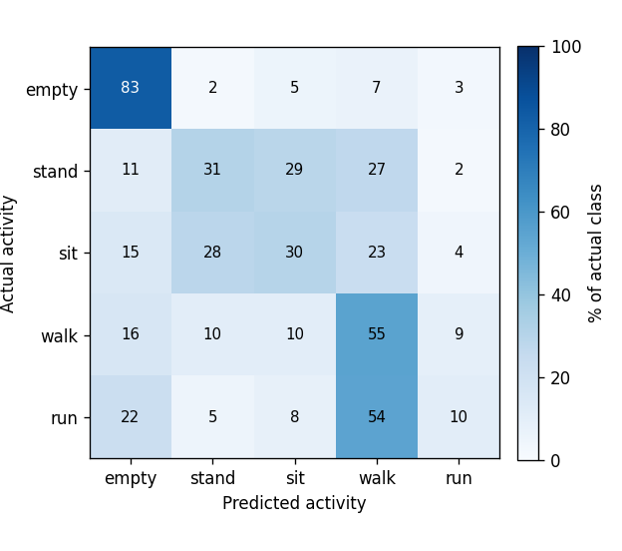
Figure 1. Activity confusion matrix (cross placement, held out). Empty is identified (83%); stand/sit confuse with each other and run is largely mixed into walk.
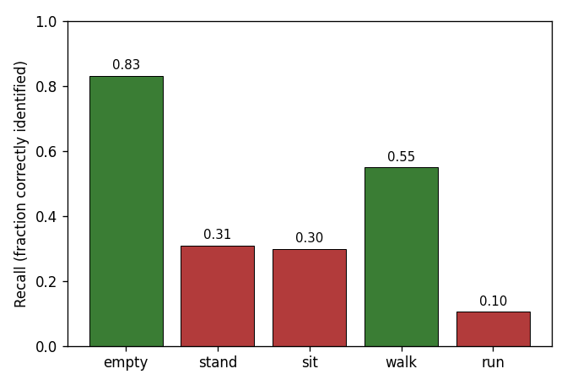
Figure 2. Per activity recall (cross placement). Empty (0.83) and walk (0.55) transfer well; stand (0.31), sit (0.30) and run (0.10) are the weak classes when generalizing to a new placement.
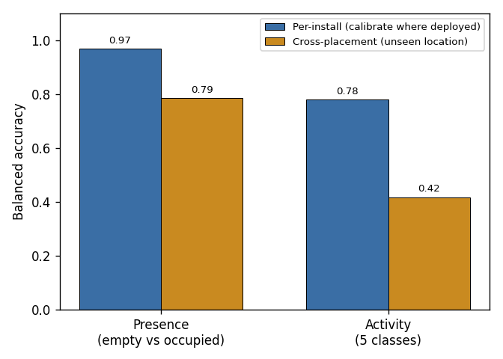
Figure 3. Per install vs. cross placement. Presence stays strong either way (0.97 > 0.79), so occupancy is portable. Activity is good on site (0.78) but drops to 0.42 across unseen placements.
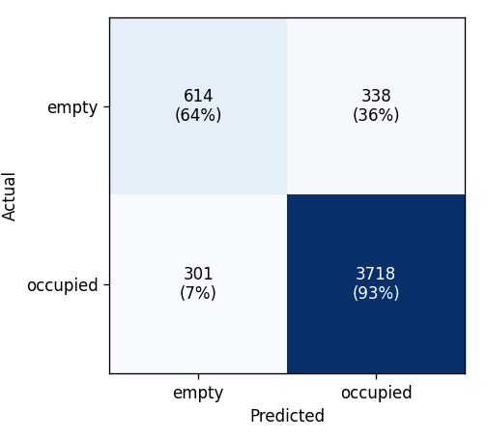
Figure 4. Presence confusion matrix (empty vs. occupied). Occupied rooms are caught almost always which the small errors occasionally calling a truly empty room occupied, caused by a motionless person (standing/sitting).
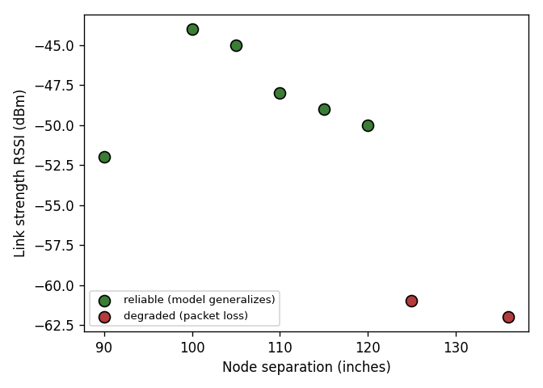
Figure 5. Link range limit. Below ~120 inches the link is strong and the model generalizes. Beyond ~120 inches RSSI drops below ~60 dBm, packets drop, and performance is affected.
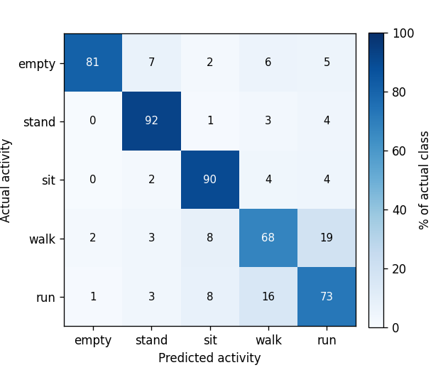
Figure 6. Activity confusion, long block protocol, per install (calibrated on site). The diagonal is strong across the board (stand 92%, sit 90%, run 73%, empty 81%). The only notable confusion is walk vs. run. Balanced accuracy 0.81.
Thoughts Thus Far
One antenna sees the room from a single POV, which is enough to determine whether someone is present, accurately and across placements, and enough to classify activities well when calibrated on site. The same single viewpoint is what limits cross placement activity transfer, causes the stand vs sit and run vs walk confusions, and makes a motionless person hard to separate from an empty room.
Deployment Guide
- Keep the nodes within ~120 inches and check that the RSSI is at least ~55 dBm before recording.
- Record a short empty room baseline (~90 seconds) at each install
- Use the long block recording protocol for activity data collection.

Future Steps
- Add a second and/or third receiver.
- Validate the multi receiver capture path.
- Add more than one subject to add subject generalization.

Index:
- Balanced: Balanced accuracy = the average of the per-class recalls, instead of the raw fraction of windows called correctly.
- Why I use the balanced metric: The classes are uneven as there are more occupied/walk windows than empty/run. Plain accuracy lets a model score high just by predicting the majority class (in this case, predicting "occupied" always would yield a better return). Balanced accuracy weights every class equally, so a less recorded class (like run) counts as much as a common one.
- How we calculate balanced: For each class we compute recall = (windows of that class predicted correctly) ÷ (total windows of that class).
- Per-class recall:
  - empty recall = 614 / 952 = 0.645 (very poor)
  - occupied recall = 3,718 / 4,019 = 0.925 (inflated)
- Balanced accuracy (average the two recalls, each class weighted equally):
- (0.645 + 0.925) / 2 = 0.785 ≈ 0.79
- So the 0.79 means the empty and occupied recalls averaged to ~0.79 on environments the model never trained on.

- “Held Out:”
- This is our evaluation scheme which is separate from the metric: leave-one-configuration-out cross-validation. We Train on every placement/orientation except one, then test on the held-out one, rotate through all configs, then combine those held out predictions and compute balanced accuracy on them. This is so no window is ever scored by a model that trained on it.

