Wi-Fi CSI Presence & Activity Sensing
Phase A interim note — single-link characterization (July 2026)

1. Setup
We are testing whether ordinary Wi-Fi hardware can tell when a room is occupied, and eventually what the person is doing, using Channel State Information (CSI) — the per-subcarrier channel measurement a receiver already computes for every packet. The current rig is a single link: two Seeed Studio XIAO ESP32-C3 boards (2.4 GHz, 20 MHz, single antenna). One board transmits a steady 100 Hz stream; the other receives it and reports CSI for 52 usable subcarriers at about 97 Hz to a laptop.
Data was collected in a small L-shaped library study room (roughly 12 ft across the short axis, open floor, furniture unchanged). For each of five configurations we ran the same scripted sequence: empty room, standing and sitting at marked floor spots, walking fixed back-and-forth paths, and running. The five configurations differ in where the two boards sit and how their antennas are oriented (flat / rotated 90° / vertical), because the system must not depend on one exact placement. That gives 5 sessions and 1,408 analysis windows.

2. How we treated it as a data-science problem
Each recording is a stream of 52-subcarrier amplitude vectors at ~97 Hz. We cut it into 2-second windows (1-second overlap) and summarize each window with a fixed feature vector: how much each subcarrier fluctuates over the window, its average shape, and how much of its energy sits in the 0.5–5 Hz motion band. A random forest then classifies each window.
Two choices matter. First, raw CSI amplitude encodes the specific room geometry, so a model trained on it memorizes the setup instead of learning “person vs no person.” We therefore also compute calibrated features: each window expressed as its deviation from that configuration’s own empty-room baseline, then standardized. This is the deployment recipe — record a short empty baseline when you install the sensor, then measure change against it. Second, we evaluate with leave-one-session-out cross-validation: train on four configurations, test on the fifth one the model has never seen, and rotate. That is the honest measure of whether it works in a new setup. For contrast, a within-session random split (which lets the model peek at the test geometry) reaches about 0.83 on the 5-class task — most of that is memorization, which is exactly what the leave-one-session-out test removes.

3. What it does well: presence detection
With calibration, detecting whether the room is occupied generalizes to configurations the model never saw: 94% overall accuracy and 0.89 balanced accuracy, with occupied correctly flagged 96% of the time and empty 83% of the time. Across the five held-out configurations the accuracy ranged from 0.83 to 0.98, so no single placement is carrying the result.
These numbers come straight from the leave-one-session-out predictions pooled over all five held-out configurations. The comparison in Figure 1 is the main point: without calibration the same features give only 0.52 balanced accuracy — the model labels almost everything “occupied,” which looks acceptable on raw accuracy but is useless. Calibration against the empty baseline is what turns CSI into a usable, portable presence signal.
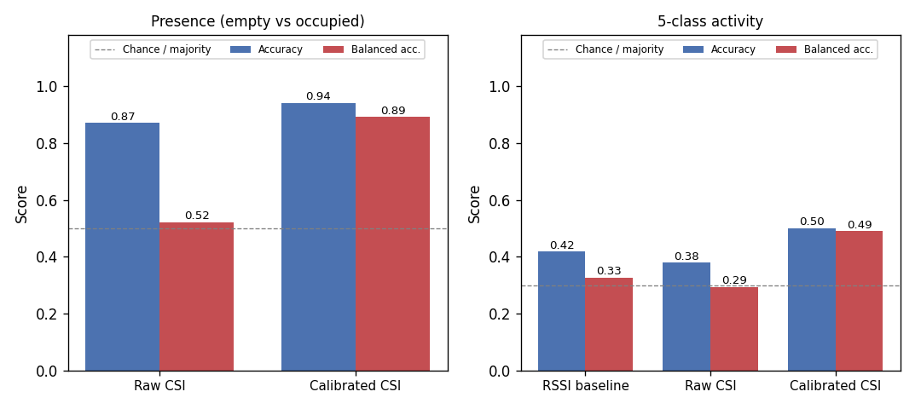
Figure 1. Leave-one-session-out performance. Left: presence. Right: 5-class activity. Blue = accuracy, red = balanced accuracy; dashed line = chance / majority-class. Calibration is what makes presence work.
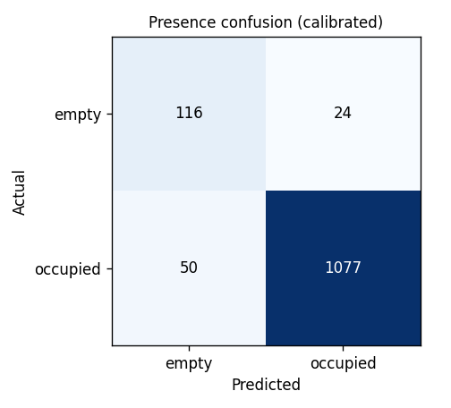
Figure 2. Presence confusion matrix (calibrated, pooled over held-out configurations). Occupied is caught reliably; the harder case is confirming the room is truly empty.

4. Where it falls short: fine activity classes
Telling the four activities apart is a different story. On the 5-class task {empty, stand, sit, walk, run} the calibrated model reaches 50% accuracy (0.49 balanced) on unseen configurations. It is still the best option — an RSSI-only baseline (signal strength, no CSI) gets 0.33 and raw CSI 0.29 — but it is well short of reliable.
The per-class breakdown (Figure 3) shows where it breaks. Empty (0.88), standing (0.63) and walking (0.53) are recognizable, but sitting (0.28) and running (0.14) are not. Sitting gets confused with standing — both are near-stationary and a single 2.4 GHz link sees little difference between them — and running gets confused with walking, since both are whole-body motion (running also has the least data so far, one segment per configuration). These recalls are again from the pooled leave-one-session-out predictions. The takeaway: one link is enough for presence but not for clean activity separation, which is the main argument for adding a second and third receiver to cover motion the single link misses.
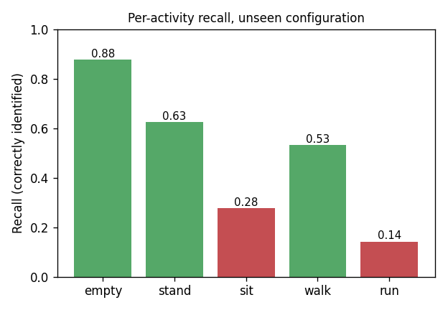
Figure 3. Per-activity recall on unseen configurations. Green ≥ 0.5, red below. Sitting and running are the failure modes.

5. A measurement finding worth flagging
Because presence leans on the empty-room baseline, we checked whether that baseline is stable. Within a session it is essentially fixed — the empty fingerprint at the start and end of an eight-minute session correlates above 0.999, with signal strength moving under 1 dB. But how you capture the baseline matters a lot. Calibrating from one short empty snapshot underestimates the normal window-to-window fluctuation of an empty room and produces false “occupied” readings (empty recall drops to 0.32, balanced accuracy 0.63). Sampling the empty baseline over a longer spread of time recovers it (0.83 / 0.89). The practical rule for deployment: record a longer, or periodically refreshed, empty baseline at install rather than a single short capture.
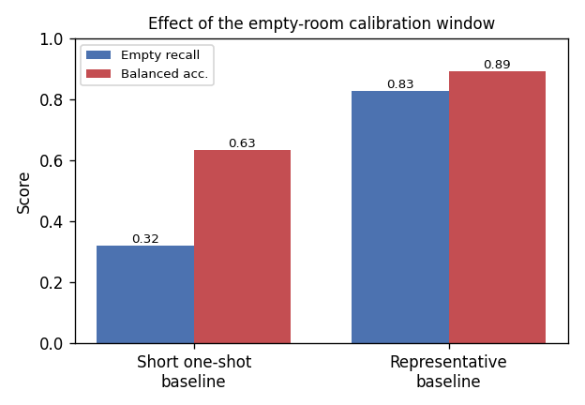
Figure 4. Same model and data, only the empty-calibration window changes. A short one-shot baseline underestimates normal variation and over-reports occupancy.

6. Status and next steps
This is an interim snapshot, not the final study. So far it is one room, one subject, and one recording per configuration, so the numbers do not yet have confidence intervals — more sessions are being recorded and will tighten them. The clear reads today: presence detection is robust and transfers across placements once calibrated; fine activity classification is not there with a single link. Planned next steps are more configurations (for confidence intervals), more sitting and running data, then a second and third receiver to improve motion coverage, followed by other rooms and subjects.

