How to submit your team project contents

You will submit your team project proposal, slides, and codes on their team repository in GitHub.

* Each team has a unique Team-ID and each team needs to select a team coordinator who has a GitHub account (or create a new one).
* The organizers have created a repository for each team based on your registration information. Your Team-ID and Team Name should be provided during checking-in.
* When finalizing team formation, inform any changes (e.g., adding/dropping a member(s), merging two or more teams, etc.) to the organizers at the registration desk.
* Check your Github Team Repository (look for your team ID) at [**https://github.com/BigDataForSanDiego**](https://github.com/BigDataForSanDiego)

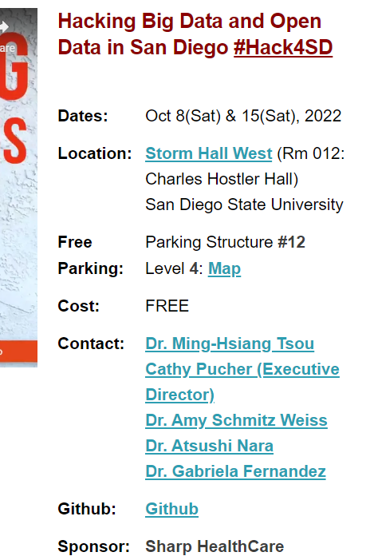

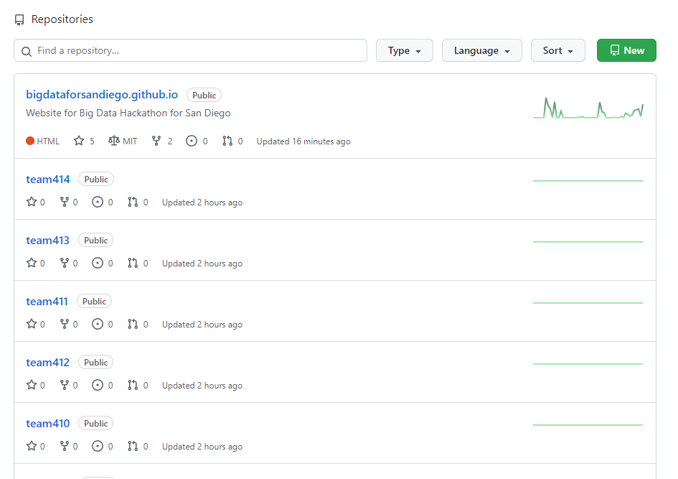

**GitHub Basic**

# Create GitHub account

Go to <https://github.com/> and sign up.

# Creating a GitHub repository

You can create your own repository. (For Hackathon, your team repository has been created)

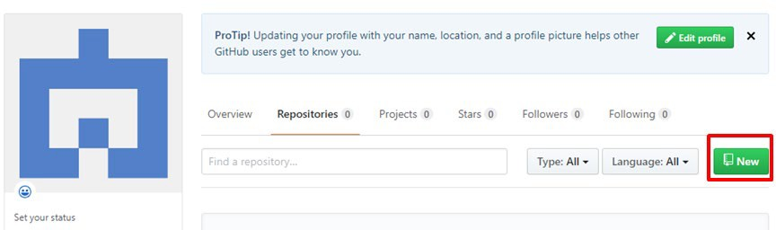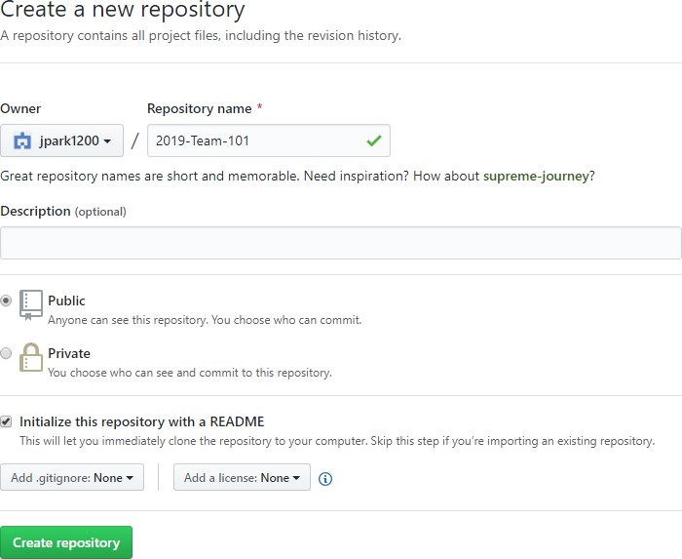

…Or you can create a repository on the command line

echo "# <repository>" >> README.md git init

git add README.md

git commit -m "first commit"

git remote add origin https://github.com/<your name>/<repository>.git git push -u origin master

# Clone your repository to a local computer

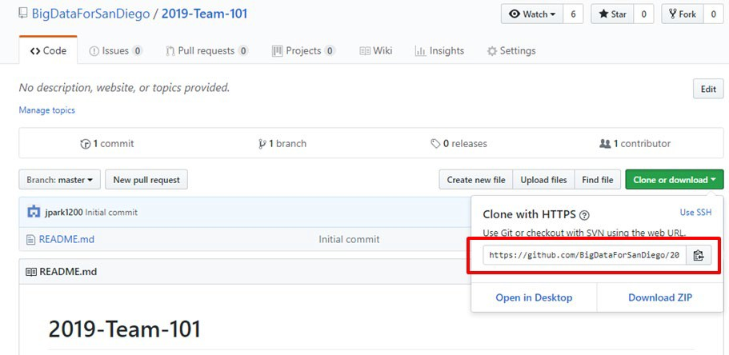

# git clone command is used to download a remote repository to local computer git clone https://github.com/BigDataForSanDiego/2019-Team-101.git

1. **Push and Pull (upload and download)**

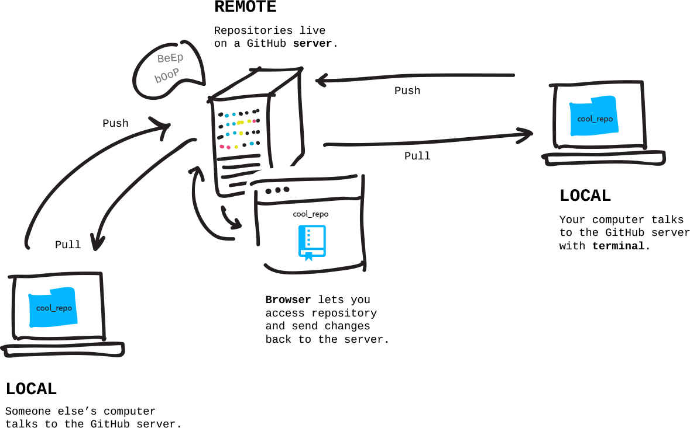

# git push command is used to upload content to a remote repository git push -u origin master

# git fetch git pull both are used to download remote content git pull <repository>

GitHub tutorials: <https://www.youtube.com/watch?v=0fKg7e37bQE>

<https://product.hubspot.com/blog/git-and-github-tutorial-for-beginners>