**HOME PAGE: *EAT WELL San Diego***

***Tabs: home, know your status/ get CalFresh, facts and figures, maps, resources, GET TEXTS!, create a profile, team members***

***Banners: Know your status! GET TEXTS!***

***Mission: Our goal is to connect***

**KNOW YOUR Food Security Status:**

**Banner: Know your status -  survey**

**After taking survey, we give you your results in tables and tell you:**

**\* You may qualify for CalFresh * (if you are food secure - links to help others!**

* **Link to find out if ELIGIBLE for CalFresh**

**Website:** [**http://www.calfresh.ca.gov/PG849.htm**](http://www.calfresh.ca.gov/PG849.htm)

**https://www.mybenefitscalwin.org/**

**Phone #: 1-877-847-3663**

* **Link to fill out application - SIGN UP**
  + **Can call CalFresh if do not have computer/internet**

**Application Process website:** [**http://www.calfresh.ca.gov/PG847.htm**](http://www.calfresh.ca.gov/PG847.htm)

**CalFresh Benefits Hotline: 1-877-847-3663**

**Hands-on help: Call 2-1-1**

**What does your status mean?**

**Low food security: 7.7% of U.S. households have low food security and 5.0% have very low food security. You are likely eligible for CalFresh and other assistance programs!**

**Very low food security: 5.0% of U.S. households have very low food. You are likely eligible for CalFresh and other assistance programs!**

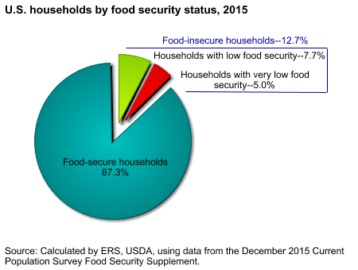

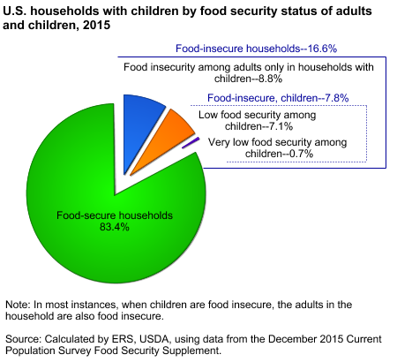

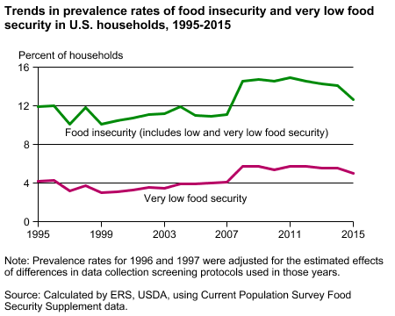

**Resource:** [**https://www.ers.usda.gov/topics/food-nutrition-assistance/food-security-in-the-us/key-statistics-graphics.aspx**](https://www.ers.usda.gov/topics/food-nutrition-assistance/food-security-in-the-us/key-statistics-graphics.aspx)

**FACTS AND FIGURES:**

**Food insecurity, described by the USDA, is a “household-level economic and social condition of limited or uncertain access to adequate food”. This means lower than adequate quality or nutrition of foods or also quantity of food. This doesn’t necessarily mean households are food insecure at all times. It may just reflect the fact that a household may need to make trade-offs between buying adequately nutritious foods and important basic needs, such as paying home or medical bills. According to Feeding America San Diego, 423,130 people, including 151,440 children in San Diego County are food insecure. The average cost of a meal in San Diego County is higher than the national average cost, by 33 cents.**

**As of 2016 13% is the average level of food insecurity in the US. San Diego County is no different, and for those who suffer from food insecurity there are many resources which can help in alleviating this epidemic. But these resources need to be accessed: In 2016 the leading association of food insecurity is determined to be income not location.**

**OUR MISSION:**

**We of *EatWell San Diego* aim to bring easier access of food banks, soup kitchens and shelter services to those in need and do not have income to afford perishable food. *EatWellSD* does this by compiling together a directory of resources in one place through our SMS & web services. With the impact of “big data” we understand the overwhelming task of sifting through large amounts of information when all an individual desires is a regular meal and proper nutrition.**

**OUR IMPACT:**

**Research has shown the largest impact that individuals have on the environment is through the food we eat. Food decision-making affects households' sustainability profiles, even more so than their energy and direct water consumption. Food consumes approximately 50% of urban households' water, and contributes 28% of their greenhouse gas emissions and 47% of the municipal waste that goes to landfill (including food and green waste). Food is very topical in the case of San Diego County, where California has recently experienced one of the most severe droughts on record.**