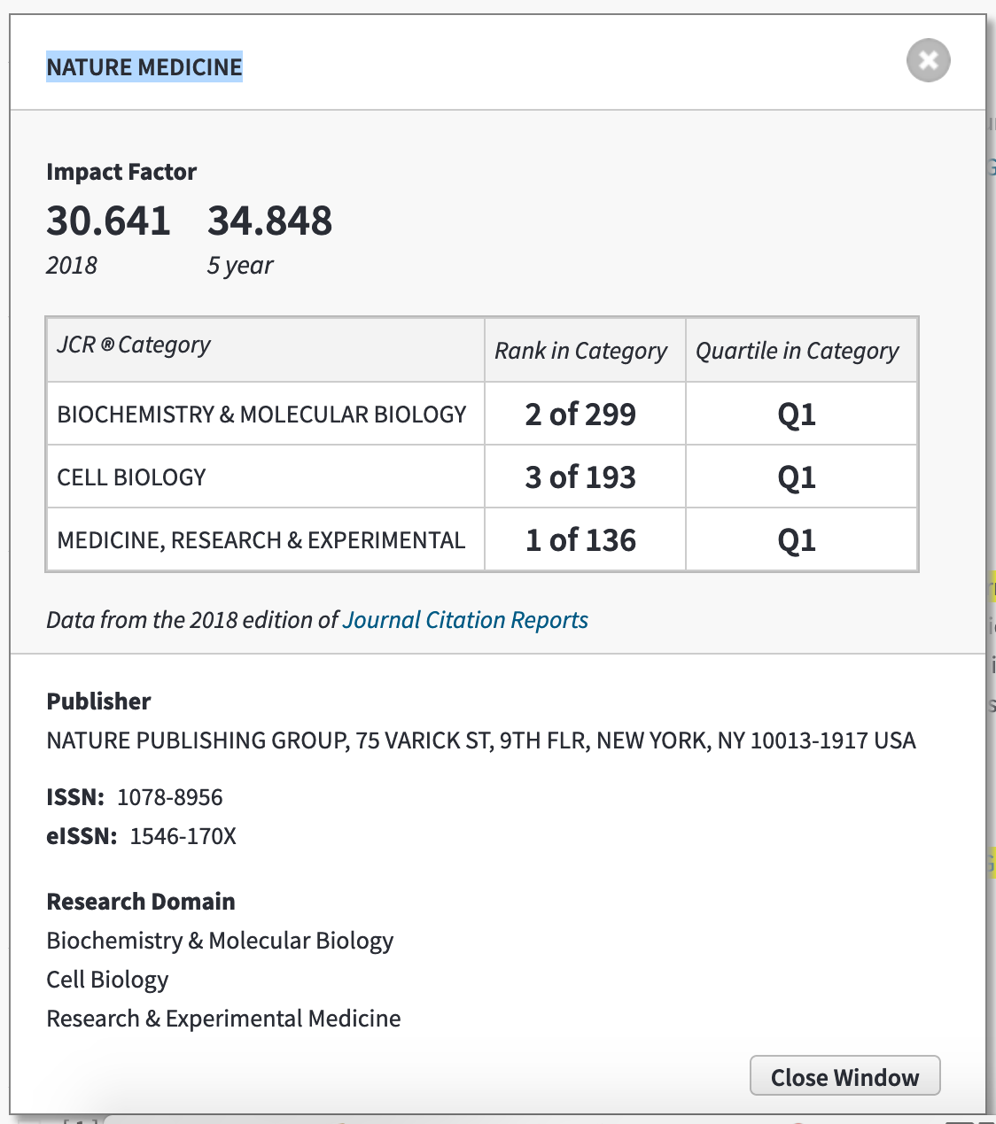

REFERENCIAS

Esteva, A., Robicquet, A., Ramsundar, B., Kuleshov, V., DePristo, M., Chou, K., Cui, C., Corrado, G., Thrun, S., & Dean, J. (2019). A guide to deep learning in healthcare. Nature Medicine, 25(1), 24-29.

Zou, J., Huss, M., Abid, A., Mohammadi, P., Torkamani, A., & Telenti, A. (2019). A primer on deep learning in genomics. Nature Genetics, 51(1), 12-18.

Eraslan, G., Avsec, Z., Gagneur, J., & Theis, F. J. (2019). Deep learning: New computational modelling techniques for genomics. Nature Reviews Genetics, 20(7), 389-403.

Cheng, J., Nguyen, T. Y. D., Cygan, K. J., Celik, M. H., Fairbrother, W. G., Avsec, Z., & Gagneur, J. (2019). MMSplice: Modular modeling improves the predictions of genetic variant effects on splicing. Genome Biology, 20, 48.

Guo, Y., Shang, X., & Li, Z. (2019). Identification of cancer subtypes by integrating multiple types of transcriptomics data with deep learning in breast cancer. Neurocomputing, 324, 20-30.

Avsec, Z., Barekatain, M., Cheng, J., & Gagneur, J. (2018). Modeling positional effects of regulatory sequences with spline transformations increases prediction accuracy of deep neural networks. Bioinformatics, 34(8), 1261-1269.

Korvigo, I., Afanasyev, A., Romashchenko, N., & Skoblov, M. (2018). Generalising better: Applying deep learning to integrate deleteriousness prediction scores for whole- exome SNV studies. Plos One, 13(3), e0192829.

Diao, J. A., Kohane, I. S., & Manrai, A. K. (2018). Biomedical informatics and machine learning for clinical genomics. Human Molecular Genetics, 27(R1), R29-R34.

Rowlands, C. F., Baralle, D., & Ellingford, J. M. (2019). Machine Learning Approaches for the Prioritization of Genomic Variants Impacting Pre-mRNA Splicing. Cells, 8(12), 1513.

Dias, R., & Torkamani, A. (2019). Artificial intelligence in clinical and genomic diagnostics. Genome Medicine, 11(1), 70.

