# **Business Assistant Application**

## **1. Introduction**

### **Background**

Starting and managing a business involves navigating a complex landscape of government regulations, legal requirements, and market dynamics. Entrepreneurs often face challenges in understanding local regulations, accessing relevant legal information, and gauging market sentiment for their products or services. The **Business Assistant Application** aims to streamline this process by providing users with comprehensive tools and information to set up and manage their businesses effectively.

### **Objective**

The primary goal of this project is to develop a prototype of a Business Assistant Application that assists users in establishing businesses in specific locations. The application will provide insights into government regulations, legal requirements, and perform sentiment analysis on businesses and products. By leveraging data processing and AI technologies, the application will offer personalized recommendations and solutions through an intuitive chat interface.

## **2. Project Overview**

### **Scope**

* **Data Sources**: Web scraping from government websites, legal databases, market analysis platforms, and social media.
* **Technologies**: AWS S3, Snowflake, Azure Document Intelligence, Apache Airflow, FastAPI, Streamlit, and AI models for sentiment analysis.
* **Deliverables**:
  + Simplified data ingestion pipeline
  + Data preprocessing and storage setup
  + Basic backend API
  + Frontend interface with chat functionality
  + Sentiment analysis module
  + Regulatory and legal advisory features (basic version)

### 

### 

### **Stakeholders**

* **End Users**: Entrepreneurs, small business owners, startups, legal consultants, and market analysts.

## **3. Problem Statement**

### **Current Challenges**

* **Complex Regulatory Environment**: Entrepreneurs struggle to understand and comply with local government regulations and legal requirements.
* **Data Management Inefficiencies**: Handling large volumes of structured and unstructured data from various sources is time-consuming and error-prone.
* **Lack of Market Insights**: Difficulty in accessing real-time sentiment analysis and market trends for informed decision-making.
* **Limited Accessibility**: Existing solutions may lack user-friendly interfaces or comprehensive support for setting up and managing businesses.

### **Opportunities**

* **Streamlined Compliance**: Providing easy access to relevant regulations and legal information can simplify the business setup process.
* **Enhanced Data Processing**: Utilizing advanced ETL tools and data storage solutions can improve data management efficiency.
* **Informed Decision-Making**: Sentiment analysis and market insights can empower users to make strategic business decisions.
* **User-Centric Design**: An intuitive chat interface can enhance user engagement and accessibility.

## **4. Methodology**

### **Data Sources**

* **Government Websites**: For regulations and legal requirements.
  + [Data.gov](https://catalog.data.gov/dataset?q=&sort=views_recent+desc)
  + [Federal Register](https://www.federalregister.gov/)
  + [Small Business Administration](https://www.sba.gov)

### **Project Phases**

#### **Part 1: Data Ingestion and Preprocessing**

**Tasks:**

* Implement web scraping scripts for selected government and legal websites.
* Use Apache Airflow to orchestrate ETL workflows.
* Convert scraped data to JSON format using Azure Document Intelligence.
* Store processed data in AWS S3 and Snowflake.

**Responsibilities:**

* **Aishwarya**: Develop and maintain web scraping scripts.
* **Deepak**: Set up ETL pipelines with Airflow and manage data storage solutions.
* **Nivedhithaa**: Handle data preprocessing and integration with Azure Document Intelligence.

### **Data Processing and Transformation: Methods and Algorithms**

#### **1. Data Acquisition and Storage**

**Data Gathering**

The data is sourced dynamically from platforms like Regulations.gov through:

* **API Integration**: Queries are constructed using endpoint URLs and parameters such as keywords, agency names, or docket numbers.
* **Web Scraping**: For sources without APIs, tools like Scrapy or BeautifulSoup extract relevant information from webpages.

**Data Storage**

Data is stored in two forms:

* **Structured Databases (Snowflake)**: Ideal for fields like titles, summaries, agencies, and key dates.
* **Semi-Structured Data**:
  + Fields like titles, summaries, agencies, and key dates can be stored in a serialized format (e.g., JSON) and uploaded as individual objects in S3.
* **Vector Databases (Pinecone)**: For fast similarity-based searches. Textual fields such as summaries and titles are transformed into embeddings and indexed.

#### **2. Data Transformation**

**Vector Embedding Generation**

* **Purpose**: Represent textual data (e.g., titles, summaries) as dense numerical vectors to enable similarity-based search.
* **Model Used**: Pre-trained LLM models.

**Indexing in Pinecone**

* Store generated embeddings in a vector database (e.g., Pinecone).
* Configure indexes for Approximate Nearest Neighbor (ANN) searches to optimize retrieval speed.

#### **3. User Query Processing**

**Input Handling**

* The user provides a query (e.g., "What are the regulations for opening a bakery in California?").

**Parameter Extraction**

* Use LangChain/LangGraph to extract structured inputs such as:
  + **Business Type**: Bakery
  + **Location**: California
  + **Regulatory Need**: Opening requirements

**Querying the Data**

* **Structured Data Retrieval**:
  + Query the Snowflake database for records matching business type or location.
* **Similarity-Based Search**:
  + Convert the user query into an embedding using the same pre-trained LLM model.
  + Perform a vector similarity search in Pinecone to retrieve the most relevant documents.

#### **4. Vector Embeddings for Enhanced Retrieval**

**Role of Vector Embeddings**

* Enable semantic search capabilities by understanding the context and meaning of user inputs.
* Compare the user query's embedding with stored embeddings to find the closest matches based on cosine similarity.

**Advantages**

* Handles synonyms and varied terminology.
  + **Query**: "Bakery regulations in California."
  + **Retrieved Document**: "Guidelines for opening a pastry shop in the state of California."
* Retrieves results ranked by relevance, ensuring that users receive the most contextually appropriate information.

#### **5. User Output Generation**

**Data Processing for Output**

* Combine results from structured and similarity-based searches.
* Summarize lengthy regulatory documents using AI agents.

**Delivery through User Interface**

* Present the processed information through an intuitive chat interface.
* Allow users to interact with the data, ask follow-up questions, and receive personalized advice.

#### **Part 2: Backend Development and API Integration**

**Tasks:**

* **FastAPI**: RESTful API framework to serve all endpoints.
* **HuggingFace Pipelines and Transformers**: Integrate sentiment analysis for user input (options: DeBERTa-base, RoBERTa-base, DistilBERT, legal-bert-base-uncased).
* **Endpoints for File Management**: Storing, uploading, parsing, and summarization of PDFs and images.
* **Vector Search Integration**: Implement with Pinecone.
* **Generate PDF Reports and Image-to-Text Summarization**: Use LangChain summarization pipelines.
* **LangChain & LangGraph**: Manage agent workflows to integrate services.
* **Sentiment Analysis**: Implement via HuggingFace.
* **LLM for Content Generation and Chat Interactions**

#### **Part 3: Frontend Development and Integration with FastAPI**

**Tasks:**

* Design and develop the user interface using Streamlit.
* Implement a chat interface for user interactions.

**Responsibilities:**

* **Aishwarya**: Design the frontend layout and user interface.
* **Deepak**: Implement chat functionality and integrate with backend APIs.
* **Nivedhithaa**: Develop and integrate sentiment analysis features.

## 

## 

## **5. Project Plan and Timeline**

Given the academic context and the team size of three members, the project timeline is adjusted to span **three weeks**, allowing for in-depth development and testing.

### **Milestones and Deliverables**

#### **Week 1: Project Initiation**

* **Define** project requirements and objectives.
* **Set up** project repository on GitHub.
* **Assign** roles and responsibilities.

**Data Ingestion Setup**

* Implement web scraping scripts.
* Configure AWS S3 and Snowflake for data storage.
* Develop ETL workflows with Airflow.

#### **Week 2: Backend Development**

* Build and document APIs with FastAPI.
* Integrate regulatory and legal advisory modules.
* Ensure data flow between backend and storage solutions.

**Frontend Development**

* Design UI with Streamlit.
* Implement chat interface for user interactions.

#### **Week 3: AI Integration and Testing**

* Integrate sentiment analysis models.
* Conduct unit and integration testing.
* Perform user acceptance testing and gather feedback.

**Deployment and Presentation**

* Deploy the application on a cloud platform (e.g., AWS).
* Prepare project documentation and presentation materials.
* Demonstrate the application to stakeholders.

## 

## **6. Roles and Responsibilities**

### **Data Engineers: Aishwarya and Deepak**

* Develop and maintain web scraping scripts.
* Set up ETL pipelines with Airflow.
* Manage data storage solutions (AWS S3 and Snowflake).

### **Backend Developers: Nivedhithaa and Deepak**

* Develop and document APIs using FastAPI.
* Integrate regulatory and legal advisory modules.
* Optimize API performance and ensure data flow.

### **Frontend and AI Specialists: Aishwarya and Nivedhithaa**

* Design and develop the user interface with Streamlit.
* Implement chat functionality and integrate with backend APIs.
* Develop and integrate sentiment analysis features using AI models.

## **7. Resources**

### **Data Sources**

* Federal Register Documents
* Georgetown Data Science for Public Policy
* Virginia Tech Library Guides
* [Congress.gov](https://www.congress.gov/)
* [Regulations.gov](https://www.regulations.gov/)

### **Technologies and Tools**

* **Programming Languages**: Python
* **Web Scraping**: BeautifulSoup, Scrapy
* **Data Storage**: AWS S3, Snowflake
* **ETL Orchestration**: Apache Airflow
* **Backend Development**: FastAPI
* **Frontend Development**: Streamlit
* **AI and Machine Learning**: Pre-trained models (e.g., BERT)
* **Version Control**: GitHub
* **Project Management**: GitHub Projects

## **8. Risks and Mitigation Strategies**

### **Identify Risks**

* **Data Privacy Concerns**: Handling sensitive legal and business data.
* **Regulatory Changes**: Frequent updates to government regulations.
* **Technical Challenges**: Integration issues between multiple technologies and platforms.
* **Project Delays**: Potential delays in data collection or development phases.
* **AI Model Accuracy**: Ensuring the sentiment analysis and AI agents provide reliable results.

### **Mitigation Strategies**

* **Data Privacy**: Implement robust user security measures with JWT authentication and Guardrails AI to manage generative AI behavior.
* **Regulatory Monitoring**: Establish a process for regularly updating the application with the latest regulations.
* **Technical Planning**: Conduct thorough technical assessments and maintain clear documentation to facilitate integration.
* **Project Management**: Use agile methodologies with regular check-ins to mitigate delays.
* **Content Moderation**: Use OpenAI Moderation API or Azure Content Moderator to handle potential violations.

## **9. Expected Outcomes and Benefits**

### **Measurable Goals**

* **User Adoption**: Achieve a target number of active users within the project timeline.
* **Data Processing Efficiency**: Demonstrate a functional data ingestion and processing pipeline.
* **Sentiment Analysis Accuracy**: Attain an initial accuracy rate of at least 70% for sentiment analysis, with plans for improvement.
* **Regulatory Compliance Assistance**: Successfully assist users in meeting compliance requirements for at least three different locations.

### **Expected Benefits**

* **Simplified Business Setup**: Streamlined access to necessary regulations and legal information.
* **Informed Decision-Making**: Enhanced market insights through sentiment analysis and trend monitoring.
* **Operational Efficiency**: Automated data processing and management reduce manual effort and errors.
* **User Engagement**: Intuitive chat interface improves user experience and satisfaction.
* **Academic Contribution**: Provide a working prototype that demonstrates the integration of data processing and AI in business applications.

## **10. Conclusion**

The Business Assistant Application addresses critical challenges faced by entrepreneurs and business owners by providing a comprehensive platform that simplifies business setup, ensures regulatory compliance, and offers valuable market insights. By leveraging data processing technologies and AI-driven solutions, the application aims to empower users with the tools and information needed to succeed in their ventures. The structured project plan, dedicated team, and strategic mitigation of risks position this academic project for successful execution and meaningful outcomes within the given timeframe and team size.

**11. Architecture Diagrams:**

* **Data Pipeline Architecture:**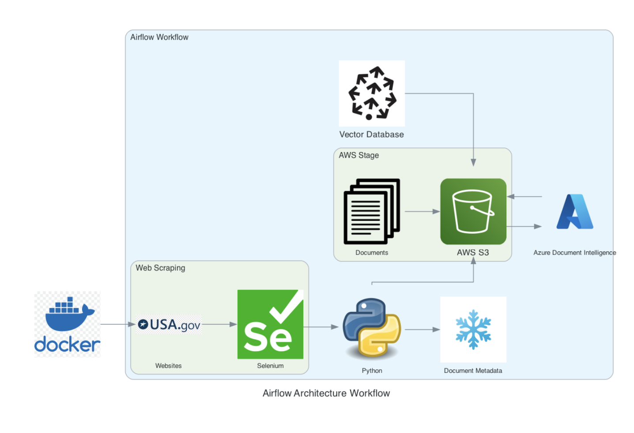

* **Application Architecture:**

