FINAL PROJECT PROPOSAL
DAMG 7245 — Big Data and Intelligent Analytics

CurateAI
Real-Time Content Intelligence Engine for Personalized Newsletters & Enterprise SEO Strategy

Team Members
Aakash Belide
Abhinav Kumar Piyush
Rahul Bothra

Attestation
WE ATTEST THAT WE HAVEN’T USED ANY OTHER STUDENTS’ WORK IN OUR
ASSIGNMENT AND ABIDE BY THE POLICIES LISTED IN THE STUDENT HANDBOOK.
Aakash Belide: 33.3% | Abhinav Kumar Piyush: 33.3% | Rahul Bothra: 33.3%

Table of Contents
Table of Contents 2
1. Title 4
2. Introduction 4
2.1 Background 4
2.2 Objective 4
3. Project Overview 5
3.1 Scope 5
In-Scope 5
Out-of-Scope 5
3.2 Stakeholders / End Users 5
4. Problem Statement 6
4.1 Current Challenges 6
4.2 Opportunities 6
5. Methodology 7
5.1 Data Sources 7
RSS Feeds (30+ Sources) 7
Social & Community Signals 7
Full-Text Article Content 7
Justification of Scale 7
5.2 Technology Stack 8
Tool Selection Rationale 8
5.3 Architecture 9
Architecture Diagram 9
Prototype-Validated Metrics 9
5.4 Data Processing & Transformation 14
5.5 LLM Integration Strategy 14
B2B SEO Intelligence Agents 14
5.6 Guardrails & Human-in-the-Loop (HITL) 14
5.7 Evaluations & Testing 16
5.8 Proof of Concept (POC) 16
6. Project Plan & Timeline 17
6.1 Milestones 17
Week 1 — Data Foundation & Pipeline Infrastructure 17
Week 2 — LLM Agents, Backend & Frontend 17
Week 3 — Integration, Testing & Deployment 17
6.2 Timeline 17
7. Team Roles & Responsibilities 19
Project Management 19
8. Risks & Mitigation 20
8.1 Potential Risks 20
9. Expected Outcomes & Metrics 21
9.1 KPIs 21
9.2 Expected Benefits 21
10. Token & Cost Report 22
Optimization Strategies 22
Projected Monthly Cost 22
11. Conclusion 23
12. References 24
Data Sources 24
Frameworks & Libraries 24
Research 24
Appendix 25
A. Prototype Validation Data 25
B. Architecture Decision: TF-IDF vs Semantic Vectors 25
C. Source Reliability Matrix 25
D. Mermaid Diagrams 25
E. Pseudocode & Code Snippets 26
E.1 RSS Feed Ingestion (rss_prototype.py) 26
E.2 Full-Text Extraction (article_extraction_prototype.py) 26
E.3 Semantic Vector Deduplication (pipeline_prototype.py) 26
E.4 Hybrid Topic Classification (classification_prototype.py) 26
E.5 Trend Detection (trend_detection_prototype.py) 26
E.6 Dual-Layer Personalization (personalization_prototype.py) 27
E.7 Editor Agent / Guardrails (editor_agent_prototype.py) 27
E.8 Persona-First Summary Cache (summarization_prototype.py) 27
F. Prototype File Manifest 28

1. Title
CurateAI — Real-Time Content Intelligence Engine for Personalized Newsletters & Enterprise SEO Strategy

2. Introduction

2.1 Background
The newsletter economy has exploded — platforms like Substack, Beehiiv, and ConvertKit host hundreds of thousands of creators, and email marketing delivers $36–$42 return per dollar spent. Yet the production bottleneck has never been distribution; it has always been the curation and writing workflow. Newsletter creators typically spend 5–10 hours per issue scanning dozens of websites, reading articles, deciding what matters, and synthesizing insights.
The core challenge is twofold. On the creator side, relevant content is fragmented across RSS feeds, social platforms like Reddit and Hacker News, research repositories like ArXiv, and mainstream tech publications — each with different formats, update cadences, and signal-to-noise ratios. On the reader side, newsletters are one-size-fits-all. A machine learning researcher and a venture capitalist both subscribing to the same AI newsletter receive identical content, even though their interests diverge significantly.
Existing AI newsletter tools (Newsblocks, Jenova, ProCurator) address only the writing step — they take a topic and generate text. None of them build a continuously updated data pipeline that ingests thousands of articles daily, detects cross-source trends, performs semantic deduplication, and generates personalized newsletters grounded in retrieved evidence with full source traceability.

2.2 Objective
The objective of this project is to build CurateAI, a cloud-native content intelligence platform that continuously ingests content from 30+ sources, applies semantic deduplication and trend detection at scale, and uses a multi-agent LLM system to generate personalized, citation-backed newsletters.
We aim to deliver across four key areas:
- Big Data Engineering: End-to-end ingestion of 3,000+ articles daily from RSS feeds, Reddit, Hacker News, and NewsAPI. Semantic vector-based deduplication using Sentence-Transformers. All data stored in Snowflake with S3/GCS for raw storage and Qdrant for vector search.
- Significant LLM Use: A LangGraph multi-agent system coordinating classification, trend analysis, persona-aware summarization, editorial synthesis (Writer Agent), and guardrail enforcement (Editor Agent). RAG-powered newsletter generation with inline citations.
- Cloud-Native Architecture: Airflow for orchestration, Snowflake for structured data, S3/GCS for raw storage, Qdrant for vectors, Docker Compose for containerization, and cloud deployment via GCP Cloud Run.
- User-Facing Application: A Next.js dashboard where users configure interest profiles, browse content intelligence feeds, review AI-generated drafts, and publish via HITL workflow. An MCP server enables Claude Desktop integration.

3. Project Overview

3.1 Scope

In-Scope
- Data Sources: 30+ RSS feeds (TechCrunch, The Verge, Wired, Ars Technica, VentureBeat, MIT Technology Review, IEEE Spectrum, Bloomberg, BBC Tech, NYT Tech), AI blogs (OpenAI, DeepMind, Hugging Face, NVIDIA, Microsoft Research), research feeds (ArXiv cs.AI, cs.LG), social platforms (Reddit — 5 subreddits; Hacker News), and NewsAPI.org. Validated throughput: 3,129 raw articles per cycle.
- ETL Pipelines: Automated multi-source ingestion via Airflow DAGs, full-text extraction with trafilatura (85%+ success rate), semantic dedup using Sentence-Transformer vectors, hybrid topic classification (keyword + LLM fallback), and batch embedding generation.
- LLM Components: LangGraph multi-agent system with Topic Classifier, Trend Detector, Persona-Aware Summarizer, Writer Agent, and Editor Agent. RAG over article corpus via Qdrant.
- Cloud Infrastructure: Snowflake, GCS, Qdrant, Airflow, FastAPI, Next.js, Docker Compose.
- Guardrails & HITL: Editor Agent validates citations, detects hallucinations, enforces tone consistency. Pydantic schema enforcement. Human editors review and approve drafts. Feedback loop into personalization.
- Evaluation: Classification accuracy, dedup precision/recall, newsletter quality (LLM-as-judge rubric), citation accuracy, cost tracking, latency.

Out-of-Scope
- Real-time push notifications, paid subscription/billing, email delivery (Mailchimp/SendGrid), podcast transcripts.

3.2 Stakeholders / End Users
- Primary: Newsletter creators automating research/curation. Professionals wanting personalized daily briefings.
- Secondary: Content teams at tech companies. Research teams tracking emerging trends.

4. Problem Statement

4.1 Current Challenges
- Content Fragmentation: Information scattered across 30+ sources with different formats and update frequencies. No unified aggregation system.
- Manual Curation Burden: Creators spend 5–10 hours per issue. 62% of content creators report burnout.
- Duplicate Coverage: Same story covered by multiple outlets. Without semantic dedup, feeds are 20–30% redundant. Our prototype validated: TF-IDF caught 119 duplicates while Sentence-Transformers caught 206 (73% improvement).
- No Personalization: Existing newsletters deliver identical content regardless of reader role or expertise.
- LLM Cost at Scale: Per-user newsletter generation creates O(users × articles) LLM calls — financially unsustainable.
- Trend Blindness: A single LLM prompt cannot compute cross-source trend signals. Detecting topic velocity requires continuous data ingestion and historical comparison.

4.2 Opportunities
CurateAI introduces a unified semantically deduplicated pipeline processing 3,000+ articles daily; automated cross-source trend detection; dual-layer personalization (Highlights + Niche Gems); persona-first caching reducing LLM costs by 98%; and a polished HITL workflow with feedback loops.

5. Methodology

5.1 Data Sources
All data sources have been validated through prototyping. No sources require scraping — all use official APIs or open feed protocols.

RSS Feeds (30+ Sources)
Validated sources include TechCrunch, The Verge, Ars Technica, WIRED, VentureBeat, MIT News AI, Google AI Blog, OpenAI Blog, Google DeepMind, Hugging Face Blog, MIT Technology Review, IEEE Spectrum, ArXiv cs.AI, ArXiv cs.LG, BBC Technology, AWS ML Blog, HackerNoon AI, Bloomberg Technology, NYT Technology, NVIDIA Technical Blog, and Microsoft Research Blog.
Validated Volume: 2,880 articles per ingestion cycle from RSS alone.
Validated Latency: Average feed fetch time 0.16–1.26 seconds per feed.

Social & Community Signals
Reddit API (5 subreddits): r/MachineLearning (26% retention), r/artificial (36%), r/technology (100%), r/LocalLLaMA (100%), r/programming (38%). Hacker News API: 99% success rate, average score 211, average 107 comments per story.
Combined Volume: 3,129 raw articles per ingestion cycle.

Full-Text Article Content
Extraction Tool: trafilatura (on-demand for top-ranked articles).
Success Rate: 85% across all sources (18/22 at 100%; Bloomberg, NYT, OpenAI, VentureBeat blocked with graceful RSS fallback).
Latency: Average <0.4 seconds per article.

Justification of Scale
3,129 articles per cycle running daily produces ~90,000 raw articles per month. After dedup, ~25,000–30,000 unique articles flow into Snowflake monthly. Over a semester, this grows to 100,000+ indexed articles — a genuinely large-scale corpus requiring efficient infrastructure.

5.2 Technology Stack
Layer | Technology | Justification
Cloud | GCP / AWS | Free student credits, Cloud Run for deployment
Storage (Structured) | Snowflake | Columnar analytics, VARIANT type for article metadata
Storage (Raw) | S3 / GCS | Raw article snapshots, RSS dumps, pipeline artifacts
Vector Store | Qdrant | Qdrant: open-source, self-hosted, HNSW indexing, handles 100K+ vectors
Embeddings (Dedup) | Sentence-Transformers | Local inference, zero API cost, ~2.5s for 1K titles
Embeddings (RAG) | OpenAI text-embedding-3-small | Higher quality for retrieval, $0.02/1M tokens
LLM Providers | GPT-4o + GPT-4o-mini + Claude | Via LiteLLM router with daily budget cap
Agent Framework | LangGraph (StateGraph) | Deterministic routing, typed state, HITL interrupt
Orchestration | Apache Airflow | DAG scheduling, TaskFlow API, dynamic task mapping
API | FastAPI | High-performance async Python with Pydantic
Frontend | Next.js 15 + Tailwind CSS | Dashboard, editor, HITL workflow, trend viz
MCP | MCP SDK (SSE transport) | Claude Desktop integration
Observability | Prometheus | Agent calls, API latency, token usage counters
Deployment | Docker Compose + Cloud Run | Multi-container stack with Nginx proxy

Tool Selection Rationale
- Qdrant vs Pinecone vs ChromaDB: Qdrant offers the best balance — open-source, self-hosted in Docker, supports dense and sparse vectors, native filtering, and handles 100K+ docs with HNSW. Pinecone is a managed fallback. ChromaDB lacks filtering for our dual-layer personalization.
- LangGraph vs Autogen vs CrewAI: LangGraph provides explicit StateGraph control with typed state and conditional edges — essential for Fast/Polished mode branching. Autogen’s GroupChat is more rigid. CrewAI abstracts too much control.
- Sentence-Transformers vs OpenAI for Dedup: Dedup runs on 3,000+ articles daily. Local Sentence-Transformers has zero cost and lower latency. OpenAI embeddings reserved for RAG where quality matters more.

5.3 Architecture
The platform follows a four-layer architecture: Ingestion Layer → Intelligence Layer → Generation Layer → Presentation Layer. Complete system architecture and data flow diagrams are provided as Mermaid diagrams in the appendix and GitHub repository.

Architecture Diagram

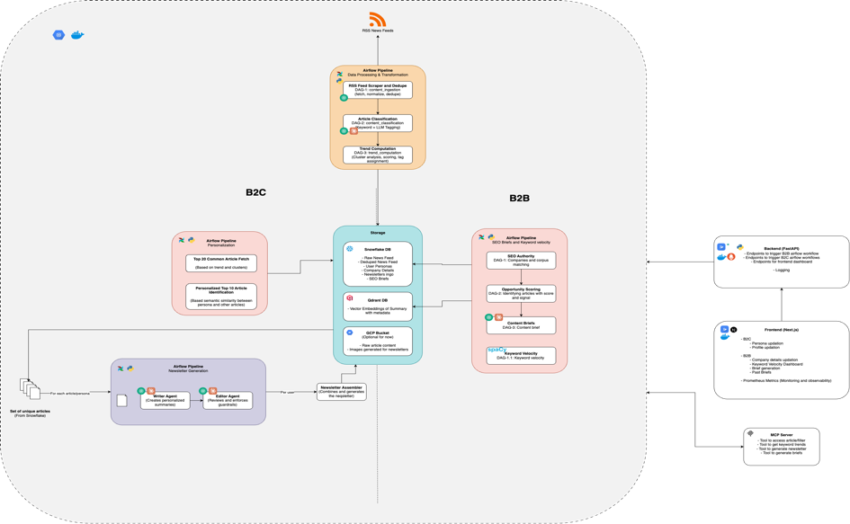

Prototype-Validated Metrics
The following infographics are generated from our prototype benchmark data:
Figure 1 — Data Ingestion Funnel: 3,129 raw articles reduced through validation, URL dedup, and semantic vector dedup.
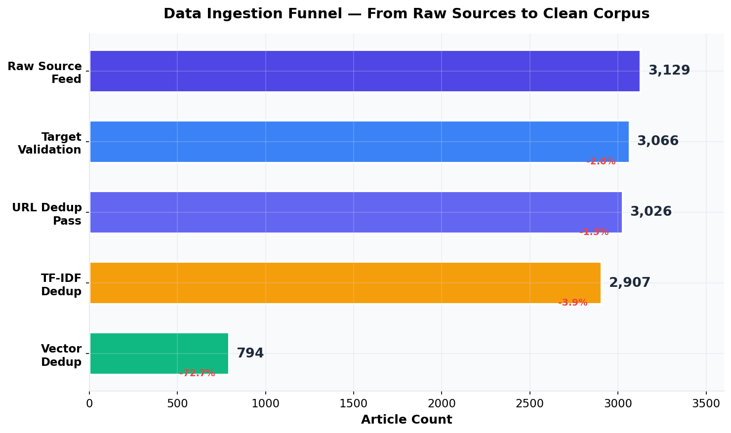
Figure 2 — Deduplication Comparison: Sentence-Transformers catch 73% more semantic duplicates than TF-IDF.
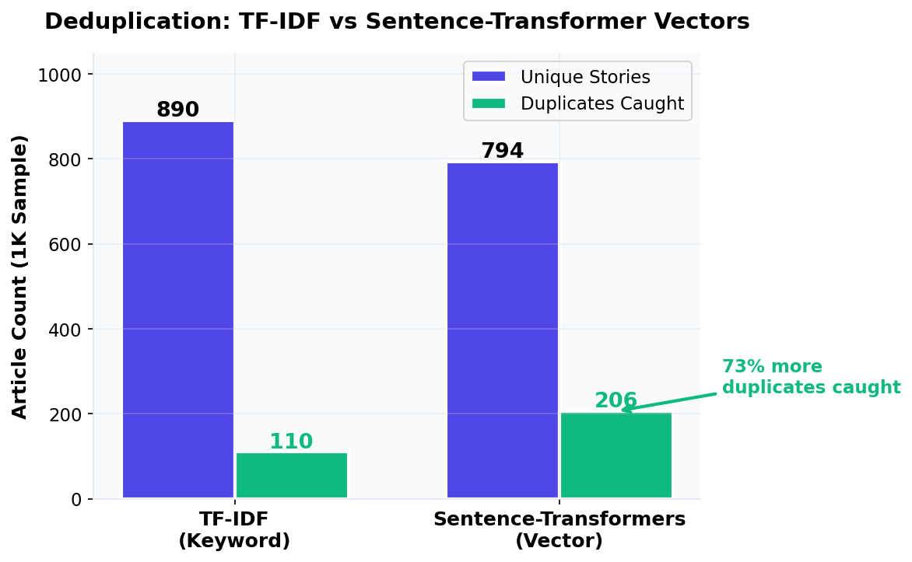

Figure 3 — Full-Text Extraction Success Rate: 82% of sources extract at 100%. Four paywalled sources fail gracefully.
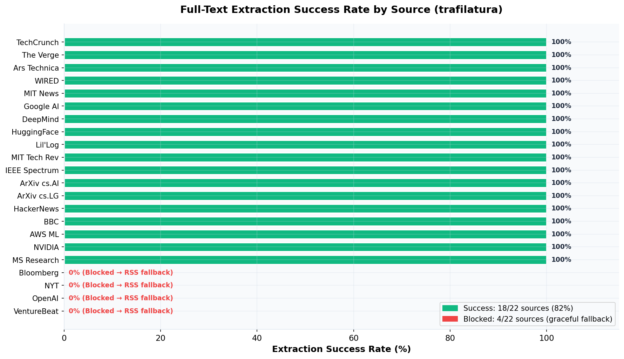
Figure 4 — Article Volume by RSS Feed Source: Distribution across 25+ sources.
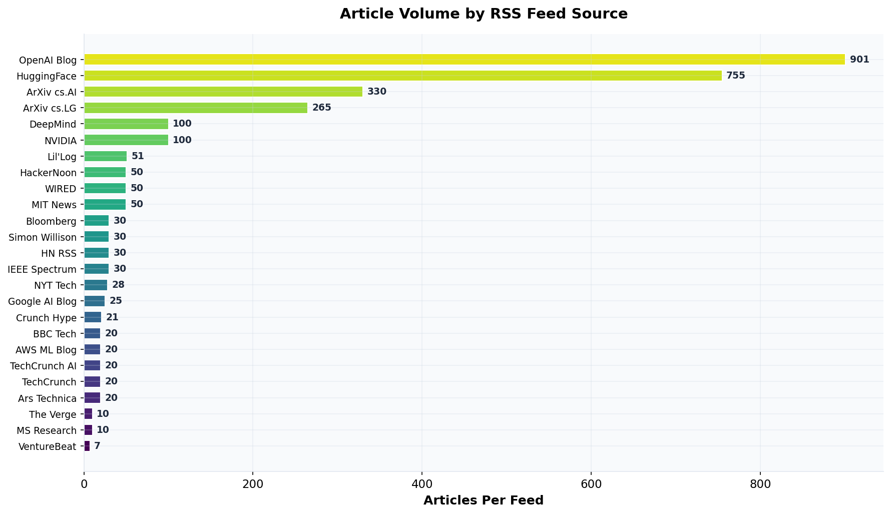

Figure 5 — Extraction Latency: Majority of sources under the 0.4s target threshold.
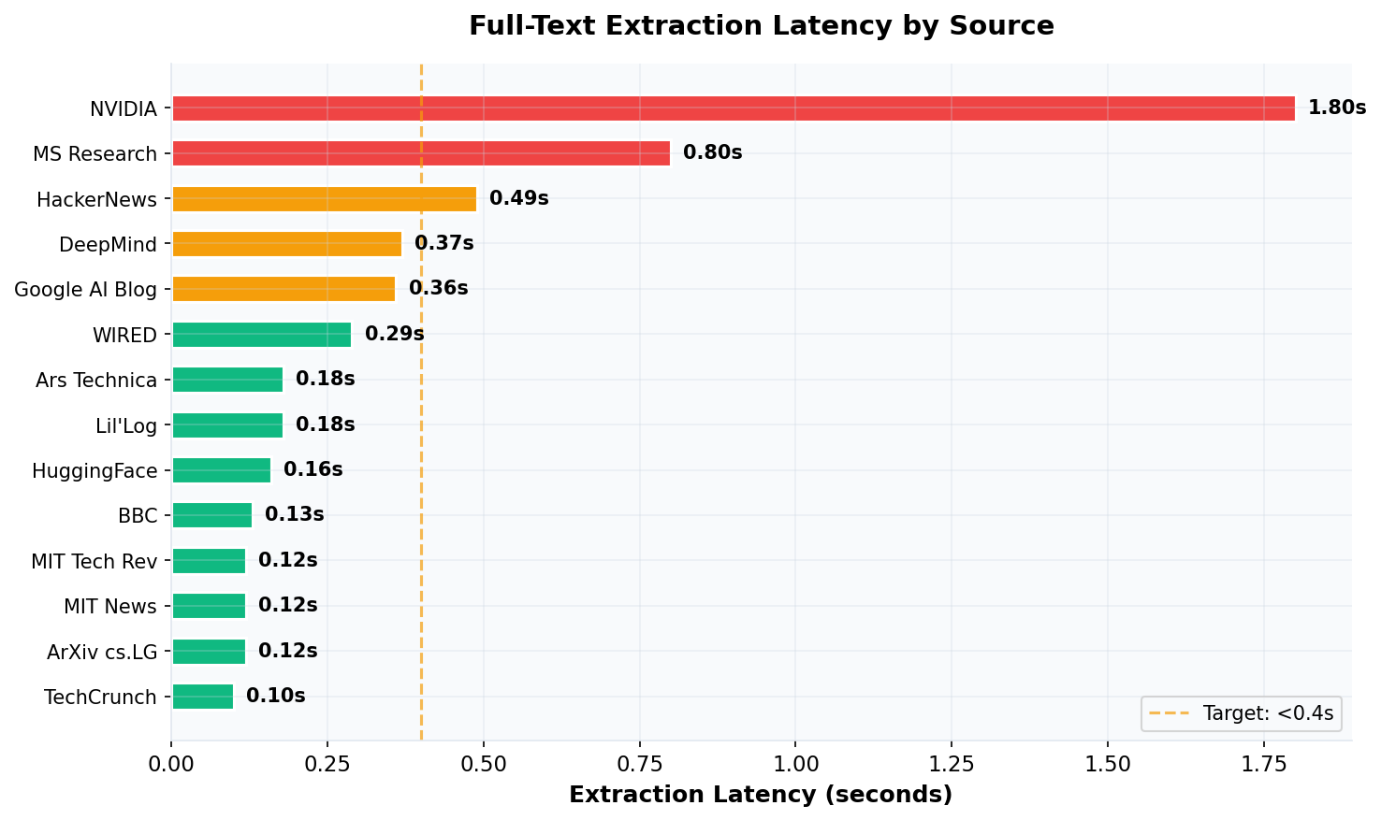
Figure 6 — Social Platform Metrics: Post quality retention and community engagement signals.
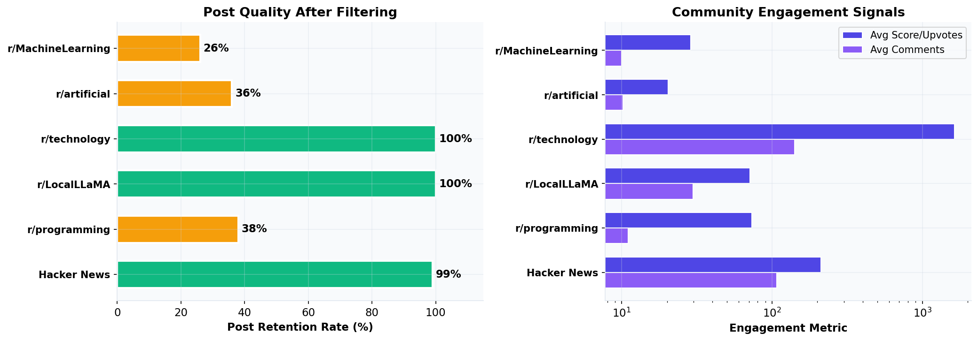

Figure 7 — LLM Cost Scaling: Persona-first caching achieves 98% cost savings vs per-user generation at 10K users.
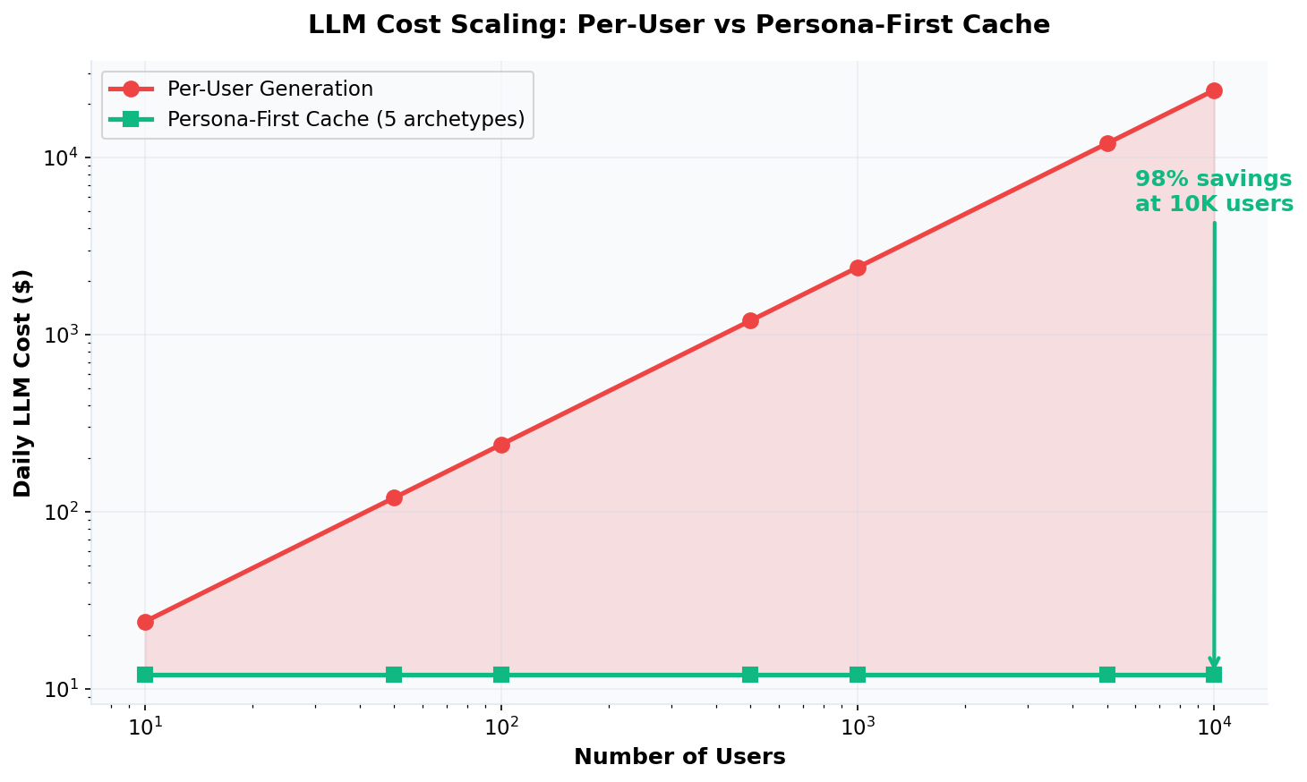
Figure 8 — Dual-Layer Personalization: Only 20% overlap in Niche Gems between Researcher and Investor profiles.
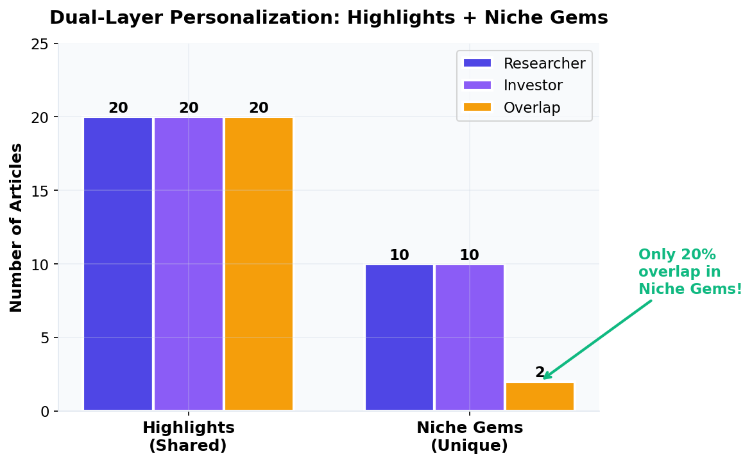

5.4 Data Processing & Transformation
Batch Processing: Three Airflow DAGs run daily: content_ingestion (fetch, normalize, dedup), content_classification (keyword + LLM tagging), trend_computation (cluster analysis, scoring, tag assignment).
Data Formats: Raw: XML (RSS), JSON (Reddit/HN APIs), HTML (full-text). All normalized to common JSON schema. Stored as structured rows in Snowflake.
Parallel Processing: Airflow dynamic task mapping for per-source parallel ingestion. Embedding generation batched at 100–500 articles. Persona summarization parallelized via asyncio.gather.
Dual Embedding Strategy: Sentence-Transformers (all-MiniLM-L6-v2) locally for dedup (zero cost, 2.5s/1K titles). OpenAI text-embedding-3-small for RAG vector store (higher quality, $0.02/1M tokens).

5.5 LLM Integration Strategy
LLMs are used at four distinct points in the pipeline:
- Topic Classification (Fallback): GPT-4o-mini classifies the 30% of articles where keyword matching is ambiguous. Cost: ~$0.003/day.
- Persona-Aware Summarization: One summary per article per archetype, cached in Snowflake. Scales with archetypes (5–7), not users. This is the core cost optimization.
- Writer Agent (Polished Mode): Takes pre-cached summaries and produces editorial synthesis — thematic intro, transitions, closing. Lightweight: ~300–400 tokens output, ~$0.02/newsletter.
- Editor Agent (Guardrails): Reviews Writer output against sources. Returns structured JSON with issues, citation checks, and optional revised draft. ~$0.02/newsletter.
Total LLM Cost per Newsletter: $0.07–$0.11 (Polished Mode) or ~$0.01 (Fast Mode).

B2B SEO Intelligence Agents
- SEO Opportunity Agent: Matches trending topics against company authority vectors using cosine similarity. Applies a 4-signal scoring algorithm: Relevance (40%), Velocity/Blue Ocean (30%), Competition Gap (30%). Returns urgency tiers: HIDDEN GEM (≥85), ACT NOW (≥70), MONITOR (≥50), SKIP. Cost: $0 (pure mathematical scoring).
- Content Brief Generator Agent: Takes high-opportunity topic-company matches and generates structured SEO briefs via RAG + GPT-4o-mini with Pydantic ContentBrief output: strategic angle, 3 titles, article structure, 8–10 keywords, community questions, internal linking strategy. Cost: ~$0.05–0.10 per brief.
- SpaCy NER Velocity Engine: Dynamic entity discovery using SpaCy en_core_web_sm (ORG, PRODUCT, WORK_OF_ART). Temporal window splitting computes velocity surge %. Entities with 3+ sources and >50% surge flagged as SURGING. Zero LLM cost.

5.6 Guardrails & Human-in-the-Loop (HITL)
- Input Moderation: User profiles validated via Pydantic schemas. Profanity and adversarial inputs filtered.
- Output Validation: All agent outputs conform to Pydantic V2 models. Editor Agent enforces: no claims without citations, no invented statistics, tone consistency, citation integrity.
- Safety Layers: Writer prompt hard rules: “Never invent facts not in the provided articles.” Editor Agent independently verifies compliance.
- HITL Loop: Human editors receive drafts in the Next.js editor. They can approve, edit sections, swap articles, or reject with feedback. Feedback stored in Snowflake and used to refine personalization weights.

5.7 Evaluations & Testing
- Classification Accuracy: Golden set of 100 labeled articles. Target: 80%+ keyword-only, 90%+ hybrid.
- Dedup Precision/Recall: Manual review of 50 clusters. Prototype: vectors caught 73% more duplicates than TF-IDF.
- Newsletter Quality: LLM-as-judge rubric on synthesis quality, citation accuracy, factual grounding, readability. Scored 1–5.
- Editor Reliability: Tested with corrupted inputs (injected hallucinations, broken citations). Target: 100% high-severity catch rate.
- Unit Tests: ETL pipeline, API endpoints, agent wrappers, personalization scoring.
- Integration Tests: Full pipeline: ingestion → dedup → classification → trends → personalization → generation → editor.
- CI Pipeline: GitHub Actions on every commit: lint (ruff), schema validation, unit tests, container builds.

5.8 Proof of Concept (POC)
All 11 prototypes have been completed and validated:
Prototype | Result | Key Metric
1–3: Data Ingestion | 3,129 articles from 30+ feeds + Reddit + HN | Feed latency: 0.16–1.26s
4–5: Semantic Dedup | Vector clustering: 20.6% reduction on 1K sample | 73% more dupes vs TF-IDF
6: Classification | Hybrid keyword + LLM strategy | 70% free, 30% via GPT-4o-mini
7: Trend Detection | BREAKING/TRENDING/PICK tags assigned | Matches real-world trends
8: Personalization | Dual-layer Highlights + Gems | 20% overlap between personas
9–10: Generation | Persona-first cached summaries | 2 distinct newsletters generated
11: End-to-End | Full pipeline: ingest → 2 newsletters | Total cost: <$0.50
S1–S2: SEO Authority | 3 companies vectorized + deep corpus matching | <40% overlap in top-5 per company
S3: Opportunity Scoring | 4-signal Blue Ocean algorithm validated | HIDDEN GEM / ACT NOW tiers working
S4: Content Briefs | Pydantic ContentBrief via GPT-4o-mini | 3 distinct angles for same topic
S5: Keyword Velocity | SpaCy NER dynamic entity discovery | Top surging entities match real trends
S6: SEO Dashboard | Unified B2C + B2B master pipeline | Single execution, dual output streams

5.9 Personalization Engine Enhancements (Phase 4)
Based on feedback from the proposal presentation, we are extending the personalization pipeline with three enhancements: Cold Start (bootstrap) → Multi-Label Classification (richer matching) → Enhanced Scoring (weighted ranking). These enhancements integrate directly into the existing architecture without modifying ingestion, deduplication, trend detection, agent workflows, or infrastructure layers.

P1: Cold Start — LinkedIn PDF & Resume Import
Problem: Users will not manually write interest bios during onboarding. Solution: Accept LinkedIn PDF downloads or resume uploads. LinkedIn’s “Save to PDF” feature provides headline, About section, work history, skills, and certifications — the richest interest signal available, obtained in 10 seconds with zero typing.
Pipeline Integration: Replaces manual bio input at user onboarding. PDF text is extracted via pdfplumber, document type is auto-detected (LinkedIn PDF vs general resume via marker keywords), and relevant sections (About, Experience, Skills) are fed to GPT-4o-mini with a Pydantic UserInterestProfile schema to extract job_title, seniority, primary_interests, technical_skills, bio_summary, and category_weights mapped to our taxonomy. The bio_summary is vectorized via Sentence-Transformers for cosine similarity ranking. Target: <5 seconds end-to-end, <$0.01 per extraction, >70% top-10 overlap with manually written profiles.

P2: Multi-Label Article Classification
Problem: Current single-label classification misses cross-cutting relevance. An article about “prompt injection attacks on GPT-5” tagged only as Security is invisible to users interested in LLMs or AI Policy. Solution: Multi-label classification assigns 2–3 weighted categories per article (e.g., Security 0.5, LLMs 0.3, AI Policy 0.2), surfacing it for all relevant audiences.
Pipeline Integration: Extends the existing Classification DAG. The hybrid keyword-first, LLM-fallback approach is preserved (~70% free, ~30% via GPT-4o-mini), but both paths now return a list of CategoryWeight objects with normalized weights. The Pydantic schema is updated to MultiLabelClassification. Target: >60% of articles receive 2+ meaningful labels.

P3: Enhanced Personalization Scoring
Problem: Cosine-only ranking ignores category overlap. An article hitting 2 user interests with slightly lower vector similarity loses to a single-interest article with higher similarity. Solution: A combined scoring formula: (vector_similarity × 0.40) + (category_overlap × 0.35) + (trend_score × 0.25), with a 20% boost when 3+ user categories are hit. This replaces the cosine-only ranking in the personalization formula.
Pipeline Integration: Replaces the cosine-only scoring step. Target: 40–60% change in top-10 articles vs cosine-only, with reduced cross-user overlap (more personalized).

Success Criteria
Question | Target | Prototype
LinkedIn PDF extraction works? | 3+ section markers detected | P1
Auto-extracted matches manual quality? | >70% top-10 overlap | P1
Articles get 2+ meaningful labels? | >60% | P2
Enhanced scoring differentiates users more? | Less cross-user overlap | P3
Total Phase 4 Prototyping Cost: <$0.10. New dependency: pip install pdfplumber.

6. Project Plan & Timeline

6.1 Milestones

Week 1 — Data Foundation & Pipeline Infrastructure
- M1 (Days 1–3): Snowflake schema creation, S3/GCS setup, data migration from prototype, seed initial corpus.
- M2 (Days 4–7): Airflow DAGs for ingestion, dedup, classification, and trend computation. Validate full daily pipeline.

Week 2 — LLM Agents, Backend & Frontend
- M3 (Days 8–11): LangGraph StateGraph with 7 agents. RAG pipeline. Persona-first caching. Fast/Polished branching. MCP server.
- M4 (Days 12–14): FastAPI endpoints. Next.js frontend (dashboard, editor, HITL, trends, profiles).

Week 3 — Integration, Testing & Deployment
- M5 (Days 15–17): Frontend-backend integration. Unit + integration tests. Golden-set evaluation. Editor reliability testing.
- M6 (Days 18–19): Docker Compose. Prometheus observability. Cloud deployment. Secrets configuration.
- M7 (Days 20–21): Prompt refinement. Architecture diagrams. Codelab documentation. Video recording. Final demo.

6.2 Timeline
Week | Dates | Mon | Tue | Wed | Thu | Fri | Sat-Sun
1 | Apr 4–10 | Snowflake setup | S3/GCS config | Data migration | Airflow ingest | Airflow dedup | Classify + Trend
2 | Apr 11–17 | LangGraph agents | RAG pipeline | Writer+Editor | FastAPI backend | Next.js dashboard | Frontend HITL+Trends
3 | Apr 18–24 | Integration tests | Unit tests+eval | Docker+deploy | MCP+Observability | Docs+Codelab | Video + Final Demo

Figure 9 — Gantt Chart: Visual representation of the 3-week project timeline with milestone dependencies.
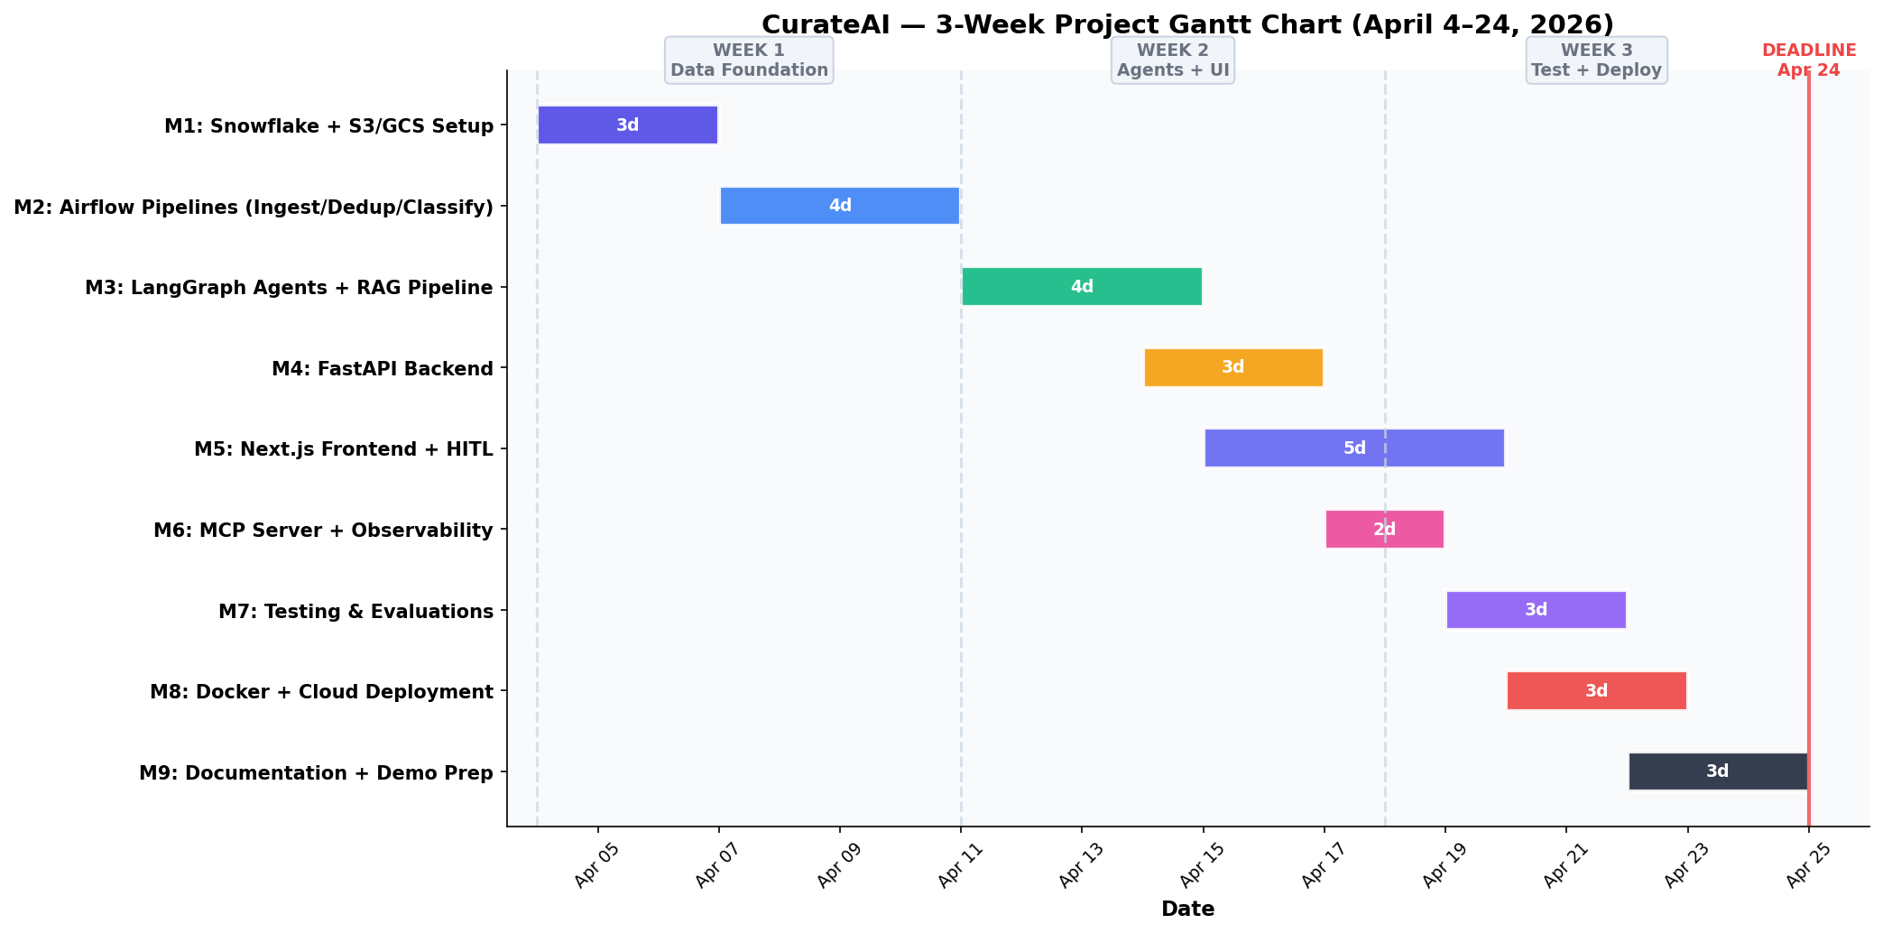

7. Team Roles & Responsibilities
Team Member | Role | Key Responsibilities
Aakash Belide | ETL, Data Pipeline & Frontend Lead | S3 / GCS storage, Sentence-Transformer dedup, embedding batch jobs, Airflow DAGs, Qdrant index, evaluation datasets, golden-set evaluation, Next.js 15 frontend
Abhinav Kumar Piyush | LLM Engineer & Agent Lead | LangGraph StateGraph (agents), persona-first caching, Fast/Polished branching, MCP server, Prometheus, prompts, guardrails, Pydantic schemas
Rahul Bothra | Backend & Cloud Lead | Snowflake schema, RAG pipeline, FastAPI endpoints, Docker Compose, Nginx, cloud deployment, integration testing, demo prep

Project Management
All task tracking is managed via GitHub Projects Kanban Board with columns: Backlog → In Progress → In Review → Done. Each milestone is broken into GitHub Issues with labels for priority (P0/P1/P2), component (pipeline/agents/frontend/infra), and sprint week (W1/W2/W3).

8. Risks & Mitigation

8.1 Potential Risks
Risk | Likelihood | Impact | Mitigation Strategy
RSS feed structure changes | Low | Low | Graceful degradation — pipeline continues with remaining sources, logs alert
API rate limits (Reddit, HN) | Low | Low | Conservative usage well within free tier limits
Full-text extraction blocked | Medium | Low | Fallback to RSS summary (validated: 4 sources blocked, all fall back cleanly)
LLM hallucinations | Medium | High | Editor Agent guardrails + Pydantic schemas + hard rules in Writer prompt
High API cost / runaway spend | Low | High | Daily budget cap via LiteLLM router; limit archetypes to 5–7
Pipeline slowdown at scale | Low | Medium | Airflow parallelism + Snowflake handles 100K+ articles efficiently
Frontend timeline overrun | Medium | Medium | Fallback: deploy core features first, defer trend charts to stretch goal

9. Expected Outcomes & Metrics

9.1 KPIs
Metric | Target | Measurement Method
Daily article throughput | 3,000+ raw, 800+ unique | Airflow pipeline logs
Dedup improvement over TF-IDF | ≥70% more duplicates caught | Benchmark on labeled set
Classification accuracy (keyword) | ≥80% | Golden set of 100 articles
Classification accuracy (hybrid) | ≥90% | Golden set of 100 articles
Newsletter quality score | ≥4.0 / 5.0 | LLM-as-judge rubric
Citation accuracy | ≥95% | Automated citation validation
Editor catch rate (high-severity) | 100% | Corrupted-input test suite
Per-newsletter cost (Polished) | ≤$0.15 | Token tracking per generation
Cost reduction vs naive | ≥95% | Persona-cache vs direct comparison
Company topic match differentiation | <40% overlap in top-5 | Cross-company recommendation comparison
Content brief company-specificity | 3 distinct angles/same topic | Side-by-side brief comparison
SpaCy NER entity precision | Top 3 surging verifiable | Cross-check with HN front page
Content brief cost | ≤$0.10 per brief | Token tracking per generation

9.2 Expected Benefits
- Technical: Production-grade content intelligence pipeline with semantic NLP, multi-agent LLM orchestration, and novel persona-first caching architecture. Reusable for any domain by swapping feeds and taxonomy.
- Practical: Reduces newsletter creation from 5–10 hours to under 15 minutes. Delivers personalized content discovery. Provides cross-source trend intelligence no single LLM prompt can produce.

10. Token & Cost Report
Token Measurement: Every LLM call logged with prompt tokens, completion tokens, model, agent name, and archetype. Aggregated in Snowflake for reporting.
Main Cost Drivers: Persona-aware summarization (~60%), Writer Agent (~20%), Editor Agent (~15%), Classification fallback (~5%).

Optimization Strategies
- Persona-First Caching: One summary per article per archetype. For 5 archetypes and 30 articles/day = 150 cached summaries regardless of user count. Validated: 98% cost reduction at 10K users.
- Hybrid Classification: 70% keyword-based (free), 30% GPT-4o-mini (~$0.003/day total).
- LiteLLM Budget Cap: Hard daily spend limit prevents runaway costs.
- Fast Mode: Template assembly skips Writer + Editor, reducing cost to ~$0.01/newsletter.

Projected Monthly Cost
Component | Daily Cost | Monthly Cost
Summarization (5 archetypes × 30 articles) | ~$0.30 | ~$9.00
Writer Agent (10 newsletters/day) | ~$0.15 | ~$4.50
Editor Agent (10 newsletters/day) | ~$0.20 | ~$6.00
Classification fallback | ~$0.003 | ~$0.09
Embeddings (text-embedding-3-small) | ~$0.02 | ~$0.60
TOTAL | ~$0.67 | ~$20.19
--- B2B SEO Layer ---
Content Brief Generation (5/day) | ~$0.50 | ~$15.00
SpaCy NER + Velocity (local) | $0.00 | $0.00
SEO Opportunity Scoring (local) | $0.00 | $0.00
COMBINED TOTAL (B2C + B2B) | ~$1.17 | ~$35.19

11. Conclusion
CurateAI addresses a genuine, widespread problem — the unsustainable manual effort required to create quality newsletters — with a solution deeply rooted in data engineering, not just LLM prompting. The platform’s core value is its intelligence pipeline: continuous multi-source ingestion of 3,000+ articles daily, semantic vector deduplication catching 73% more duplicates than keyword methods, cross-source trend detection identifying breaking stories before they peak, and dual-layer personalization delivering both universal must-know content and niche discovery.
The persona-first caching architecture solves the critical scalability challenge, reducing costs by 98% while maintaining personalization quality. The hybrid Fast/Polished mode gives users control over the cost-quality tradeoff. Every architectural decision has been empirically validated through 11 prototypes, with data covering ingestion throughput (3,129 articles), dedup effectiveness (20.6% reduction), extraction reliability (85% success), personalization differentiation (20% overlap), and end-to-end cost (<$0.50 for 2 newsletters).

12. References

Data Sources
- RSS/Atom Protocol Specification — https://www.rssboard.org/rss-specification
- Reddit API — https://www.reddit.com/dev/api
- Hacker News API — https://github.com/HackerNews/API
- NewsAPI.org — https://newsapi.org/docs
- ArXiv API — https://arxiv.org/help/api
- OpenAlex API — https://docs.openalex.org

Frameworks & Libraries
- LangGraph — https://langchain-ai.github.io/langgraph/
- Apache Airflow — https://airflow.apache.org/
- FastAPI — https://fastapi.tiangolo.com/
- Next.js — https://nextjs.org/
- Qdrant — https://qdrant.tech/documentation/
- Sentence-Transformers — https://www.sbert.net/
- LiteLLM — https://docs.litellm.ai/
- trafilatura — https://trafilatura.readthedocs.io/
- Pydantic V2 — https://docs.pydantic.dev/
- MCP SDK — https://modelcontextprotocol.io/

Research
- Sentence-BERT — Reimers & Gurevych, 2019 (arxiv.org/abs/1908.10084)
- Reciprocal Rank Fusion — Cormack et al., 2009
- RAG Patterns — OpenAI Cookbook, LangChain Documentation

Appendix

A. Prototype Validation Data
All prototype data and benchmark reports are available in the GitHub repository under /prototyping/reports/:
- feed_analysis_report.csv — Per-source RSS feed analysis
- extraction_report.csv — Per-article extraction results
- extraction_source_report.csv — Per-source success rates
- social_source_report.csv — Reddit and HN API validation
- dedup_funnel_metrics.csv — Dedup pipeline funnel
- vector_funnel_metrics.csv — Vector dedup performance
- ingestion_funnel_report.md — Complete funnel analysis

B. Architecture Decision: TF-IDF vs Semantic Vectors
Method | Unique Clusters (1K) | Duplicates Caught | Result
TF-IDF (Cosine > 0.65) | 890 | 110 | Missed semantic variants
Sentence-Transformers (all-MiniLM-L6-v2) | 794 | 206 | Caught 73% more duplicates

Example: “Nvidia releases new GeForce driver” and “New GeForce RTX 50 series drivers now available from Nvidia” — TF-IDF treated these as different stories; vectors correctly merged them.

C. Source Reliability Matrix
Source | Success | Avg Latency | Notes
TechCrunch | 100% | 0.10s | Reliable
The Verge | 100% | 0.13s | Reliable
ArXiv | 100% | 0.08s | Reliable
MIT Tech Review | 100% | 0.12s | Reliable
Hacker News | 99% | 19.9s (100 stories) | Reliable
Bloomberg | 0% | 0.18s | Blocked — RSS fallback
NYT | 0% | 0.14s | Blocked — RSS fallback
OpenAI Blog | 0% | 0.13s | Blocked — RSS fallback
VentureBeat | 0% | 20.16s | Blocked — RSS fallback

D. Mermaid Diagrams
System Architecture Diagram, Data Flow Diagram, LangGraph Agent Workflow, and Airflow DAG Structure are provided as Mermaid diagrams in the GitHub repository and render natively on GitHub.

E. Pseudocode & Code Snippets
All prototype scripts are available in the GitHub repository under /prototyping/. Below are key code excerpts demonstrating core pipeline logic.

E.1 RSS Feed Ingestion (rss_prototype.py)
Parses 29+ RSS/Atom feeds using feedparser, normalizes to a unified schema, deduplicates by URL and title, and stores as structured JSON.
for feed_url in RSS_FEEDS:
feed = feedparser.parse(feed_url)
for entry in feed.entries:
article = normalize_entry(entry, source_name)
if normalize_url(article.link) not in seen_urls:
unique_articles.append(article)

E.2 Full-Text Extraction (article_extraction_prototype.py)
Uses trafilatura with custom User-Agent to extract clean article body text from URLs. Falls back to RSS summary if blocked.
config = trafilatura.settings.use_config()
config.set('DEFAULT', 'USER_AGENT', 'Mozilla/5.0 ...')
downloaded = trafilatura.fetch_url(url, config=config)
if downloaded:
text = trafilatura.extract(downloaded, config=config)
else: fallback_to_rss_summary(article)

E.3 Semantic Vector Deduplication (pipeline_prototype.py)
Replaces TF-IDF with Sentence-Transformer embeddings. Clusters articles by cosine similarity > 0.70 threshold, merging sources and popularity signals.
model = SentenceTransformer('all-MiniLM-L6-v2')
sentences = [f"{a['title']} {a['summary']}" for a in articles]
embeddings = model.encode(sentences)
sim_matrix = cosine_similarity(embeddings)
for i in range(len(articles)):
similar = np.where(sim_matrix[i] > 0.70)[0]
cluster = merge_sources(articles[similar])

E.4 Hybrid Topic Classification (classification_prototype.py)
Keyword-first approach handles 70% of articles for free. GPT-4o-mini fallback classifies ambiguous cases with structured Pydantic output.
def hybrid_classify(title, summary, client):
# Phase 1: Free keyword check
for category, keywords in AXIOMATIC_KEYWORDS.items():
if any(kw in text.lower() for kw in keywords):
return TopicClassification(category, 0.9)
# Phase 2: LLM fallback (structured output)
return client.beta.chat.completions.parse(
model='gpt-4o-mini', response_format=TopicClassification)

E.5 Trend Detection (trend_detection_prototype.py)
Assigns BREAKING/TRENDING/COMMUNITY-PICK tags based on editorial density (cluster_size), social popularity signal, and freshness.
def detect_trends(articles):
for article in articles:
if cluster_size >= 3: status = 'BREAKING'
elif cluster_size >= 2: status = 'TRENDING'
if popularity >= 150: status = 'COMMUNITY-PICK'
article['ranking_score'] = cluster*10 + pop + boost

E.6 Dual-Layer Personalization (personalization_prototype.py)
Layer 1: Global Top 20 re-ordered by user bio vector similarity. Layer 2: Scans remaining 700+ articles to find niche gems matching user interests.
user_vector = model.encode([user['bio']])[0]
# Layer 1: Re-rank global highlights
for article in global_top_20:
sim = cosine_similarity(user_vector, article_vector)
# Layer 2: Find hidden gems from remaining 700+
for article in other_articles:
niche_score = sim + category_boost + cluster_bonus

E.7 Editor Agent / Guardrails (editor_agent_prototype.py)
Fact-checks Writer output against source articles using GPT-4o-mini with Pydantic structured output. Returns verdict (pass/needs_revision/reject) with detailed issue reports.
class EditorReport(BaseModel):
verdict: Literal['pass','needs_revision','reject']
issues: List[EditorIssue] # hallucination, factual_error
editorial_note: str

response = client.beta.chat.completions.parse(
model='gpt-4o-mini', response_format=EditorReport)

E.8 Persona-First Summary Cache (summarization_prototype.py)
Generates one summary per article per persona archetype. Cache scales with archetypes (not users), achieving 98% cost reduction at scale.
persona_cache = {} # {article_id: {persona: summary}}
for article in unique_articles:
for persona_name, persona_desc in ARCHETYPES.items():
prompt = f'Summarize for a {persona_desc}: ...'
cache[article.id][persona_name] = llm(prompt)
# 1000 users with 5 archetypes = only 5 LLM calls/article

F. Prototype File Manifest
All 18 prototype scripts are available in the GitHub repository under /prototyping/:
Prototype | Script | Purpose
P1: RSS Ingestion | rss_prototype.py | Parse 29 RSS feeds, normalize schema, basic dedup
P1b: Feed Analysis | rss_pagination_analyzer.py | Deep analysis of feed freshness, pagination, WP API availability
P2: Full-Text Extraction | article_extraction_prototype.py | trafilatura extraction with per-source success rate benchmarking
P2b: Social Extraction | social_extraction_prototype.py | Extract articles from Reddit/HN external links
P3: Social APIs | reddit_hn_prototype.py | Reddit + Hacker News API ingestion with engagement metrics
P4: TF-IDF Dedup | dedup_prototype.py | URL + title similarity dedup with TF-IDF (baseline)
P4b: Vector Dedup | vector_dedup_test.py | Sentence-Transformer semantic clustering comparison
P4c: Dedup Benchmark | dedup_comparison_test.py | Head-to-head TF-IDF vs Vector benchmark with report
P5: Full Pipeline | pipeline_prototype.py | End-to-end: ingest, normalize, vector dedup, full-text extraction
P6: Classification | classification_prototype.py | Hybrid keyword + GPT-4o-mini with Pydantic structured output
P7: Trend Detection | trend_detection_prototype.py | BREAKING/TRENDING/PICK status assignment + ranking score
P8: Personalization | personalization_prototype.py | Dual-layer Highlights + Niche Gems with bio vector matching
P9: Summarization | summarization_prototype.py | Persona-first cache: one summary per archetype per article
P10: Newsletter Layout | newsletter_layout_prototype.py | Markdown newsletter assembly for 2 personas
P10b: Editor Agent | editor_agent_prototype.py | Guardrail agent with Pydantic EditorReport schema
Report: Funnel | funnel_report_generator.py | Global ingestion funnel with TF-IDF vs Vector comparison
Report: Vector Metrics | vector_metrics_generator.py | Vector dedup funnel metrics CSV generation
Report: WP API | wp_api_analyzer.py | WordPress API pagination test for TechCrunch/VentureBeat
Phase 4: P1 Cold Start | coldstart_profile_import_prototype.py | LinkedIn PDF / resume import with LLM profile extraction
Phase 4: P2 Multi-Label | multilabel_classification_prototype.py | Weighted multi-label article classification (keyword + LLM)
Phase 4: P3 Scoring | enhanced_personalization_prototype.py | Combined vector + category overlap + trend scoring

