**Programming Design Worksheet - Redfield  
 for CS1310** (programs 2-7) **and CS1311** (programs 1-6) Copy this file. Type and past images to create new documents for designs.  
Print it for class (if you must miss, submit one file to Designs).

First name **Davide** Last name **Russillo**

Design for program name **Family Data**

**DATA**

Variables needed in **WORDS for** **main** and **globally**    
GLOBAL:

current date in mm-dd-yyyy format

family structure with name, street, csz, relation, and birthday

MAIN:

input file pointer

output file pointer

C ***DECLARATIONS*** for main & global

GLOBAL:

char current_date[10] = "11-19-2024"; (example date)

struct family {

char name[50];

char street[50];

char csz[50];

char relation[50];

char birthday[11];

};

struct family people[7];

MAIN:

FILE *infile;

FILE *outfile;

**Algorithm to PSEUDOCODE level** for each function   
(*remember to indent under* if, switch, while, do-while, for)  
**main**:

infile = fopen("familyin.txt");

outfile = fopen("familyout.txt");

read_data from infile

write_data to outfile

close infile

close outfile

**other** functions (**bold the names**): (put them before main in the program!)

void **fprint_age**(FILE *out, char *birthday)

delcare and set birthday_month to atoi of birthday

delcare and set birthday_day to atoi of birthday+3

delcare and set birthday_year to atoi of birthday+6

delcare and set current_month to atoi of current_date

delcare and set current_day to atoi of current_date+3

delcare and set current_year to atoi of current_date+6

if current_month is less than birthday_month

print current_year - birthday_year - 1 to out

else if current_month is more than birthday_month

print current_year - birthday_year to out

else if current_day is less than birthday_day

print current_year - birthday_year - 1 to out

else

print current_year - birthday_year to out

void **fprint_datef**(FILE *out, char *date)

declare and set month to atoi of date

declare and set day to atoi of date+3

declare and set year to atoi of date+6

switch on month

case its one

print January to out

case its two

print February to out

case its three

print March to out

case its four

print April to out

case its five

print May to out

case its six

print June to out

case its seven

print July to out

case its eight

print August to out

case its nine

print September to out

case its ten

print October to out

case its eleven

print November to out

case its twelve

print December to out

otherwise (default outcome)

print ERROR: INVALID MONTH VALUE to out

print day, year to out

void **read_data**(FILE *inputfile)

declare line string

declare person integer for iteration

for each person, until the seventh person

set line to line in inputfile

set last character in line to \0 to remove newline

set name of index person in people to line

set line to line in inputfile

set last character in line to \0 to remove newline

set street of index person in people to line

set line to line in inputfile

set last character in line to \0 to remove newline

set csz of index person in people to line

set line to line in inputfile

set last character in line to \0 to remove newline

set relation of index person in people to line

set line to line in inputfile

set last character in line to \0 to remove newline

set birthday of index person in people to line

void **write_data**(FILE *outputfile)

declare person integer for iteration

for each person until the seventh person

print person's name and relation to stdout

print person's name and relation to outputfile

print person's street to stdout

print person's street to outputfile

fprint_datef of person's birthday to stdout

fprint_datef of person's birthday to outputfile

print newline to stdout

print newline to outputfile

print person's csz to stdout

print person's csz to outputfile

fprint_age of person's birthday to stdout

fprint_age of person's birthday to outputfile

print two newlines to stdout

print two newlines to outputfile

**OTHER part of the design** (see assignment - *input or sample output*)

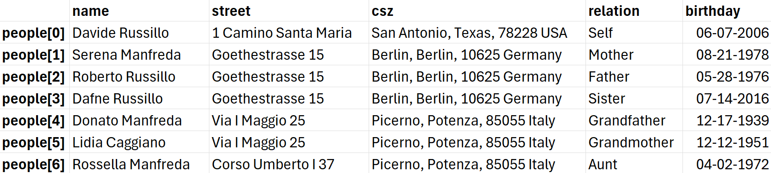

**familyin.txt:**

Davide Russillo

1 Camino Santa Maria

San Antonio, Texas, 78228 USA

Self

06-07-2006

Serena Manfreda

Goethestrasse 15

Berlin, Berlin, 10625 Germany

Mother

08-21-1978

Roberto Russillo

Goethestrasse 15

Berlin, Berlin, 10625 Germany

Father

05-28-1976

Dafne Russillo

Goethestrasse 15

Berlin, Berlin, 10625 Germany

Sister

07-14-2016

Donato Manfreda

Via I Maggio 25

Picerno, Potenza, 85055 Italy

Grandfather

12-17-1939

Lidia Caggiano

Via I Maggio 25

Picerno, Potenza, 85055 Italy

Grandmother

12-12-1951

Rossella Manfreda

Corso Umberto I 37

Picerno, Potenza, 85055 Italy

Aunt

04-02-1972