Programming Design Worksheet - Redfield
for CS1310 (programs 2-7) and CS1311 (programs 1-6)
Copy this file. Type and past images to create new documents for designs.
Print it for class (if you must miss, submit one file to Designs).
First name Davide Last name Russillo
Design for program name Family Data
DATA
Variables needed in WORDS for main and globally
GLOBAL:
current date in mm-dd-yyyy format
family structure with name, street, csz, relation, and birthday
MAIN:
input file pointer
output file pointer
C DECLARATIONS for main & global
GLOBAL:
char current_date[10] = "11-19-2024"; (example date)
struct family {
char name[50];
char street[50];
char csz[50];
char relation[50];
char birthday[11];
};
struct family people[7];
MAIN:
FILE *infile;
FILE *outfile;

Algorithm to PSEUDOCODE level for each function
(remember to indent under if, switch, while, do-while, for)
main:
infile = fopen("familyin.txt");
outfile = fopen("familyout.txt");
read_data from infile
write_data to outfile
close infile
close outfile

other functions (bold the names): (put them before main in the program!)

void fprint_age(FILE *out, char *birthday)
delcare and set birthday_month to atoi of birthday
delcare and set birthday_day to atoi of birthday+3
delcare and set birthday_year to atoi of birthday+6
delcare and set current_month to atoi of current_date
delcare and set current_day to atoi of current_date+3
delcare and set current_year to atoi of current_date+6

if current_month is less than birthday_month
print current_year - birthday_year - 1 to out
else if current_month is more than birthday_month
print current_year - birthday_year to out
else if current_day is less than birthday_day
print current_year - birthday_year - 1 to out
else
print current_year - birthday_year to out

void fprint_datef(FILE *out, char *date)
declare and set month to atoi of date
declare and set day to atoi of date+3
declare and set year to atoi of date+6

switch on month
case its one
print January to out
case its two
print February to out
case its three
print March to out
case its four
print April to out
case its five
print May to out
case its six
print June to out
case its seven
print July to out
case its eight
print August to out
case its nine
print September to out
case its ten
print October to out
case its eleven
print November to out
case its twelve
print December to out
otherwise (default outcome)
print ERROR: INVALID MONTH VALUE to out
print day, year to out

void read_data(FILE *inputfile)
declare line string
declare person integer for iteration
for each person, until the seventh person
set line to line in inputfile
set last character in line to \0 to remove newline
set name of index person in people to line
set line to line in inputfile
set last character in line to \0 to remove newline
set street of index person in people to line
set line to line in inputfile
set last character in line to \0 to remove newline
set csz of index person in people to line
set line to line in inputfile
set last character in line to \0 to remove newline
set relation of index person in people to line
set line to line in inputfile
set last character in line to \0 to remove newline
set birthday of index person in people to line

void write_data(FILE *outputfile)
declare person integer for iteration
for each person until the seventh person
print person's name and relation to stdout
print person's name and relation to outputfile
print person's street to stdout
print person's street to outputfile
fprint_datef of person's birthday to stdout
fprint_datef of person's birthday to outputfile
print newline to stdout
print newline to outputfile
print person's csz to stdout
print person's csz to outputfile
fprint_age of person's birthday to stdout
fprint_age of person's birthday to outputfile
print two newlines to stdout
print two newlines to outputfile

OTHER part of the design (see assignment - input or sample output)
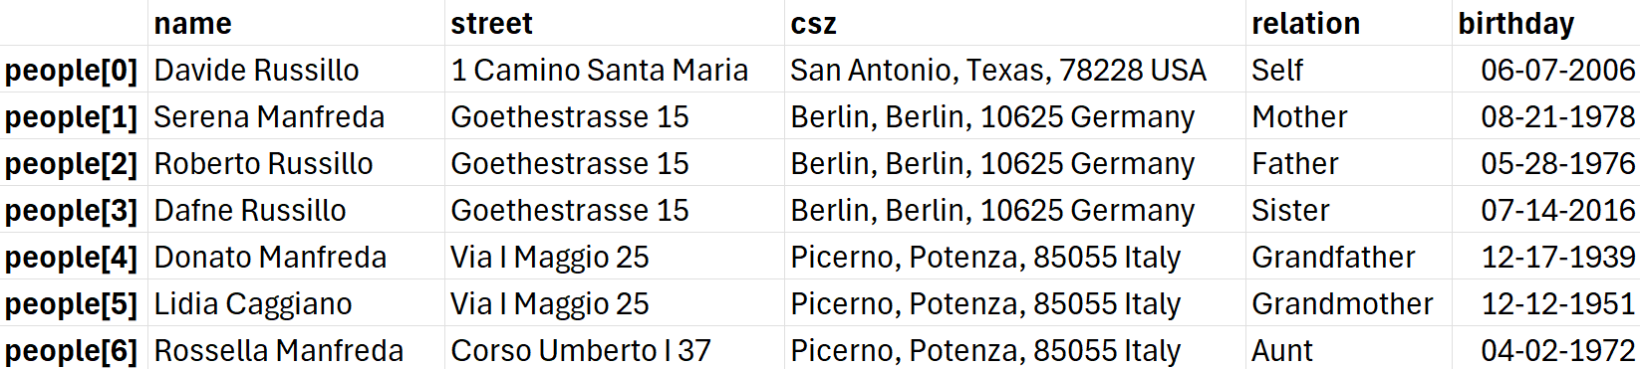
familyin.txt:
Davide Russillo
1 Camino Santa Maria
San Antonio, Texas, 78228 USA
Self
06-07-2006
Serena Manfreda
Goethestrasse 15
Berlin, Berlin, 10625 Germany
Mother
08-21-1978
Roberto Russillo
Goethestrasse 15
Berlin, Berlin, 10625 Germany
Father
05-28-1976
Dafne Russillo
Goethestrasse 15
Berlin, Berlin, 10625 Germany
Sister
07-14-2016
Donato Manfreda
Via I Maggio 25
Picerno, Potenza, 85055 Italy
Grandfather
12-17-1939
Lidia Caggiano
Via I Maggio 25
Picerno, Potenza, 85055 Italy
Grandmother
12-12-1951
Rossella Manfreda
Corso Umberto I 37
Picerno, Potenza, 85055 Italy
Aunt
04-02-1972

