David Tassoni

Demo 2

The main program loads the two registers (r2 & r3) with the address for Switches and LEDs. In the loop, the values are read from r2 and stored in r3, so that when you activate a switch, the corresponding led will turn on.

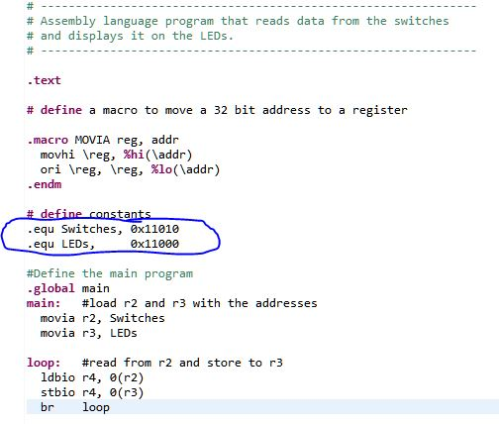

Seen above in the screenshot are the two constants, with the base addresses that I copied over from the system.h header file.