David Tassoni

Cache Demo

23 March 2020

**Q1: As jmax increases from 1 towards 1000, at which value of jmax will you see a significant increase in the execution time? (hint: execution time will increase linearly until you reach a certain value of jmax. At that point execution time will increase significantly).**

The value of jmax that will see a significant increase in the execution time is jmax = 125.

**Q2: Why does this happen?**

I think this will happen because at this point, jmax will be over 100, and the execution time will no longer be linear since jmax is so high at this point.

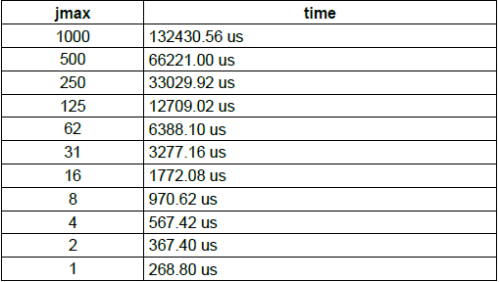

**Q3: Which configuration would you expect to have the shortest execution time for loop 1?**

Configuration C

**Q4: Why?**

Configuration C has more bytes per cache line (32 bytes or *8* words), so the loop will finish quick since *i+=8* on each iteration.

**Q5: Which configuration would you expect to have the shortest execution time for loop 2?**

Configuration E

**Q6: Why?**

Configuration E is 1 word, and i++ for each iteration, so it will have a shorter execution time.

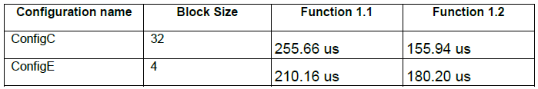

My predictions were correct.

**Q7: Which loop would have a shorter execution time in ConfigB?**

Loop 2 (function 2.8)

**Q8: Why?**

The loops are 256 and 8, while the other function has 128 and 16. Having a smaller outer loop and larger nested loop will result in a quicker execution time because ConfigB has no data cache.

**Q9: Which loop would have a shorter execution time in ConfigC?**

Loop 1 (Function 2.7)

**Q10: Why?**

Config C has a data cache, so the smaller nested loop and larger outer loop sizes will work better with Configuration C.

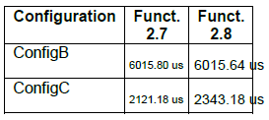

ConfigC finished booth functions quicker than ConfigB, with function 2.7 executing quicker than 2.8. ConfigB finished function 2.8 quicker than 2.7, but the time difference is very small.

**Q11: For which memory would you expect the shortest execution time?**

I would expect the on-chip memory to have a shorter execution time.

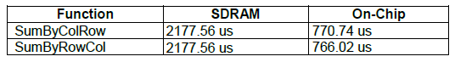

My prediction was correct.