|  |  |  |
| --- | --- | --- |
|  | Fmax | Setup Time |
| Slow 1100mV 85C | 442.67 MHz | -1.259 |
| Slow 1100mV 0C | 424.27 MHz | -1.357 |
| Fast 1100mV 85C | N/A | -0.271 |
| Fast 1100mV 0C | N/A | -0.207 |

Longest Path: -1.259

**From** Synchronizer:Synchonizer_1|flop_2[13] **to** Synchronizer:Synchonizer_Sum|flop_1[14]

Clock Delay: -0.060

Data Delay: 2.029

Slack: -1.259

|  |  |  |
| --- | --- | --- |
|  | Fmax | Setup Time |
| Slow 1100mV 85C | 274.05 MHz | 16.351 |
| Slow 1100mV 0C | 275.18 MHz | 16.366 |
| Fast 1100mV 85C | N/A | 17.696 |
| Fast 1100mV 0C | N/A | 17.883 |

Longest Path: 17.030

**FROM** Synchronizer:Synchonizer_2|flop_2[2] **TO** Synchronizer:Synchonizer_Sum|flop_1[6]

Clock Delay: -0.071

Data Delay: 2.729

Slack: 17.030

New slack for previously failing path: 18.090

New Clock Delay: -0.072

New Data Delay: 1.668

New Slack: 18.090

The clock delays are close, with the previous being -0.060 compared to the new value of -0.072. Data delays are a bit different, with a previous value of 2.029, and a new lower value of 1.668. And the biggest difference is in the slack times, with an original value of -1.259 and a new value of 18.090.

RTL View

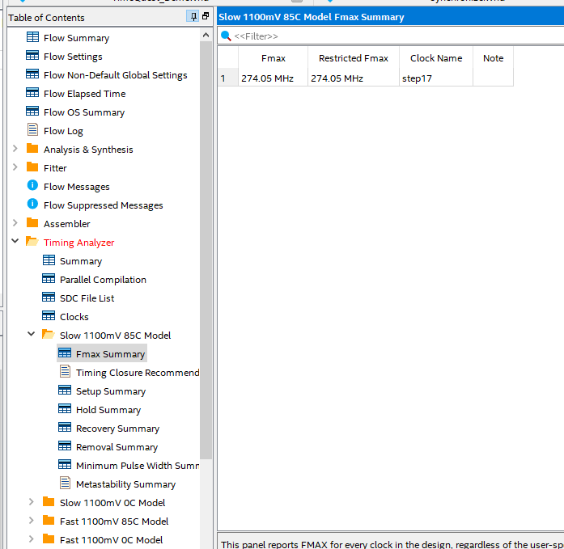

Example of one of the model analyses for checking the Fmax value (in this case, for Slow 1100mV 85C model)

Step 25: Image showing the new information (path 206) for the previously failing path from steps 11-14.

At first, the slack is negative, meaning that I need to save that much time in order to pass the 1 nanosecond time constaraint. Once the clock is changed to the 20 nanosecond period, the slack is positive, and the Fmax changes as well. The data is no longer computed behind schedule, so the new design is faster. The timequest tool is useful in performing detailed analysis of design timing, with any issues regarding setup/completion time being easily viewed and fixed, so that the designs can be completed quick.