# DSD5

## Overview

DSD5 is a 64 bit RISC oriented core with a segmentation model applied. DSD5 borrows features from the RISC-V ISA although it is not a RISC-V core. There are relatively few different types of instructions and complex operations requiring multiple clock cycles like multiply and divide have been left out.

## Instruction Size

DSD5’s minimum instruction parcel size is a 32 bit word. Instructions may be more than one word in length.

# Control and Status Registers (CSR)

There could be up to four sets of CSR’s depending on the available core operating levels. The CSR set selected is chosen from the upper two bits of the CSR register number. Since the register number is a 13 bit field there could be up to 2048 CSR’s for each operating level.

|  |  |  |  |  |
| --- | --- | --- | --- | --- |
| Regno11 | Width |  |  |  |
| 0x000 | 64 |  | reserved – reads as zero |  |
| 0x00F | 64 | SP | stack pointer |  |
| 0x010 | 32 | DS | DS selector |  |
| 0x011 | 32 | ES |  |  |
| 0x012 | 32 | FS |  |  |
| 0x013 | 32 | GS |  |  |
| 0x014 | 32 | HS |  |  |
| 0x015 | 32 | JS |  |  |
| 0x016 | 32 | CS | CS is read-only |  |
| 0x017 | 32 | DS | same as register 0x10 |  |
| 0x018 | 32 | SS | stack selector |  |
| 0x019 | 32 | LDT | selector for local descriptor table |  |

# Segmentation

## Overview

Segmentation is a low overhead means of memory protection and virtualization. Providing separate protected address spaces for different applications is the job of the operating system. Ideally segmentation hardware should not be visible to the application. The application should appear as though it has a flat memory model. The core contains seven segment registers. The segmentation system is managed via a combination of hardware and software. Up to 256 privilege levels are available.

## Privilege levels

Memory access is available according to privilege levels. The segmentation system allows up to 256 privilege levels.

## Operating Levels

While the core supports 256 privilege levels there are four basic sets of privilege operating levels for the core. User, supervisor, hypervisor and machine levels are available. These four sets map onto the available privilege levels as the following table shows.

|  |  |  |
| --- | --- | --- |
| Privilege Level Set | Privilege Level |  |
| 0 | 0 | Machine mode privilege level |
| 1 | 1 | Hypervisor level |
| 2 | 2 to 7 | Supervisor levels |
| 3 | 8 to 255 | User levels |

## Segment Registers

There are seven segment registers in the architecture – CS,DS,ES,FS,GS,HS and JS. The stack is managed as part of the data segment and the stack bounds register is also loaded from a descriptor. Writing a selector value into a segment register causes the hidden portion of the register to be loaded from the descriptor table.

|  |  |  |  |  |  |
| --- | --- | --- | --- | --- | --- |
| VA63..61 |  | Reset Value | CSR | Read /Write |  |
| 000 | DS |  | 010h |  | data segment (positive offsets) |
| 001 | ES |  | 011h |  |  |
| 010 | FS |  | 012h |  |  |
| 011 | GS |  | 013h |  |  |
| 100 | HS |  | 014h |  |  |
| 101 | JS |  | 015h |  |  |
| 110 | CS | 00000h | 016h | ro | code segment |
| 111 | DS |  | 017h |  | data segment (negative offsets) |
|  | SS |  | 018h |  | stack bounds |
|  | LDT |  | 019h |  | local descriptor table selector |

## Selecting a segment register

A specific segment register for a memory operation may be selected using the upper three bits of the virtual data address. The upper three bits of the program counter do not select a segment since the segment association is always fixed to the code segment. Code addresses always use segment register #6 – the code segment.

## Selectors

The core uses selectors as a more compact way to represent segment registers. Rather than pass the entire segment descriptor to routines (256 bits) and have each routine check for privilege violations, the core uses 32 bit selectors. Privilege violations are checked for at the time the segment register components (base, limit and access rights) are loaded. The selector includes a field identifying the privilege level, and a second field identifying which segment descriptor the selector is associated with. The selector format is shown below.

#### Selector Format:

|  |  |  |
| --- | --- | --- |
| 31 24 | 23 | 22 0 |
| PL8 | T | Index23 |

PL8: the privilege level associated with the segment

Index23: the index into the descriptor table

T: 0 = global, 1 = local descriptor table

## Descriptors

### Memory Descriptors

Memory descriptors describe the location and size of memory segments. They have the following format:

|  |  |  |
| --- | --- | --- |
| n+3 | ~48 | ACR16 |
| n+2 | ~64 | |
| n+1 | Limit63..0 | |
| n | Base63..0 (Lower limit for stack) | |

#### The Access Rights Field (ACR16) – Memory Descriptor

|  |  |  |  |  |  |  |  |  |
| --- | --- | --- | --- | --- | --- | --- | --- | --- |
| 15 |  |  | 12 | 11 | 10 | 9 | 8 | 7 0 |
| P | DC | ~ | 1/S | Ex | C/Stk | W/R | A | DPL8 |

P: 1 = segment present, 0 = segment not present

DC: 1 = descriptor cacheable, 0 = non-cacheable

S: 0 = system descriptor, 1 = memory descriptor

EX: 1 = executable, 0 = data

Code Segment Data Segment

C: 1= conforming Stk: 1=stack bounds

R: 1 = readable W: 1=writeable

A: 1= accessed

DPL8 = descriptor privilege level

#### Typical Values for ACR

9A00 – executable, readable code segment, privilege level zero

9200 – read/writeable data segment, privilege level zero

9600 – read / writeable stack segment, privilege level zero

### Stack Segment Descriptors

There is no base address specified for a stack segment descriptor instead a lower stack limit is specified in the descriptor. The stack must be part of the data segment and inherits the data segment base address. There isn’t a way to select the stack segment from the virtual address instead the stack bounds information is accessed as part of the data segment.

### System Segment Descriptors

System descriptors are identified by having bit12 of the access rights character set to zero. There are potentially sixteen different system descriptor types.

#### The Access Rights Field (ACR16) – System Descriptor

|  |  |  |  |  |  |  |  |  |  |  |  |
| --- | --- | --- | --- | --- | --- | --- | --- | --- | --- | --- | --- |
| 15 |  |  | 12 | 11 | 10 | 9 | 8 | 7 |  |  | 0 |
| P | DC | ~ | 0 | Type4 | | | | DPL8 | | | |

|  |  |  |
| --- | --- | --- |
| Type4 | Gate |  |
| 0 | unused |  |
| 1 | TSS descriptor |  |
| 2 | LDT descriptor |  |
| 3 | Busy TSS descriptor |  |
| 4 | Call gate |  |
| 5 | Task Gate |  |
| 6 | Interrupt Gate |  |
| 7 | Trap gate |  |

#### Interrupt Gate Descriptor

|  |  |  |  |  |
| --- | --- | --- | --- | --- |
| 86h8 | DPL8 | ~11 | 05 | Selector31..0 |
| Offset63..0 | | | | |

#### Trap Gate Descriptor

|  |  |  |  |  |
| --- | --- | --- | --- | --- |
| 87h8 | DPL8 | ~11 | 05 | Selector31..0 |
| Offset63..0 | | | | |

#### Task Gate Descriptor

|  |  |  |  |  |
| --- | --- | --- | --- | --- |
| 85h8 | DPL8 | ~11 | 05 | Selector31..0 |
| 063..0 | | | | |

#### Call Gate Descriptor

|  |  |  |  |
| --- | --- | --- | --- |
| ACR16 | ~11 | N5 | Selector31..0 |
| Offset63..0 | | | |

### Compressed Descriptors

A compressed version of descriptors is used by the exception descriptor table. Since this table can only hold interrupt, trap or task gates and all fields of a descriptor are not required the descriptors are stored in a compressed format. Descriptor entries in the EDT require only two words of information.

# Exceptions

## Exception Descriptor Table

The exception descriptor table contains compressed descriptors that point to exception handling routines. There may only be interrupt, trap, or task gate descriptors in the exception descriptor table. Interrupt gates and trap gates are identical except that interrupt gates mask off further interrupts while trap gates do not.

The exception vector table provides room for up to 512 compressed descriptors.

# Memory Operations:

## Basic Operations

Basic memory operations include loads, stores, and subroutine calls. Other than those operations there are no other instructions that access memory.

## Memory Addressing Modes

The core supports both register indirect with displacement and indexed addressing. Indexed addressing is supported only with the general purpose register load store operations.

Register indirect addressing looks up both a register value and a segment register value from the register files and adds a displacement from the instruction to form an address.

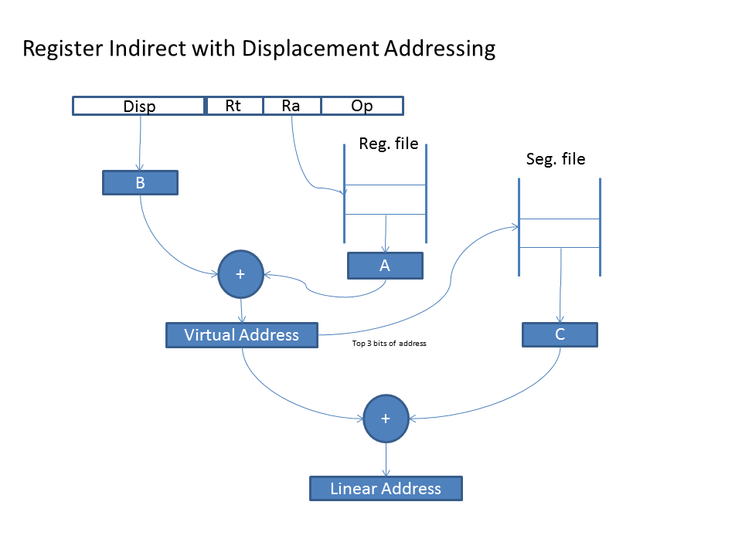

Indexed addressing looks up two register file values and a segment register value then adds all three values to form an address.

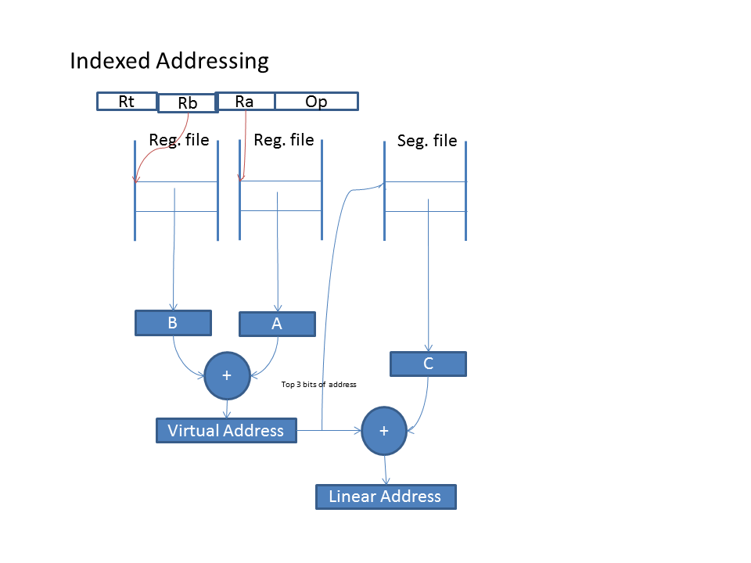

# Detailed Instruction Set

## ADDI

Description:

Calculate the sum of a register and an immediate value and place the result in the target register.

Instruction Format:

|  |  |  |  |  |  |  |  |  |
| --- | --- | --- | --- | --- | --- | --- | --- | --- |
| w0 | Immediate15 | | Rt5 | | Ra5 | 04h7 | | I15 |
| w0 | 80h8 | ~7 | Rt5 | Ra5 | | | 04h7 | I32 |
| w1 | Immediate31..0 | | | | | | |
| w0 | 81h8 | ~7 | Rt5 | Ra5 | | | 04h7 | I64 |
| w1 | Immediate31..0 | | | | | | |
| w2 | Immediate63..32 | | | | | | |

Operation:

Rt = Ra + Imm

Clock Cycles: 1

## ANDI

Description:

Perform the bitwise ‘AND’ of a register and an immediate value and place the result in the target register.

Instruction Format:

|  |  |  |  |  |  |  |  |  |
| --- | --- | --- | --- | --- | --- | --- | --- | --- |
| w0 | Immediate15 | | Rt5 | | Ra5 | 08h7 | | I15 |
| w0 | 80h8 | ~7 | Rt5 | Ra5 | | | 08h7 | I32 |
| w1 | Immediate31..0 | | | | | | |
| w0 | 81h8 | ~7 | Rt5 | Ra5 | | | 08h7 | I64 |
| w1 | Immediate31..0 | | | | | | |
| w2 | Immediate63..32 | | | | | | |

Operation:

Rt = Ra & Imm

Clock Cycles: 1

## BEQ

Description:

Branch if two registers specified are equal. The 15 bit displacement is shifted left and sign extended before being added to the program counter. The branch range is then +/- 8k words.

Instruction Format:

|  |  |  |  |  |
| --- | --- | --- | --- | --- |
| Displacement15..1 | Rb5 | Ra5 | 13 | 04 |

Operation:

if (Ra = Rb)

pc <= pc + displacement * 2

Clock Cycles: 3 if branch is taken, otherwise 1

## BNE

Description:

Branch if two registers specified are not equal. The 15 bit displacement is shifted left and sign extended before being added to the program counter. The branch range is then +/- 8k words.

Instruction Format:

|  |  |  |  |  |
| --- | --- | --- | --- | --- |
| Displacement15..1 | Rb5 | Ra5 | 13 | 14 |

Operation:

if (Ra <> Rb)

pc <= pc + displacement * 2

Clock Cycles: 3 if branch is taken, otherwise 1

## BRK – Break

Description:

Execute a breakpoint interrupt. The interrupt executed is identified by a nine bit vector. The vector is an index into the exception descriptor table. This instruction may be followed by up to two instruction words of information.

Instruction Format:

|  |  |  |  |  |  |  |  |
| --- | --- | --- | --- | --- | --- | --- | --- |
| w0 | ~15 | | ~ | Vector9 | 00h7 | |  |
| w0 | 80h8 | ~7 | ~ | Vector9 | | 00h7 | I32 |
| w1 | Data31..0 | | | | | |
| w0 | 81h8 | ~7 | ~ | Vector9 | | 00h7 | I64 |
| w1 | Data31..0 | | | | | |
| w2 | Data63..32 | | | | | |

Operation:

Clock Cycles: 10

## LDT

Description:

Loads into either the exception or the global descriptor table pointer register and limit register. The address specified is a non-segmented 76 bit physical address. The address is calculated as the sum of the 76 bit immediate constant and the contents of register Ra. The address should be word aligned. This instruction is only available at machine level. The global descriptor table register must be loaded before segment registers can be loaded. The exception descriptor table register must be loaded before interrupts and exceptions can be executed.

Instruction Format:

|  |  |  |  |  |
| --- | --- | --- | --- | --- |
| Immediate19..3 | | Rt3 | Ra5 | h7 |
| Immediate51..20 | | | | |
| ~8 | Immediate75..52 | | | |

|  |  |
| --- | --- |
| Rt3 | Register Loaded |
| 1 | EDT |
| 2 | GDT |
|  |  |

Format of data loaded:

|  |  |  |  |  |
| --- | --- | --- | --- | --- |
| Base address63..4 | | | | 04 |
| ~4 | Table Limit27..0 | ~20 | Base75..64 | |

The base address should be 16 byte aligned.

The table limit field accommodates the maximum number of entries that can be specified in a selector. In practice this limit will be set to a lower value.

The maximum number of entries in the exception descriptor table is 512.

# Opcode Formats:

|  |  |  |  |  |  |  |  |  |  |  |  |  |  |  |  |  |  |  |  |  |
| --- | --- | --- | --- | --- | --- | --- | --- | --- | --- | --- | --- | --- | --- | --- | --- | --- | --- | --- | --- | --- |
| 32 | Immediate15 | | | | | | | Rt5 | | | | | | Ra5 | | Opcode7 | | | | I15 |
| 64 | 80h8 | | | | ~7 | | | Rt5 | | | | | Ra5 | | | | Opcode7 | | | I32 |
| Immediate31..0 | | | | | | | | | | | | | | | | | | |
| 96 | 81h8 | | | | ~7 | | | Rt5 | | | | | Ra5 | | | | Opcode7 | | | I64 |
| Immediate31..0 | | | | | | | | | | | | | | | | | | |
| Immediate63..32 | | | | | | | | | | | | | | | | | | |
| 32 | Funct7 | | | ~3 | | Rt5 | | Rb5 | | | | | | Ra5 | | | Opcode7 | | | R2 |
|  | Funct5 | Rt5 | | | | Rc5 | | Rb5 | | | | | | Ra5 | | | Opcode7 | | | R3 |
| 32 | Displacement15..1 | | | | | | | Imm4..0 | | | | | | Ra5 | | | 23 | Cnd4 | | Bri5 |
| 64 | Displacement15..1 | | | | | | | 10h5 | | | | | | Ra5 | | | 23 | Cnd4 | | Bri32 |
| Immediate31..0 | | | | | | | | | | | | | | | | | | |
|  | Displacement15..1 | | | | | | | 11h5 | | | | | | Ra5 | | | 23 | Cnd4 | | Bri64 |
|  | Immediate31..0 | | | | | | | | | | | | | | | | | | |
|  | Immediate63..32 | | | | | | | | | | | | | | | | | | |
| 32 | Displacement15..1 | | | | | | | Rb5 | | | | Ra5 | | | | 13 | | Cnd4 | | Brr |
| 32 | Address25..1 | | | | | | | | | | | | | | | Opcode7 | | | | J26 |
| 64 | 80h8 | | | | ~17 | | | | | | | | | | | Opcode7 | | | | J32 |
| Address31..1 | | | | | | | | | | | | | | | | | | ~1 |
| 96 | 81h8 | | | | ~17 | | | | | | | | | | | Opcode7 | | | | J64 |
| Address31..1 | | | | | | | | | | | | | | | | | | ~1 |  |
| Address63..32 | | | | | | | | | | | | | | | | | | |  |
| 128 | 81h8 | | | | ~17 | | | | | | | | | | | Opcode7 | | | | JF |
| Address31..1 | | | | | | | | | | | | | | | | | | ~1 |
| Address63..32 | | | | | | | | | | | | | | | | | | |
| Selector31..0 | | | | | | | | | | | | | | | | | | |
|  | CSR13 | | | | | | Op2 | | Rt5 | | | Ra5 | | | | Opcode7 | | | | CSR |
|  | CSR13 | | | | | | Op2 | | Rt5 | | | Imm4..0 | | | | Opcode7 | | | | CSRI |
|  |  | |  | | | |  | |  | | |  | | | |  | | | |  |
| 128 | Address23..0 | | | | | | | | | | | | | | | Opcode8 | | | | LDI seg,# |
| Address55..24 | | | | | | | | | | | | | | | | | | |
| ACR16 | | | | | | | | | ~5 | Seg3 | | | | Address63..56 | | | | |
| Selector31..0 | | | | | | | | | | | | | | | | | | |
|  |  | |  | | | |  | |  | | |  | | | |  | | | |  |

|  |  |  |
| --- | --- | --- |
| Op2 | CSR | CSRI |
| 0 | CSRRW | CSRRWI |
| 1 | CSRRS | CSRRSI |
| 2 | CSRRC | CSRRCI |
|  |  |  |

# Opcode Maps

## Major Opcodes

|  |  |  |  |  |  |  |  |  |  |  |  |  |  |  |  |  |
| --- | --- | --- | --- | --- | --- | --- | --- | --- | --- | --- | --- | --- | --- | --- | --- | --- |
|  | x0 | x1 | x2 | x3 | x4 | x5 | x6 | x7 | x8 | x9 | xA | xB | xC | xD | xE | xF |
| 0x | BRK |  |  |  | ADDI | CMPI | CMPUI |  | ANDI | ORI | EORI |  |  |  |  |  |
| 1x | BEQ | BNE | BLT | BGE | BLE | BGT | BLTU | BGEU | BLEU | BGTU |  |  |  |  |  | CSR |
| 2x | BEQI | BNEI | BLTI | BGEI | BLEI | BGTI | BLTUI | BGEUI | BLEUI | BGTUI |  |  |  |  |  | CSRI |
| 3x | {r2} | {r3} |  |  | JMP | JSR |  |  | LDT |  |  |  |  |  |  |  |
| 4x | LB | LBU | LC | LCU | LH | LHU | LW | LWR |  |  |  |  |  |  | EXB | EXL |
| 5x | SB | SC | SH | SW | SWC |  |  |  |  |  |  |  |  |  |  |  |
| 6x |  |  |  |  |  |  |  |  |  |  |  |  |  |  |  |  |
| 7x | NOP | RTS | RTE | RTF | JMF | JSF |  | SYNC | MEMSB | MEMDB | CLI | SEI |  |  |  |  |

## {r2} Funct7 Opcodes

|  |  |  |  |  |  |  |  |  |  |  |  |  |  |  |  |  |
| --- | --- | --- | --- | --- | --- | --- | --- | --- | --- | --- | --- | --- | --- | --- | --- | --- |
|  | x0 | x1 | x2 | x3 | x4 | x5 | x6 | x7 | x8 | x9 | xA | xB | xC | xD | xE | xF |
| 0x |  |  |  |  | ADD | CMP | CMPU | SUB | AND | OR | EOR |  | NAND | NOR | ENOR |  |
| 1x |  |  |  |  |  |  |  |  |  |  |  |  |  |  |  |  |
| 2x |  |  |  |  |  |  |  |  |  |  |  |  |  |  |  |  |
| 3x |  |  |  |  |  |  |  |  |  |  |  |  |  |  |  |  |
| 4x | LBX | LBUX | LCX | LCUX | LHX | LHUX | LWX | LWRX |  |  |  |  |  |  |  |  |
| 5x | SBX | SCX | SHX | SWX | SWCX |  |  |  |  |  |  |  |  |  |  |  |
| 6x |  |  |  |  |  |  |  |  |  |  |  |  |  |  |  |  |
| 7x |  |  |  |  |  |  |  |  |  |  |  |  |  |  |  |  |

## {r3} Funct5 Opcodes

|  |  |  |  |  |  |  |  |  |  |  |  |  |  |  |  |  |
| --- | --- | --- | --- | --- | --- | --- | --- | --- | --- | --- | --- | --- | --- | --- | --- | --- |
|  | x0 | x1 | x2 | x3 | x4 | x5 | x6 | x7 | x8 | x9 | xA | xB | xC | xD | xE | xF |
| 0x | CAO | CSO | CAC | CSC |  |  |  |  | CAOI | CSOI | CACI | CSCI |  |  |  |  |
| 1x |  |  |  |  |  |  |  |  |  |  |  |  |  |  |  |  |