Count Down

Create by BigEgg

# Introduction

The Countdown application is used to save multiple customer alerts, and show out when the time is coming.

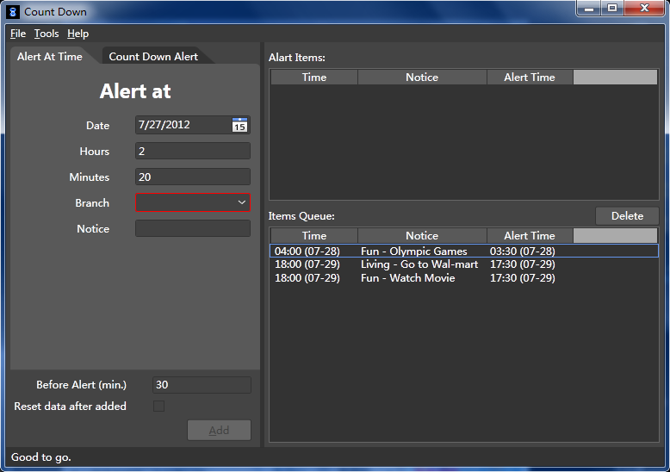

It creates by the WPF and the Model-View-ViewModel pattern (MVVM).

# Run Application

This application requires the .Net Framework 4.0. Please download (<http://www.microsoft.com/zh-cn/download/details.aspx?id=17718>) and install it before run the executable file.

Run the CountDown.exe.

# Features

## Localization and language selector

The CountDown application is localized in English and Chinese. The user can select the language in the menu.

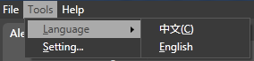 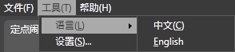

## Fantastic UI

All the controls in the application have the animation when mouse over, press and focus.

 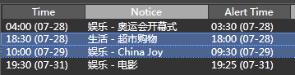

## Validation with the input

The application will automate validate the input of the user, and show the error message.

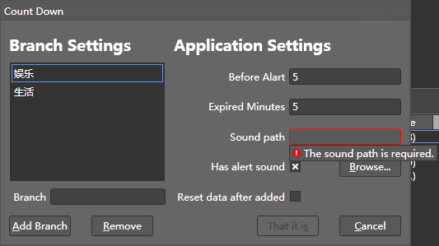 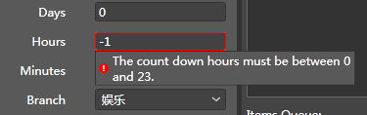

## Multiple alert types

The application current supports two type of the alert. One is set the specific time to alert and another one is the countdown alert.

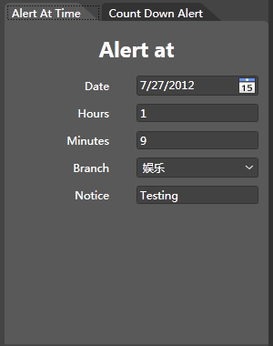 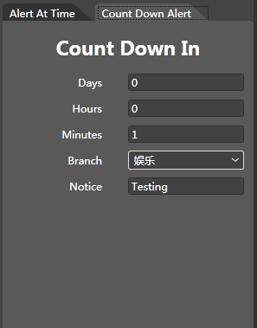

## Alert with dialog and sound

The application will show a dialog when their have any alert items need to be alert.

After user setting the sound path in the setting dialog, it will also play the sound when the alert dialog shows up.

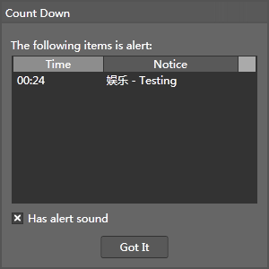 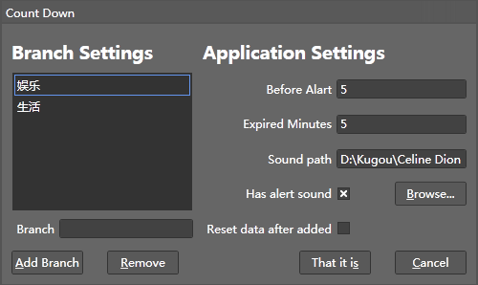

## Alert item in the task bar

After user add the alert item, application will automate set the items count in the task bar.

This feature is only support in the Win7.



## Automate Saving

Application will automate saving the alert information, the customer setting and the window location and size.