Star Private School

Bo Bo & Thant Zin Htun

**Project Description**

This project is about developing computerized school management system that include function for day to day processes of managing students, courses, classes, scheduling timetable, managing attendances, monthly test report etc.

Secondly, create a website for student and parents to easily access and check their month test mark, feedback etc.

**Permission and Role**

|  |  |
| --- | --- |
| Admin | * Manage academic year * Manage standard * Manage classes * Manage Subjects * Manage Teacher Manage Students * Manage Staff * Manage Student Payment |
| Staff | * Manage Timetable * Manage Attendance * Manage Student Payment |
| Teacher | * Test Paper upload * Give Mark and Feedback |
| Student | * Check Test Paper & Feedback |

**Problem Statement**

With increase in number of students issues also rises in existing manual system and staffs are more prone to make mistakes and increase work load. Moreover, with increased number of private schools in country competition become fiercer. So, stakeholders of star private school want to develop new computerize system that can solve the issues of current system and provide more effective management of private school. Secondly to develop website which can not only help for marketing but also to improve teacher parent communication, to provide parent to easily keep track of their children academic progress etc.

**Entity Relationship Diagram**

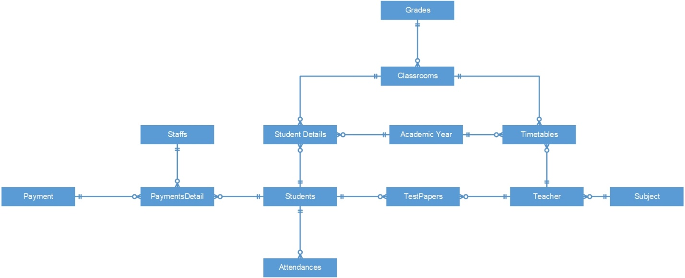

**Database Structure**

|  |  |  |  |
| --- | --- | --- | --- |
| Academic Years | | | |
| Fieldname | | Datatype | Action |
| 1 | Id | Int | Primary key (auto-increment) |
| 2 | Year | Varchar (255) |  |
| 3 | Startdate | Date |  |
| 4 | Enddate | Date |  |
| 5 | Created_at | Timestamp |  |
| 6 | Updated_at | Timestamp |  |

|  |  |  |  |
| --- | --- | --- | --- |
| Grades | | | |
| Fieldname | | Datatype | Action |
| 1 | Id | Int | Primary key (auto-increment) |
| 2 | Name | Varchar (255) |  |
| 3 | Created_at | timestamp |  |
| 4 | Updated_at | Timestamp |  |
|  |  |  |  |

|  |  |  |  |
| --- | --- | --- | --- |
| Classroom | | | |
| Fieldname | | Datatype | Action |
| 1 | Id | Int | Primary key (auto-increment) |
| 2 | Name | Varchar (255) |  |
| 3 | Created_at | timestamp |  |
| 4 | Updated_at | Timestamp |  |
| 5 | Grade_id | Int | Foreign key |

|  |  |  |  |
| --- | --- | --- | --- |
| Subjects | | | |
| Fieldname | | Datatype | Action |
| 1 | Id | Int | Primary key (auto-increment) |
| 2 | Name | Varchar (255) |  |
| 3 | Created_at | timestamp |  |
| 4 | Updated_at | Timestamp |  |

|  |  |  |  |
| --- | --- | --- | --- |
| Teachers | | | |
| Fieldname | | Datatype | Action |
| 1 | Id | Int | Primary key (auto-increment) |
| 2 | Name | Varchar (255) |  |
| 3 | Address | Text |  |
| 4 | Email | Varchar (255) |  |
| 5 | Phone | Varchar (255) |  |
| 6 | Gender | Varchar (255) |  |
| 7 | NRC | Varchar (255) |  |
| 8 | Subject_id | Int | Foreign key |
| 9 | Created_at | Timestamp |  |
| 10 | Updated_at | Timestamp |  |
| 11 | Photo | Text |  |
| 12 | Password | Varchar(255) |  |

|  |  |  |  |
| --- | --- | --- | --- |
| Timetable | | | |
| Fieldname | | Datatype | Action |
| 1 | Id | Int | Primary key (auto-increment) |
| 2 | Date | Date |  |
| 3 | Start_time | Varchar (199) |  |
| 4 | End_time | Varchar (199) |  |
| 5 | Class_id | Int | Foreign key |
| 6 | Teacher_id | Int | Foreign key |
| 7 | Created_at | Timestamp |  |
| 8 | Updated_at | Timestamp |  |
| 9 | Academic_year |  | Foreign Key |

|  |  |  |  |
| --- | --- | --- | --- |
| Students | | | |
| Fieldname | | Datatype | Action |
| 1 | Id | Int | Primary key (auto-increment) |
| 2 | Name | Varchar (255) |  |
| 3 | Address | Text |  |
| 4 | Email | Varchar (255) |  |
| 5 | Phone | Varchar (255) |  |
| 6 | Gender | Varchar (255) |  |
| 7 | DOB | Varchar (255) |  |
| 8 | Guardian_Name | Varchar (255) |  |
| 9 | Guardian_NRC | Varchar (255) |  |
| 10 | Guardian_Phone | Varchar (255) |  |
| 11 | Guardian_Address | Varchar (255) |  |
| 12 | Occupation | Varchar (255) |  |
| 13 | Created_at | Timestamp |  |
| 14 | Updated_at | Timestamp |  |
| 15 | Photo | Text |  |
| 16 | Password | Varchar(255) |  |

|  |  |  |  |
| --- | --- | --- | --- |
| TestPaper | | | |
| Fieldname | | Datatype | Action |
| 1 | Id | Int | Primary key (auto-increment) |
| 2 | Student_ID | Int | Foreign key |
| 3 | Month | Varchar (255) |  |
| 4 | Mark | Int |  |
| 5 | Remark | Text |  |
| 6 | Teacher_ID | Int | Foreign key |
| 7 | Created_at | Timestamp |  |
| 8 | Updated_at | Timestamp |  |

|  |  |  |  |
| --- | --- | --- | --- |
| Attendance | | | |
| Fieldname | | Datatype | Action |
| 1 | Id | Int | Primary key (auto-increment) |
| 2 | Student_Id | Int | Foreign key |
| 3 | Date | Date |  |
| 4 | Status | Varchar (255) |  |
| 5 | Created_at | Timestamp |  |
| 6 | Updated_at | Timestamp |  |

|  |  |  |  |
| --- | --- | --- | --- |
| Staffs | | | |
| Fieldname | | Datatype | Action |
| 1 | Id | Int | Primary key (auto-increment) |
| 2 | Name | Varchar (255) |  |
| 3 | Address | Text |  |
| 4 | Email | Varchar (255) |  |
| 5 | Phone | Varchar (255) |  |
| 6 | Gender | Varchar (255) |  |
| 7 | NRC | Varchar (255) |  |
| 8 | Created_at | Timestamp |  |
| 9 | Updated_at | Timestamp |  |
| 10 | Photo | text |  |
| 11 | Password | Varchar(255) |  |

|  |  |  |  |
| --- | --- | --- | --- |
| Student Detail | | | |
| Fieldname | | Datatype | Action |
| 1 | Id | Int | Primary key (auto-increment) |
| 2 | Student_Id | Int | Foreign key |
| 3 | Class_id | Int | Foreign key |
| 4 | Academic_Year_id | Int | Foreign key |
| 3 | Assign Date | Date |  |
| 4 | Status | Varchar (255) | Active Pass etc |
| 5 | Created_at | Timestamp |  |
| 6 | Updated_at | Timestamp |  |

\

|  |  |  |  |
| --- | --- | --- | --- |
| Payment | | | |
| Fieldname | | Datatype | Action |
| 1 | Id | Int | Primary key (auto-increment) |
| 2 | Total_Amount | int |  |
| 3 | Status | int |  |
| 4 | Left_over_Amount | int |  |
| 5 | Created_at | Timestamp |  |
| 6 | Updated_at | Timestamp |  |

|  |  |  |  |
| --- | --- | --- | --- |
| Payment Detail | | | |
| Fieldname | | Datatype | Action |
| 1 | Id | Int | Primary key (auto-increment) |
| 2 | Payment_id | int | Foreign_Key |
| 3 | Student_id | Int | Foreign_Key |
| 4 | Voucher_no | varchar |  |
| 5 | Payment_Date | date |  |
| 6 | Paid_amount | int |  |
| 7 | Created_at | Timestamp |  |
| 8 | Updated_at | Timestamp |  |