GIOELE BIGINI is Ph.D. Student in Research Methods in Science and Technology at University of Urbino since 2019. He received double M.Sc. in Computer Science and Engineering at Politecnico di Milano, Milan, Italy and Informatics Engineering at Universidad Politécnica de Madrid, Madrid, Spain in 2019. He is also part of the Alumni of the European Institute of Innovation and Technology (EIT Digital), receiving the Diploma in Data Science in 2019. His research interests include big data, artificial intelligence, distributed ledger technologies, distributed systems and internet of things.

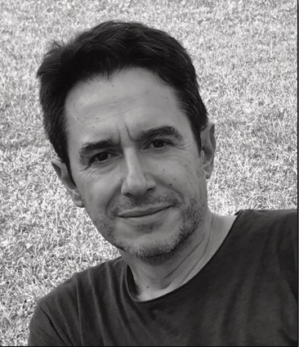

VALERIO FRESCHI graduated in Electronic Engineering at University of Ancona, Italy, in 1999 and received the Ph.D. degree in Computer Science Engineering from University of Ferrara, Italy in 2006. He is currently Assistant Professor in Computer Engineering at the Department of Pure and Applied Sciences (DiSPeA) of the University of Urbino, Italy. His research interests include wireless sensor networks, energy-efficient algorithms, bioinformatics, mobile crowdsensing.

EMANUELE LATTANZI received the Laurea degree (summa cum laude) in 2001 and the Ph.D. degree from the University of Urbino, Italy, in 2005. Since 2001, he has been with the Information Science and Technology Institute, University of Urbino. In 2003, he was with the Department of Computer Science and Engineering, Pennsylvania State University, as a Visiting Scholar with Prof. V. Narayanan. From 2008 until 2020, he has been Assistant Professor in Computer Engineering at the Department of Pure and Applied Sciences (DiSPeA) of the University of Urbino, Italy, where hi is currently Associate Professor in Computer Engineering. His research interests include wireless sensor networks, wireless embedded systems, energy-aware routing algorithms, dynamic power management, multimedia applications, and simulation.