# Coding Standards

Fheuo;ejo;

Add a new section to your report called Coding standards.

* Identify the elements of common coding standards. (LO3.1)

Explain the role and importance of good coding practices. (LO3.2)   
  
  
 lots of screenshots

Good vs bad??

Coding standards as a habbit

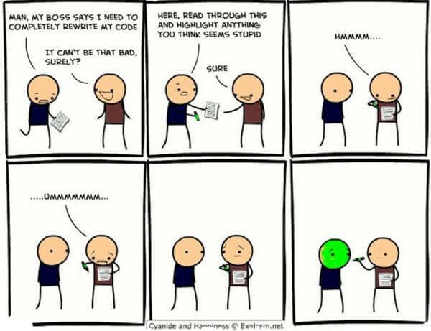

Coding standards are a set of guidelines for programmers to follow when writing their software. These standards can cover several aspects such as naming conventions, indentation standards, code organization, commenting and handling exceptions. The aim of coding standards is to increase code readability, maintainability and consistency.

* **Consistency:** Coding standards ensure uniformity across codebases and teams, making it easier for developers to read, understand, and maintain code.
* **Readability:** Well-defined standards enhance code readability, reducing errors and improving collaboration.
* **Error Prevention:**Consistent practices help catch common mistakes early, preventing bugs and improving code quality.
* **Scalability:** Adhering to standards ensures code can scale without becoming unwieldy or unmanageable.
* **Cross-Team Collaboration:**Shared standards facilitate collaboration among developers, even in large teams.
* **Code Reviews:**Standards provide clear criteria for code reviews, leading to more effective feedback.
* **Efficient Maintenance:**Following standards simplifies debugging, refactoring, and maintenance tasks.

Standards can be defined at many different levels, from personal preference, organisation standards and open coding standards. Open coding standards are publicly available allowing for community feedback and improvement. In contract, closed organisation standards are only enforced within the organisation.

The standards required by an organisation vary from place to place, but can include guidelines covering the following areas:

* Languages to be used – does the organisation only use a few specific languages, and each language can have its own variant of guidelines. Which language for which purpose … javascript vs typescript, powershell or batch files, language constraints – no goto blocks, use of datatypes for specific purposes, error handling methods
* commenting
* Layout of code blocks – white space, indentation brace alignment
* Naming conventions-polish code,
* Captialisation – camel, pascal
* Open coding standards and the implications thereof.
* Organisational coding standards
* Language constructs
  + For ex no goto statements,
* Languages available 7
  + The lanugages used by an organisation
* ‘Good Practice’ in coding
* Logs and Journals
* Use of indention
* Naming conventions
* camelCase/PascalCase etc.
* Refactoring

The process of refactoring … rewriting code without altering it external behavour. Why – improve use of standards, performance, etc. when….