Business responses and risk buffers need separate tests
FICC and ECS feedback review and supplemental association analysis
October 6, 2026 Observations through 2026Q2
Post-result exploratory extension

Conclusion and business implication
Business responses and risk-buffer adequacy should be tested separately. Adding margin calls, variation margin payments and changes in quarter-end initial margin produces some positive relationships, but associations still change with the outcome, lag and sample period. The evidence supports continued monitoring and investigation; it does not yet support a stable business risk score.
For GSD, the full-sample same-quarter correlation between the absolute daily change in the 10-year Treasury yield and quarter-on-quarter initial margin growth is 0.408. It is 0.441 through 2024Q4 and −0.147 in the following six quarters. Its full-sample ordinary BH-adjusted q-value is 0.172, above the 5% multiple-testing threshold.
There are 294 comparison combinations, each reported for the earlier, later and full samples, producing 882 statistical records. In the full sample, 48 comparisons meet ordinary BH 5%; 24 also have a positive correlation and a four-quarter block-bootstrap interval above zero. No earlier-sample comparison meets ordinary BH 5%. These are post-result exploratory extensions. Ordinary p-values do not adequately address quarterly dependence, and the 24 comparisons must not be presented as 24 validated transmission channels.
The extension extracts 207 new raw field values across 23 quarters and three clearing services. The original event tests, outcomes, thresholds and files are preserved. This report does not reassign risk weights or interpret the new statistics as default probabilities or official risk grades.

What to adopt and correct in the feedback
Adopt the separation of business responses from buffer adequacy, report same-quarter and next-quarter associations separately, seek earlier disclosures, and account for overlapping twelve-month windows. The original 4.4.3 / 6.1.1 ratio may remain a vulnerability candidate, but should not alone establish that a shock reached the business. Item 4.4.3 already measures stress loss in excess of initial margin, rather than total gross stress loss.
A negative correlation does not demonstrate effective risk management. Increasing initial margin can reduce the ratio, but positions, business scale, model parameters, reporting windows and other changes can produce a similar result. The explanation requires evidence of exposures and actual risk-management changes.
The original analysis already includes same-quarter and numerator/denominator diagnostics. For GSD Treasury yield changes versus the stress-loss ratio, the full-sample same-quarter rho is 0.209, while the earlier-sample value is approximately −0.291. Quoting only the positive full-sample value hides instability. Contemporaneous correlation also cannot identify the effect of a particular event.
The SOFR−EFFR peak of 0bp applies to the specified SVB event window, not the whole of 2023. The frozen daily data show a full-year peak of approximately 7bp. Missing contemporaneous PQD for 2019 and early 2020 limits event matching, but some 2020Q4 trailing-twelve-month disclosures may include the pandemic period.
Excluding the current observation from thresholds, chronological grouping, BH correction and block bootstrap improve reproducibility. However, original historical vintages and first-release dates remain unverified. Directory listing dates proxy public availability, so this is not a fully validated point-in-time backtest.

New response measures and field definitions
IM means initial margin, VM means variation margin, and PQD means public quantitative disclosure. The new raw fields are 6.6.1 average daily variation margin paid, 6.7.1 maximum variation margin paid on a business day, and 6.8.1 maximum aggregate initial margin call on a business day. Their observation windows are the reporting quarter. Item 6.1.1 is quarter-end initial margin required. Seven formulations derived from these fields are compared separately, without selecting a final measure from the observed fit.
DTCC explains that VM is a cash pass-through process across GSD and MBSD members, while NSCC VM charges form part of clearing fund requirements. These amounts are not DTCC revenue or realized business losses. Item 6.8.1 represents the largest aggregate deficit over collateral already deposited and the actual call, including intraday calls; it is not the maximum increase in total margin requirements.
Measure | Formula | Window and unit | Interpretation limit
IM quarter-on-quarter growth | 6.1.1(t) / 6.1.1(t−1) − 1 | Quarter-end stock change | Business growth, model and composition changes
Peak daily IM call | 6.8.1 | Quarterly peak USD | Net of deposited collateral; includes intraday calls
IM call / quarter-end IM | 6.8.1(t) / 6.1.1(t) | Fraction | Quarter peak and quarter-end stock differ in timing
IM call / prior-quarter IM | 6.8.1(t) / 6.1.1(t−1) | Fraction sensitivity | Prior scale may differ from current exposure
Average daily VM | 6.6.1 | Quarterly daily mean USD | Payment mechanics differ across services
Peak daily VM | 6.7.1 | Quarterly peak USD | Affected by positions and market conditions
Peak / average VM | 6.7.1 / 6.6.1 | Multiple | Sustained stress can also raise the denominator

Supplemental same-quarter and next-quarter results
The six displayed examples were specified before this extension was run, based on economic channels and the feedback questions. They were not selected from the largest positive correlations. The earlier sample ends at target quarter 2024Q4; the later sample covers 2025Q1–2026Q2 and has only six valid pairs. The later period has already been viewed and is not a new blind test.
The full-sample positive same-quarter Treasury-shock correlation with initial margin growth is consistent with a margin-demand response, but its q-value, period reversal and possible business-scale effects leave the evidence inconclusive. Peak margin calls scaled by quarter-end margin remain negatively correlated: using a more direct-looking ratio does not automatically resolve the identification problem.
For MBSD, the same-quarter Treasury-shock correlation with peak VM is 0.736 in the later six quarters, compared with 0.053 earlier and 0.200 overall. For NSCC, the same-quarter VIX correlation with peak VM is 0.326 overall and approximately −0.029 later. Retain these small-sample results, but do not interpret a high coefficient as established transmission.
Next-quarter comparisons use the completed quarter-t maximum external indicator, which becomes known only after quarter-end. They are historical association diagnostics, not an event-day real-time forecast.
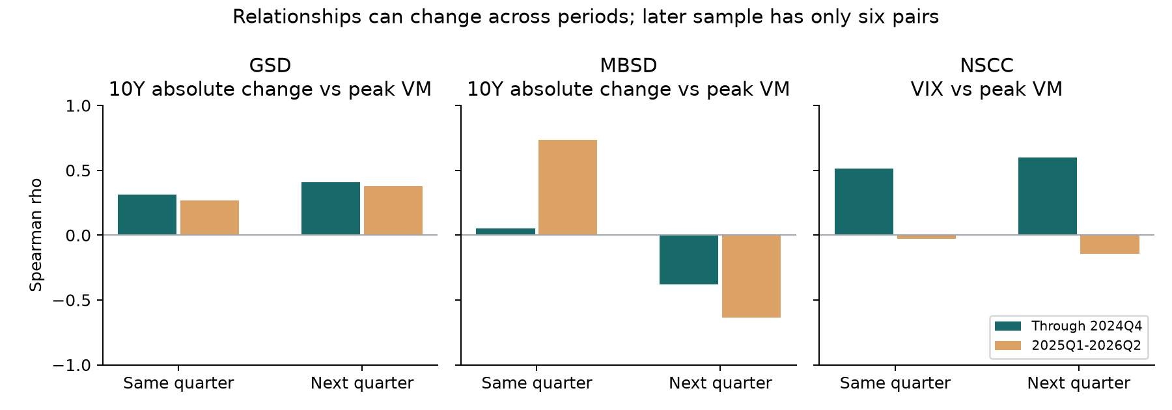
Figure 1 Associations by period and lag The later sample has only six pairs

Complete statistics for displayed cases
A GSD 10Y absolute daily yield change → IM quarter-on-quarter growth
B GSD 10Y absolute daily yield change → IM call / quarter-end IM
C GSD 10Y absolute daily yield change → Peak daily VM
D MBSD 10Y absolute daily yield change → Peak daily VM
E NSCC VIX → Peak daily VM
F GSD Adjusted SOFR−EFFR → Peak / average VM
Case | Lag | n | rho | BH q | 95% interval | Earlier rho | Later rho
A | 0 | 22 | 0.408 | 0.172 | 0.010 to 0.766 | 0.441 | -0.147
A | 1 | 22 | 0.464 | 0.109 | -0.107 to 0.712 | 0.549 | 0.058
B | 0 | 23 | -0.274 | 0.375 | -0.598 to 0.198 | -0.393 | 0.294
B | 1 | 23 | -0.307 | 0.313 | -0.515 to 0.354 | -0.340 | -0.116
C | 0 | 23 | -0.179 | 0.597 | -0.777 to 0.510 | 0.311 | 0.265
C | 1 | 23 | -0.013 | 0.977 | -0.722 to 0.551 | 0.410 | 0.377
D | 0 | 23 | 0.200 | 0.547 | -0.313 to 0.693 | 0.053 | 0.736
D | 1 | 23 | -0.200 | 0.547 | -0.610 to 0.286 | -0.382 | -0.638
E | 0 | 23 | 0.326 | 0.280 | -0.114 to 0.776 | 0.512 | -0.029
E | 1 | 23 | 0.408 | 0.160 | 0.053 to 0.701 | 0.600 | -0.143
F | 0 | 23 | -0.329 | 0.275 | -0.612 to 0.207 | -0.332 | 0.429
F | 1 | 23 | -0.521 | 0.057 | -0.882 to 0.091 | -0.376 | -0.771

Lag 0 is same-quarter; lag 1 is next-quarter. Intervals use the full-sample four-quarter moving-block bootstrap. Earlier target quarters end in 2024Q4; later targets are 2025Q1–2026Q2. q-values adjust the full family of 294 comparisons.

Validation method and evidence limits
Four of the original seven candidates passed the original event screen. This extension does not change that finding or establish that every candidate has passed both tests. Reuse the original seven daily transformations and quarterly maxima; do not change the original event windows or alarm thresholds. Compare seven external indicators with seven response formulations and two lags separately for GSD, MBSD and NSCC. Apply BH to all 294 ordinary Spearman p-values within each sample. Displayed q-values come from the complete comparison family, not just the displayed cases.
For at least twelve pairs with adequate distinct values, use moving blocks of four consecutive calendar quarters, 2000 replicates and a 95% interval. The later six-quarter sample is descriptive and does not meet this threshold. Calendar-aligned first differences help examine nominal-value trends, but do not substitute for controls for exposures and model changes.
Ratio components may be measured on different days: the quarter peak call divided by quarter-end IM is approximate scaling. Peak/average VM measures concentration of peak payments; average VM can also rise during sustained quarterly stress. Retain raw amounts alongside ratios and never replace missing observations with zero.
Business scale, membership composition and margin-model changes remain uncontrolled. Quarterly aggregates cannot locate the event day; trailing-twelve-month stress outcomes overlap. Correlations describe co-movement, not causality, and do not validate the external-shock-times-vulnerability structure.
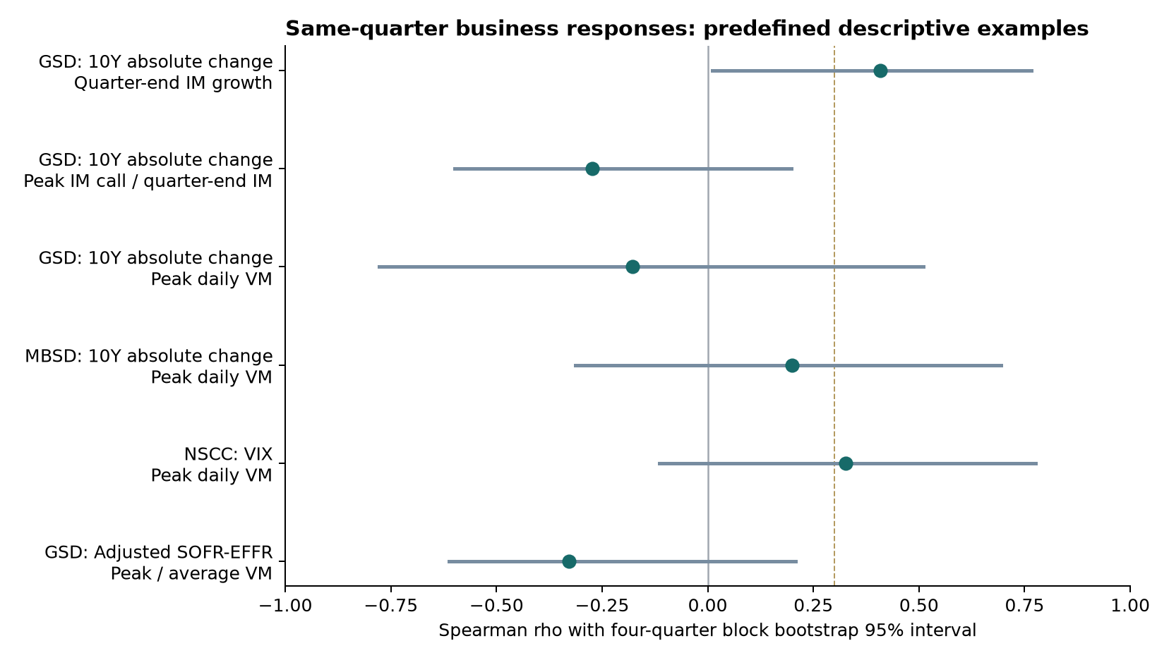
Figure 2 Full-sample same-quarter associations and 95% intervals The dashed line marks the original 0.3 directional threshold It does not establish causality or validation

Data priorities and implementation
Freeze the definitions and complete results, then collect new evidence that has not contributed to this interpretation. The already-viewed 2025Q1–2026Q2 period cannot be relabeled an independent final test set.
Prioritize 2019 and early-2020 PQD, original historical versions and verified first-release dates. Seek daily margin requirements, calls, VM payments, available liquidity and coverage breaches. Earlier public files can be searched; any project-team data request should clearly specify public or otherwise approved data scope.
For FICC, keep GSD Treasury/repo exposures separate from MBSD MBS spreads and duration/convexity conditions. For ECS, preserve the distinction between NSCC clearing and DTC settlement evidence. Complete MOVE histories and dedicated MBS data remain gaps. This report does not establish DAS or operational-risk scoring.
Use event cards initially: event, business, channel, external indicator change, vulnerability available at that time, and evidence strength. Automated weights, a common 0–100 scale and business-loss forecasts require more stable validation.

Sources and reproducibility
The observation cutoff is 2026Q2 and the report date is October 6, 2026. Original market and PQD files were collected on October 5–6. This extension reuses frozen files and extracts additional fields; it does not add earlier PQD quarters.
The PQD inputs are 22 XLSX files and the official 2024Q4 PDF, covering 2020Q4–2026Q2. New 2024Q4 values come from page 13, with USD MM multiplied by 1000000 to obtain USD. Raw values, cells or pages, download URLs and SHA256 hashes are retained in response_cell_evidence.csv and source_manifest.json.
Definitions are checked against the CPMI–IOSCO public quantitative disclosure standards and DTCC quarterly explanatory notes. Validation principles follow the project Quant-tech material on out-of-sample evaluation and overfitting. The separate extension directory retains the plan, 207 field-evidence records, a 69-row quarterly panel, paired observations and all 882 statistical records.
DTCC quantitative disclosure directory
CPMI–IOSCO disclosure standards February 2015
FRED SOFR
FRED EFFR
FRED Treasury yield
FRED VIX
FRED Baa spread

Reproducible files
Analysis script src/analyze_responses.py
Raw field evidence data/response_cell_evidence.csv
Complete results results/response_correlations.csv
Source manifest source_manifest.json

