DTCC Project Workflow and Business Impact Assessment
Data processing model validation and business specific transmission
October 15, 2026

01 Project purpose and delivery boundary
We are building a risk-intelligence workflow that explains how external events may affect different DTCC businesses. Public news, market series and business disclosures are the inputs. The intended output is an evidence-backed event-by-business assessment: the potential transmission route, the outcome to monitor and the facts that remain unknown.
A headline should not immediately become the same risk score for every business. We first establish the event, check its connection to a specific business, asset, member or provider, and separate the external shock, business exposure, internal vulnerability and observed business response. Models and statistical tests constrain those judgments; they do not replace business mechanisms or event evidence.
Prepared October 15, 2026. Model and PQD tests still use frozen observations through 2026Q2. The public-data refresh and shared database were updated and verified in the cloud on October 14. The preparation date does not mean all data extend through October 15 or that models were retrained today.
Stage | Work already completed | What remains
Public data | Collection prototype, shared database, provenance, source mappings for ten businesses and daily GitHub workflow | Manual checks for dynamic disclosure directories and some webpages
Business logic | Nine FICC transmission chains; business scope and data requirements for ten lines | Event-level exposure, workload and service-quality evidence
Training and testing | Ridge comparisons, risk-family expansion, event screening, PQD associations and supplemental tests | Stable performance on genuinely new periods and causal identification
Impact assessment | Interpretable monitoring framework and candidate indicators | Reliable cross-business calibration and automated event attribution

Read the overall workflow first, then the supporting data and models, and finally the cross-business comparison and event example.

02 End to end workflow
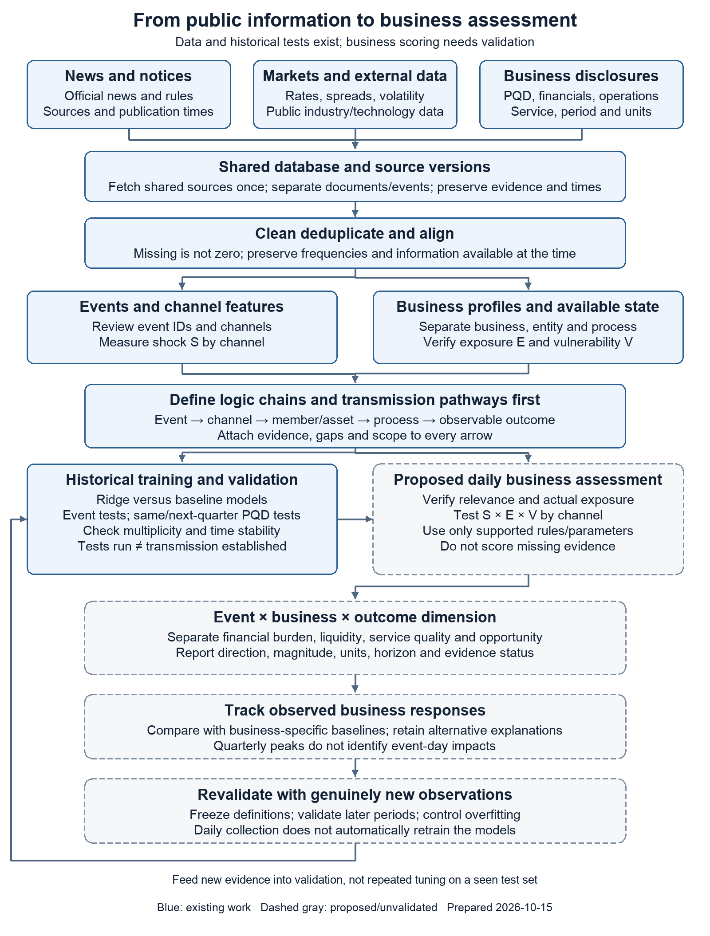
Blue denotes existing data or research steps. Dashed gray denotes assessment modules still requiring integration or validation. Tests have been run; that does not mean the indicators, transmission pathways or risk scores have passed validation.

03 Data inputs and processing
We separate four types of input and preserve their actual frequencies. News describes what happened; markets describe changes in the external environment; business outcomes describe the response; risk buffers describe capacity before the shock. These layers cannot substitute for one another. [P1–P4]
Layer | Inputs used or collected | Processed output
Public information | Federal Reserve, SEC, CFTC, ECB and BIS; DTCC notices; ESMA, FCA and Federal Register | Titles, summaries, sources and times; events and business tags awaiting review
External markets | FRED funding rates, Treasury yields, VIX and credit spreads; industry and public technology-event inputs | Economically defined funding, rates, credit, equity and other channel features
Business responses | PQD and financial disclosures, FICC daily/monthly activity, ECS/ITP monthly snapshots, underwriting and RDS reports | Outcome series separated by entity, service, period and unit
Internal state | Already-public margin, payment obligations, liquidity resources and member concentration | Business-specific vulnerability candidates; unavailable fields remain missing

Cleaning and storage rules
Fetch each shared source once and link it to multiple businesses. Document deduplication and event consolidation are separate: one canonical URL usually identifies one document; different reports should share an event ID only after matching the entity, time and event facts, not merely keywords.
Keep publication, event, effective, observation, first-collection and revision times separate. A date-only source must not receive an invented UTC timestamp. Missing is not zero; quarterly values do not become daily business labels through forward filling.
Standardize monetary units and distinguish quarterly flows from cumulative financial totals. Align calendar quarters before calculating changes. Preserve raw values, definitions, cells/pages, URLs and hashes. Revisions create new versions rather than erase evidence.

Information availability
A daily feature can use only information already public at assessment time. A complete quarterly maximum is known only after quarter-end; it cannot be inserted into an event-day forecast within that quarter.

04 Logic chains and transmission pathways
A logic chain explains why a relationship is plausible. A transmission pathway identifies the specific objects and operational steps through which a shock could change an outcome. Use: event → risk channel → affected member or asset → service process → observable outcome. Attach evidence and gaps to every arrow. Define this logic before feature selection and training; do not create a causal story after seeing a correlation.
For example, repo funding pressure may make financing harder for a relevant member, increase margin or settlement-payment pressure, and, if payment delay or default occurs, increase GSD contingency-liquidity needs. A market spread supports only the first step. Membership, payment capacity and actual resource demands require separate evidence. [S1, P1]
Existing FICC chain | Business and intermediate route | Outcome to verify
1 Treasury volatility | GSD: repricing → positions and liquidation exposure → margin response | Margin, calls and stress exposure; not automatically a loss
2 Repo funding pressure | GSD: member financing → margin and settlement payments | Payment obligations, funding sources and coverage
3 Institution deterioration | GSD/MBSD: verify clearing relationship → ability to perform | Actual exposure, failed payments and default-management evidence
4 Agency MBS changes | MBSD: prices, duration, convexity and prepayment → MBS exposure | MBS-specific signals and margin response
5 Rule changes | GSD and others: scope/effective date → access and processing changes | Activity, implementation workload and readiness
6 Activity/member growth | GSD/MBSD: scale and concentration → capacity/resource needs | Volumes, concentration, quality and resources
7 Critical service disruption | GSD/MBSD: verify dependency → processing or settlement disruption | Availability, latency, backlog and recovery time
8 MBS data/notice problems | MBSD: data or pool notices → matching and delivery | Corrections, unmatched items, timeliness and fails
9 Clearing competition | GSD: customer adoption and alternatives → pricing/share/scale | Actual migration, market share and revenue evidence

These are nine mechanism hypotheses, not nine successfully trained models. Growth, rule changes and competitor news are not inherently losses.

05 How the historical models were trained
The first-stage models examine business-metric associations; they are not news-text classifiers. We trained separate Ridge regressions by entity and target. Ridge is a linear model with coefficient shrinkage, used to reduce instability from small samples and correlated features. It tests whether risk proxies add information, not whether a news item caused a loss. [P2, S3]
The baseline uses the previous quarter’s business change and quarter-of-year controls. The augmented model adds six risk proxies: volatility change, rate repricing, credit-condition change, funding spread, regulatory-announcement activity and monetary-policy-announcement activity. Counts measure communication activity rather than severity.
There are 13 entity–target series: revenue growth and margin changes for FICC, NSCC and DTC, plus clearing trade-side and notional growth for GSD and MBSD. NSCC and DTC are legal-entity measures; they must not be pooled into invented standalone ECS revenue.
Step | Implementation | Purpose
Define targets | Observed quarterly growth or percentage-point changes; no fabricated missing targets | Ask a specific observable question
Time split | Training ends 2025Q2; original holdout is 2025Q3–2026Q2 | Preserve temporal order
Tune parameters | Four ordered validation windows inside training; alpha candidates 1, 10, 100 | Keep holdout errors out of tuning
Fit preprocessing | Scaling and necessary lag-control imputation fitted within each training fold | Prevent future-information leakage
Compare fairly | Augmented and baseline models use the same target and periods; evaluate MAE | Measure incremental information

Five of 13 targets had lower holdout mean absolute error (MAE), but each target had only 2–4 usable test quarters. Current-vintage histories and same-quarter risk features make this a retrospective conditional-association experiment, not a verified real-time forecasting backtest. Later periods already examined cannot become a new blind test set.
Event-level modeling would require reviewed event–business labels, exposure and vulnerability available at the time, defined outcome windows and more frequent business results. A validated news-impact classifier or loss predictor covering all ten businesses has not yet been trained.

06 What the validation establishes
Event tests ask whether an indicator responds during known stress windows. Business-association tests ask whether it co-moves with the corresponding business outcome. A market alarm is not evidence of actual business damage. [P3–P5]
Study | Verified result | Interpretation
12-family expansion | 20 features; 482 same/next-quarter associations; none pass exploratory FDR 5% | Broader coverage, without stable established relationships
Daily event screening | Four of seven candidates pass the original event gate | Detection in selected windows, not business-impact validation
Original next-quarter PQD test | No GSD/MBSD candidate passes both gates; two NSCC funding candidates pass only initial screening | NSCC intervals cross zero and BH does not pass
Supplemental response tests | 882 records; 48 full-sample ordinary-BH passes, but zero in the earlier sample | Post-result extension with instability; ordinary p-values do not fully handle serial dependence
Shock × vulnerability | NSCC adjusted-funding example: selection rho 0.430; later rho -0.143 | The product has not shown a stable advantage

Controls against misleading conclusions
The original daily threshold is the 90th percentile of 252 preceding valid observations, with at least 126 values, excluding today. Quarterly stress uses the prespecified maximum with at least 45 valid days. Non-designated-event alarms are only a false-alarm proxy because event labels are incomplete.
Same-quarter and next-quarter relationships are separate. The former is closer to contemporaneous response; the latter examines persistence or lead relationships. Spearman ranks, BH adjustment, four-quarter block bootstrap, differences and sample splits assess robustness; none identifies causality.
Original windows and gates were fixed before this analysis, after the historical events were already public; they were not preregistered at event time. Supplemental tests were designed after reviewing earlier results and must not be described as an independent validation because they look better.

07 Separate business response from vulnerability
A response is a change in demand, workload or service performance after a shock. Vulnerability describes buffers and capacity beforehand. Higher margin can reflect risk management, scale or model changes. It does not automatically mean worse performance or successful risk control. [P3, P5]
Measure | Use | What it does not establish
6.1.1 quarter-end IM and its change | Margin demand and scale response | Not an event-day loss; activity/rules can change it
6.6.1 average VM; 6.7.1 peak daily VM | Quarterly payment flow and peak burden; inspect peak/average too | Not DTCC revenue, realized loss or service failure
6.8.1 peak daily IM call | Largest aggregate deficit over deposited collateral and actual calls, including intraday | Not the largest increase in total margin required
4.4.3 / 6.1.1 | Stress loss beyond IM relative to quarter-end IM; a vulnerability candidate | Not total gross stress loss; T12m/quarter-end timing can differ
Stress payments / quantified resources | Liquidity-vulnerability candidate; retain cash/commitment subset | Resources are not all cash; a cross-date ratio above one is not an actual shortfall
18.2.2 top-five open-position share | Member-concentration candidate | Not market share or observed member default

Use the latest disclosure already public at assessment time, not automatically quarter t−1. For example, the 2026Q1 PQD listing date is May 28, 2026, so its availability cannot be assumed at the start of Q2. Listing dates remain proxies for first availability; original historical vintages are not fully verified.
ITP, RDS, Asset Services, DAS, DDA, Data Services and Consulting require measures such as delays, errors, capacity, data quality, provider dependence or customer concentration. CCP margin ratios cannot substitute for their missing vulnerabilities.

08 Assess one event differently by business
First represent the event as a vector of channel shocks S rather than a universal severity number. A banking event can affect rates, credit and funding differently; each channel requires evidence. Exposure E determines whether the channel connects to the business. Vulnerability V describes capacity to absorb the shock, conditional on exposure.
Where scope, evidence and common scales are sufficient, a candidate channel-level priority is P(e,b,c)=100×S(e,c)×E(e,b,c)×V(b,c; a). Here e is the event, b the business, c the channel and a the latest state public by assessment time. This is a framework to test, not a fitted probability model. S×E can represent the business-specific external shock, preserving the original shock×vulnerability framework. Do not multiply by E again if exposure is already embedded in the shock.
Component | Question | Current rule
Relevance and exposure gate | Does the event involve the business’s assets, members, geography, customers, systems or providers? | Separate verified, plausibly relevant, insufficient evidence and not applicable; unknown is not zero
External shock S | How unusual, directional and persistent is the channel movement? | Use prespecified measures and past-only scales; article counts are not severity
Vulnerability V | What known pre-event buffer or operational weakness matters? | Use business-specific, already-available fields; no score if a required input is missing
Outcome vector | Financial burden, margin/liquidity, service quality or strategic opportunity? | Report directions, magnitudes, horizons and units separately
Evidence quality | What supports each arrow and the actual outcome? | Report evidence status, coverage and uncertainty separately from pressure

A 0–100 range does not make scores comparable. Within-business percentiles describe relative unusualness, not equal economic losses. Cross-business ranking requires calibrated exposure definitions, vulnerability scales and outcome anchors. For now, report business-specific measures, directions and evidence rather than force a ranking of all ten.
Consolidate multiple reports into an event and check overlapping pathways before aggregation. Do not assign channel weights directly from correlations or repeatedly select the highest full-sample association.

09 Business specific pathways and measures Part one
These are mechanism and data-requirement comparisons, not established event impacts. Official business scope supports interpretation; event relevance and consequences need separate evidence. [P1, P4, S1, S4, S5]
Business and scope | Typical pathway | Outcomes and vulnerabilities
FICC fixed income  GSD/MBSD separate | Treasury/repo or agency MBS shock → positions, financing and payments → clearing resources | Outcomes: margin, calls, payment burden, fails and volume. Vulnerability: resources and concentration; MBSD also needs MBS exposure.
ECS equity clearing/settlement  NSCC/DTC separate | Equity/ETF activity, volatility or settlement-rule change → payments and securities delivery | NSCC margin/activity; DTC fails/delays. Define clearing and settlement vulnerability separately; entity financials are not pure ECS results.
RDS repository and derivatives | Rule/field change or trading activity → reporting, validation and lifecycle processing | Rejections, corrections, timeliness and uptime. Vulnerability: data quality and customer/jurisdiction/system concentration; public aggregates are activity proxies.
WIS wealth and investment | Fund flows, insurance/private-market change → subscription/redemption and settlement processing | Volumes, rejects, cash/instruction backlog and product revenue. Vulnerability: channel/customer concentration and capacity; industry assets are not WIS volume.
ITP institutional processing | T+1, a trading surge or SSI errors → allocation, matching, affirmation and deadlines | Match/affirmation rates, exceptions, latency and backlog. Vulnerability: manual processes, SSI quality and connectivity; CCP margin is inapplicable.

Revenue or volume growth can create commercial opportunity and operational workload at the same time. Record these directions separately.

10 Business specific pathways and measures Part two
Business and scope | Typical pathway | Outcomes and vulnerabilities
Asset Services | Issuance, corporate actions, tax or custody change → eligibility, records, payments and notices | Processing volume, deadline compliance, payment/tax errors and reconciliation. Vulnerability: issuer/agent concentration and backlog; underwriting value is not revenue.
DAS DTC digital asset solutions | Tokenized-securities rules/network change → conversion and connection to traditional settlement | Tokenized securities volume, conversion/redemption fails, reconciliation and uptime. Vulnerability: chain/custody/interfaces; BTC/ETH do not measure these securities’ exposure.
DDA digital asset technology | Vulnerability, interoperability or provider issue → platform/API and smart-contract workflow | Errors, latency, interruption and retention. Vulnerability: component, chain and provider concentration; a public CVE does not prove exposure.
Data Services | Upstream source or data-rule change → product processing, APIs and delivery | Completeness, errors/revisions, delay, uptime and retention. Vulnerability: upstream dependence and validation capacity; market volume is not data sales.
Consulting | Regulatory deadlines, T+1 or digital adoption → client readiness and advisory demand | Orders, backlog, delivery time, utilization and profit. Vulnerability: client concentration/staff capacity; regulatory news may be opportunity rather than loss.

Public information does not supply equally strong supervised-learning labels for all ten businesses. Historical FICC, NSCC and DTC financials and selected operations are available, but most other lines lack continuous independent revenue, quality, capacity, dependency and exposure measures. The table identifies requested fields, not internal data already obtained.
Prioritize approved aggregate business outcomes and exposure, then test alignment with event time. Where actual labels are unavailable, retain mechanisms and evidence cards; do not substitute another entity’s measures.

11 One historical event with different business implications
Consider SVB-related banking stress in March 2023. Our fixed research window is March 8–17, not the only defensible window. These are observed market summaries from the frozen inputs, not DTCC business losses. [P3]
Candidate channel | Observed window peak | Original historical threshold
Absolute daily 10-year yield change | 23 bp | Alarm on 50% of eight valid days
20-day Baa spread widening | 41 bp | Alarm on 50% of eight valid days
Raw SOFR−EFFR spread | 0 bp | Can alarm against its own negative historical baseline; not evidence of severe repo funding scarcity
VIX | 26.52 | Does not cross the original rolling 90th-percentile threshold in this window; not proof of no equity risk

One event can register strongly in rates and credit changes without equivalent intensity in the raw funding spread or selected VIX threshold. A bank failure does not establish the same funding crisis for every business.
Business | Route to investigate | Current evidence boundary
GSD | Treasury repricing → margin and member payments; examine funding separately | Relevant channel; event-day positions/calls are missing, so no attributed loss
MBSD | Rates → MBS duration/convexity and prices → margin | Plausible mechanism; MBS-specific signals/exposure are missing; no identical GSD weight
ECS | Equity activity and payments → NSCC clearing/DTC settlement | Need equity and business outcomes; Treasury indicators do not establish ECS harm
ITP and RDS | Volatility/trade adjustments → processing or reporting workload | Need exceptions, backlog or reporting-quality evidence; volume alone is not failure
Other six lines | Check their own assets, processes, customers or platform dependencies | Retain unresolved relevance where event-level results are absent; no automatic zero or high score

Quarterly peaks and T12m PQD measures cannot isolate the SVB event day. Same-quarter changes can include other events, scale and model adjustments.

12 Report comparable outcomes and evidence
Each event–business record should retain the event ID, business/entity, channel, evidence for every step, actual exposure, vulnerability available at assessment time, outcome dimension, direction, units, horizon, baseline, data vintage and open questions. Distinguish observed fact, mechanism inference, model estimate and not yet observed; do not invent confidence probabilities.
Start with changes relative to that business’s baseline: margin growth, percentage-point changes in failure rates, latency, or peak calls divided by a known scale. If a reliable conditional model exists, also report observed minus baseline-estimated change. That residual is not a causal event effect. Incompatible units cannot be added.
Hypothetical business | S | E | V | 100×S×E×V
GSD | 0.80 | 0.90 | 0.60 | 43.2
MBSD | 0.80 | 0.70 | 0.80 | 44.8
ECS NSCC | 0.80 | 0.40 | 0.50 | 16.0

Illustrative arithmetic only
Assume a common rate-channel shock S=0.80 and hypothetical E/V values defined on a common scale. These are invented teaching inputs, not actual DTCC observations or fitted parameters. They only show why one event can produce different candidate priorities.
Under these assumptions, MBSD’s lower exposure is outweighed by higher vulnerability. This is framework arithmetic only: it does not establish that actual MBSD risk exceeds GSD risk, and 44.8 is not a 44.8% loss probability. Missing real E or V should produce “not scored.”
A practical card should say, for example, “margin demand may increase; event-day business evidence is insufficient; member exposure needs verification,” rather than show only a total score. Financial burden, operational pressure, service quality and commercial opportunity belong in separate fields.

13 Implementation sequence and evidence index

Next implementation steps
First maintain the database/daily collection and add event IDs and reviewed business relevance. Next obtain approved aggregate exposure, service-quality and business-outcome histories for each line, preserving versions actually available at the time.
Then freeze outcomes, windows and gates. Use genuinely new periods for chronological comparisons of baseline, external-only, vulnerability-only, additive and interaction models. Establish stable incremental value before choosing weights or a common cross-business scale. Quantify only supported pathways; retain qualitative evidence and gaps for the rest.
Daily refresh and research training are different jobs. GitHub updates the data and republishes the complete package; it does not automatically retrain models or turn new headlines into confirmed impacts.

Local evidence files
[P1] reports/FICC_九条逻辑链_中英对照.docx; data_refresh_2026_10_14/business_requirements.json.
[P2] risk_business_ml/models/model_manifest.json; results/model_comparison.csv; Analysis_Results_and_Usage_Guide_EN.md.
[P3] risk_business_ml/event_vulnerability_tests_2026_10_06/analysis_plan.json; results/event_detail.csv, event_screen.csv, pqd_lagged_spearman.csv and interaction_vs_persistence_baseline.csv.
[P4] risk_business_ml/risk_category_expansion/results/expanded_analysis_summary.json; data/risk_taxonomy.csv.
[P5] risk_business_ml/feedback_revision_report_2026_10_06/results/analysis_summary.json; report_content.json; data/response_cell_evidence.csv.
[P6] capstone_database/schema.sql, update.py and sources.json; repository .github/workflows/daily-data.yml. Relative paths use Capstone_Project as root.

Official business and methods references
[S1] DTCC Clearing and Settlement Services
[S2] CPMI IOSCO Public Quantitative Disclosure Standards
[S3] scikit learn Ridge documentation
[S4] DTCC Trade Processing Solutions
[S5] DTCC Repository and Derivatives Services
[S6] DTCC Asset Services
Figures above were checked against existing artifacts. Preparing this report did not retrain models or reselect results.

14 Abbreviations and terminology
Term | Full name | Meaning in this report
DTCC | Depository Trust and Clearing Corporation | Group
FICC | Fixed Income Clearing Corporation | Fixed-income CCP
GSD | Government Securities Division | Government securities clearing
MBSD | Mortgage Backed Securities Division | Agency MBS clearing
ECS | Equity Clearing and Settlement | Business-line scope
NSCC | National Securities Clearing Corporation | Equity clearing entity
DTC | Depository Trust Company | Settlement/custody entity
RDS | Repository and Derivatives Services | Repository/derivatives business
WIS | Wealth and Investment Solutions | Wealth/fund services
ITP | Institutional Trade Processing | Trade-processing business
DAS | DTC Digital Asset Solutions | DTC digital-securities service
DDA | DTCC Digital Assets | Digital-asset technology business
FRED | Federal Reserve Economic Data | Market data platform
PQD | Public Quantitative Disclosures | Quantitative disclosure
CCP | Central Counterparty | Central counterparty
IM / VM | Initial Margin / Variation Margin | Margin/payment measures
SOFR | Secured Overnight Financing Rate | Secured overnight benchmark
EFFR | Effective Federal Funds Rate | Federal funds benchmark
VIX | Cboe Volatility Index | Equity implied volatility
MBS / SSI | Mortgage Backed Securities / Standing Settlement Instructions | Asset / settlement instructions
MAE / BH | Mean Absolute Error / Benjamini Hochberg | Prediction error / test adjustment

Ten businesses, twelve risk families, nine FICC logic chains and seven market indicators describe different classification levels.

