CE / CS / SE 3354 · SOFTWARE ENGINEERING · FALL 2026
Project Deliverable P1
Proposal and Requirements — Team Template
Weight 4% · Due Sunday 18 October 2026, 11:59 PM Central · Submit one PDF per team on Canvas
Field | Your entry
Project title | RoomRadar
Team number and section | Team 02 Section 003
Team members (name · net ID) | Adam Khazem - AHK220002, Raghameena Ramasubbu - RXR230062, Noor Suhwail - NCS220001, Roshan Palani - DAL872106, Malak Zaarour - DAL028239, Tien Nguyen - DAL726120, Jeimy Rodriguez - JXR200054
Repository URL | https://github.com/BigKhaz15/RoomRadar/
Document version | 0.2
Date | October 17, 2026

0 Revision History and Contribution Record
Both tables below are graded. The contribution record carries the individual 20% of this milestone and must be consistent with your repository history.
Version | Date | Author | Summary of change
0.1 | 2026-10-15 | Team 02 | Initial baseline for P1
0.2 | 2026-10-17 | Adam Khazem | Revised scope, requirements, use cases, diagrams, traceability, project plan, and references; corrected inconsistencies.

0.1 Individual contribution record
Team member | What this person produced for P1 | Evidence in the repository
Adam Khazem | Introduction (1.1,1.2,1.3) and github repo setup | Issue #2
Raghameena Ramasubbu | 1.4, 2.4, 3.2, 4.4 | Issue #3
Jeimy Rodriguez | 2.2,2.6,3.4 | Issue #8
Tien Nguyen | 2.5, 3.1, 3.3 | Issue #7
Roshan Palani | 1.3, 3.2 | Issue #5
Noor Suhwail | 2.1,2.3,4.1, 4.2 | Issue #4
Malak Zaarour | 4.3, 5, 3.4 (UC-02), 3.5 | Issue #6
1 Introduction
1.1 Purpose of this document and of the system
This document establishes the initial scope, stakeholders, feasibility, functional and quality requirements, constraints, and use cases for RoomRadar. It is intended for the course instructor, stakeholders, and development team who are creating and reviewing the requirements baseline.
RoomRadar helps UTD students find suitable study rooms by browsing a team-maintained catalog and filtering by building, capacity, and amenities. Students may anonymously report whether a room is empty or occupied when they observe it; periodic updates are not required. The application displays the latest reported status and its submission time, changing the status to Unknown when the report expires. Occupancy reports provide supplementary information rather than guaranteed availability, and rooms remain searchable even when no current report exists.

1.2 Scope
In scope — we will build this | Out of scope — we will not, and why
Browse a team-maintained catalog of UTD study rooms with locations, capacities, and amenities. | Track the individual availability of the seats; the system focuses on the rooms themselves.
Filter rooms by building, capacity, and amenities | Reserve rooms or manage bookings; the system provides information rather than services.
Accept anonymous occupancy reports containing a selected room, an empty or occupied status, and an automatically recorded submission time | Names, usernames, email collection, user accounts, sign-in, and student identity verification; these are not needed for the reporting workflow
Display the latest reported occupancy status and its timestamp | Automatically detect occupancy using sensors or cameras; this would require additional hardware and infrastructure.
Display an Unknown status when no report exists or the latest report has expired | Integrate with already existing UTD booking systems; access to those systems has not been established.
 | Administrator interfaces for adding, editing, or removing catalog entries; the development team maintains the catalog outside the application.
 | Guarantee current room availability; anonymous reports may be inaccurate or outdated.

Why the exclusions were excluded: These exclusions keep the project achievable within the course timeline by focusing on room discovery and anonymous occupancy reporting using a team-maintained catalog. Reservations, individual seat tracking, automatic occupancy detection, university system integration, user accounts, and administrator interfaces are excluded to limit implementation complexity and external dependencies; current room availability cannot be guaranteed because reports may be inaccurate or outdated.

1.3 Definitions, acronyms and abbreviations
Term or abbreviation | Meaning as used in this project
User (Student) | A person using RoomRadar to browse and filter study rooms, view reported occupancy, or submit an occupancy report. UTD students are the intended users; student identity is not verified.
UTD | The University of Texas at Dallas, the campus covered by RoomRadar
Occupancy Status | The room’s reported condition, displayed as Reported Empty, Reported Occupied, or Unknown.
Study Room | An enclosed campus space designed for individual or group study.
Room Catalog | The collection of study rooms listed in RoomRadar, including their locations, room identifiers, capacities, and amenities.
Occupancy Report | An anonymous submission containing a selected room, an observation that the room is empty or occupied, and an automatically recorded submission time. No name, username, or email is collected.
Timestamp | The date and time recorded when an occupancy report is submitted
Unknown | A status indicating that no occupancy report exists or the latest report has expired
Expired Report | An occupancy report whose submission timestamp is at least 60 minutes old.
Capacity | The number of people a study room is intended to accommodate.
Amenities | Room features, such as whiteboards or power outlets.

1.4 References
[R1] University of Texas at Dallas, Eugene McDermott Library. Space Availability – Study Rooms. https://libcal.utdallas.edu/reserve/studyrooms.
[R2] University of Texas at Dallas, Eugene McDermott Library. Reserve a Study Room. https://library.utdallas.edu/about-the-library/reserve-a-study-room/

2 Overall Description
2.1 Product perspective and context

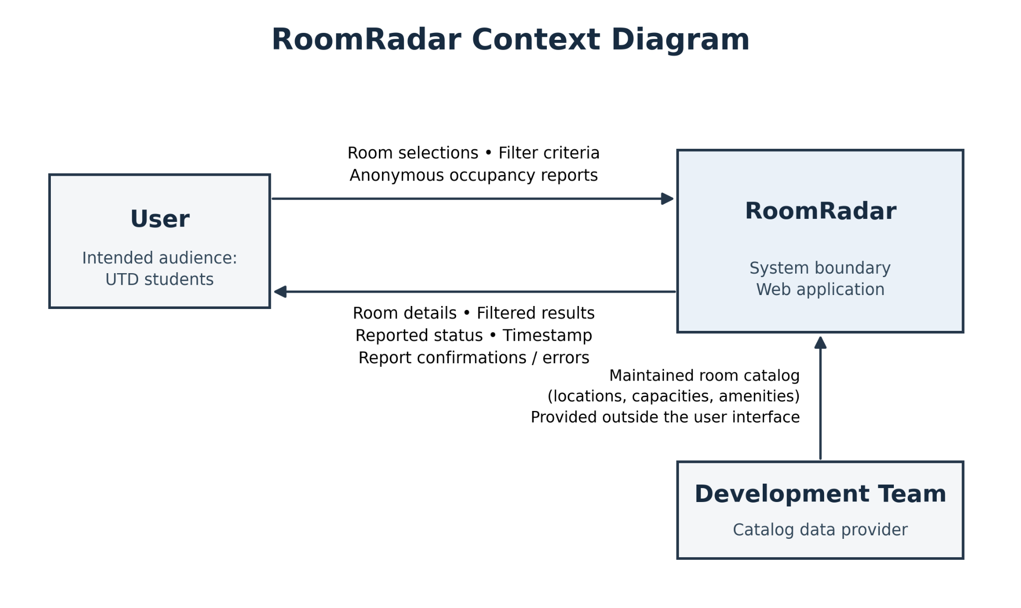

RoomRadar is a standalone web application intended for UTD students. Its system boundary includes browsing the room catalog, filtering rooms, accepting anonymous occupancy reports, and displaying reported statuses, timestamps, and Unknown states when reports expire. Users interact with these functions through a web browser without signing in. The development team supplies and maintains the room catalog outside the application’s user interface. RoomRadar does not connect to university booking systems, identity services, or occupancy sensors.

2.2 Stakeholders and how you reached them
Stakeholder | Role in relation to the system | What they need from it | How you learned this
UTD students | Primary intended users who search for study rooms and optionally submit anonymous occupancy reports. | Find rooms matching their location, capacity, and amenity needs, and understand the freshness and limitations of occupancy reports. | Team assumptions based on members’ own campus experience; broader student needs have not yet been validated.
Campus facilities and library staff | Non-user stakeholders responsible for spaces listed in the room catalog. | Accurate room descriptions and clear communication that reported occupancy does not grant permission to use or reserve a room. | Team assumptions about staff responsibilities and concerns; no staff consultation has been documented.
Development team | Builds and maintains RoomRadar and supplies the room catalog. | A manageable scope, obtainable room information, and clear, testable requirements. | Team project planning and scope decisions documented in this proposal.

2.3 User characteristics
UTD students are the primary users of RoomRadar. They may have different levels of technical experience and may access the web application on phones while moving between buildings or on laptops while planning a study session. Students need readable room information, straightforward filters, and clearly labeled occupancy reports with timestamps. Status information must be understandable without relying on color alone, and primary controls must support keyboard navigation. Students are not expected to maintain catalog information; the development team supplies and maintains room locations, capacities, and amenities outside the application’s user interface.

2.4 Constraints
RoomRadar’s first release is subject to the following team-established constraints:
C1 — The application must support browsing and occupancy reporting without user accounts, sign-in, or collection of names, usernames, or email addresses. Source: the anonymous-reporting scope decision in section 1.2.
C2 — The application must operate without integration with university booking systems, university identity services, or physical occupancy sensors. Source: the first-release exclusions in section 1.2.
C3 — Room catalog maintenance must occur outside the application’s user interface; the first release will not include an administrator interface. Source: the team-maintained catalog decision in section 1.2.
These are project constraints established by the team, not requirements imposed by UTD.

2.5 Assumptions and dependencies
# | Assumption or dependency | What breaks if it does not hold
A1 | The team can obtain sufficiently accurate locations, capacities, and amenity information for a limited catalog of UTD study rooms. | Room details and filtering results may be misleading. If suitable information cannot be obtained, the demonstration must use clearly labeled sample data rather than claim to represent actual campus rooms.
A2 | Some users will voluntarily submit occupancy reports when they observe rooms; periodic updates are not assumed. | Few rooms will have recent reports, so occupancy status will frequently be Unknown. Catalog browsing and filtering will remain usable.
A3 | Voluntary reports will be accurate often enough to provide useful supplementary information. This assumption has not yet been validated. | Incorrect or deliberately false reports may mislead users and reduce trust. Timestamps and expiration limit the age of displayed reports but do not establish their accuracy.
A4 | Users have an internet connection when accessing the application or submitting reports. | Users cannot retrieve current shared information or submit reports while disconnected. Offline operation is not planned for the first release.

2.6 Feasibility summary
Feasibility gate | Verdict | Evidence behind the verdict
Technical | Conditionally Feasible | The scope is limited to a room catalog, filtering, and storing anonymous occupancy reports; it excludes sensors and university-system integrations (Sections 1.2 and 2.4). Relevant team experience and the implementation approach still need confirmation. The technical check planned in Section 4.2 will assess catalog access and report storage.
Operational | Conditionally Feasible | The proposed need comes from the team’s campus experience; outside student feedback has not yet been collected. Browsing and filtering do not require occupancy reports, but the usefulness of reported status depends on voluntary participation and report accuracy. Student feedback is planned for Oct. 22.
Schedule | Conditionally  Feasible | Section 4.2 assigns dated milestones and owners through Nov. 8. Members have conflicting availability, so shared-document editing and GitHub issue updates support work between meetings. Individual time commitments still need confirmation before the schedule can be considered achievable.
Economic / resource | Conditionally feasible | The agreed scope requires no purchased occupancy hardware or university-system integration. The student team will perform development using its existing collaboration tools. Hosting and database costs have not yet been confirmed, so affordability remains dependent on the selected services.

3 Specific Requirements
3.1 Functional requirements
ID | Requirement — one “shall” sentence | Priority | Source | Acceptance criterion
FR-01 | The system shall determine each room’s displayed occupancy status from its latest successfully accepted report, using Unknown when no report exists or the report has expired. | MUST | Development team — occupancy-status rules (Section 1.2–1.3) | Using four test rooms, verify that a current empty report produces Reported Empty, a current occupied report produces Reported Occupied, an expired report produces Unknown, and no report produces Unknown.
FR-02 | The system shall allow users to submit occupancy reports without creating an account, signing in, or providing identifying information. | MUST | Development team — anonymous-reporting scope decision (Section 1.2) | A user with no account can successfully submit a report by selecting only a room and an Empty or Occupied status.
FR-03 | The system shall display the selected room’s building, room identifier, capacity, and amenities as recorded in the catalog. | MUST | UTD students — team-assumed room-information need (Section 2.2) | Select a test room and verify that every displayed field matches its catalog record.
FR-04 | The system shall filter the room list by a user-selected building. | MUST | UTD students — team-assumed building-filter need (Section 2.2) | With rooms from Buildings A and B in the catalog, selecting Building A displays all and only rooms in Building A.
FR-05 | The system shall display exactly one occupancy label per room: Reported Empty, Reported Occupied, or Unknown. | MUST | Development team — defined occupancy labels (Section 1.3) | Test each of the three states and verify that each room displays exactly one permitted label.
FR-06 | The system shall list all catalog rooms when no filters are active, regardless of occupancy status. | MUST | Development team — catalog remains usable without current reports (Section 1.1) | With six catalog rooms covering all three statuses, verify that all six appear when no filters are active.
FR-07 | The system shall filter rooms by a user-selected minimum capacity. | MUST | UTD students — team-assumed capacity-filter need (Section 2.2) | With room capacities of 2, 4, and 6, selecting a minimum of 4 displays the rooms with capacities of 4 and 6 only.
FR-08 | The system shall filter rooms by a user-selected amenity. | MUST | UTD students — team-assumed amenity-filter need (Section 2.2) | Selecting Whiteboard displays all and only rooms whose catalog records include a whiteboard.
FR-09 | The system shall display all and only catalog rooms satisfying every active filter when multiple filters are selected. | MUST | Development team — combined-filter behavior | Select Building A, minimum capacity 4, and Whiteboard; verify that the results include all and only rooms meeting all three conditions.
FR-10 | The system shall display a no-matching-rooms message when no catalog rooms satisfy the active filters. | MUST | Development team — no-results behavior | Apply a filter combination matching zero rooms and verify that an explicit no-matching-rooms message appears.
FR-11 | The system shall store each accepted occupancy report with its selected catalog room, Empty or Occupied status, and an automatically assigned submission timestamp. | MUST | Development team — structured anonymous-reporting scope (Section 1.2) | Submit one Empty report and one Occupied report for different test rooms; verify that each stored report contains the correct room, status, and a system-generated timestamp without requiring the user to enter a time.
FR-12 | The system shall treat the most recently accepted report for a room as that room’s latest report, resolving equal timestamps by acceptance order. | MUST | Development team — latest-accepted-report precedence rule | Accept an Empty report followed by an Occupied report for the same room and verify that Occupied is selected as the latest report, including when the timestamps are equal.
FR-13 | The system shall display the submission date and time of a room’s latest accepted report, including after that report expires. | MUST | Development team — report-timestamp display rule | Verify that the displayed date and time match the latest report before and after expiration; a room with no report displays “No reports yet” instead of a timestamp.
FR-14 | The system shall change a room’s displayed status to Unknown when its latest report reaches 60 minutes of age, including while the room view remains open. | MUST | Development team — proposed 60-minute expiration rule | With no newer report, verify that the reported status remains at 59 minutes 59 seconds and becomes Unknown at 60 minutes without a page reload.
FR-15 | The system shall display the outcome of each report-submission attempt as a success confirmation only after storage succeeds or an error message if storage fails. | MUST | Development team — submission success and failure behavior | A successful save produces confirmation; a simulated storage failure produces an error without claiming success or replacing the previously accepted report.

3.2 Quality requirements
ID | Requirement — with threshold, condition and method | Priority | Source | How it will be verified
QR-01 | All room-status information shall remain understandable without color, using the text labels defined in FR-05. | MUST | Development team — accessibility decision (Section 2.3) | View all three occupancy states in grayscale and verify that their text labels remain visible and distinguishable.
QR-02 | At least 95% of valid report submissions shall display a success confirmation within 3 seconds of submission under a test load of 10 concurrent users. | SHOULD | Development team — proposed reporting-performance target | Run 100 valid submissions with 10 concurrent users in a documented test environment; at least 95 must display confirmation within 3 seconds. Failed submissions count as failures to meet the target.
QR-03 | At least 95% of room-list filtering operations shall display the matching results or a no-results message within 5 seconds under a test load of 10 concurrent users and a 100-room catalog. | SHOULD | Development team — proposed filtering-performance target | Run 100 filtering operations using building, capacity, and amenity filters; measure from applying filters to displaying the result. At least 95 must complete within 5 seconds.
QR-04 | The occupancy-reporting workflow shall collect and store zero names, usernames, email addresses, passwords, student IDs, or birthdates. | MUST | Development team — anonymous-reporting scope (Section 1.2) | Inspect reporting controls, submitted request data, and stored report records; verify that none of the listed identifying fields are requested, transmitted, or stored by the workflow.
QR-05 | The room list, room details, and reporting views shall display without horizontal scrolling at viewport widths of 375, 768, and 1280 CSS pixels. | MUST | Development team — phone and laptop use (Section 2.3) | Inspect each view at all three widths using representative catalog content, including its longest room names and amenity lists; verify zero horizontal overflow.
QR-06 | All controls required to browse rooms, apply filters, and submit reports shall be operable using only a keyboard, with a visible focus indicator. | MUST | Development team — keyboard accessibility (Section 2.3) | Complete all three workflows using only the keyboard; verify that every required control is reachable, operable, and visibly focused.

3.3 Constraint requirements
ID | Constraint — one sentence | Source | Why it cannot be negotiated
CON-01 | The system shall support browsing and occupancy reporting without accounts, sign-in, or collection of names, usernames, or email addresses. | Development team — C1, Section 2.4 | Anonymous access is an agreed release boundary; changing it requires revising the scope and privacy requirements.
CON-02 | The system shall operate without integration with university booking systems, university identity services, or physical occupancy sensors. | Development team — C2, Section 2.4 | These integrations are excluded from the agreed release scope and would introduce additional dependencies.
CON-03 | The system shall exclude an administrator interface for room catalog maintenance. | Development team — C3, Section 2.4 | The team maintains catalog data outside the user interface; adding an administrator interface would expand the agreed scope.

3.4 Initial use cases
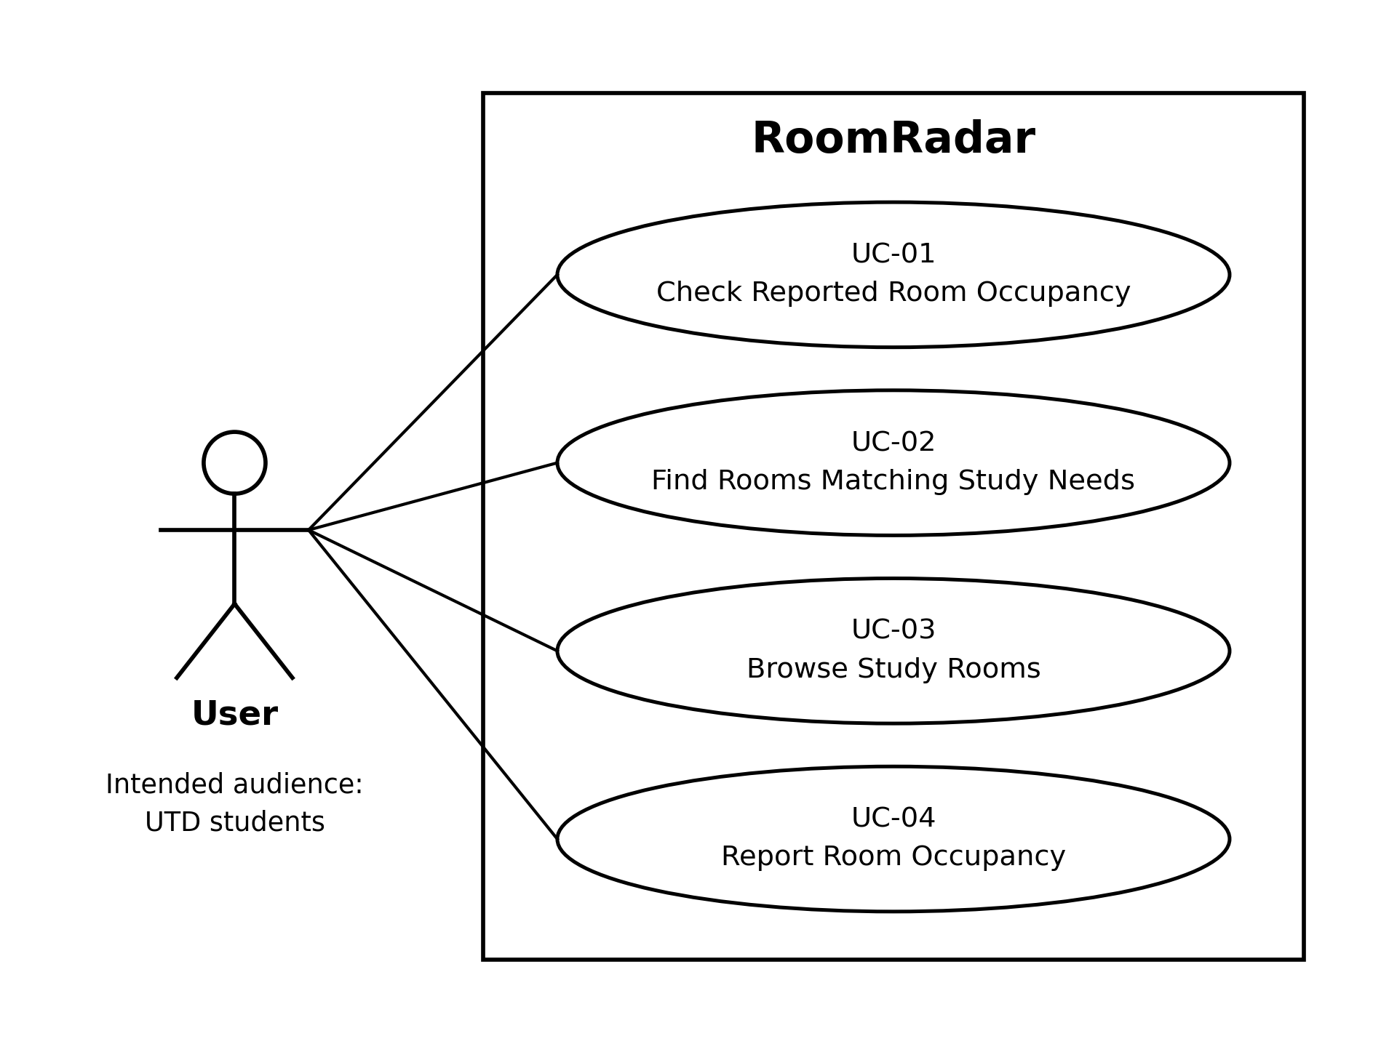

ID | Use Case | Summary
UC-01 | Check Reported Room Occupancy | The user checks a selected room’s reported status and latest report timestamp. Missing or expired reports produce Unknown status.
UC-02 | Find Rooms Matching Study Needs | The user filters the catalog by building, minimum capacity, and amenity to find suitable rooms.
UC-03 | Browse Study Rooms | The user explores the room catalog and views room locations, capacities, and amenities, regardless of occupancy status.
UC-04 | Report Room Occupancy | The user anonymously submits an Empty or Occupied observation for a selected room and receives confirmation or an error.
Use Case 1: Find Rooms Matching Study Needs
Field | Content
Identifier and name | UC-02 — Find Rooms Matching Study Needs
Primary actor | User (intended audience: UTD students)
Supporting actors | None
Preconditions — what must be true before it starts | The user can access RoomRadar and its room catalog. No account or sign-in is required.
Trigger — what starts it | The user chooses to filter the room catalog.
Main success scenario — numbered steps | 1. The system displays building, minimum-capacity, and amenity filter options.  2. The user selects one or more criteria and applies the filters.  3. The system displays all and only rooms meeting every selected criterion.  4. Each matching room displays its reported occupancy status.  5. The user selects a room.  6. The system displays its building, room identifier, capacity, amenities, and latest report timestamp, if one exists.
Alternative and exception flows | No matches: The system displays a no-matching-rooms message; the user may change the filters and repeat the search.  No current report: The room remains in the results with Unknown status. An expired report retains its timestamp; a room with no report displays “No reports yet.”  Filters cleared: The system displays all catalog rooms regardless of occupancy status.
Postconditions — what is true when it succeeds | The user has viewed rooms matching the selected criteria and, if a room was selected, its details. No catalog data or occupancy reports are changed. Physical availability is not guaranteed.
Requirements realised | FR-01, FR-03, FR-04, FR-05, FR-06, FR-07, FR-08, FR-09, FR-10, FR-13

Use Case 2: Report Room Occupancy
Field | Content
Identifier and name | UC-04 — Report Room Occupancy
Primary actor | User (intended audience: UTD students)
Supporting actors | None
Preconditions — what must be true before it starts | The user can access RoomRadar, and the selected room exists in the catalog. No account or sign-in is required.
Trigger — what starts it | The user chooses to report the selected room’s occupancy.
Main success scenario — numbered steps | 1. The system identifies the selected room and presents Empty and Occupied reporting options.  2. The user selects the status they observed.  3. The user submits the report without providing identifying information.  4. The system stores the selected room, reported status, and an automatically assigned submission timestamp.  5. The system treats the newly accepted report as the room’s latest report.  6. The system confirms successful submission and displays the latest reported status and timestamp.
Alternative and exception flows | Storage fails: The system displays an error without claiming success. The failed submission does not replace the previously accepted report.  User leaves before submitting: No report is stored.  Another report is accepted: The most recently accepted report determines the displayed status. Reports with equal timestamps are ordered by acceptance order.
Postconditions — what is true when it succeeds | On success, an anonymous report is stored for the selected room. The latest accepted report determines the displayed occupancy status until it is superseded or reaches 60 minutes of age, when the status becomes Unknown. The report does not reserve the room or verify its actual occupancy.
Requirements realised | FR-01, FR-02, FR-05, FR-11, FR-12, FR-13, FR-14, FR-15

3.5 Requirements to use case traceability
Requirement ID | Use case(s) that realise it | If blank — why, and what you will do
FR-01 | UC-01, UC-02, UC-04
FR-02 | UC-04
FR-03 | UC-02, UC-03
FR-04 | UC-02
FR-05 | UC-01, UC-02, UC-04
FR-06 | UC-02, UC-03
FR-07 | UC-02
FR-08 | UC-02
FR-09 | UC-02
FR-10 | UC-02
FR-11 | UC-04
FR-12 | UC-04
FR-13 | UC-01, UC-02, UC-04
FR-14 | UC-01, UC-04
FR-15 | UC-04

What the matrix revealed, and what you changed because of it:
The traceability review revealed that the original use cases did not cover anonymous report submission, timestamp recording, report precedence, expiration, or submission failures. Adding UC-04 addressed these reporting gaps, while revising UC-02 covered building, capacity, and amenity filtering, combined filters, and no matching results. UC-01 covers checking reported occupancy and expiration; UC-03 covers catalog browsing and room details. Every functional requirement now links to at least one use case, and every use case links to at least one functional requirement. Catalog maintenance was removed from the application’s use cases because an administrator interface is outside the agreed scope.

4 Project Plan
4.1 Team roles and working agreement
Team member | Role for P1 to P2 | How the team makes a decision when it disagrees
Adam Khazem | Team coordinator and repository lead: coordinate deadlines, maintain the repository, organize contribution evidence, and review document consistency. | Discuss options and evidence; if there’s no consensus, vote and record the decision.
Raghameena Ramasubbu | Quality requirements and documentation lead: maintain measurable quality requirements, references, and tooling documentation. | Same team decision process.
Jeimy Rodriguez | Stakeholder and use-case lead: document stakeholder needs, maintain use-case flows, and coordinate feasibility input from the team. | Same team decision process.
Tien Nguyen | Functional requirements and constraints lead: maintain functional requirements, assumptions, dependencies, and release constraints. | Same team decision process.

Roshan Palani | Technical feasibility lead: investigate room data, occupancy-report storage, and the technical approach; document findings and limitations. | Same team decision process.

Noor Suhwail | Project planning lead: maintain milestones, team responsibilities, and the working agreement; flag scheduling issues. | Same team decision process.

Malak Zaarour | Traceability and risk lead: maintain requirement-to-use-case links, support use-case revisions, and track risks and unresolved questions. | Same team decision process.

4.2 Plan to P2
Date | What will be finished | Owner
Oct. 18 | Finalize and submit the P1 proposal; confirm scope, team roles, and contribution evidence. | Adam Khazem
Oct. 22 | Gather initial student feedback on room discovery and occupancy reporting; document findings and unresolved needs. | Jeimy Rodriguez
Oct. 26 | Revise functional requirements, assumptions, and constraints using the feedback; update acceptance criteria where needed. | Tien Nguyen
Oct. 30 | Review quality requirements and their acceptance checks; update supporting references and tooling documentation. | Raghameena Ramasubbu
Nov. 2 | Review the main and alternate use-case flows against the revised requirements; resolve inconsistencies. | Jeimy Rodriguez
Nov. 5 | Complete a technical feasibility check for the room catalog and anonymous reporting using sample data; document results and limitations. | Roshan Palani
Nov. 7 | Review requirement-to-use-case traceability, project risks, and open questions; record remaining gaps. | Malak Zaarour
Nov. 8 | Coordinate the final P2 readiness review; assemble the required deliverables and verify repository links and contribution evidence. | Noor Suhwail

4.3 Risks
# | Risk | Likelihood | Impact | Mitigation — action and owner
R1 | A room’s occupancy may change before its latest report expires, misleading users. | High | High | Tien Nguyen: verify that requirements specify reported-status labels, submission timestamps, and automatic Unknown status after 60 minutes; include expiration acceptance checks.
R2 | Too few students may submit reports, leaving many rooms with Unknown status. | High | High | Jeimy Rodriguez: gather student feedback on willingness to report and whether room browsing and filtering remain useful when occupancy is Unknown; document findings.
R3 | Accurate campus room information may be unavailable or incomplete. | Medium | High | Roshan Palani: check available sources for room metadata and document gaps; prepare clearly labeled sample data for prototype work when verified information is unavailable.
R4 | Requests for reservations, accounts, or university integrations may expand the agreed scope and delay delivery. | Medium | High | Adam Khazem: record proposed scope changes in GitHub issues, assess their schedule and requirement impacts, and obtain a team decision before adding them to the release.
R5 | Users may submit inaccurate or deliberately false anonymous reports. | Medium | High | Malak Zaarour: check that requirements and planned interface wording identify occupancy as unverified, student-reported information; document that timestamps and expiration limit report age but do not establish accuracy.

4.4 Repository and tooling
Repository: https://github.com/BigKhaz15/RoomRadar
The team edits one shared Google Doc. Adam uploads document snapshots to docs/p1/ on the repository’s main branch. Updated snapshots replace the file at the same path, preserving earlier versions through GitHub’s commit history. Commit messages describe the changes made.
Each member records their completed sections, specific contributions, and completion dates in their own GitHub contribution issue. Supporting evidence includes document snapshots, relevant commits, and Google Docs version history. Teammate reviews are conducted in person or during virtual meetings, with corrections made during the review. A brief summary identifying the reviewer, sections reviewed, and outcome is recorded in the relevant GitHub contribution issue.
Team members use their own GitHub accounts to record contributions. Adam manages repository uploads and ensures the instructor can access the repository and submitted documents.

4.5 Declaration of AI tool use
Tool | What it was used for | Who used it | How the output was checked
ChatGPT | Assisted with proposal drafting and revision, requirements clarification, diagrams, and project organization. | Noor S, Adam K | Reviewed suggestions against course instructions and project scope; checked consistency, testability, and requirement-to-use-case links, and corrected unsuitable suggestions.
Gemini | Assisted in gathering research | Roshan P, Adam K | Checked by all other team members against the agreed scope.

5 Open Questions
# | The question | Who can answer it | Needed by | What you assumed in the meantime
Q1 | Are there campus rules restricting publication of room information or student-submitted occupancy observations? | Relevant facilities/library staff; Roshan coordinates the inquiry. | Oct 24 | Prototype work uses clearly labeled sample data and makes no claim of university endorsement. Applicable restrictions remain unverified.
Q2 | Which campus rooms have verifiable building, room identifier, capacity, and amenity information suitable for the catalog? | Facilities/library staff and available campus sources; Roshan investigates. | Oct 24 | Use a small, clearly labeled sample catalog until actual room details can be verified.
Q3 | Will students voluntarily submit occupancy reports, and is the catalog useful when room statuses are Unknown? | Prospective student users; Jeimy gathers feedback. | Oct. 22 | Reporting remains optional; browsing and filtering remain available without current reports.
Q4 | Is the proposed 60-minute report lifetime useful for students interpreting occupancy information? | Prospective student users; Jeimy gathers feedback and Tien reviews the requirement. | Oct. 26 | Retain the agreed 60-minute expiration rule unless feedback supports a documented requirement change.

6 Baseline Declaration
▸ WHAT GOES HERE
Once you submit, the content of this document is your P1 baseline. From this point, changes to requirements are made through change control, not by quiet editing — this is the Chapter 5 practice, applied to your own project.
At P2 you will submit this same document, grown and revised, with the revision history in section 0 showing what changed and why. Do not start a new file.

We confirm that the requirements in section 3 represent our agreed baseline as of the submission date, and that every team member has read this document in full.
Team member | Signature or typed name | Date
 |  | 10/17/2026
 |  | 10/17/2026
 |  | 10/17/2026
 |  | 10/17/2026
 |  | 10/17/2026
 |  | 10/17/2026
 |  | 10/17/2026

