6.3 Component view
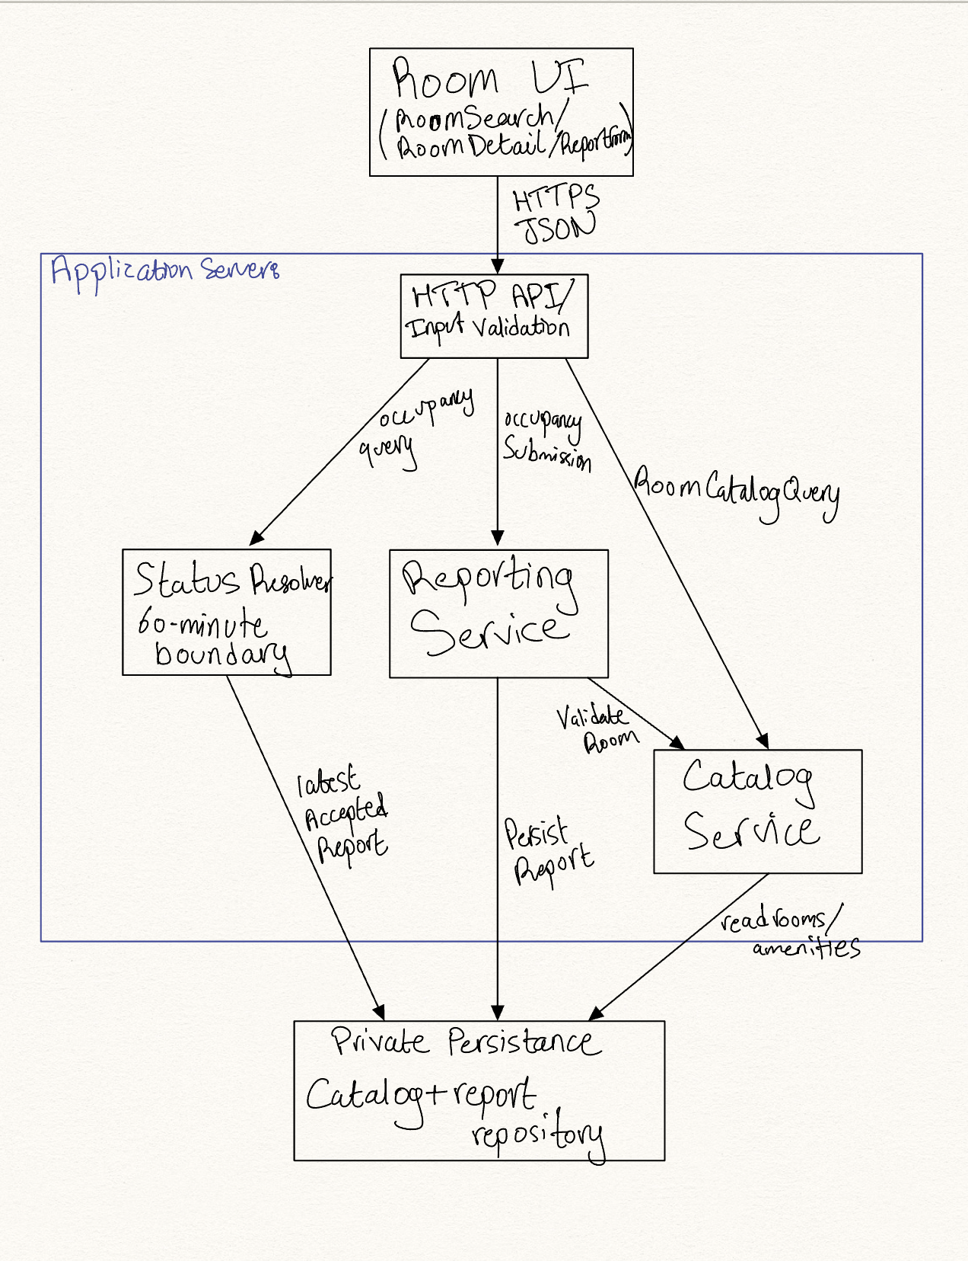 Figure 6.3 Component diagram: components, provided and required interfaces, external systems

Component | Responsibility (one sentence) | Provides | Requires | Answers to (UC / QAS / ADR)
Room UI | Display catalog, combined criteria, room details, labels and confirmation. | Room browsing, filtering, report actions | HTTP API | UC-01/02/03/04; QAS-04
HTTP API/validation | Validate inputs and standardize error/success messages. | RoomCatalogQuery, OccupancyQuery, OccupancySubmission | Catalog, Reporting, Status | UC-02/04; QR-04
Catalog Service | Read preloaded buildings, rooms, amenities and evaluate AND filters. | CatalogQuery | Repository | UC-02/03; QAS-02
Reporting Service | Accept valid anonymous observation and record timestamp/order atomically. | ReportAcceptance | Catalog Service, repository | UC-04; ADR-02/03
Status Resolver | Derive latest accepted status and 60-minute expiration. | OccupancyQuery | Repository | UC-01/02/04; QAS-05
Catalog + report repository | Persist team-maintained catalog and accepted anonymous reports. | RoomRead, ReportAppend, LatestReport | Database storage | UC-02/04; ADR-02

6.5 From analysis to architecture
Analysis object (from 5.1 and 5.2) | Component that owns it (6.3) | Note (split, merged, external)
Building/StudyRoom/Amenity | Catalog Service + repository | Catalog domain records loaded from team-maintained data.
SearchCriteria | Room UI + Catalog Service | Captured client-side, checked server-side as needed; ephemeral.
OccupancyReport | Reporting Service + repository | Append-only accepted report and precedence order.
DisplayedRoomStatus | Status Resolver + Room UI | Derived output; never maintained as a separate source of truth.

6.6 Design principles applied
Principle | Where it shows in your design | Evidence (component,  interface, ADR)
Separation of concerns | Browser renders; API validates; services enforce rules; repository persists. | Component view, ADR-01
Information hiding | Clients never see report ordering internals or DB credentials. | Reporting Service, ADR-02
Low coupling | Services exchange defined catalog/occupancy capabilities, not UI structures. | 6.3 named interfaces
High cohesion | Catalog search and reporting acceptance are independent responsibilities. | 6.3 Catalog vs Reporting
Design for change | 60-minute policy isolated in Status Resolver; data source behind repository. | ADR-03, Status Resolver
Keep it simple (KISS) | Single backend avoids microservice orchestration and pushes infrastructure. | ADR-01 / ADR-03

9 Traceability
9.1 Extended traceability matrix
Requirement | Use case | Analysis classes | Component(s) | QAS / ADR | Evidence
FR-01 | UC-01,02,04 | OccupancyReport; DisplayedRoomStatus | Status Resolver | QAS-05/ ADR-03 | Occupancy status rules defined; prototype verification pending.
FR-02 | UC-04 | OccupancyReport | Reporting Service / API | QAS-03 / ADR-02 | Anonymous reporting process designed; testing pending.
FR-03 | UC-02,03 | StudyRoom; Building; Amenity | Catalog Service /UI | ADR-01 | Room information display designed; testing pending.
FR-04 | UC-02 | SearchCriteria; Building | Catalog Service | QAS-02 | Building filtering designed; testing pending.
FR-05 | UC-01,02,04 | DisplayedRoomStatus | Status Resolver /UI | QAS-05 | Status labels and timestamps defined; testing pending.
FR-06 | UC-02,03 | StudyRoom | Catalog Service / UI | QAS-02 | Room catalog structure designed; testing pending.
FR-07 | UC-02 | SearchCriteria; StudyRoom | Catalog Service | QAS-02 | Capacity filtering designed; testing pending.
FR-08 | UC-02 | SearchCriteria;  Amenity | Catalog Service | QAS-02 | Amenity filtering designed; testing pending.
FR-09 | UC-02 | SearchCriteria; StudyRoom | Catalog Service | QAS-02 | Combined filtering behavior defined; testing pending.
FR-10 | UC-02 | SearchCriteria | Catalog Service /UI | QAS-02 | No-results response defined; testing pending.
FR-11 | UC-04 | OccupancyReport | Reporting Service / repository | ADR-02 | Report submission process designed; storage testing pending.
FR-12 | UC-04 | OccupancyReport | Reporting Service / Status Resolver | ADR-02 | Report acceptance ordering in prototype verification pending; team verification pending.
FR-13 | UC-01,02,04 | OccupancyReport; DisplayedRoomStatus | Status Resolver / UI | QAS-05 | Automatic timestamp recording designed; testing pending.
FR-14 | UC-01,04 | OccupancyReport; DisplayedRoomStatus | Status Resolver / UI | QAS-05 / ADR-03 | 60-minute expiration in prototype verification pending; automatic refresh testing pending.
FR-15 | UC-04 | OccupancyReport | Reporting Service / UI | QAS-01 | Storage-failure handling designed; testing pending.
QR-01 | UC-01,02,04 | DisplayedRoomStatus | Room UI / Status Resolver | QAS-05 | Text-based occupancy labels planned; accessibility testing pending.
QR-02 | UC-04 | OccupancyReport | API / Reporting Service | QAS-01 | Performance target defined; testing pending.
QR-03 | UC-02 | SearchCriteria | Catalog Service | QAS-02 | Filtering response-time target defined; testing pending.
QR-04 | UC-04 | OccupancyReport | API / Reporting Service | QAS-03 | Anonymous data handling designed; privacy verification pending.
QR-05 | UC-01,02,04 | StudyRoom; SearchCriteria; DisplayRoomStatus | Room UI | QAS-04 | Responsive layout planned; device testing pending.
QR-06 | UC-01,02,04 | SearchCriteria | Room UI | QAS-04 | Keyboard accessibility planned; testing pending.
CON-01 | UC-01,02,04 | OccupancyReport | API / UI | ADR-01/02 | No user accounts or login included in the design.
CON-02 | UC-01,02,04 | StudyRoom; OccupancyReport | Catalog + Reporting | ADR-01 | No university systems or sensors included in the architecture.
CON-03 | UC-02,03 | StudyRoom; Amenity | Catalog Service / repository | ADR-01 | Catalog managed externally; no administrator interface included.

9.2 Gap analysis
Gap | Items | What you did about it
Requirements with no component | None | All functional requirements, quality requirements, and constraints are mapped to responsible components in Section 9.1. These mappings will be verified during implementation.
Components with no requirement, QAS or ADR | None | All components in the high-level architecture are associated with at least one use case, quality-attribute scenario, or architecture decision.
Use cases not analyzed (and why that is acceptable) | UC-03 (Browse Study Rooms) | UC-03 was not expanded in Section 4 because it represents a relatively straightforward catalog-browsing interaction. The team prioritized filtering, occupancy reporting, and status expiration because they involve more complex interactions and higher design risks. UC-03 remains represented in the domain model, component architecture, and traceability matrix.

