CE / CS / SE 3354 · SOFTWARE ENGINEERING · FALL 2026
Project Deliverable P1
Proposal and Requirements — Team Template
Weight 4% · Due Sunday 18 October 2026, 11:59 PM Central · Submit one PDF per team on Canvas
Field | Your entry
Project title | RoomRadar
Team number and section | Team 02 Section 003
Team members (name · net ID) | Adam Khazem - AHK220002, Raghameena Ramasubbu - RXR230062, Noor Suhwail - NCS220001, Roshan Palani - DAL872106, Malak Zaarour - DAL028239, Tien Nguyen - DAL726120, Jeimy Rodriguez - JXR200054
Repository URL | https://github.com/BigKhaz15/RoomRadar/
Document version | 0.1
Date | October 15, 2026

▸ HOW TO USE THIS TEMPLATE
This template is the structure we expect, not a form to pad out. It follows the section ordering of ISO/IEC/IEEE 29148, the current international standard for requirements engineering, so that the document you start now grows into a full requirements specification by P2 rather than being thrown away and rewritten.
Delete every blue box like this one before you submit. They are instructions, not content, and a document that still contains them has not been read by its own authors.
Length: aim for 10 to 14 pages of your own content. A longer document is not a better one. Every section below carries a budget; a section that runs to twice its budget is usually padded, and padding is visible.

▸ WHAT P1 DOES NOT ASK FOR
P1 is a baseline, not a finished specification. At this milestone we are NOT asking for:
— a software architecture or any design decision (that is P2, after Chapter 8)
— class diagrams, sequence diagrams or state models (that is P2, after Chapters 7 and 9)
— a test plan (that is P3, after Chapter 11)
— any code, screens or a working prototype (P1 is marked on reasoning, not on implementation)
A team that submits an architecture diagram at P1 has spent its effort in the wrong place and will not be credited for it.

0 Revision History and Contribution Record
Both tables below are graded. The contribution record carries the individual 20% of this milestone and must be consistent with your repository history.
Version | Date | Author | Summary of change
0.1 | 2026-10-15 | Team 02 | Initial baseline for P1

0.1 Individual contribution record
Team member | What this person produced for P1 | Evidence in the repository
Adam Khazem | Introduction (1.1,1.2,1.3) and github repo setup
Raghameena Ramasubbu | 1.4, 2.1, 2.4, 3.2, 4.4
Jeimy Rodriguez | 2.2,2.6,3.4
Tien Nguyen | 2.5, 3.1, 3.3
Roshan Palani
Noor Suhwail
Malak Zaarour

▸ WHAT GOES HERE
Evidence means something a reader can open: a commit range, an issue number, a pull-request review, a document section you wrote. “Helped with requirements” is not evidence.
Every member must appear with a distinguishable contribution. A row that duplicates another row word for word earns neither member credit.
If a member did not contribute, say so here rather than at the end of term. Section 'Teamwork, Accountability, and Academic Honesty' in the syllabus explains why late complaints cannot be evaluated fairly.

1 Introduction
1.1 Purpose of this document and of the system
▸ WHAT GOES HERE
Two short paragraphs. The first says what this document is and who it is for. The second says what the system is for — the problem, and whose problem it is.
Budget: half a page.
Worked example: “CometLocker addresses the loss of parcels left at the campus post office counter, which currently requires a staffed desk during business hours and leaves students without a way to collect a delivery outside those hours.”

This document establishes the initial scope, stakeholders, feasibility, functional and quality requirements, constraints, and use cases for RoomRadar. It is intended for the course instructor, stakeholders, and development team who are creating and reviewing the requirements baseline.
University students may spend time checking multiple rooms or buildings before finding a suitable study space because they lack current information about room occupancy. RoomRadar is a proposed web application that helps university students find campus study rooms that meet their needs. Students can browse rooms, filter by building, capacity, and amenities, and view occupancy reports submitted by other students. Each report includes a timestamp so users can judge how recently the room’s status was observed.

1.2 Scope
▸ WHAT GOES HERE
A scope statement is only useful if it says what is excluded. Fill both columns. An empty right-hand column means you have not scoped anything.
Budget: the table, plus two sentences on why the exclusions were excluded.

In scope — we will build this | Out of scope — we will not, and why
Browse a catalog of campus study rooms with location, capacity, and amenities. | Track the individual availability of the seats; the system focuses on the rooms themselves.
Filter rooms by building, capacity, and amenities | Reserve rooms or manage bookings; the system provides information rather than services.
Allow students to report whether a room is empty or occupied | Guarantee current room availability; student reports may be inaccurate or outdated.
Display the latest reported occupancy status and its timestamp | Automatically detect occupancy using sensors or cameras; this would require additional hardware and infrastructure.
Display an Unknown status when no report exists or the latest report has expired | Integrate with already existing UTD booking systems; access to those systems has not been established.

Why the exclusions were excluded: These exclusions keep the project achievable within the course timeline by focusing on room discovery and student-submitted occupancy reports. Reservations, individual seat tracking, and automatic occupancy detection are excluded because they require additional functionality, infrastructure, or university system access.

1.3 Definitions, acronyms and abbreviations
▸ WHAT GOES HERE
Every term your stakeholders use in a way a newcomer would misread, and every abbreviation, expanded at first use. If a word in your domain has two meanings, that is a finding — record both meanings here and resolve it in section 5.

Term or abbreviation | Meaning as used in this project
User (Student) | A student who uses RoomRadar to browse and filter study rooms, view occupancy reports, or submit an occupancy report.
UTD | The University of Texas at Dallas, the campus covered by RoomRadar
Occupancy Status | The room’s reported condition, displayed as Reported Empty, Reported Occupied, or Unknown.
Study Room | An enclosed campus space designed for individual or group study.
Room Catalog | The collection of study rooms listed in RoomRadar, including their locations, room identifiers, capacities, and amenities.
Occupancy Report | A student-submitted observation indicating whether a room is empty or occupied.
Timestamp | The date and time recorded when an occupancy report is submitted
Unknown | A status indicating that no occupancy report exists or the latest report has expired
Expired Report | An occupancy report older than the system’s defined freshness limit.
Capacity | The number of people a study room is intended to accommodate.
Amenities | Room features, such as whiteboards or power outlets.

1.4 References
▸ WHAT GOES HERE
Anything you relied on: a standard, a campus policy, an existing system's documentation, an interview transcript in your repository. Give each a number so requirements in section 3 can cite it as a source.

[R1] The current UTD room availability and locations
[R2] UTD policy on use of university facilities and space reservation

2 Overall Description
2.1 Product perspective and context
▸ WHAT GOES HERE
Draw the context diagram: one box for your system, every external actor and external system around it, and a labelled line for each interface. Paste the image here.
This is the diagram that decides what you are responsible for. Anything inside the box is your work. Anything you call on and do not build is an external system — and it still goes on the diagram.
Budget: one diagram and one paragraph explaining the boundary choice.

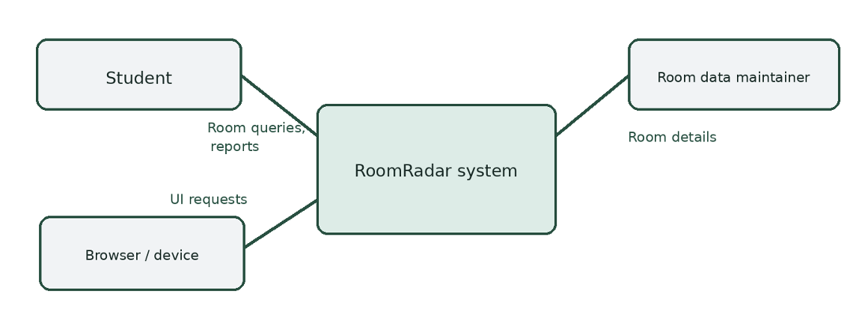

2.2 Stakeholders and how you reached them
▸ WHAT GOES HERE
Everyone whose needs shape the system, including the ones who will never use it — whoever pays, whoever operates it, whoever has to comply with something because of it.
The last column is the one that earns marks. “We assumed” is an honest and acceptable answer at P1; “interviewed on 9 Oct, notes in /docs/elicitation” is a better one. An entry with no basis at all is not.

Stakeholder | Role in relation to the system | What they need from it | How you learned this
UTD Students | Primary Roles | To find empty study rooms | We assumed based on own campus use; needs student validation
Campus Facility | Secondary Roles | Accurately describe the room state is in. | Assumed stakeholder need
University Admins | Secondary Roles | Privacy and compliance with University Standards. | Assumed University Standard Code

2.3 User characteristics
▸ WHAT GOES HERE
Who the users are, what they already know, what they cannot be assumed to know, and anything about them that constrains the system — accessibility needs, the device they will be holding, the hurry they are in.
Budget: a short paragraph per user class.

UTD students will be able to use this application from their phones. The students should be able to clearly understand the symbols being used in the app declaring which are available and when they are not.

2.4 Constraints
▸ WHAT GOES HERE
A constraint removes a design choice. “We must use the existing campus single sign-on service” is a constraint. “The system should be fast” is not — that is a quality requirement, and it belongs in 3.2.
Record the source of each constraint. An unsourced constraint is usually a preference somebody has mistaken for a rule.

Must be a UTD Student or staff member to access the app. Cannot use any third party add ons.

2.5 Assumptions and dependencies
▸ WHAT GOES HERE
An assumption is something you are treating as true without having confirmed it. A dependency is something outside your control that your plan needs.
State what breaks if each one turns out to be wrong. That sentence is the whole value of this section.

# | Assumption or dependency | What breaks if it does not hold
A1 | The list of study rooms and the state of the room is always up to date, including maintenance, construction, and occupancy | Information about room state is not accurate
A2 | Users are willing to report room status after they are done using the study room | Information about room availability is not accurate.

2.6 Feasibility summary
▸ WHAT GOES HERE
Four short verdicts, each with the evidence behind it. This is the Chapter 4 material, applied to your own project.
A verdict with no evidence is an opinion. “Technically feasible — two team members have used this framework before, see repository /spike-01” is evidence. “We think we can do it” is not.

Feasibility gate | Verdict | Evidence behind the verdict
Technical | Conditionally Feasible | Some members have not used GIt hub in quite some time.
Operational | Conditionally Feasible | Student search is plausible , but usefulness depends on students declaring whether the rooms are empty or occupied.
Schedule | Conditionally  Feasible | Not all members can meet at the same time.
Economic / resource | Likely Feasible | No sensors or paid booking system integration.

3 Specific Requirements
▸ WHAT GOES HERE
This section carries the most marks in P1. Everything else sets it up.
Expected volume: 8 to 15 functional requirements, 4 to 6 quality requirements, 2 to 4 constraint requirements, 4 to 6 use cases with 2 written out in full. More is not better; vague is worse than few.
Every requirement must pass the testability test from Chapter 5: a reader must be able to decide pass or fail without arguing. That needs a measurable condition and a stated way of checking it.
Write every requirement as a single “shall” sentence. If you need the word “and” twice, you have two requirements.

3.1 Functional requirements
▸ WHAT GOES HERE
What the system does. Use the identifier FR-nn and keep the identifiers stable from now on — P2 and P3 will refer back to them.
Priority uses MoSCoW: MUST (the release fails without it), SHOULD (important, there is a workaround), COULD (desirable), WON'T (agreed out of this release).
Source is the stakeholder or reference the requirement came from — a row from 2.2, or a reference from 1.4.

ID | Requirement — one “shall” sentence | Priority | Source | Acceptance criterion
FR-01 | The system shall show if a study room is currently available | MUST | UTD Students | The tester can confirm by going to 5 random study rooms to see if the availability matches what is shown on the app.
FR-02 | The system shall not display any personal information | MUST | University Admins | The tester can go to a room that is currently being occupied and see what information is showing up on the app
FR-03 | The system shall display the selected room’s number and building | MUST | Campus Facility | The tester should be able to find available rooms by checking the room number.
FR-04 | The system shall filter the room list by buildings and capacity | SHOULD | UTD Students | The tester should use the filter feature on the app, and then check whether the app displays the correct room in accordance with the building layout.
FR-05 | The system shall display only one label at a time | MUST | Campus Facility | The tester should go into a room and change the availability, then leave the room, changing the availability again to see if the correct label is displayed only one time at a time.

3.2 Quality requirements
▸ WHAT GOES HERE
A quality requirement says how well, not what. Performance, availability, usability, accessibility, security, maintainability.
Three ingredients, every time: a number, the condition it holds under, and how it will be measured. “The system shall be responsive” has none of the three and earns nothing.
Worked example: “QR-01 Ninety-five percent of searches shall return results within 2 seconds, measured over one working week under normal load of up to 50 concurrent users.”

ID | Requirement — with threshold, condition and method | Priority | Source | How it will be verified
QR-01 | Ninety-five percent of the students should be self reporting the availability of the rooms. | MUST | Students | Run the number of times that a reported study room is available or not and calculate the percentage of that.
QR-02 | Ninety five percent of the availability status update request must finish within 3 seconds with 10 users. | SHOULD | Students | Measure 100 report calls with 10 users to see how long it takes for the status to update.
QR-03 | Ninety five percent of the searches for available rooms should be returned within 5 seconds for 10 users. | SHOULD | Students | Run an aggregate test report to see if 95% of the searches return within 5 seconds.
QR-04 | Ninety five percent

3.3 Constraint requirements
▸ WHAT GOES HERE
Constraints carried forward from 2.4, written in requirement form with an identifier so they can be traced like any other requirement.

ID | Constraint — one sentence | Source | Why it cannot be negotiated
CON-01 | Only UTD Students and staff can access the app | UTD Admins | UTD campus study rooms are only open to UTD students.
CON-02 | Cannot use any unauthorized third-party application or modification | UTD Admins | UTD has more than enough equipment to accommodate the project, and they do not want to extend the budget for unnecessary third-party services.

3.4 Initial use cases
▸ WHAT GOES HERE
First the diagram: actors, use cases, the system boundary, and any «include» or «extend» relationships. Paste the image.
Then write out two use cases in full — choose the two that are hardest to scope, not the two that are easiest to write. Use the template below for each.
Reminder from Chapter 6: a use case is started by an actor, ends when that actor has finished something they came to do, and has value on its own. “Validate Password” is a step, not a use case.

Paste the use case diagram here.
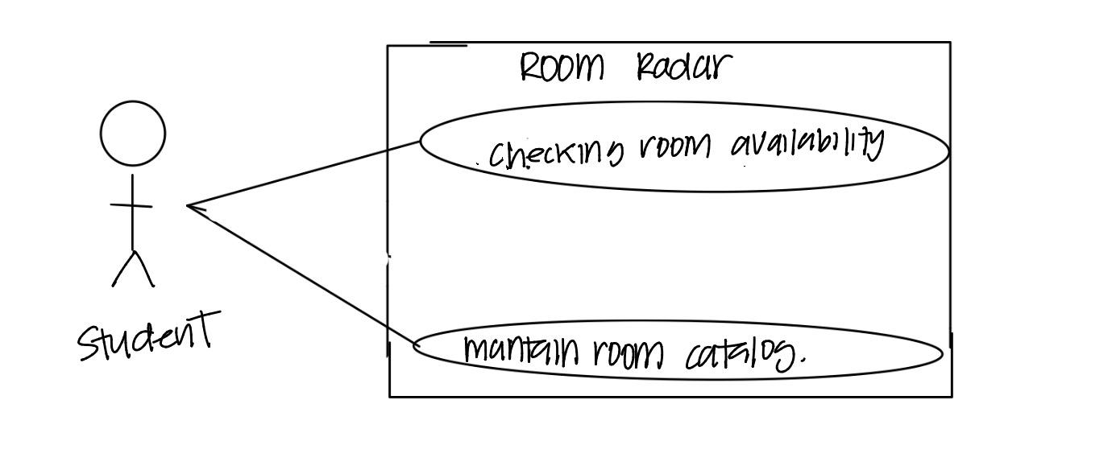

Expanded use case — copy this block for each of your two
Field | Content
Identifier and name | UC-01
Primary actor | Student
Supporting actors | Application
Preconditions — what must be true before it starts | Students must be able to sign in to the application. Must see the rooms catalog
Trigger — what starts it | Student opens Room radar
Main success scenario — numbered steps | 1.System displays the room that is available. 2.Student selects building and room. 3. The system shows the rooms that are available. 4. The student goes to the room and it's available.
Alternative and exception flows | Catalog unavailable: show loading and error state
Postconditions — what is true when it succeeds | Student has the correct room details and will be able to go the study room without problems
Requirements realised | FR- 1,FR- 2,FR- 3, FR- 4,FR- 5

3.5 Requirements to use case traceability
▸ WHAT GOES HERE
One row per requirement. The matrix is doing its job when it shows you something you did not already know.
Two shapes of trouble, and you must say what you did about each: a requirement that reaches no use case (either a use case is missing, or the requirement is not functional and belongs in 3.2), and a use case nothing traces to (either it is out of scope, or a requirement was never written down).

Requirement ID | Use case(s) that realise it | If blank — why, and what you will do
FR-01
FR-02
FR-03
FR-04
…

What the matrix revealed, and what you changed because of it:

4 Project Plan
4.1 Team roles and working agreement
Team member | Role for P1 to P2 | How the team makes a decision when it disagrees

4.2 Plan to P2
▸ WHAT GOES HERE
Milestones between now and 8 November, each with a date and a named owner. Five to eight rows is right.

Date | What will be finished | Owner

4.3 Risks
▸ WHAT GOES HERE
Your five biggest. A risk is something that has not happened yet — if it has already happened it is a problem, and it belongs in section 5.
Mitigation must be an action with an owner, not an intention. “Start early” is not a mitigation.

# | Risk | Likelihood | Impact | Mitigation — action and owner
R1 | Room status reports are outdated | High | High | Requirements lead: define 30-minute expiry and Unknown status; test edge cases.
R2 | Too few students report statuses | High | High | Stakeholder lead: interview prospective users and evaluate usability of Unknown state by Oct 24.
R3 | Actual campus room data or permissions unavailable | Medium | High | Coordinator: verify availability rules; prepare clearly labeled sample catalog.
R4 | Requirements expand into reservation integration | Medium | Medium | Requirements lead: require documented change request and impact assessment.

4.4 Repository and tooling
▸ WHAT GOES HERE
The repository URL, the branch and commit conventions you have agreed, how issues are used, and who has access. The instructor must be able to open it.

https://github.com/BigKhaz15/RoomRadar
Pull request review before merging
Issues are used to recap the sections that we worked on individually
All team members

4.5 Declaration of AI tool use
▸ WHAT GOES HERE
List every artificial intelligence tool the team used for P1, what it was used for, and what you did to check its output.
Using these tools is permitted. Not declaring them is not. Start the log now — the full AI-use log is required evidence at P3, and reconstructing it in December is much harder than keeping it from October.

Tool | What it was used for | Who used it | How the output was checked
ChatGPT | Grammar, punctuality, revisioning | Noor S, Adam K | Spell checked and second-checked for accuracy by all team members upon completion of any given item(s)
Claude |  | Adam K
Gemini |  | Roshan P

5 Open Questions
▸ WHAT GOES HERE
A question you cannot answer from what you have is a finding, not a failure. It belongs here, in writing, with the name of the person who can answer it and the date you need the answer by.
This section is graded, and an empty one is a warning sign. Every real project at this stage has open questions. A team reporting none has either not looked hard enough or has quietly invented answers — and an invented answer is a business decision the team had no authority to make.
Carry each open question forward into P2 with its resolution, or with a note that it is still open.

# | The question | Who can answer it | Needed by | What you assumed in the meantime
Q1 | Are students permitted to share room occupancy information without campus approval? | Facilities / library staff | Oct 24
Q2 | Which campus rooms can be listed with reliable locations and capacity details? | Facilities staff; team research lead | Oct 24 | Start with a small manually labeled sample catalog.
Q3 | Should students authenticate to prevent spam or false reports? | Team and campus policy stakeholders | Oct 30

6 Baseline Declaration
▸ WHAT GOES HERE
Once you submit, the content of this document is your P1 baseline. From this point, changes to requirements are made through change control, not by quiet editing — this is the Chapter 5 practice, applied to your own project.
At P2 you will submit this same document, grown and revised, with the revision history in section 0 showing what changed and why. Do not start a new file.

We confirm that the requirements in section 3 represent our agreed baseline as of the submission date, and that every team member has read this document in full.
Team member | Signature or typed name | Date
Noor Suhwail | Noor Suhwail | 10/15/2026
 |  | 10/15/2026
 |  | 10/15/2026
 |  | 10/15/2026

10/15/2026

10/15/2026

10/15/2026

How P1 Is Marked
P1 is worth 4% of the course grade. Following the syllabus, 80 points are for the shared team artifact and 20 for individual contribution evidence.
Criterion | Points | What full marks look like
Problem, scope and context (1.1, 1.2, 2.1) | 10 | The problem is a problem somebody actually has. The out-of-scope column is filled and the exclusions are justified. The context diagram's boundary matches what sections 2 and 3 claim.
Stakeholders and elicitation (2.2, 2.3) | 10 | Stakeholders include at least one who will never use the system. Every need has a stated basis, and assumptions are labelled as assumptions rather than disguised as findings.
Requirements quality (3.1, 3.2, 3.3) | 25 | Every requirement is one testable “shall” sentence with an identifier, a priority, a source and an acceptance criterion. Quality requirements carry a threshold, a condition and a method. Constraints are distinguished from quality requirements.
Use cases and traceability (3.4, 3.5) | 20 | Use cases are at actor-goal level, not steps. Two are written out in full, including alternative flows. The matrix is complete and the team says what the gaps mean and what they did about them.
Feasibility and plan (2.6, 4) | 10 | Each feasibility verdict is backed by evidence a reader can check. The plan has dates and owners. Risks are future events with actionable mitigations.
Open questions and baseline (5, 6) | 5 | Real open questions, with an owner and a date, and an honest statement of what was assumed in the meantime.
Document quality | — | Guidance boxes removed, sections in order, within the length budget, readable. Marks are deducted here, not awarded.
Individual contribution evidence (0.1) | 20 | Every member's contribution is distinguishable and traceable to something in the repository a reader can open.

▸ WHERE MARKS ARE LOST
Three things that cost teams the most marks every year:
1. Requirements that cannot be tested. “The system shall be user-friendly” earns nothing, however good the rest of the document is. Section 3 is 25 of the 80 team points and this is where they are lost.
2. Use cases written at step level. “Log In”, “Validate Card” and “Open Gate” are three steps of one use case. A diagram of fifteen tiny ovals scores lower than one with five real ones.
3. An empty section 5. It reads as a team that resolved its ambiguities by guessing.

