Modular directory structure:
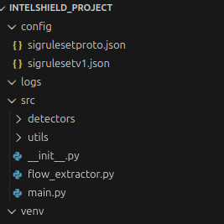

JSON ruleset schema:
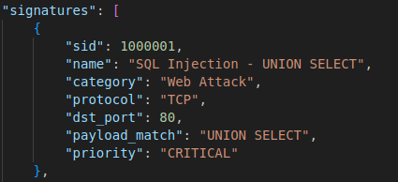

Flow extractor terminal output

Garbage collection code snippet
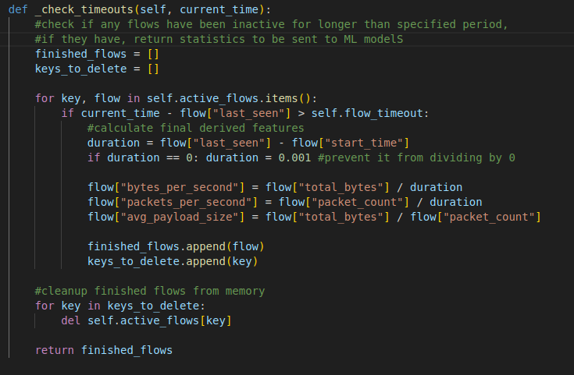

Logger working proof
