Ilia State University
Faculty of Business, Technology, and Education
School of Technology
P.P.A.M.S – Posture Pillow Attachment Monitoring System
Proposal

Team Members:
Jambuli Chkhikvadze
Samir Mansour
Giorgi Erkomaishvili

Computer Engineering Undergraduate Program
Senior Design Project A
Project Supervisors: Prof. Paata Gogishvili, Prof. George Modebadze
12/18/20205
Tbilisi, Georgia

Contents
Abstract 3
Introduction 3
3D device Diagram 4
System Diagram 4
Device Diagram 5
Electrical Diagram 5
Github Reposetory 7
Industry Standards 8
Sensor Precision & Resolution 8
Power System 9
Wire Management 9
System Accuracy and Calibration Performance 9
Gant Chart 10
Budget 11
References 12

Abstract
This project proposes the design and development of the Posture Pillow Attachment Monitoring System (P.P.A.M.S), a consumer wellness device intended to improve sitting posture awareness among office workers and university students who spend extended periods seated. Prolonged poor posture is a widespread problem that often develops unconsciously and may lead to long-term discomfort and reduced well-being. The primary objective of the project is to monitor seated posture in real time and provide timely feedback that encourages users to self-correct their posture before harmful habits becomes persistent.
The proposed system will consist of a removable chair attachment incorporating pressure sensors, embedded processing, and wireless communication capabilities. Sensor data will be processed by an embedded microcontroller and compared against a user calibrated baseline to identify sustained deviations from a correct sitting posture. When poor posture is detected, the system will provide gentle feedback through vibration and audio alerts. A companion mobile application will support system calibration, configuration, real-time monitoring, and visualization of posture history.
The project will employ standard embedded systems design practices, wireless communication technologies, and basic data-driven adaptation techniques. Expected outcomes include a functional hardware prototype, a mobile application, and complete technical documentation. The project has educational value by integrating hardware, software, and system design, and practical value by promoting healthier sitting behavior in everyday environments.

Introduction
Prolonged sitting is a common part of modern academic and professional life, especially for university students and office workers who spend long hours at desks. Maintaining poor posture for extended periods can lead to discomfort, fatigue, and long-term musculoskeletal problems. A major challenge is that many individuals are unaware of their posture while working, allowing unhealthy habits to develop over time.
Existing solutions such as ergonomic chairs, lumbar supports, and wearable posture trackers attempt to address this issue, but each has limitations. Ergonomic furniture does not actively monitor user behavior, while wearable devices can be intrusive or uncomfortable for continuous use. These shortcomings indicate a need for a non-intrusive system that can monitor seated posture and provide timely feedback without disrupting daily activities.
The Posture Pillow Attachment Monitoring System is proposed as a removable chair attachment that integrates sensing, embedded processing, and wireless communication to improve posture awareness. The project fits within modern embedded systems and user-centered engineering practices, offering educational value through hands-on system integration and practical relevance by encouraging healthier sitting habits in everyday environments.

3D device Diagram
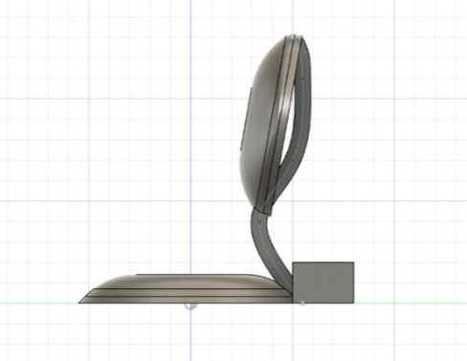
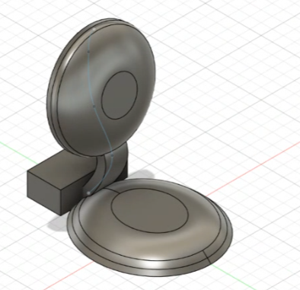

System Diagram

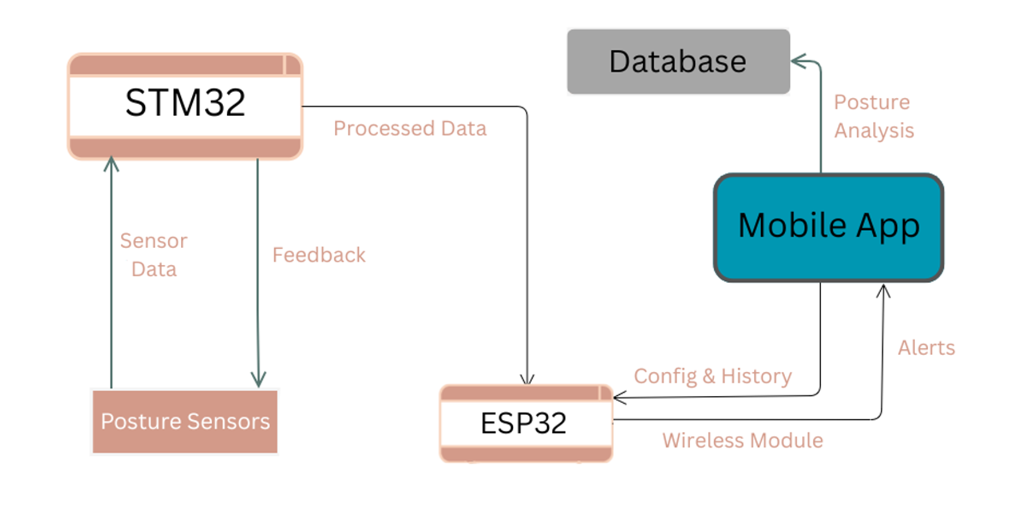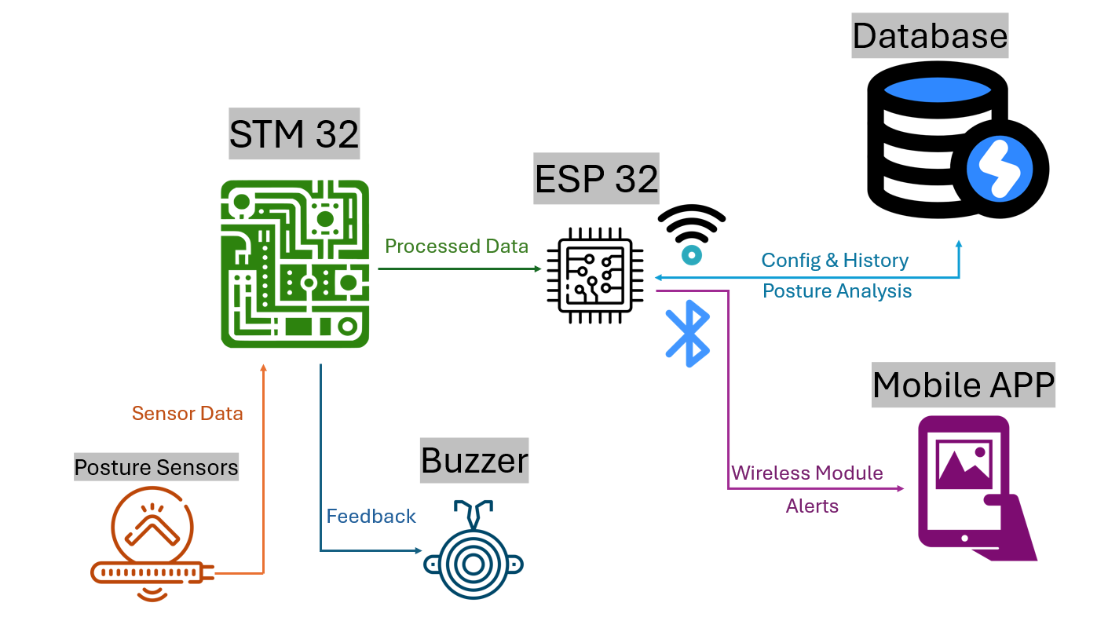

Device Diagram
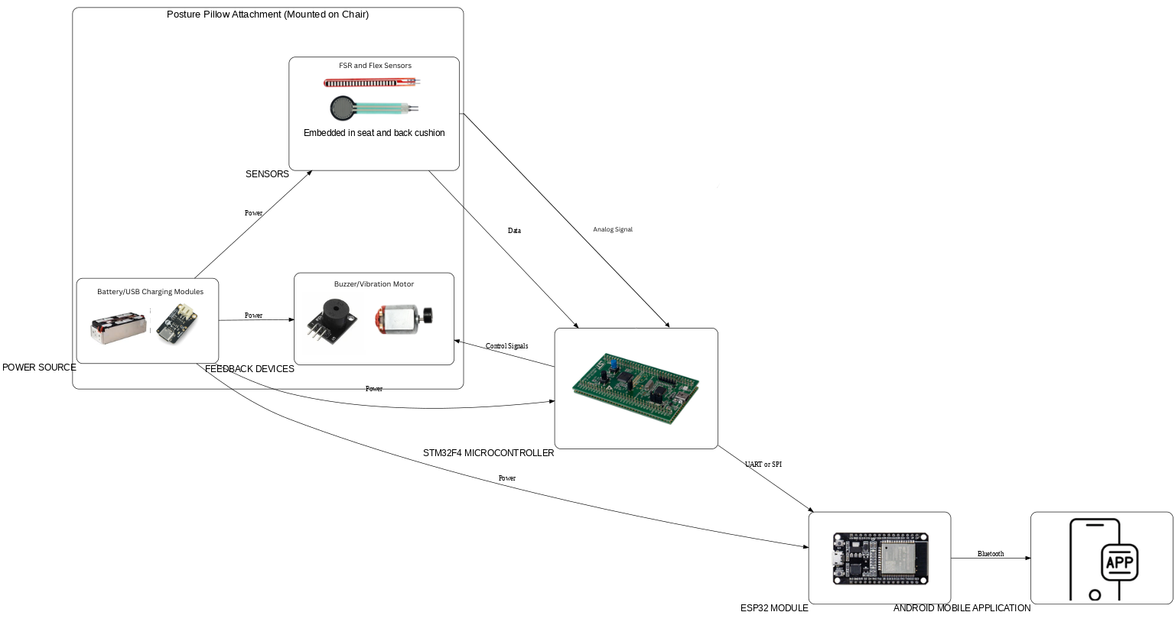

Electrical Diagram
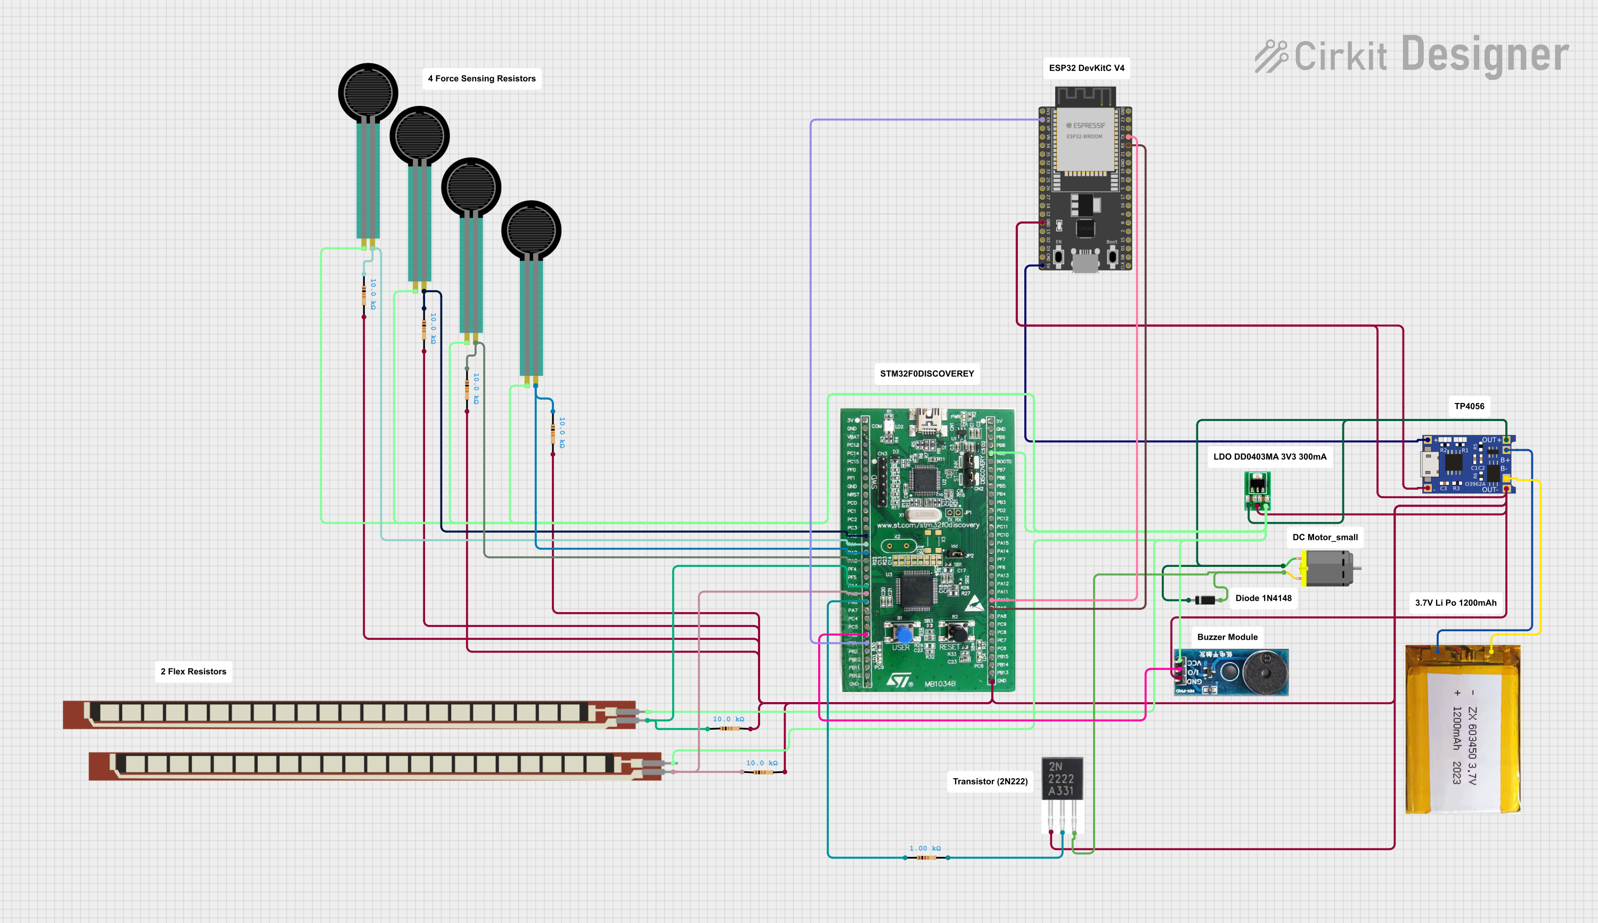

SCH shema
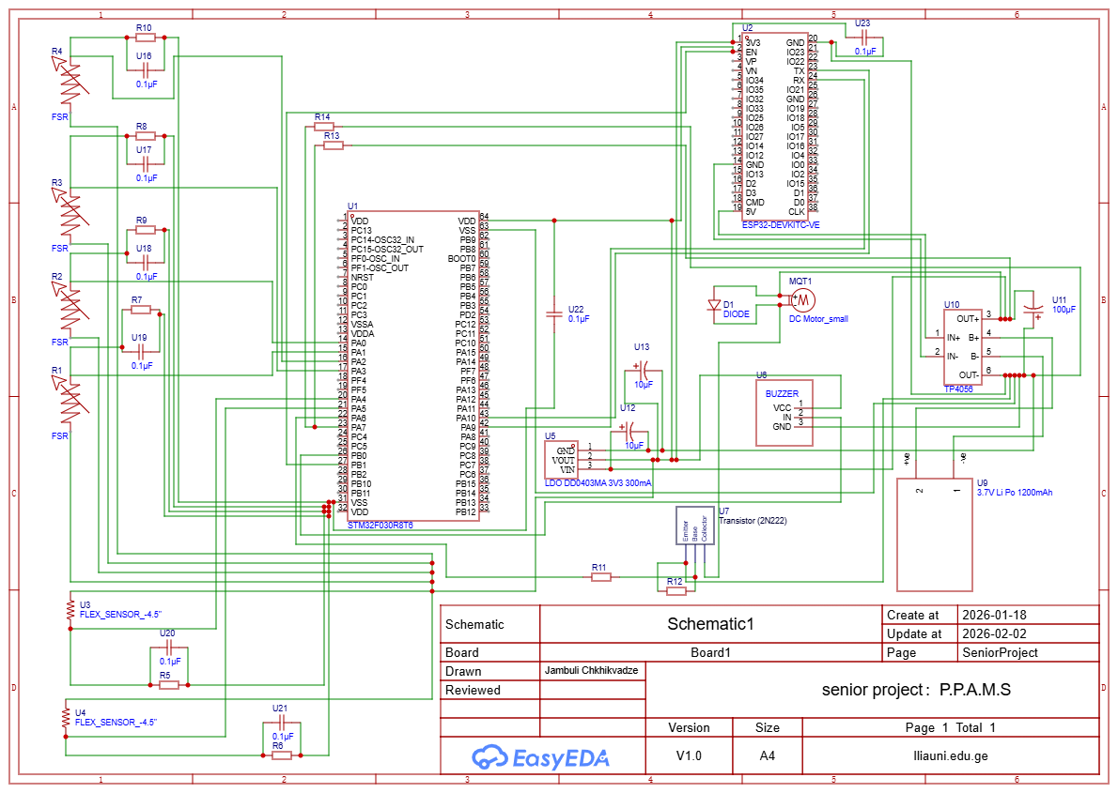
Cable Management
In the P.P.A.M.S system, cable management is meant to be safe, healthy, and durable, while also ensuring total aesthetic appeal. This is achieved through internal cable management of the wires connecting the sensors. The wires are within the interior of the posture pillow, never in direct contact with the user of the chair. The wires are also guaranteed to remain safe from damage through this internal connection. The wires are led through an internal 90-degree cable management point connecting the back part of the chair to the lower part of the chair. The wires are then led straight to the electronics enclosure located at the bottom of the chair. The wires are largely protected against excessive movement through the P.P.A.M.S. The aesthetic appeal of the chair is remarkably enhanced through the absence of exposed wires. Through the cable management mechanisms, the existence of interconnect wires is largely protected. The modular configuration of the posture pillow is remarkably achieved.

Github Reposetory
This chapter provides detailed technical information and supporting materials for the project. All development resources are maintained in a dedicated GitHub repository to support collaboration, version control, and documentation.
The repository contains the project source code, including embedded firmware and application-related components, as well as the original drawing files referenced in the “Drawings” section. All diagrams and design images are organized in a separate folder dedicated to proposal and design assets.
Project documentation will also be included in the repository. This documentation will serve as a user and technical guide, describing system setup, calibration procedures, and maintenance requirements necessary for specialists to configure and support the final product. Additional materials such as selected snippets, charts, and appendixes may be included where they improve technical clarity.
The final project presentation and supplementary resources will be uploaded to the same repository upon project completion.
GitHub Repository:
https://github.com/BigMoon-103/PPAMS

Industry Standards
The Posture Pillow Attachment Monitoring System (P.P.A.M.S) is designed with consideration of relevant industry standards and engineering best practices to ensure safety, interoperability, and technical reliability. Although the system is a consumer wellness device and not a medical product, recognized standards guide the design process and improve system quality.
Wireless communication follows IEEE 802.11 and IEEE 802.15 standards, which define Wi-Fi and Bluetooth technologies used by the ESP32 for device-to-mobile connectivity. Electrical safety and electromagnetic compatibility principles are informed by IEC 62368-1 and IEC 61000 standards, supporting safe low-voltage operation and noise-resistant design.
Printed circuit board layout and fabrication follow IPC-2221 guidelines to ensure proper trace spacing, component placement, and manufacturability. Embedded firmware development on the STM32 platform aligns with ARM CMSIS standards, providing a standardized interface to microcontroller peripherals and improving code portability.
Software structure and system requirements are guided by ISO/IEC/IEEE 29148 principles, while general networking behavior follows relevant RFC standards. These standards collectively ensure that the system is developed in line with modern embedded systems and IoT engineering practices.

Sensor Precision & Resolution
The sensor system converts analog voltage signals into digital values using a 12-bit ADC, allowing small posture-related changes to be measured accurately.
Specifications:
Resolution: 0.8 mV (12-bit ADC with 3.3 V reference)
Accuracy: ±5% after calibration
Range: 0–3.3 V analog input
Key Formula:
ADC Resolution = V ÷ (2¹² − 1) = 3.3 V ÷ 4095 = 0.0008 V

Power System
The power system supplies energy to the device using a lithium-polymer battery and manages charging efficiently to support long operation and fast recharging.
Specifications:
Battery Capacity: 1200 mAh LiPo (4.44 Wh)
Runtime: Greater than 8 hours of continuous monitoring
Charge Time: Less than 2 hours (0–100%)
Key Formula:
Operating Time = Battery Capacity ÷ Average Current
= 1200 mAh ÷ 13.6 mA = 88 hours
Charge Time = (Capacity × 1.15) ÷ (Charger Current − System Load)
= (1200 × 1.15) ÷ (1000 − 13.6) = 1.4 hours + CV phase
CV (Constant Voltage) – the second stage of lithium battery charging where the charger holds a steady voltage while the current gradually decreases.

Wire Management
Low sensor current and short cable lengths prevent signal degradation and ensure reliable data transmission.
Specifications:
Maximum Wire Length: Up to 5 meters, average torso human length – 70cm.
Data Rate: 115,200 baud UART
Update Rate: 10 Hz sensor sampling
Key Formula:
Voltage Drop = Current × Wire Resistance × 2 × Length
= ΔV = 0.00033 A × 0.053 Ω/m × (2 × 0.7 m)
= 0.0000245 V = 24.5 microvolts

System Accuracy and Calibration Performance
Calibration reduces combined system errors, improving posture detection reliability.
Key Formula:
Total system error:
E_total = √(3.0² + 0.04² + 0.01² + 0.5²) = 3.04%
Detection Accuracy = 100% − (Calibration_Error + RSS_Error)
= 100% − (1% + 3.8%) = 95.2%
Verified Performance: 95.2% detection accuracy after calibration

Gant Chart
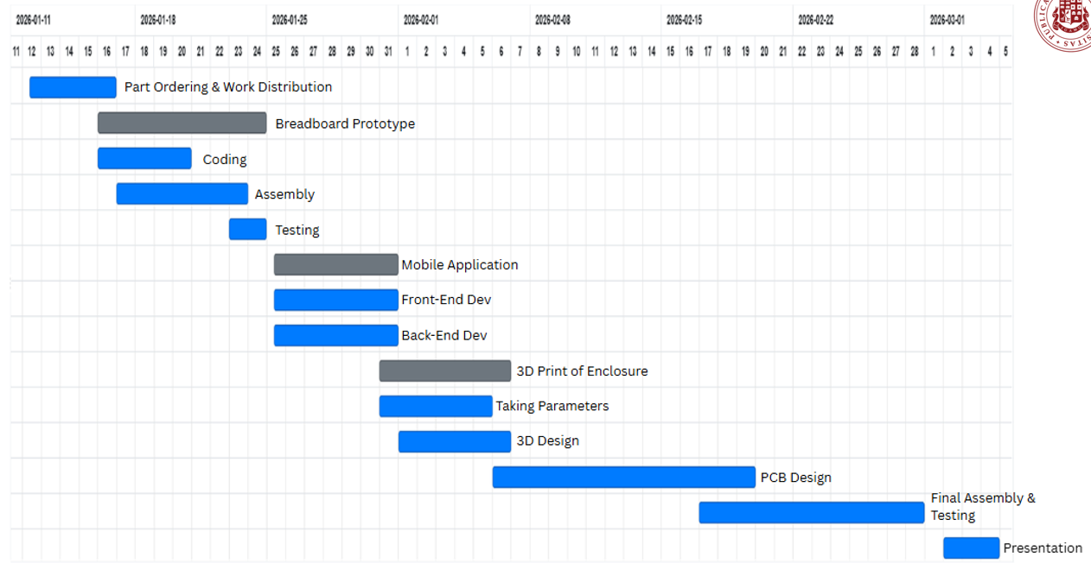

Budget

Category | Component | Quantity | Unit Price | Total Cost | Shop Link | Comment
Microcontrollers | STM32F0 Discovery Board | 1 | USD 21.00 | USD 21.00 | Ebay
 | ESP32 DevKitC V4 | 1 | USD 9.39 | USD 9.39 | Ebay
Power Management | TP4056 Li-ion Charger Module | 1 | USD 1.61 | USD 1.61 | E-bay
 | 3.7V LiPo Battery (1200 mAh) | 1 | GEL 24.17 | GEL 24.17 | Amazon
 | AMS1117-3.3 LDO regulator | 1 | GEL 2.50 | GEL2.50 | https://edisonstore.ge/shop/modules-and-sensors/modules/the-voltage-regulators/ams1117-3-3v/
 | LDO Regulator 3.3V (300 mA) | 1 | USD 2.09 | USD 2.09 | ebay
Sensors | Force Sensing Resistors (FSR) | 4 | USD 30.28 | USD 30.28 | Ebay
 | Flex Sensors | 2 | USD 19.98 | USD 19.98 | Ebay
Actuators & Feedback | Buzzer Module | 1 | USD 2.36 | USD 2.36 | Ebay
 | Vibration Motor (DC) | 1 | USD 3.98 | USD 3.98 | Ebay
Semiconductors | NPN Transistor (2N2222) | 200 | USD 5.99 | USD 5.99 | Amazon
 | Diode 553 1N4007 1000V 1A | 1 | GEL 0.10 | GEL 0.10 | D.A.C
 | Diode (1N4148) | 1 | GEL 0.20 | GEL 0.20 | D.A.C
Resistors | 1 MΩ Resistor | 10 | USD 3.99 | USD 3.99 | Amazon
 | 100 kΩ Resistor | 100 | USD 4.97 | USD 4.97 | Amazon / ebay
 | 10 kΩ Resistor | 10 | USD 3.99 | USD 3.99 | Amazon
 | 1 kΩ Resistor | 10 | GEL 2.00 | GEL 2.00 | D.A.C
 | 100 Ω Resistor | 10 | GEL 2.00 | GEL 2.00 | D.A.C
Capacitors | 100 µF Electrolytic Capacitor | 1 | GEL 0.90 | GEL 0.90 | D.A.C
 | 10 µF Electrolytic Capacitor | 2 | GEL 1.80 | GEL 1.80 | D.A.C
 | 0.1 µF Ceramic Capacitor | 8 | USD 2.56 | USD 2.56 | Sparkfun
Connectors | Taiss 560PCS 2.54mm JST-XH Connector Kit | 1 | USD 9.99 | USD 9.99 | Amazon
— | Total Estimated Cost | — | — | GEL 363.56

References
[1] STM32F4 Discovery Board Datasheet, STMicroelectronics, [Online]. Available: https://www.st.com/resource/en/datasheet/stm32f407vg.pdf.
[2] ESP32-DevKitC V4 Datasheet, Espressif Systems, [Online]. Available: https://docs.espressif.com/projects/esp-dev-kits/en/latest/esp32/esp32-devkitc/user_guide.html
[3] Interlink Electronics, FSR™ Integration Guide, Document 94-00004 Rev B, 2023. [Online].Available: https://akizukidenshi.com/goodsaffix/94-00004_Rev_B%20FSR%20Integration%20Guide.pdf

