Overview and Project scope

Description
The project I am going to be working on is called “AI Home Nutritionist”. The goal of this project is to create a program that will leverage AI to assist health conscious cooking. This program will use an AI model to classify items of food held up to the camera, the user will enter the quantity/weight of that item, and then the program will display on the screen an informed estimate of that food item’s nutritional value. The nutritional value would include the amount of calories, protein, fat, carbohydrates and micro-nutrients(vitamins etc). The neural network will initially be trained on sample data from the internet, but as customers use the product (if this feature is enabled) a feedback loop of images from their food scans will be uploaded to a database to gather more training data to train a more advanced model, for future versions of the software. The data sent back will include the quantity, so that future versions of this software would be able to estimate the quantity too, saving more for the user.
I’ve identified the gap in the market for this product when I have previously tried to track my nutrition, and found that it takes a huge amount of effort to use existing products which require me to check the label, do a calculation for every nutrient in every ingredient, or enter a list of ingredients into an app, (at a time when I’m already using both my hands to cook). It would be much easier to just set up the application on the laptop on the side, then just hold each item up to the camera, and let it classify the food item, and display info about its nutritional value. The program will also output a sum, for the whole meal.

Target users
The intended target users would be anyone who is passionate about both cooking and health. The ease of use relative to traditional calorie counting will make the product most suitable for people who often try new recipes. Anyone who frequently cooks the same dish routinely will likely not benefit from the product because they could calculate the nutrition of a meal manually once, and never need to do so again. People who have a more varied diet/routine will need an efficient way to track the nutrition of a new recipe.

Cost breakdown
???

Monetization
This product would be best monetized through a multi-tier, subscription model. Each tier should have a number of usages per month. Each usage would allow an individual to scan an ingredient, which would have the nutritional value output to the screen, and added to the total being calculated for the meal.
The free tier might allow 10 scans a month, (assuming 10 ingredients per meal). This offering would not be profitable alone, but would provide users a way to experience the product, and decide its useful for them before they commit to a paid tier.
There should be a lower tier, for infrequent users, who might use it for approximately two meals a week when trying new recipes, they would get about 80 usages a month. I expect the majority of the users would be on this tier, paying monthly.
There should also be a higher tier, with unlimited usages per month. This is for anyone using it for all meals, or cooking for multiple people.

Software Architecture and Design

User stories
Note: User stories and requirements with a * are not part of MVP1, but would likely be included in MVP2, after additional training data will facilitate training a better model, which will also support measuring the quantities of portions. These are considered aspirational and this document is primarily focused on MVP1.
Number | User Stories
1. | As a health-conscious user, I want to scan food items quickly, by holding them in front of the device so that I can record what I’m eating effortlessly.
2. | As a health-conscious user, I want to be able to manually enter a food item, so if the program occasionally misidentifies an item, I can correct that error.
3. * | As a mildly health-conscious user, I want to see an approximate estimate of the quantity of each ingredient, so I can save time instead of weighing every item I cook.
4. | As a health-conscious user, I want to be able to manually correct the quantity of an ingredient, so I can precisely calculate the nutrition of each meal
5. | As a health-conscious user, I want to see estimates of micro and macro-nutrients of food items so I can adjust my diet according to my health goals
6. | As a user, I want to see the total nutritional value of a meal’s ingredients summed up on the screen, so I can save time instead of doing the calculations myself.
7. * | As a product-owner/engineer I want to have training data sent back to a database, to continuously gain training data, to improve the machine learning aspects of my product.

Requirements
Functional Requirements
Number | Category | Description
1. | User Input and camera | The system should access the camera and continuously capture images.
2. |  | The system should display the camera feed on the UI.
3. |  | The user have the option to provide input, to correct any wrong classifications (of type or quantity).
4. | Food recognition | The system should run the image classification model locally, to identify the type of food being scanned.
5. |  | * The model should estimate the portion size in grams.
6. | Nutritional value calculation | The system should call an API to retrieve the per-unit nutritional value, and should display this information on the UI when a food item is identified.
7. |  | The portion weight should be multiplied by the per unit values for each food, to determine the nutritional value of the portion.
8. | Recognition Model feedback loop | In the settings there should be an option to disable the model feedback loop if the user wishes to do so.
9. |  | When a user scans a food item, a call should be made to an API, which includes an image of the food, the quantity and the category (if either of these are overridden by the user then that value should be used).
10. |  | An API should listen for requests to send feedback data. When a feedback data request is sent, it should be validated that the image is not corrupt, the application-to-application authentication is valid, and the image should be stored in a scaleable database.
11. |  | Iteratively, new models should be trained to recognize classes (* and quantities) of food, using this new data.
12. | Software updates and deployments | The system should make a request once to an API every time it is turned on, to check if an update to the model is available. If it is, it should make a request to download it.
13. |  | An API should be provided to answer the update checks/requests and should be able to serve the .h5 file of a new model when it is released.
14. |  | The application should be able to validate a new model has not been corrupted, then install it.

Non-functional Requirements

Number | Category | Description
1. | Accuracy | The model should classify the food item with at least 90% accuracy
2. |  | * The weight estimates should always be within 10% of the actual weight of the item.
3. | Usability | The UI should be intuitive, and easy to use. Anyone should be able to figure out how to use the software, without needing any instructions or training.
4. | Scalability | The database should scale automatically without any downtime.
5. |  | The deployment system should scale proportionally with the number of weekly users, so that when new updates are released, performance remains consistent.
6. | Privacy/Security | Feedback data should only be sent to the back-end if the user has authorized this.
7. |  | Feedback data should be anonymised, and encrypted during transmission.
** maybe add something about portability

Model Architecture
I am going to use a Convolutional Neural Network to identify the food items. The neural network that I use will have two parts. There will be a pre-trained base, which will extract visual features from the input image. Visual features can include colour, shape, texture etc. I’ll attach a Dense Head to the base, which will use the extracted features to classify the food item. I will design and train the head part of the CNN from scratch, and fix the weights of the base.
Because I have prior experience using it, I’ll use VGG16 as the per-trained base. VGG16 is for general purpose feature extraction, and is easy to use. It works with input images with the dimensions 224 * 224 and 3 colour channels.
I’ll be using fully connected dense layers in the head, so I’ll need to flattern the output of VGG with a ‘flattern’ layer. Image recognition models can be very effective, even with just a few layers in the head, so I’m going to use 2 Dense layers. The first will have 512 neurons, and the second will have 256. To avoid over-fitting, I’ll have a dropout layer after each of these.
Finally, because I’m trying to use this model to predict which of a set of classes is being detected, I’ll use a softmax output layer.
Here’s a diagram I made by defining those layers with the Keras library, and then plotting the model.
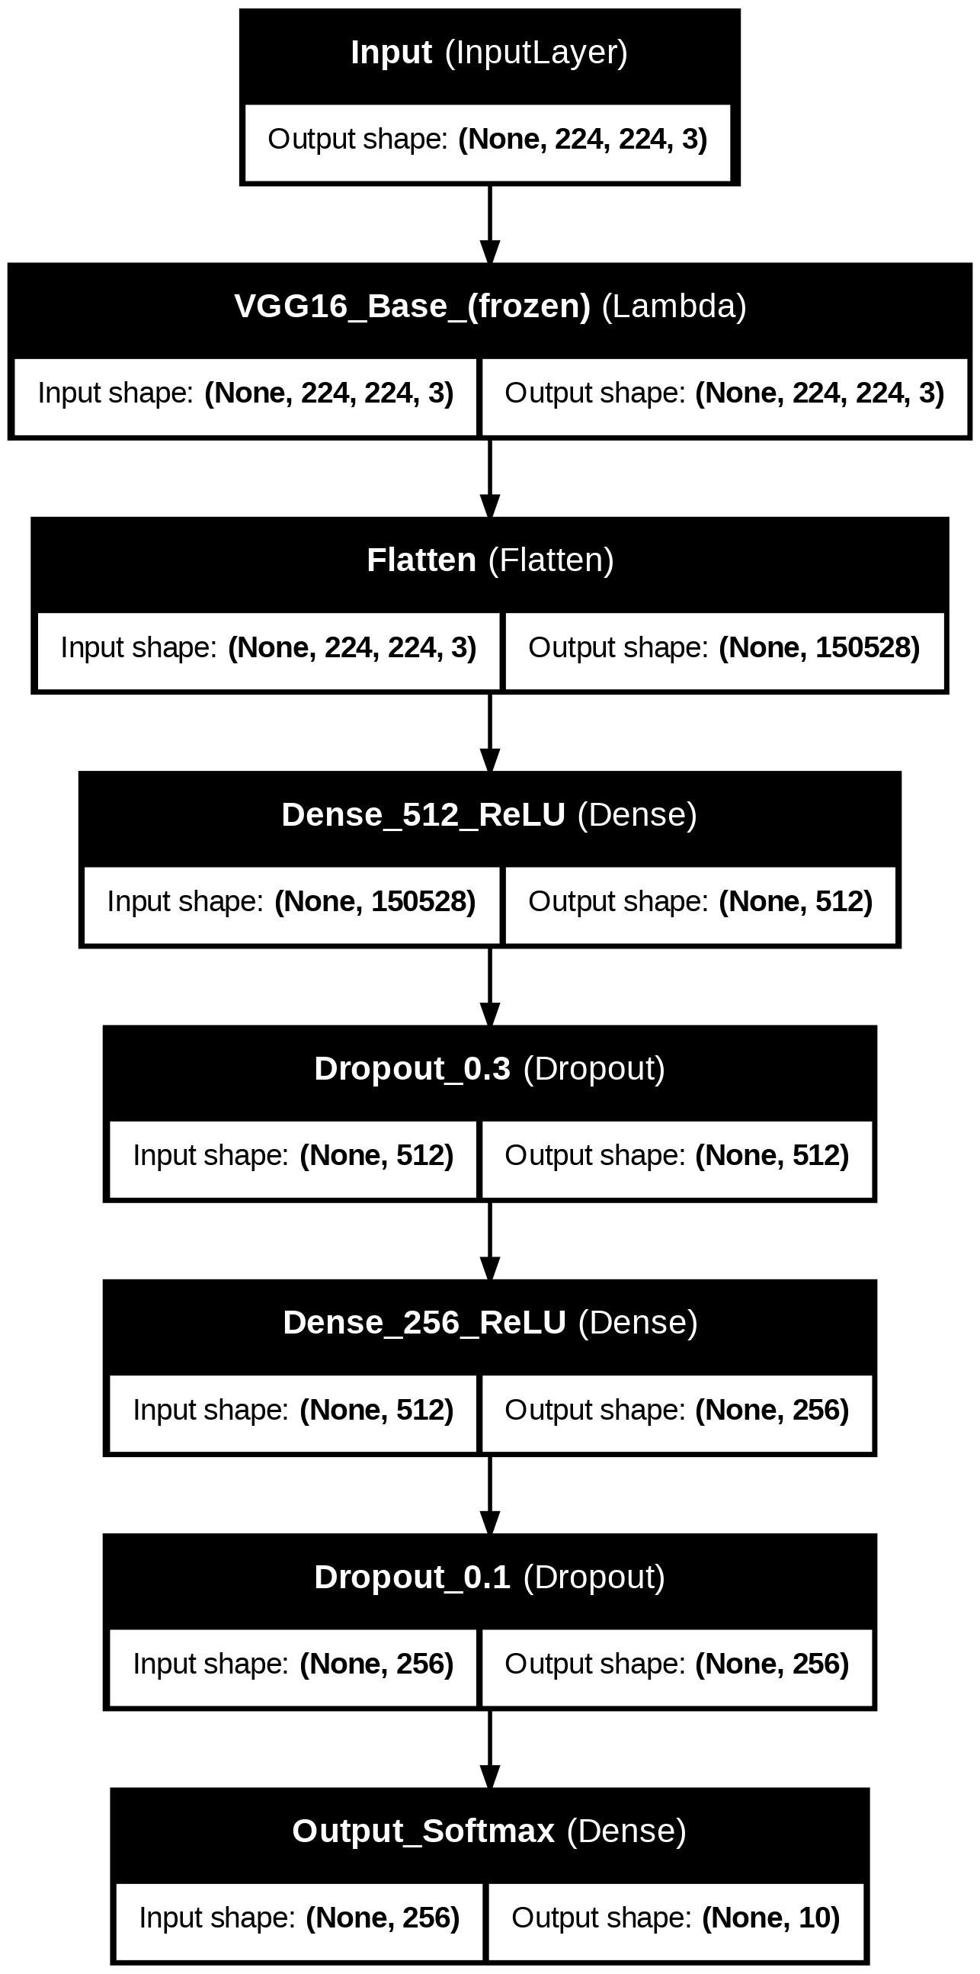

Data Flow Diagram
Here’s a data-flow diagram. I made to represent how the model will fit into the application. I’ve represented the user twice, to clearly separate their interactions with the model for inputs and outputs.

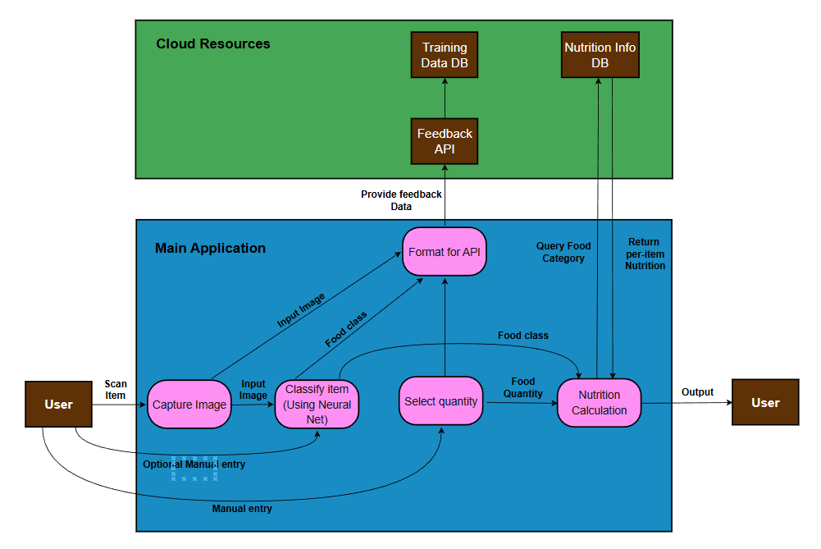

User interface
The application will have a simple user interface, with just one screen. There will be four tabs visible to the user at one time:
1. The camera live feed, so that the user can see where its pointing, and know when the item they are holding up is in frame
2. Nutritional Info. There should be two halves. The first section will display the values for the currently selected item. Eg, a user might scan 200g beef in front of the screen, see these values and choose to increase the quantity to 300g. The second half should display the values for the meal total. This also should include macro and micro nutrients.
3. The food identification tab should display what food item class the program currently has identified in front of the camera. There should be a ‘Select’ the user can tap to confirm the choice is correct. Below it there should be a similar (optional) manual identification form. This will let the user type in the food item, if it hasn’t been correctly identified.
4. Finally there should be a quantity estimate tab. This will similarly have an AI estimate, and optional manual override (Note: This will not be included in the proof of concept, but would be in the final product).
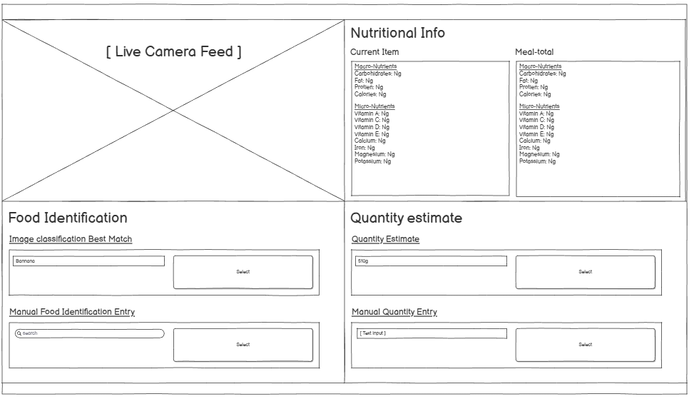

Development Methodology
I am going to use agile to develop this project. I’m going to track all of the work to do in Jira and break the work down into 2 week sprints.

Development, and machine learning

Obtaining a dataset for training
The first step is the obtain training data to train and fine tune the model on. This work is tracked in a Jira.
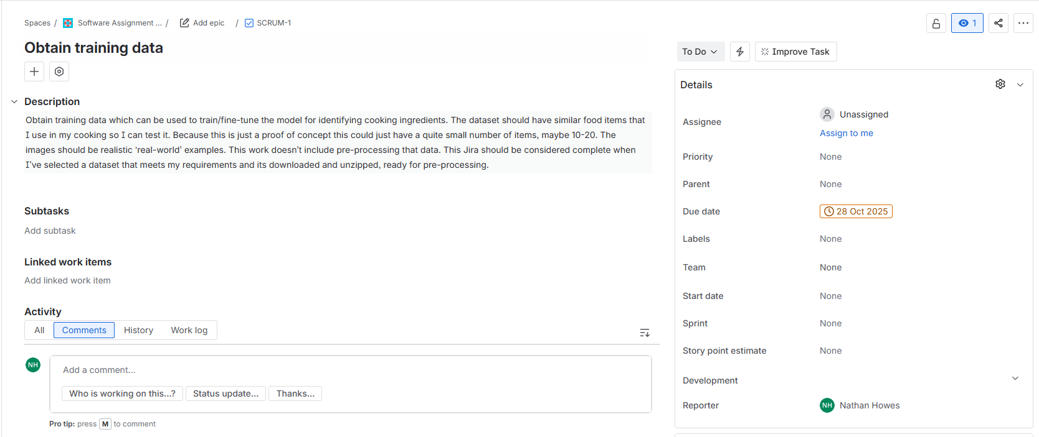
I selected the food-11 image dataset from Kaggle. Its suitable for this task because it has 11 food items, and a total of 16,643 images. It has the CC0 1.0 Universal dedication, meaning there are not legal restrictions on how I can use this data, it is shared without any copyright restrictions etc.
The data in this dataset is already divided into three categories: training, validation and evaluation.

Pre-processing the dataset
Before starting to train the model, I will need to pre-process the data. Here is the jira for that work.
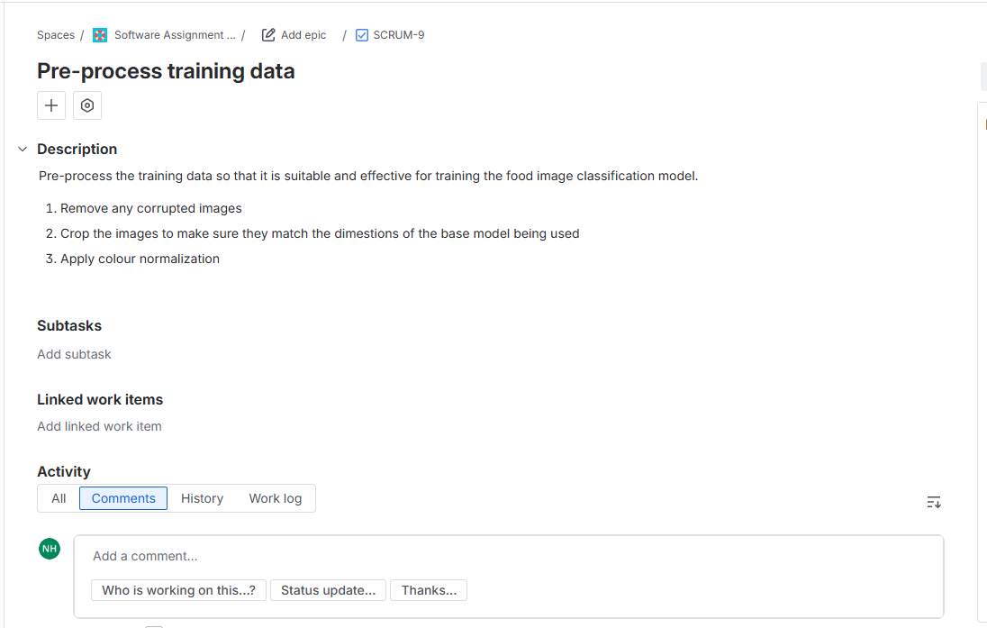
I created a notebook for pre-processing my data. The first few cells are for checking that all of the images in my dataset can be opened, and are not corrupted. If any images are corrupted then they are deleted.
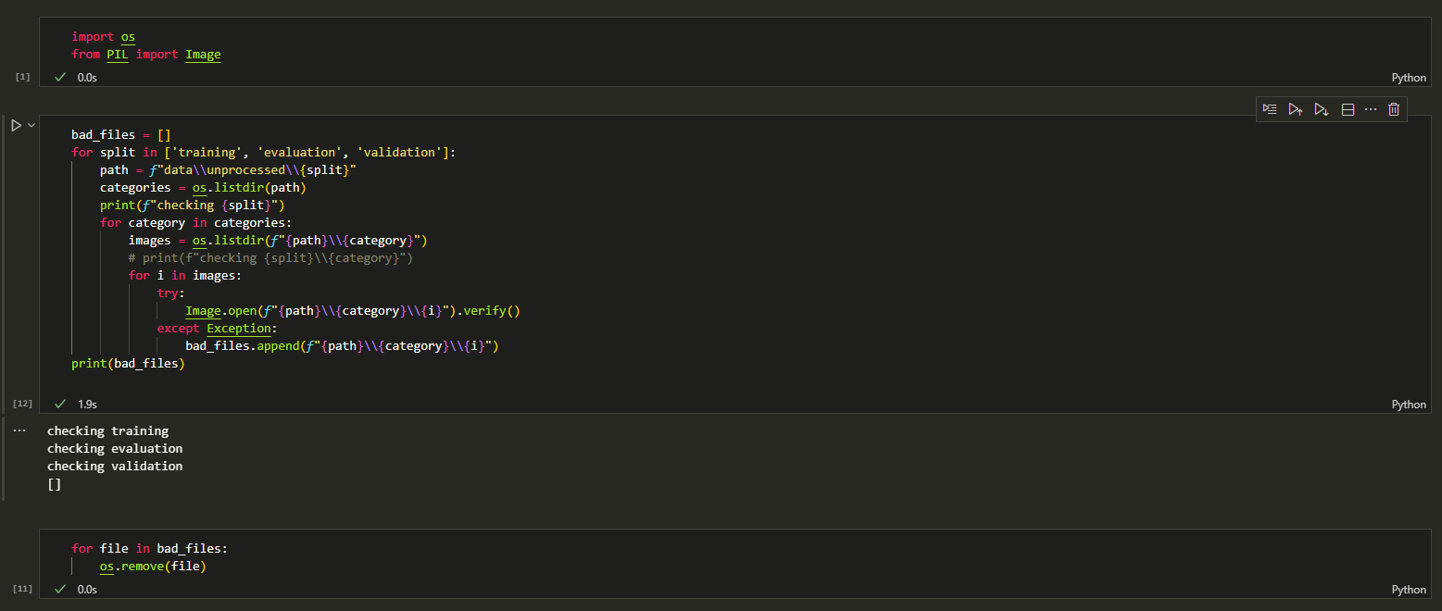
Now that I’ve validated my data, the next step is to re-size it. I’m going to be using a pre-trained base for this, likely VGG16, so I’ll need to make sure the input size is 224 * 224. The first step is the make the images square. I did this by adding some padding with the following cell.
