Scheme Interpreter(PPCA 2014)

张曦虎

2014.8.11

**目录：**

1. **简介：**
2. **当前API可支持的特性(v.1.0.0)：**
   1. Syntax
   2. Data type
   3. Procedure
3. **对于API改进的想法(v.2.0.0)：**
4. **感受**
5. **致谢**

**1.简介：**

本工程是按照Scheme的R5RS标准（部分功能与R5RS标准有所差别），使用C++语言实现的一个Scheme解释器。目前只添加了部分功能。利用当前的API接口完善解释器后可以实现大部分Scheme的功能。工程已在Visual Studio 2010 C++环境下成功编译。由于使用了C++11的部分特性，需要使用支持C++11的编译器进行编译生成。

编译环境：

请保证至少128MB的堆空间和栈空间。

在Visual Studio中设置堆保留空间和栈保留空间为33554432

或加入： /HEAP:"33554432" /STACK:"33554432"

在VS2010下请使用Release模式，如使用其它方式编译，请尽可能的打开优化。

代码内部调试部分：

Debugger\debugger.h： 启用#define __DEBUG_MODE_ON_

可以在大部分函数中启用类型或边界检查。

Parser\parser.cpp： 启用#define __PARSER_DEBUGGER_

可在屏幕上输出解释器的执行步骤。

运行：

请确保library.scm与Scheme_Interpreter在同一个目录下。

文件的输出存放在SchemeInterpreter.log内部。

Usage: Scheme_Interpreter <filename>.

**2.当前API已支持（可支持）特性：**

**注：support**指程序中已可以支持，

**can be supported**表示该特性在当前API环境下可以作为补丁加入程序。

**Unsupported**表示该特性需要改变底层API才能得到支持。

**与R5RS有差别的功能已用violation标出。**

**a）R5RS Syntax**

·R5RS Section 4.1.1 Variable references:

* <variable> <syntax support>

·R5RS Section 4.1.2 Literal expressions:

* (quote <datum>) <syntax support>
* ‘<datum> <syntax support>
* <constant> <syntax support>

·R5RS Section 4.1.3 Procedure calls:

* (<operator> <operands>…) <syntax support>

R5RS claims that the evaluation of operator and operands are in an unspecified consistent order. In this implementation, the evaluation order is always from left to right.(due to the side effect.)

·R5RS Section 4.1.4 Procedures

* (lambda <formals> <body>) <syntax support>

·R5RS Section 4.1.5 If-predicates

* (if <test> <consequent> <alternate>) <syntax support>
* (if <test><consequent>) <syntax support>

·R5RS Section 4.1.6 Assignment

* (set! <variable> <expression>)

R5RS claims that the result of the set! expression is unspecified. In this implementation, the return value is an object of void type.

Buildin-procedures can be assigned, but buildin-syntax cannot be overlapped.

·R5RS Section 4.2.1 Conditionals

* (cond <clause>…) <syntax support>

R5RS requires “cond” to have at least one clause. In this implementation, no clause “cond” is allowed and it will return an object of void type. If no clause’s test evaluate to true value, “cond” will return an object of void type.

R5RS claims that “cond” is a library syntax. In this implementation, “cond” is a syntax due to “define-syntax” is not implemented.

* (case <clause>…) <unsupported>
* (and <test>…) <procedure **violation** can be fixed>

In R5RS, “and” is a library syntax, but in this implementation, “and” is a primitive procedure and it will evaluate all the test without interruption.(Due to “lazy evaluation” is not implemented, as well as “promise”)

* (or <test>…) <procedure **violation** can be fixed>

In R5RS, “or” is a library syntax, but in this implementation, “or” is a primitive procedure and it will evaluate all the test without interruption.(Due to “lazy evaluation” is not implemented, as well as “promise”)

·R5RS Section 4.2.2 Binding Constructs

* (let <bindings> <body>) <syntax support>

In R5RS, “let” is a library syntax, but in this implementation, “let” is a syntax due to “define-syntax” is unsupported.

R5RS claims that the evaluations of <init>s is in unspecified order. In this implementation, the order is always from left to right.

* (let* <bindings> <body>) <syntax support>

In R5RS, “let*” is a library syntax, but in this implementation, “let*” is a syntax due to “define-syntax” is unsupported.

* (letrec <bindings> <body>) <syntax **violation**>

In R5RS, “letrec” is a library syntax, but in this implementation, “let*” is a syntax due to “define-syntax” is unsupported.

R5RS claims that each binding of a <variable> has the entire “letrec” expression as its region. In this implementation, “letrec” acts like “let” but it will change the lambda expression’s scope to the “letrec” region.(without any checking)

·R5RS Section 4.2.3 Sequencing

* (begin <expression>…) <syntax support>

R5RS requires “begin” followed by at least one expression. In this implementation, no expression following “begin” is allowed and it will return an object of void type instead.

·R5RS Section 4.2.4 Iteration

* (do ((<variable> <init> <step>)…)

(<test> <expression> …) <command> …)

<library syntax unsupported>

·R5RS Section 4.2.5 Delayed evaluation

* (delay <expression> …) <library syntax unsupported>

·R5RS Section 4.2.6 Quasiquotation

* (quasiquote <qq template>) <syntax can be supported>
* `<qq template> <syntax can be supported>

·R5RS Section 4.3 Macros

Unsupported.

·R5RS Section 5.2 Definition

* (define <variable> <expression>) <syntax support>
* (define (<variable> <formals>) <body>) <syntax support>
* (define(<variable> . <formals>) <body>) <syntax support>

R5RS requires definitions to appear at the top level or at the beginning of a <body>. This restriction is removed in this implementation. R5RS did not specify the return value, which is an object of void in this implementation.

**b）Data Types**

·Number

* Complex <partially support>

Some inexact complex number cannot be recognized. Such as “.23+.23i”,due to some inexact real number cannot be recognized.

* Real <partially support>

Some inexact real number cannot be recognized, such as “.23”.

* Rational <support>
* Integer <support>

·Booleans <support>

·Pairs and lists <support>

·Symbols <support>

·Characters <support>

·Strings <support>

·Promises <unsupported>

·Procedures <support>

·Void(Unspecified Value) <support>

·Environment <partially support>

**c）Procedures**

·R5RS Section 6.1 Equivalence predicates

* (eqv? obj1 obj2) <procedure support>
* (eq? obj1 obj2) <procedure support>

In this implementation, “eq?” function is the same as “eqv?”

* (equal? obj1 obj2) <library procedure support>

·R5RS Section 6.2.5 Numerical operation

* (number? obj) <procedure support>
* (complex? obj) <procedure support>

In this implementation, “complex?” is the same as “number?”.

* (real? obj) <procedure support>
* (integer? obj) <procedure support>
* (exact? obj) <procedure support>
* (inexact? obj) <procedure support>
* (= z1 z2 z3…) <procedure support>
* (< x1 x2 x3…) <procedure support>
* (> x1 x2 x3…) <procedure support>
* (<= x1 x2 x3…) <procedure support>
* (>= x1 x2 x3…) <procedure support>
* (zero? x) <library procedure support>
* (positive? x) <library procedure support>
* (negative? x) <library procedure support>
* (odd? x) <library procedure support>
* (even? x) <library procedure support>
* (max x1 x2…) <library procedure can be supported>
* (min x1 x2…) <library procedure can be supported>
* (+ z1…) <procedure support>
* (* z1…) <procedure support>
* (- z1…) <procedure support>
* (/ z1…) <procedure support>
* (abs x) <library procedure support>
* (quotient n1 n2) <procedure support>
* (remainder n1 n2) <procedure support>
* (modulo n1 n2) <procedure support>
* (gcd n1…) <library procedure can be supported>
* (lcm n1…) <library procedure can be supported>
* (numerator q) <procedure can be supported>
* (denominator q) <procedure can be supported>
* (floor x) <procedure can be supported>
* (ceiling x) <procedure can be supported>
* (truncate x) <procedure can be supported>
* (round x) <procedure can be supported>
* (exp z) <procedure can be supported>
* (log z) <procedure can be supported>
* (sin z) <procedure can be supported>
* (cos z) <procedure can be supported>
* (tan z) <procedure can be supported>
* (asin z) <procedure can be supported>
* (acos z) <procedure can be supported>
* (atan z) <procedure can be supported>
* (atan y x) <procedure can be supported>
* (sqrt z) <procedure support>
* (expt z1 z2) <procedure can be supported>
* (make-rectangular x1 x2) <procedure can be supported>
* (make-polar x3 x4) <procedure can be supported>
* (real-part z) <procedure can be supported>
* (imag-part z) <procedure can be supported>
* (magnitude z) <procedure can be supported>
* (angle z) <procedure can be supported>
* (exact->inexact z) <procedure can be supported>
* (inexact->exact) <procedure can be supported>

·R5RS Section 6.2.6 Numercial input and output

* (number->string z) <procedure can be supported>
* (number->string z radix) <procedure can be supported>
* (string->number string) <procedure can be supported>
* (string->number string radix) <procedure can be supported>

·R5RS Section 6.3.1 Booleans

* (not obj) <library procedure support>
* (boolean? obj) <library procedure support>

·R5RS Section 6.3.2 Pairs and lists

* (pair? obj) <procedure support>
* (cons obj1 obj2) <procedure support>
* (car pair) <procedure support>
* (cdr pair) <procedure support>
* (set-car! pair) <procedure support>
* (set-cdr! pair) <procedure support>
* (caar pair) <library procedure support>
* (cadr pair) <library procedure support>

...

* (cdddar pair) <library procedure support>
* (cddddr pair) <library procedure support>
* (null? obj) <library procedure support>
* (list? obj) <library procedure support>
* (list obj…) <library procedure support>
* (length list) <library procedure support>
* (append list…) <library procedure support>
* (reverse list) <library procedure support>
* (list-tail list k) <library procedure support>
* (list-ref list k) <library procedure support>
* (memq obj list) <library procedure support>
* (memv obj list) <library procedure support>
* (member obj list) <library procedure support>
* (assq obj alist) <library procedure support>
* (assv obj alist) <library procedure support>
* (assoc obj alist) <library procedure support>

·R5RS Section 6.3.3 Symbols

* (symbol? obj) <procedure support>
* (symbol->string symbol) <procedure can be supported>
* (string->symbol string) <procedure can be supported>

·R5RS Section 6.3.4 Characters

* (char? obj) <procedure can be supported>
* (char=? char1 char2) <procedure can be supported>
* (char<? char1 char2) <procedure can be supported>
* (char>? char1 char2) <procedure can be supported>
* (char<=? char1 char2) <procedure can be supported>
* (char>=? char1 char2) <procedure can be supported>
* (char-ci=? char1 char2) <library procedure can be supported>
* (char-ci<? char1 char2) <library procedure can be supported>
* (char-ci>? char1 char2) <library procedure can be supported>
* (char-ci<=? char1 char2) <library procedure can be supported>
* (char-ci>=? char1 char2) <library procedure can be supported>
* (char-alphabetic? char) <library procedure can be supported>
* (char-numeric? char) <library procedure can be supported>
* (char-whitespace? char) <library procedure can be supported>
* (char-upper-case? letter) <library procedure can be supported>
* (char-lower-case? letter) <library procedure can be supported>
* (char->integer char) <procedure can be supported>
* (integer->char n) <procedure can be supported>
* (char-upcase char) <library procedure can be supported>
* (char-downcase char) <library procedure can be supported>

·R5RS Section 6.3.5 Strings

* (string? obj) <procedure can be supported>
* (make-string k) <procedure can be supported>
* (make-string k char) <procedure can be supported>
* (string char…) <library procedure can be supported>
* (string-length string) <procedure can be supported>
* (string-ref string k) <procedure can be supported>
* (string-set! string k char) <procedure can be supported>
* (string=? string1 string2) <library procedure can be supported>
* (string-ci=? string1 string2) <library procedure can be supported>
* (string<? string1 string2) <library procedure can be supported>
* (string>? string1 string2) <library procedure can be supported>
* (string<=? string1 string2) <library procedure can be supported>
* (string>=? string1 string2) <library procedure can be supported>
* (string-ci<? string1 string2) <library procedure can be supported>
* (string-ci>? string1 string2) <library procedure can be supported>
* (string-ci<=? string1 string2) <library procedure can be supported>
* (string-ci>=? string1 string2) <library procedure can be supported>
* (substring string start end) <library procedure can be supported>
* (string-append string…) <library procedure can be supported>
* (string->list string) <library procedure can be supported>
* (list->string list) <library procedure can be supported>
* (string-copy string) <library procedure can be supported>
* (string-fill! string char) <library procedure can be supported>

·R5RS Section 6.3.6 Vectors <unsupported>

·R5RS Section 6.4 Control features

* (procedure? obj) <procedure can be supported>
* (apply proc arg1 …) <procedure support>
* (map proc list1…) <library procedure support>
* (for-each proc list1…) <library procedure can be supported>
* (force promise) <library procedure unsupported>
* (call-with-current-continuation proc) <procedure unsupported>
* (values obj…) <procedure unsupported>
* (call-with-values producer consumer) <procedure unsupported>
* (dynamic-wind before thunk after) <procedure unsupported>

·R5RS Section 6.5 Eval <can be supported>

·R5RS Section 6.6.1 Ports <unsupported>

·R5RS Section 6.6.2 Input <unsupported>

·R5RS Section 6.6.3 Output

* (display obj) <library procedure support>
* (newline) <library procedure support>
* (write obj) <library procedure unsupported>
* (write obj port) <library procedure unsupported>
* (display obj port) <library procedure unsupported>
* (newline port) <library procedure unsupported>
* (write-char char) <library procedure unsupported>
* (write-char char port) <library procedure unsupported>
* (load filename) <optional procedure unsupported>
* (transcript-on filename) <optional procedure unsupported>
* (transcript-off) <optional procedure unsupported>

**3.对于API改进的想法(v.2.0.0)：**

**关于tail recursion:**

由于底层API的Eval实现方式为递归调用函数。一直在申请栈空间，所以没有办法保证能够很好地控制递归。如果要实现tail recursion,需要将eval中的调用部分改写为手动栈实现，便于调试和实现新的功能。

**关于底层实现改进：**

再次阅读了下R5RS和MIT-Scheme Reference后，对于syntax rule有一些粗略的想法。

考虑底层实现的Eval和Apply：

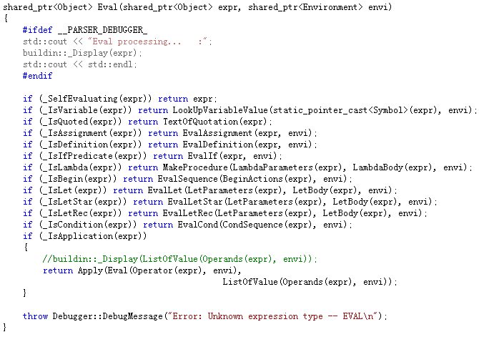

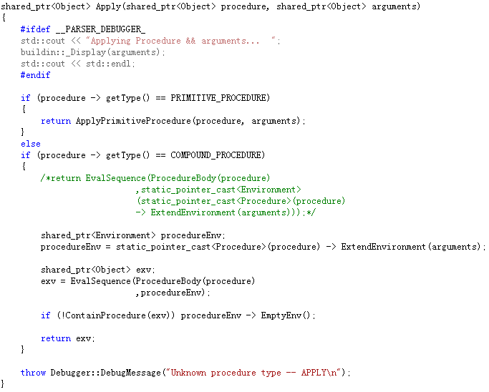

这是以《计算机程序的构造和解释》上的模版为基础写出来的Eval基础程序，但是我认为可以继续简化。

需要保留的是SelfEvaluating和Variable。SelfEvaluating的结果是自身，所以不需要进一步Eval，存储于变量中的结果是已经经过Eval处理的结果，所以不需要Eval。

而从“_IsQuoted”至“_IsCondition”之间的所有语句整合到Apply当中。然后作特殊的SyntaxApply即可。

Apply则改写为：如果查到的所谓的“operator”为syntax，则执行对应的syntax-rule（保留所有operands引用，“引用”也意味着这个值可以被修改。对于该引用暂不进行eval，当需要Eval的时候再进行Eval，当需要作赋值的时候再作赋值），如果operator为procedure则对其operands执行eval后再作传参（应用序）。最后将syntax归入当前environment。

高度整合后的Scheme期望下只有三个部分：List、Syntax、Procedure。

**4．感受：**

写Scheme解释器之前感觉解释器这个工程难度非常高。

而且最开始对Scheme的语法理解也仅仅是达到了语法树的部分。

对于Scheme的car和cdr所产生的list一开始也不是很了解，而在编写过程中才发现左儿子右兄弟这个性质就隐含在car和cdr中。Environment这个看上去有点复杂的东西本质上居然也是list。（理论上可以用list实现，但速度太慢了。）

将函数看成对象，任何复合函数都可以化为一元函数的形式。造就了使用list结构就可以进行eval的杰作。

程序即数据，数据即程序。完成这个解释器的编写也算是加深了对冯诺依曼体系的理解吧。（程序和数据以二进制代码形式不加区别地存放在存储器中，存放位置由地址决定。）

**（接下来是瞎扯，有些东西都是凭自己的理解写的，不一定对，还望指出。不胜感激。）**

首先要说的是lambda这个东西：

有个东西叫currying，中文译名“柯里化”而不是“咖喱化”。有个东西叫泛函分析，函数是对象，函数映射到函数。（或者干脆说有个东西叫公理化集合论得了）

当函数成了对象，当函数可以只由带一个参数的函数复合而成，什么都解决了。

一个猜想（毕竟没仔细读R5RS，所以只是自己的理解，不是R5RS所作要求）：

函数表达式的标志是**lambda**，而在它手下定义的东西是基于**应用序**的**procedure**.

符号保留字的标志是**syntax-rule**，定义的东西是基于**正则序（类似正则序，更准确的说是带入一种引用）**的**syntax**.

突然觉得这两个保留字都可以用一套体系来执行了。

甚至我们可以支持一种新的通用definition，它可以指定operands中哪些部分作严格求值，哪些部分作非严格求值（带引用）。从而囊括procedure和syntax两个部分的方法。在此基础上可以实现Macro。

**5．致谢：**

感谢赵卓越学长在Scheme的特性和解释器的实现以及与解释器相关的各个知识上的耐心指导。

感谢周耀达同学在Scheme与C++11特性的讨论中给予的点拨。

**参考文献：**

*[1] R. Kelsey, W. Clinger, J. Rees (eds.), Revised5 Report on the Algorithmic Language Scheme,*

*Higher-Order and Symbolic Computation, Vol. 11, No. 1, August, 1998.*

*[2]Harold Abelson, Gerald Jay Sussman, Julie Sussman, Structure and Interpretation of Computer Programs, Second Edition.*

*[3]MIT Scheme Reference: http://www.cse.iitb.ac.in/~as/mit-scheme/scheme.html*