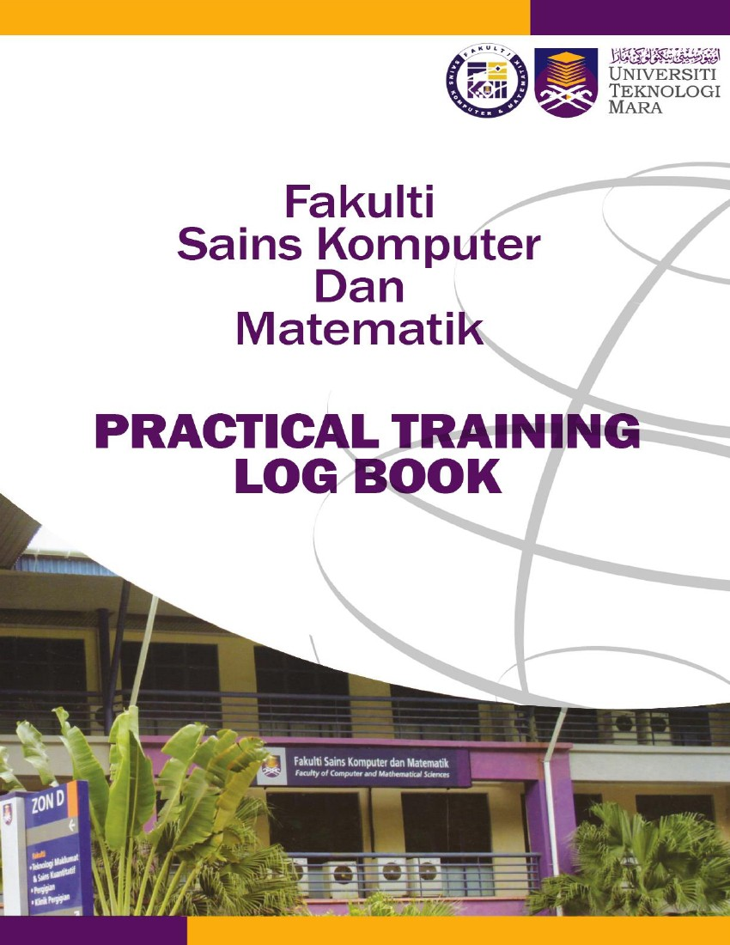



Instructions
This logbook is for you to provide a history of your industrial training and to act as a daily and/or weekly record by the work on which you are engaged.
Student’s responsibilities for keeping logbook up-to-date
Once you start your industrial training, you should consistently consult with your supervisor at the organization or supervisor-in-charge.
It is your responsibility to make the main entries of the logbook and keep it up to date. Entries
must be regularly (weekly) initialled by your Supervisor. You must ensure that:

1. Student’s name: Nur Syazwani Binti Samsawi
1. It is available at your place of work during your industrial training.
2. All entries, except sketches, are made in ink, either handwritten or typed.
3. Entries are made within a week of the work to which they refer.
4. The logbook is handed to your Academic Supervisor upon his/her visit and submitted later be
handed to the Coordinator of Industrial Training when you return to UiTM for grading.
5. The logbook contributes 10% towards your final assessment.
Recording
The log book should contain the following information.
1. A neat concise description of each of your training location and the work on which you are
engaged.
2. Relevant sketches, data, flowcharts and diagrams.
3. References to textbooks, standards and other technical information related to the work
being under taken.
4. Constructive comments on the work being undertaken and your considered opinion as to
its value as training.
5. The logbook is to be written in ENGLISH.
2. UiTM Student No: 2022876358
3. Programme Course: Bachelor’s in computer science (Hons.) Multimedia Computing

4. Address during Industrial Training: Menara LGB, Level 7 Jalan Wan Kadir, Taman Tun Dr Ismail, 60000 Kuala Lumpur
5. Name of Organization: Deloitte Malaysia
6. Address of Organization: Menara LGB, Jalan Wan Kadir, Taman Tun Dr Ismail, 60000 Kuala Lumpur

7. Name of Supervisor in-charge: Goh Yuen Fei
8. Name of Academic Supervisor: Dr. Norizan Binti Mat Diah
9. Duration of training:
From: 23/9/2024 to 3/1/2025
FOR OFFICE USE ONLY
10. Remarks: (Coordinator of Industrial Training)
________________________________________________________________________
________________________________________________________________________
________________________________________________________________________
________________________________________________________________________
________________________________________________________________________
________________________________________________________________________
DATE | NATURE OF WORK DONE | SUPERVISOR’S REMARKS/  SIGNATURE
MONDAY  23.9.2024 | - Newcomer’s Onboarding session  - Setup company device and account  - Office Tour  - Admin and IT briefing  Mandatory E-learning (In progress)  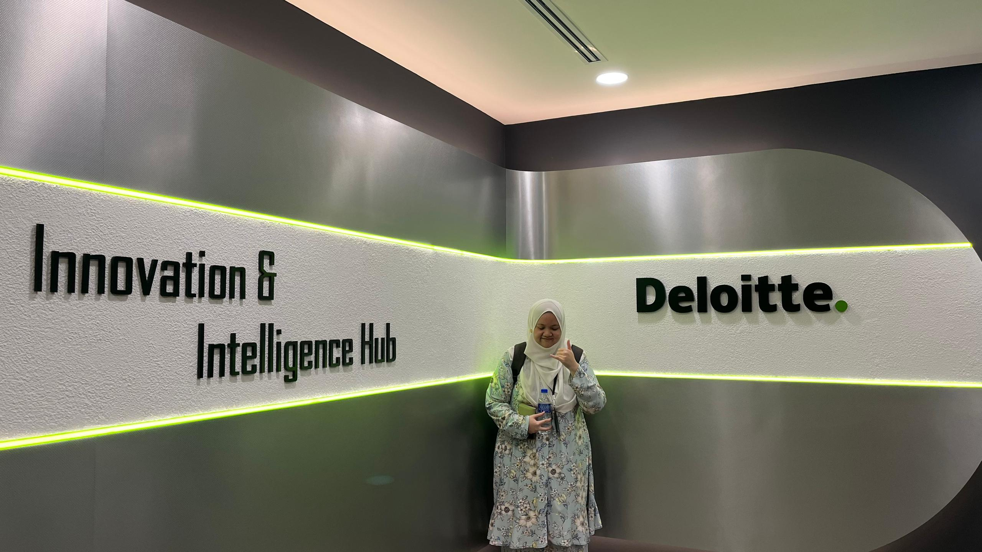
TUESDAY  24.9.2024 | - Mandatory E-learning (Completed)  - Intern Training Status Update with Mr. Deepak  - Newcomer Introduction  - Start technical learning path - Docker/Podman (In Progress)  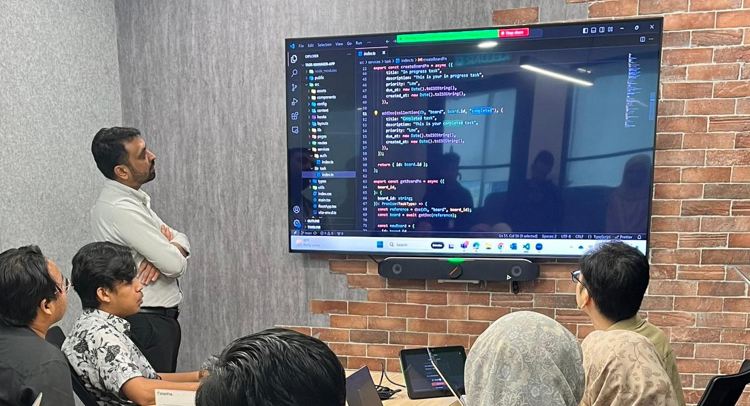
WEDNESDAY  25.9.2024 | Technical learning path – Docker/Podman (In Progress)
THURSDAY  26.9.2024 | - Technical learning path – Docker/Podman (Completed)  Technical learning path – Kubernetes (In progress)
FRIDAY  27.9.2024 | - Technical learning path – Kubernetes (In progress)  Submit intern time and expense sheet for September 2024
SATURDAY  28.9.2024 | - Day-Off
SUNDAY  29.9.2024 | - Day-Off
MONDAY  30.9.2024 | - Technical learning path – Kubernetes (In progress)
TUESDAY  1.10.2024 | - Technical learning path – Kubernetes (Completed)  - Technical learning path – Spring Boot (In progress)
WEDNESDAY  2.10.2024 | - Technical learning path – Spring Boot (In progress)
THURSDAY  3.10.2024 | - Technical learning path – Spring Boot (In progress)
FRIDAY  4.10.2024 | - Technical learning path – Spring Boot (In progress)
SATURDAY  5.10.2024 | - Day-Off
SUNDAY  6.10.2024 | - Day-Off
MONDAY  7.10.2024 | - Technical learning path – Spring Boot (In progress)
TUESDAY  8.10.2024 | - Technical learning path – Spring Boot (In progress)
WEDNESDAY  9.10.2024 | - Technical learning path – Spring Boot (In progress)
THURSDAY  10.10.2024 | - Technical learning path – Spring Boot (In progress)
FRIDAY  11.10.2024 | - Technical learning path – Spring Boot (In progress)
SATURDAY  12.10.2024 | - Day-Off
SUNDAY  13.10.2024 | - Day-Off
MONDAY  14.10.2024 | - Technical learning path – Spring Boot (In progress)
TUESDAY  15.10.2024 | - Technical learning path – Spring Boot (In progress)
WEDNESDAY  16.10.2024 | - Technical learning path – Spring Boot (In progress)
THURSDAY  17.10.2024 | - Technical learning path – Spring Boot (In progress)
FRIDAY  18.10.2024 | - Technical learning path – Spring Boot (Completed)
SATURDAY  19.10.2024 | - Day-Off
SUNDAY  20.10.2024 | - Day-Off
MONDAY  21.10.2024 | - Technical learning path – ReactJs (In progress)
TUESDAY  22.10.2024 | - Technical learning path – ReactJs (In progress)
WEDNESDAY  23.10.2024 | - Technical learning path – ReactJs (In progress)
THURSDAY  24.10.2024 | - Technical learning path – ReactJs (In progress)
FRIDAY  25.10.2024 | - Technical learning path – ReactJs (In progress)
SATURDAY  26.10.2024 | - Day-Off
SUNDAY  27.10.2024 | - Day-Off
MONDAY  28.10.2024 | - Technical learning path – ReactJs (In progress)
TUESDAY  29.10.2024 | - Technical learning path – ReactJs (In progress)  - Submit intern time and expense sheet for October 2024
WEDNESDAY  30.10.2024 | - Technical learning path – ReactJs (In progress)
THURSDAY  31.10.2024 | - Regional Holiday - Deepavali
FRIDAY  1.11.2024 | - Technical learning path – ReactJs (Completed)
SATURDAY  2.11.2024 | - Day-Off
SUNDAY  3.11.2024 | - Day-Off
MONDAY  4.11.2024 | - Assigned with Project: Customer Ticketing System (Ref: Deloitte ServiceNow system)  - Start Planning the scope and requirements  - The backend structure (ERD diagram)  - The flow of the system (Flowchart diagram)  - The rough UI design (Storyboard)  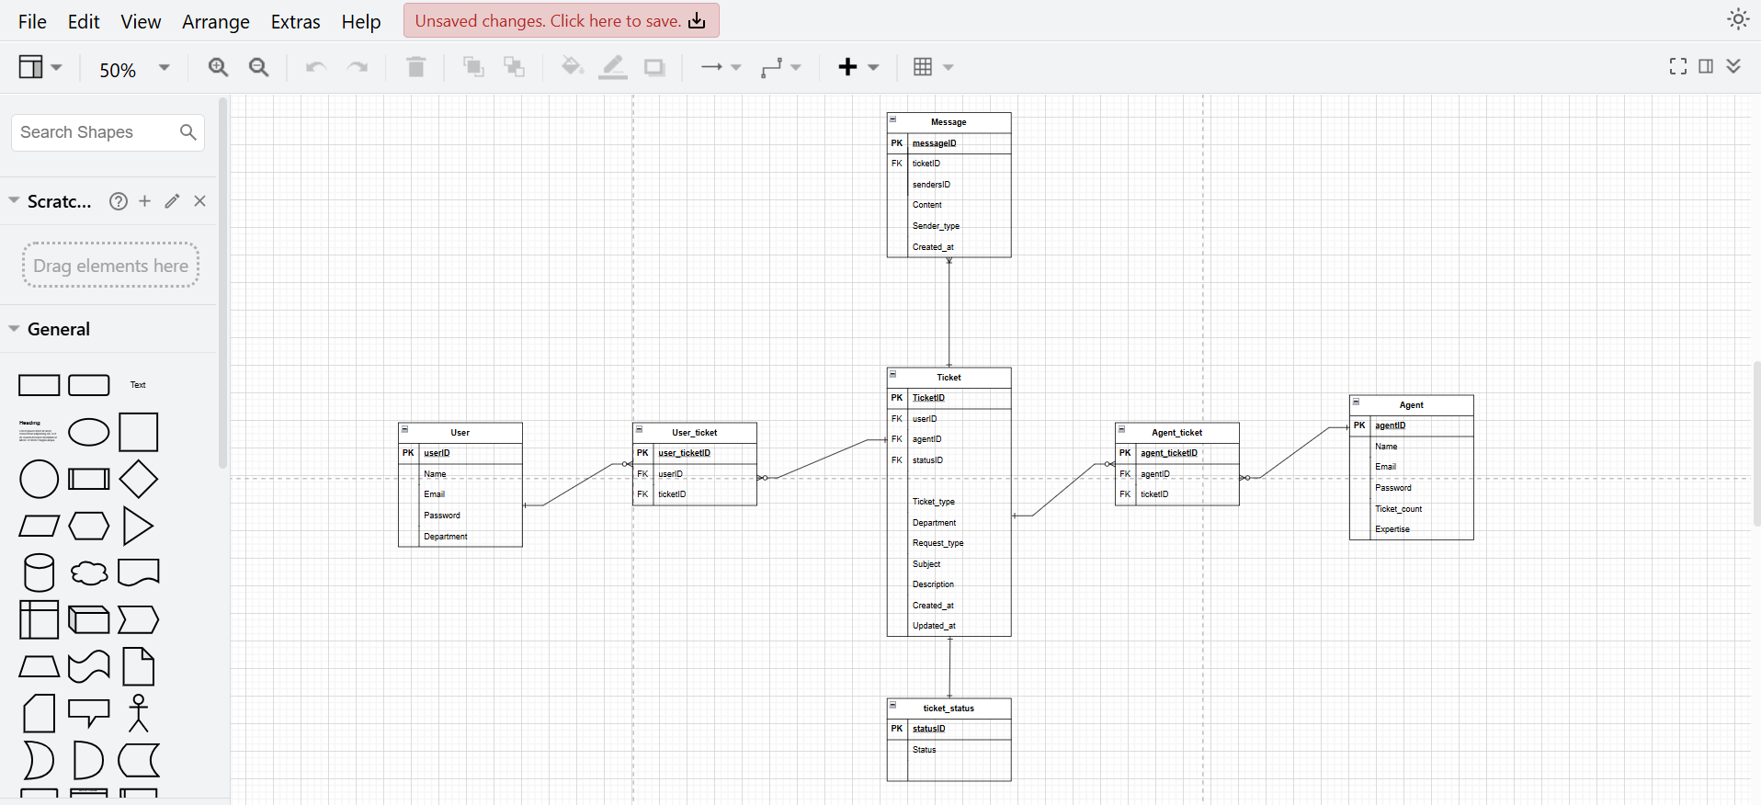
TUESDAY  5.11.2024 | - Design the system file structure (File management)  - Build on the UI Design idea  - Connect to dummy database for testing purposes (db.json)
WEDNESDAY  6.11.2024 | - Start building the user-side pages and functionalities including:  - Page routing + navigation bar  - Form submission (Add new ticket into ticket table in database)
THURSDAY  7.11.2024 | - Refactoring the functionalities code management such as using context and proper prop usage management.  - Start with ticket status tracking functionalities (fetching ticket status_id from database and matching it to the status table)
FRIDAY  8.11.2024 | - Fixing the date and time of the statuses documented on the status tracking feature (in progress)  - Build a bit on the UI styling using Tailwind CSS
SATURDAY  9.11.2024 | - Day-Off
SUNDAY  10.11.2024 | - Day-Off
MONDAY  11.11.2024 | - Fixing the date and time of the statuses documented on the status tracking feature (completed)  - Start with components for Dashboard:  - Summary Card (In progress)  - Ticket Container (In progress)  - Build on the UI styling using Tailwind CSS  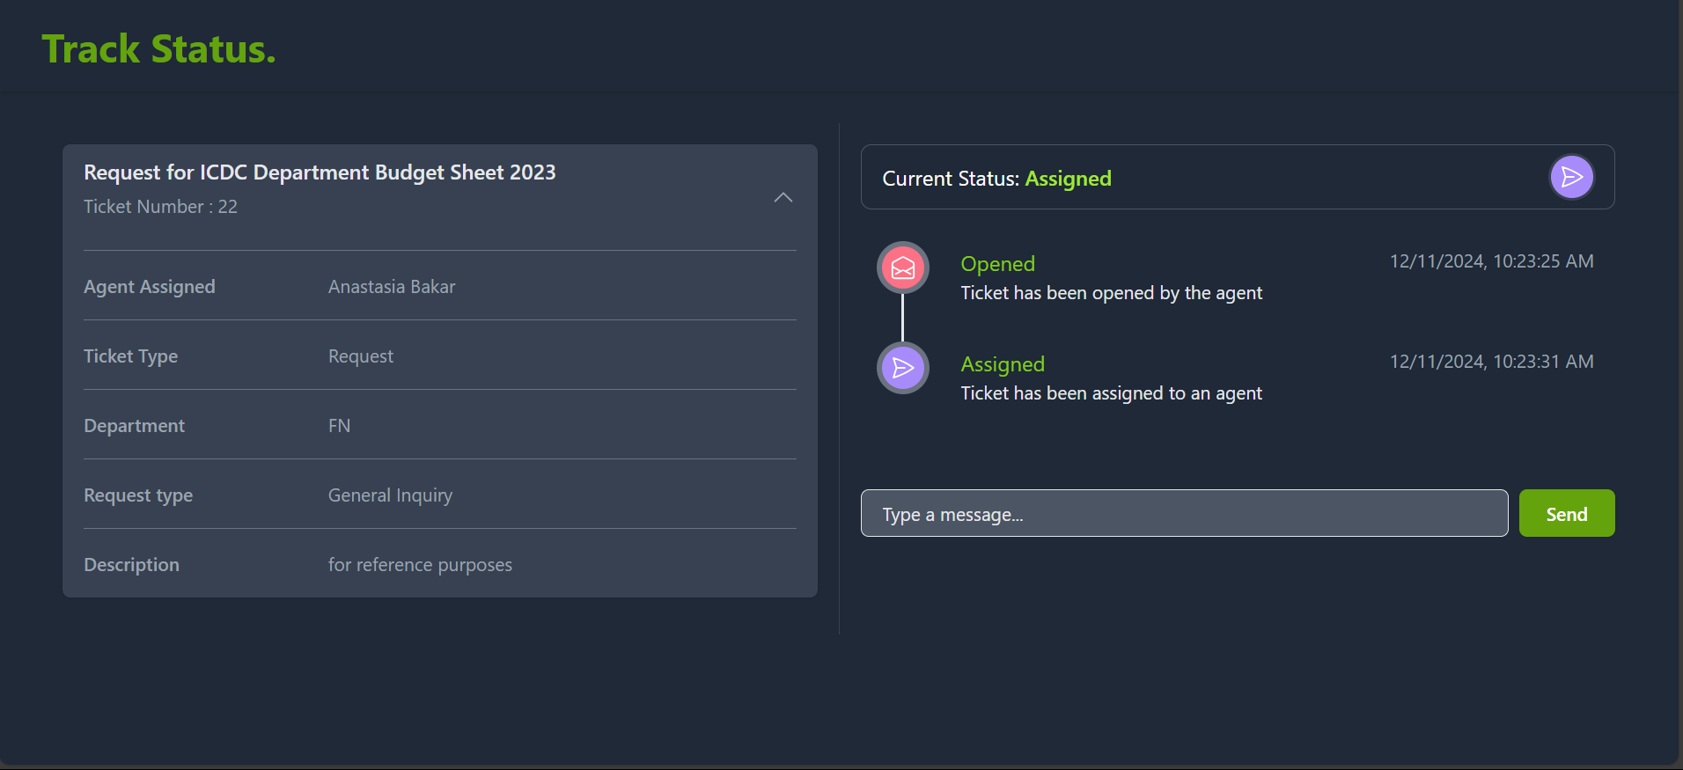
TUESDAY  12.11.2024 | - Continue with components for Dashboard:  - Summary Card (Completed)  - Ticket Container (In progress)  - Debug problem where datetime in track status displays N/A when accessed through Navigation Bar (In progress)  - Build on the UI styling using Tailwind CSS
WEDNESDAY  13.11.2024 | - Continue with components for Dashboard:  - Ticket Container (Completed)  - Debug problem where datetime in track status displays N/A when accessed through Navigation Bar (Solved)  - Build on the UI styling using Tailwind CSS  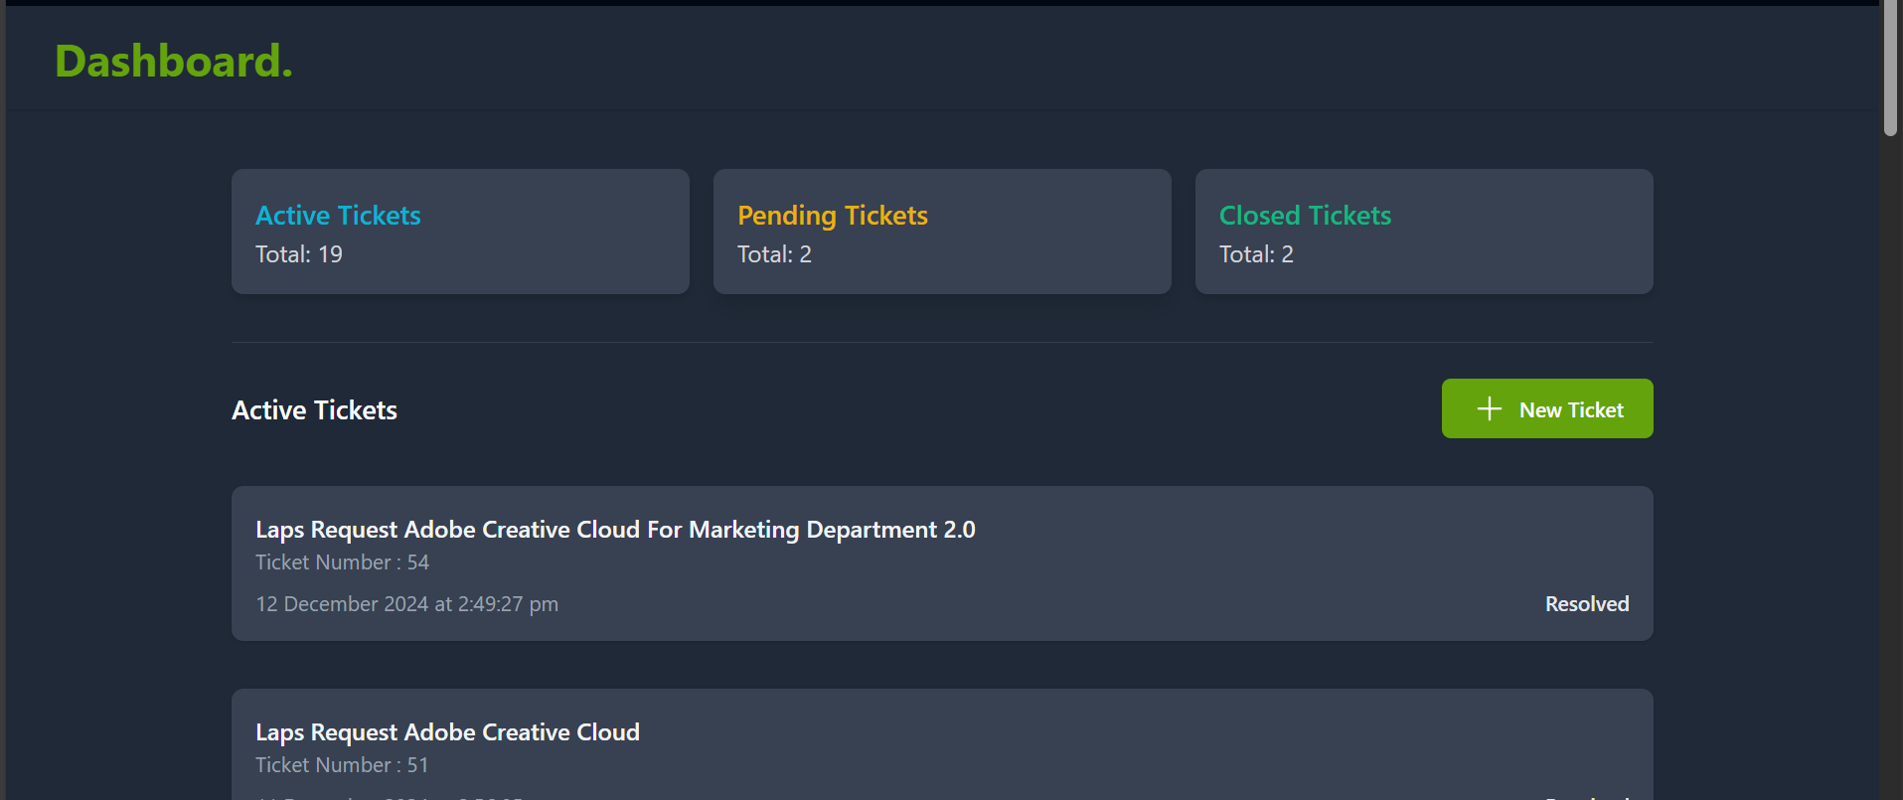
THURSDAY  14.11.2024 | - Start with ticket history page by using reusable component, ticket container.  - Debug problem where status page cannot identify ticket after page refresh (In Progress)
FRIDAY  15.11.2024 | - Refine how Track Status function is executed by displaying the containers according to ticket UpdatedAt field content.  - Debug problem where status page cannot identify ticket after page refresh (Solved)
SATURDAY  16.11.2024 | - Day-Off
SUNDAY  17.11.2024 | - Day-Off
MONDAY  18.11.2024 | - Start with Supabase integration instead of using dummy database (db.json).  - Manage user authentication configuration and proper routing accordingly with Supabase.  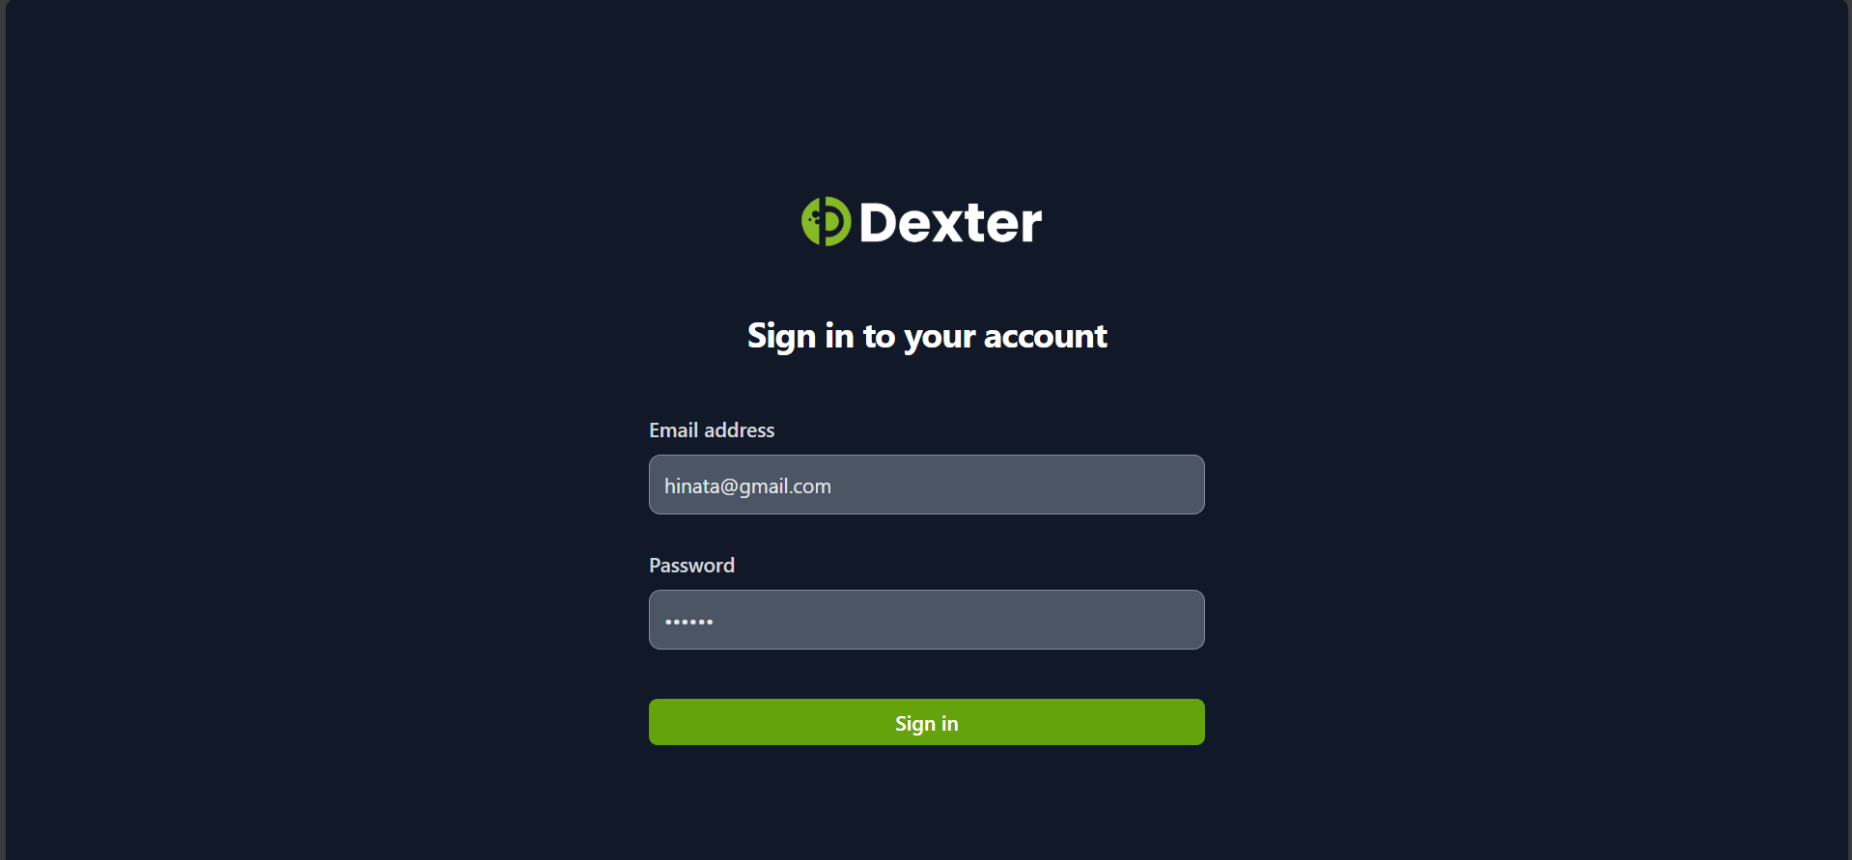
TUESDAY  19.11.2024 | - Start with refactoring codes for fetching and updating data to fetch and update data from Supabase properly. (In progress)  - Build on the UI styling using Tailwind CSS
WEDNESDAY  20.11.2024 | - Continue with refactoring codes for fetching and updating data to fetch and update data from Supabase properly. (Completed)  - Build on the UI styling using Tailwind CSS
THURSDAY  21.11.2024 | - Start with user profile page with editing features for user profile picture, username and bio. (In progress)  - Build on the UI styling using Tailwind CSS
FRIDAY  22.11.2024 | - Continue with user profile page with editing features for user profile picture, username and bio. (completed)  - Manage inserting and fetching image type data from Supabase storage for user profile picture  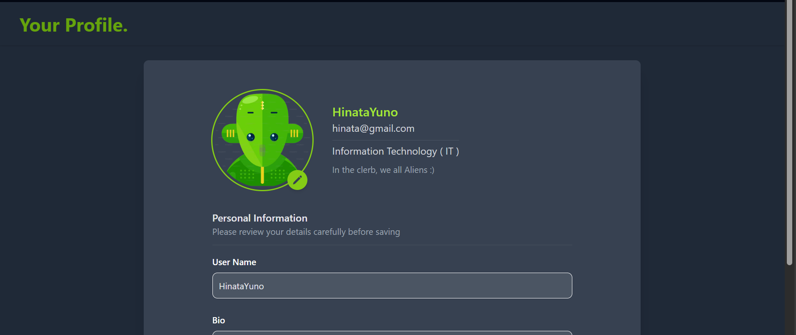
SATURDAY  23.11.2024 | - Day-Off
SUNDAY  24.11.2024 | - Day-Off
MONDAY  25.11.2024 | - Dockerized the project and publish the project as an image in Docker Hub using Podman  - Push the project to remote repository in GitHub  - Research more on CI/CD pipeline for the project
TUESDAY  26.11.2024 | - Start with dark and default mode CSS and default mode CSS (In progress)  - Design logo for project brand (Dexter)
WEDNESDAY  27.11.2024 | - Continue with building on dark and default mode CSS (In progress)  - Build on the UI styling of Admin side
THURSDAY  28.11.2024 | - Continue with building on dark mode CSS and default mode CSS (In progress)
FRIDAY  29.11.2024 | - Continue with building on dark mode CSS and default mode CSS (completed)  - Submit intern time and expense sheet for November 2024  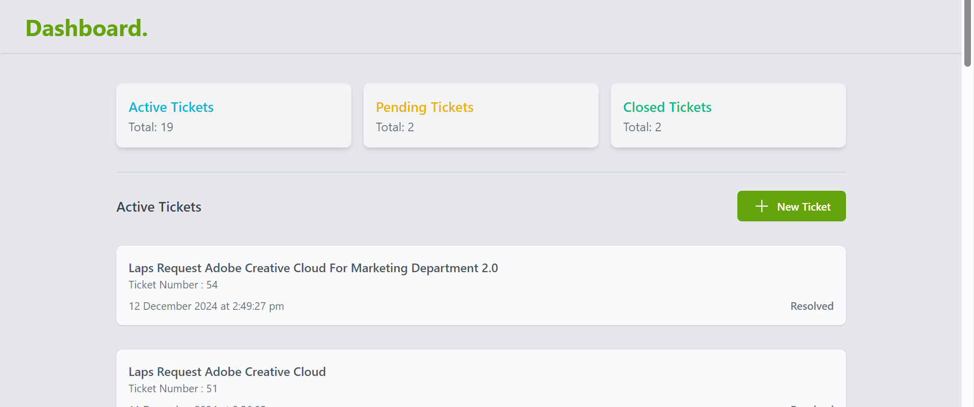
SATURDAY  30.11.2024 | - Day-Off
SUNDAY  1.12.2024 | - Day-Off
MONDAY  2.12.2024 | - Start with notification function using real-time integration in Supabase subscription. (In progress)  - Meeting with Mr. Deepak and present project progress via Microsoft teams.  - Build on the UI styling using Tailwind CSS
TUESDAY  3.12.2024 | - Continue with notification function and filter notification based on logged in users and agents (In progress)  - Build on the UI styling using Tailwind CSS  - Problem found: notifications sent during logged out is not shown when user/agent logs in
WEDNESDAY  4.12.2024 | - Problem solved: notifications sent during logged out shown when user/agent logs in by fetching notifications that are past the latest logout timestamp.  - Continue with notification function fine-tuning (In progress)
THURSDAY  5.12.2024 | - Continue with notification function fine-tuning (completed)  - Build on the UI styling using Tailwind CSS  - Pushing new modifications to GitHub repository  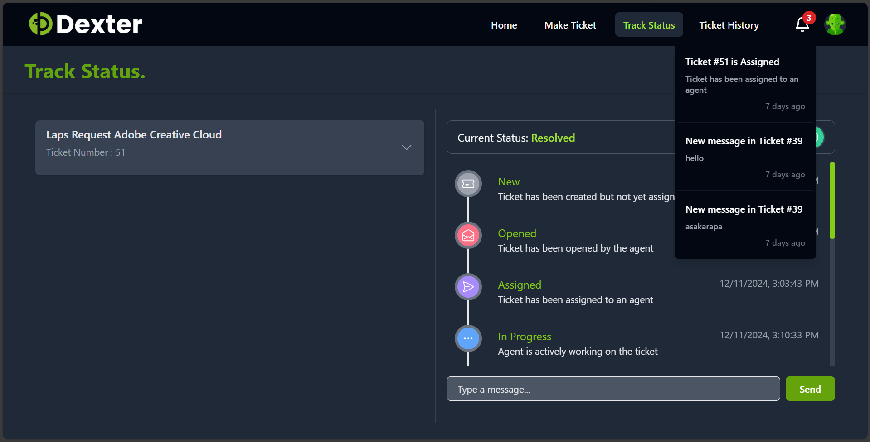
FRIDAY  6.12.2024 | - Start with Presentation Slides (In Progress)  - Build on the UI styling using Tailwind CSS  - Pushing new modifications to GitHub repository
SATURDAY  7.12.2024 | - Day-Off
SUNDAY  8.12.2024 | - Day-Off
MONDAY  9.12.2024 | - Continue with Presentation Slides (In Progress)  - Build on the UI styling using Tailwind CSS  - Pushing new modifications to GitHub repository
TUESDAY  10.12.2024 | - Continue with Presentation Slides (In Progress)  - Merging and testing agent-side to project (In Progress  - Problem found: unread notification disappears after logging second time
WEDNESDAY  11.12.2024 | - Notification fine-tuning to solve problem (In progress)
THURSDAY  12.12.2024 | - Problem solved: unread notification retains after logging second time by adding read Boolean attribute to notifications and displaying read = false notifications.  - Continue with Presentation Slides (In Progress)
FRIDAY  13.12.2024 | - Dockerized latest merged project and push to Dockerhub.  - Continue with Presentation Slides (Completed)  - Submit first draft of Presentation Slides to Mr. Deepak
SATURDAY  14.12.2024 | - Day-Off
SUNDAY  15.12.2024 | - Day-Off
MONDAY  16.12.2024 | - Start with internship report (In progress)  - Set meeting for Internship field visit.  - Prepare slides for internship progress update to present during field visit.  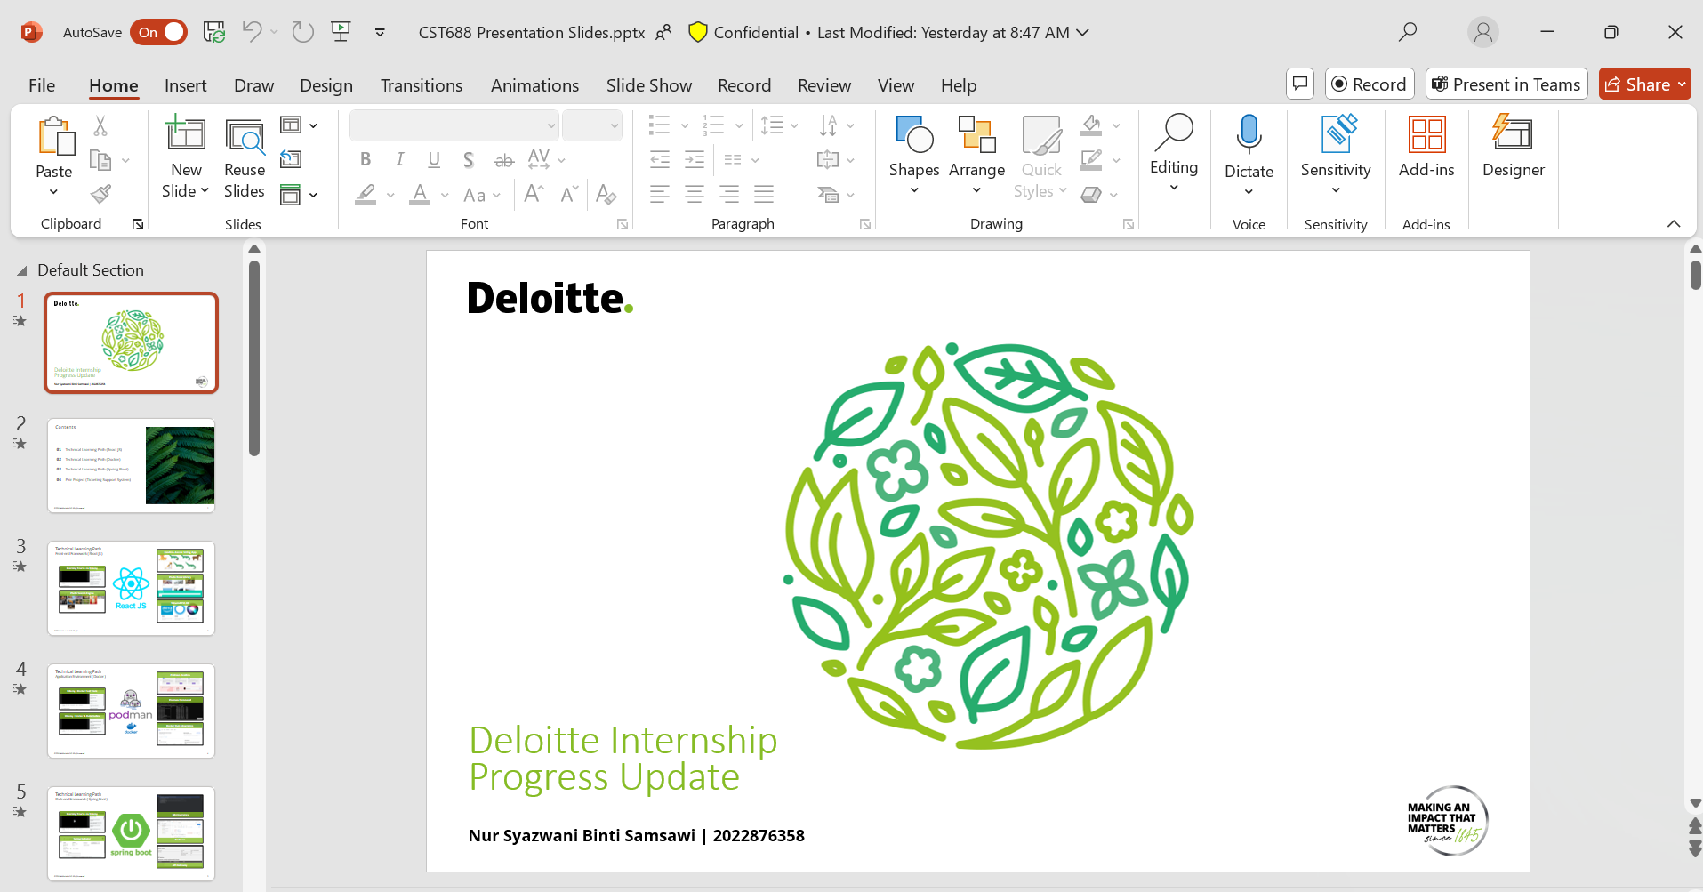
TUESDAY  17.12.2024 | - Continue with internship report (In progress)  - Progress update presentation with academic supervisor.  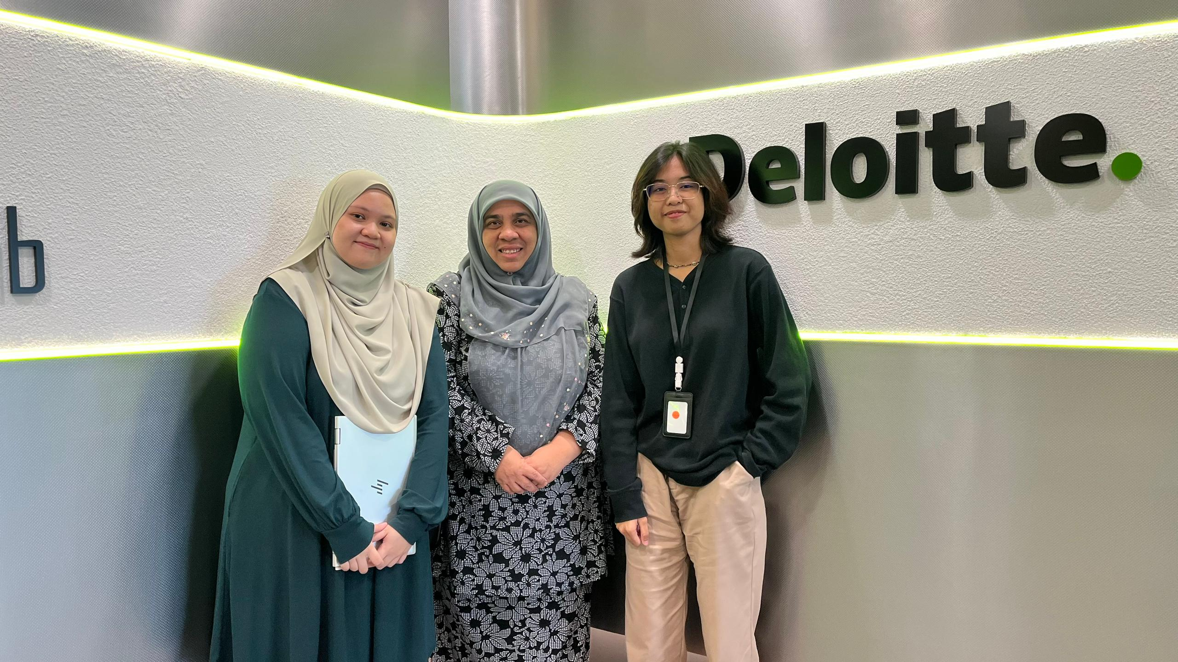
WEDNESDAY  18.12.2024 | - Continue with internship report (In progress)  - Submit intern time and expense sheet for December 2024 and January 2025
THURSDAY  19.12.2024 | - Continue with internship report (In progress)  - Complete Deloitte Intern Exit Details
FRIDAY
20.12.2024

SATURDAY  21.12.2024 | - Day-Off
SUNDAY  22.12.2024 | - Day-Off
MONDAY  23.12.2024 | - Unpaid Leave (Office Closure)
TUESDAY  24.12.2024 | - Unpaid Leave (Office Closure)
WEDNESDAY  25.12.2024 | - Public Holiday (Christmas Eve)
THURSDAY  26.12.2024 | - Unpaid Leave (Office Closure)
FRIDAY  27.12.2024 | - Unpaid Leave (Office Closure)
SATURDAY  28.12.2024 | - Day-Off
SUNDAY  29.12.2024 | - Day-Off
MONDAY  30.12.2024 | - Unpaid Leave (Office Closure)
TUESDAY  31.12.2024 | - Unpaid Leave (Office Closure)
WEDNESDAY  1.1.2025 | - Unpaid Leave (Office Closure)
THURSDAY
2.1.2025

FRIDAY
3.1.2025

