1.Cmake例子

<http://blog.csdn.net/dbzhang800/article/details/6314073>

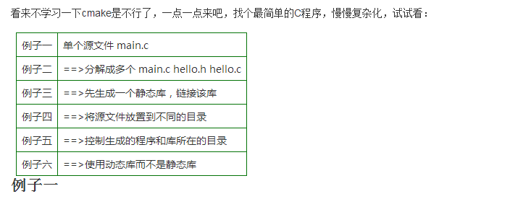

2.Qt和VTK混合

<http://blog.csdn.net/dedje/article/details/42025143>

