- 深度学习keras框架中，模型的保存和加载
参考网友 https://blog.csdn.net/cymy001/article/details/78647640
以MNIST为例
初次训练模型并保存

import numpy as np
from keras.datasets import mnist
from keras.utils import np_utils
from keras.models import Sequential
from keras.layers import Dense
from keras.optimizers import SGD

#载入数据
(x_train, y_train), (x_test, y_test) = mnist.load_data()
#(60000, 28, 28)
print('x_shape:', x_train.shape )

#(60000, 28, 28)
print('y_shape:', y_train.shape)

#(60000, 28, 28)->(60000, 784)
x_train = x_train.reshape( x_train.shape[0], -1 )/255.0
x_test = x_test.reshape( x_test.shape[0], -1)/255.0

#换成 one hot格式
y_train = np_utils.to_categorical( y_train, num_classes = 10 )
y_test = np_utils.to_categorical( y_test, num_classes = 10 )

#创建模型，输出784个神经元，输出10个神经元
model = Sequential( [ Dense(units = 10, input_dim = 784, bias_initializer = 'one', activate = 'softmax')] )

#定义优化器
sgd = SGD(lr=0.2)

#定义优化器，loss function,训练过程中计算准确率
model.compile( optimizers = sgd, loss = 'mse', metrics =['accuracy'] )

#训练模型
model.fit( x_train, y_train, batch_size = 64, epoch = 5 )

#评估模型
loss,accuracy = model.evaluate(x_test, y_test)

print("\ntest loss", loss)
print("accuracy", accuracy)

#保存模型
model.save( 'model.h5' ) #HDF5文件，pip install h5py

载入模型，训练模型，保存模型
import numpy as np
from keras.datasets import mnist
from keras.utils import np_utils
from keras.models import Sequential
from keras.layers import Dense
from keras.optimizers import SGD
from keras.models import load_model
# 载入数据
(x_train,y_train),(x_test,y_test) = mnist.load_data()
# (60000,28,28)
print('x_shape:',x_train.shape)
# (60000)
print('y_shape:',y_train.shape)
# (60000,28,28)->(60000,784)
x_train = x_train.reshape(x_train.shape[0],-1)/255.0
x_test = x_test.reshape(x_test.shape[0],-1)/255.0
# 换one hot格式
y_train = np_utils.to_categorical(y_train,num_classes=10)
y_test = np_utils.to_categorical(y_test,num_classes=10)

# 载入模型
model = load_model('model.h5')

#评估模型
loss,accuracy = model.evaluate(x_test, y_test)
print("\ntest loss",loss)
print('accuracy',accuracy)

#训练模型
model.fit(x_train, y_train, batch_size = 64, epoch = 2 )

#评估模型
loss,accuracy = model.evaluate( x_test, y_test )

print("\ntest loss", loss)
print("accuracy", accuracy)

#保存参数,载入参数
model.save_weight('my_model_weight.h5')
model.load_weight('my_model_weight.h5')

#保存网络结构，载入网络结构
from keras.models import model_from_json
json_string = model.to_json()
model = model_from_json( json_string )

print( json_string )

- tensorflow中指定GPU即GPU现存设置
命令：nvidia-smi
功能：定时更新显示机器上的gpu的使用情况

在运行程序的时候指定使用那块GPU
CUDA_VISIBLE——DEVICE= 0,1 python yourcode.py

在Python代码中指定GPU
import os
os.environ[“CUDA_VISIBLE_DEVICES”] = “0” // 序号为0的这块GPU可见

设置GPU的使用量
config = tf.ConfigProto()
config.gpu_options.per_process_gpu_memory_fraction = 0.9 #占用GPU90%的显存
session = tf.Session( config = config )

设置最小的GPU使用量
config = tf.ConfigProto()
config.gpu_options.allow_growth = True
session = tf.Session( config = config )

限制GPU资源的使用：
动态申请显存：需要多少就申请多少
config = tf.ConfigProto()
config.gpu_options.allow_growth = True
session = tf.Session( config = config )

限制GPU的使用
config = tf.ConfigProto()
config.gpu_options.per_process_gpu_memory_fraction = 0.4
session = tf.Session( config = config )

补充 Tensorflow中的保存和加载模型：

- 利用keras对训练图像进行增强，提高模型的泛化能力
#下面的代码是对图像进行旋转、剪切等变换，得到增强后的图像

from keras.preprocessing.image import ImageDataGenerator, array_to_img, img_to_array, load_img

datagen = ImageDataGenerator(
rotation_range = 40,
width_shift_range = 0.2,
height_shift_range = 0.2,
shear_range = 0.2,
zoom_range = 0.2,
horizontal_flip = True,
fill_mode = 'nearest'
)

img = load_img( 'c:/users/wxfou/desktop/1.jpg',) #this is a PIL image
x = img_to_array( img ) #this is a Numpy array with shape( )
x = x.reshape( (1,) + x.shape ) #this is a Numpy array with shape( 1, )

# the flow() command below generates batches of randomly transformed images
# and saves the results to the preview/directory
i = 0
for batch in datagen.flow( x, batch_size = 1, save_to_dir = './preview', save_prefix='cat', save_format='png'):
i += 1
if i > 20:
Break

- 基于keras的CNN可视化
参考网友：芥末的无奈
https://blog.csdn.net/weiwei9363/article/details/79112872
https://github.com/fchollet/deep-learning-with-python-notebooks

Import keras
Keras.__version__

# load model
from keras.models import load_model
Model = load_model( ‘c:/users/wxfou/desktop/model/cats.h5’ )
Model.sumary() #查看模型的结构
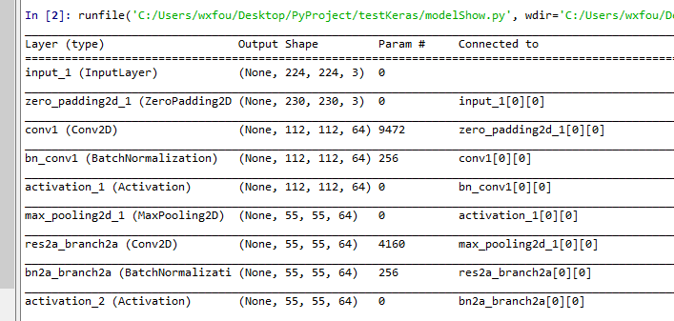

- 模型训练的数据增强（绘制模型训练过程中的loss曲线）
参考网友：曹荣禹
基于CIFAR-10数据集
https://github.com/persistforever/cifar10-tensorflow

- Keras中回调函数设置
参考网友：一路前行1
https://blog.csdn.net/weiyongle1996/article/details/79342875

