Mosquitto on EC2

We have our broker on the Cloud for easier handling of the publish/subscribe style we are using for the handling of different Diagrams.

Connecting to our broker

SSH to the EC2:

ssh -i [Path to secret key .pem] ec2-user@ec2-18-194-233-30.eu-central-1.compute.amazonaws.com

Send me(guseberjo/Joacim) a message if you need to connect and I'll send you the key.

When you connect to the EC2 you can install software with sudo yum install [thing to install].

To connect to our broker from unity:

For publishing create a MqttClientDAVE. 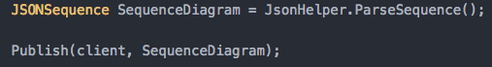

This is the syntax for publishing.

How to test the connection:

Use MQTTBox (Chrome extension):

Then just run Unity in the coordinator branch (Todo: UPDATE this)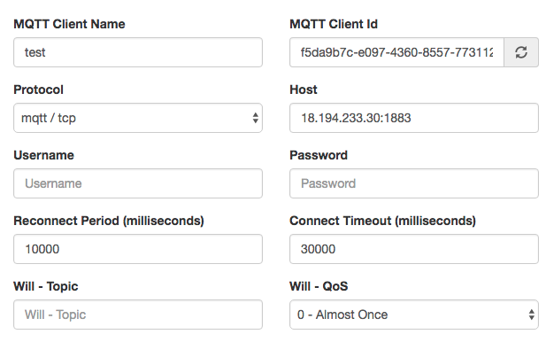

Inside the ssh connection to the EC2:

netstat -a -n | grep 1883

This looks at if there is a connection and all packages send through the standard port.