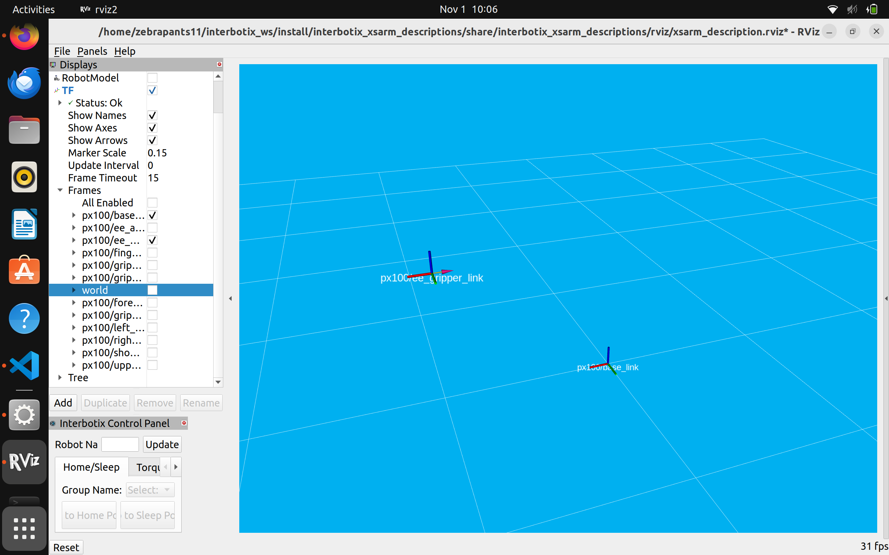

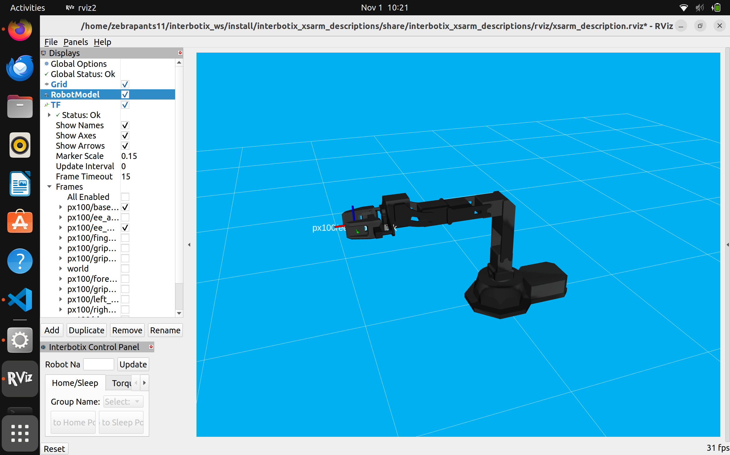

t1 = 0

t2 = 0

t3 = 0

t4 = 0

t5 = 0

# Might need the end effector included as prismatic

theta = [t1,t2,t3,t4,t5]

H1 = 89.45/1000

H2 = 100/1000

L1 = 35/1000

L2 = 100/1000

L3 = 107.6/1000

a = [[0,0,0],[0,0,H1],[L1,0,H1+H2],[L1+L2,0,H1+H2],[L1+L2+L3,1,H1+H2]]

rot = [[0,0,1],[0,1,0],[0,1,0],[0,1,0],[0,0,0]]

jt = 'RRRRP' # Maybe R at end

M = [[1,0,0,L1+L2+L3],[0,1,0,0],[0,0,1,H1+H2],[0,0,0,1]]

R,p=FK_PoE(theta,a,rot,jt,M)

print("R is", np.round(R))

print("p is", p)

Tf [[1. 0. 0. 0.2426 ]

[0. 1. 0. 0. ]

[0. 0. 1. 0.18945]

[0. 0. 0. 1. ]]

R is [[1. 0. 0.]

[0. 1. 0.]

[0. 0. 1.]]

p is [0.2426 0. 0.18945]

Pose matches zero position.

For 0,0,-90,90

Tf [[1. 0. 0. 0.1426 ]

[0. 1. 0. 0. ]

[0. 0. 1. 0.28945]

[0. 0. 0. 1. ]]

R is [[1. 0. 0.]

[0. 1. 0.]

[0. 0. 1.]]

p is [0.1426 0. 0.28945]

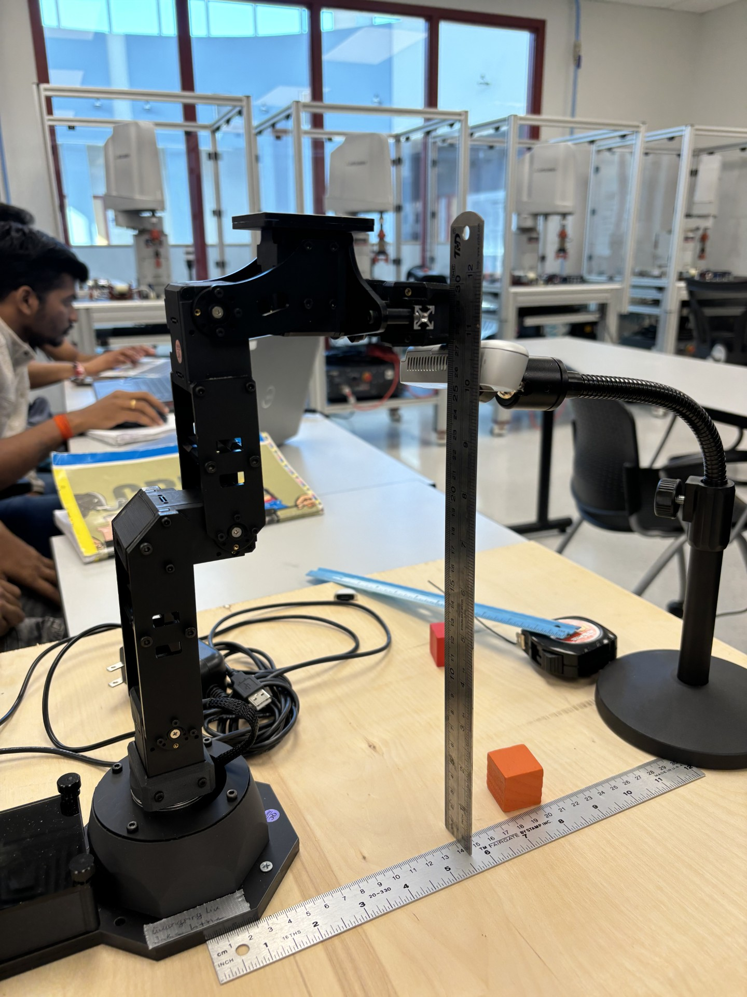

These match!