根据ppt完成小程序：

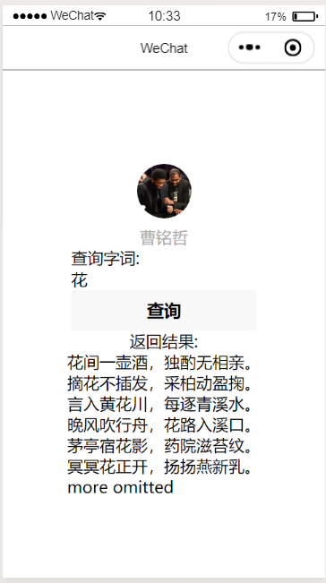

添加了可以输入多个字的功能：

for (var i1 in lines) {

if (reg.test(lines[i1])) {

cti++;

this.data.res += cti + "." + lines[i1] + "\n"

console.log(lines[i1])

/\* if (++cti > 5) {

this.data.res += "more omitted\n"

break;

}\*/

}

for (var k = 0; k <= lines[i1].length - str.length; k++) {

if (lines[i1].substring(k, k + str.length) == str) {

var array = [{

num: cti + ".",

front: lines[i1].substring(0, k),

keyword: str,

behind: lines[i1].substring(k + str.length, lines[i1].length),

}]

this.data.sentence = this.data.sentence.concat(array)

}

}

}

结果：

