单步走之飞花令

界面设计：
界面选择相对布局，第一个textview放“请输入关键字：”字样
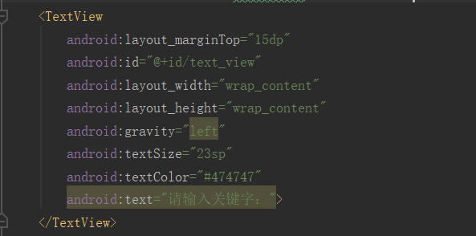
EditText负责填入想要搜索的关键字
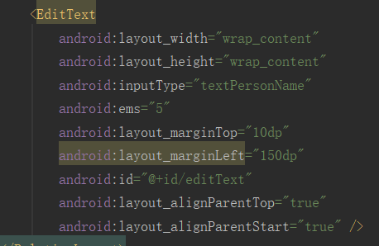
Button点击查询
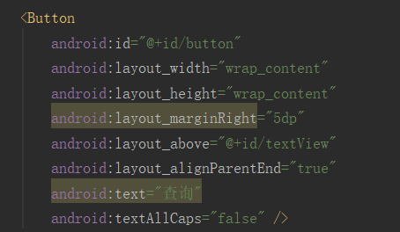
另外一个textview负责显示查询结果
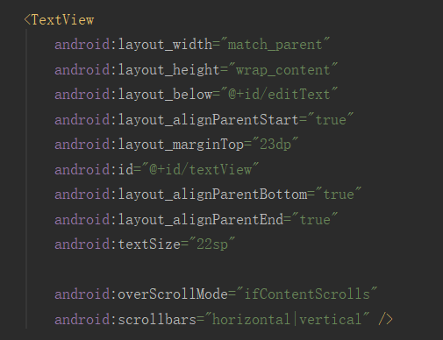
后端实现：
Button点击调用showResult方法。
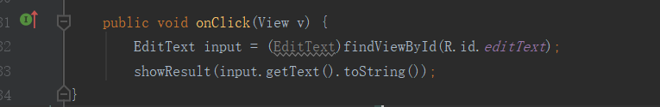
ShowResult方法：
从诗三百中获取符合的诗句不断地添加到ans里然后最终显示。
public void showResult(String str) {
TextView textView = (TextView)findViewById(R.id.textView);
textView.setMovementMethod(ScrollingMovementMethod.getInstance());
textView.setHorizontallyScrolling(true);
InputStream context = getClass().getClassLoader().getResourceAsStream("assets/poem300");
BufferedReader br = new BufferedReader(new InputStreamReader(context));
String ans = "", title = "", line;
try {
int count = 0;
while ((line = br.readLine()) != null) {
if (line.length() == 0) continue;
if ('0'<= line.charAt(0) && line.charAt(0) <= '9') {
title = line.substring(3, line.length());
continue;
}
if (line.contains(str))
// ans += "" + (++count) + "." + line + ' ' + title + '\n';
ans += "" + (++count) + "." + '\t' + title + '\n' + line + '\n'+'\n';
}
SpannableStringBuilder builder = new SpannableStringBuilder(ans);
for (int i = 0; i < ans.length() - str.length(); i++) {
if (ans.substring(i, i + str.length()).equals(str)) {
ForegroundColorSpan redSpan = new ForegroundColorSpan(Color.RED);
builder.setSpan(redSpan, i, i + str.length(), Spannable.SPAN_EXCLUSIVE_EXCLUSIVE);
i += str.length() - 1;
} else if (ans.charAt(i) == ' ') {
int j = i + 1;
while (ans.charAt(i) != '\n') i++;
ForegroundColorSpan graySpan = new ForegroundColorSpan(Color.GRAY);
builder.setSpan(graySpan, j, i, Spannable.SPAN_EXCLUSIVE_EXCLUSIVE);
} else {
ForegroundColorSpan blackSpan = new ForegroundColorSpan(Color.BLACK);
builder.setSpan(blackSpan, i, i + 1, Spannable.SPAN_EXCLUSIVE_EXCLUSIVE);
}
}
Toast.makeText(MainActivity.this, "一共找到" + count + "句", Toast.LENGTH_SHORT).show();
textView.setText(builder);
} catch (IOException e) {
textView.setText("出错了！");
}
}

演示：
