Iteration Plan:
Iteration #1

Group 12

Kyle Nickerson,
Catherine Rendell &
Ben Morrison

Github repository: https://github.com/BigTuna08/cs3716

Plan

We will be using a feature driven development approach, because the 3 main features of our system- the schedule creation, ability to request rooms and the ability to decide requests- are not closely related. Also we have a limited time frame for this iteration, and the feature driven approach will allow us to have working code to show the client faster. In our first iteration we are going to be implementing the schedule creation feature. We chose this because it is a part of the essence of our system. The other two main features deal with requests, but it only makes sense for requests to happen after the schedule has been created (because it contains the info of what rooms/times can be requested).

Use Case: Principal creates schedule

1. Principal starts system
2. System displays list of possible actions
3. Principal selects option to create schedule
4. System prompts principal to enter room names
5. Principal enters room names
6. System prompts principal for each rooms availability
7. Principal enters each rooms availability
8. The system displays blank schedule for confirmation
8a. Principal confirms schedule is correct
8b. Principal rejects schedule
1. Repeat steps 4-8 as needed
9. System stores the empty schedule

Sequence for Schedule Creation

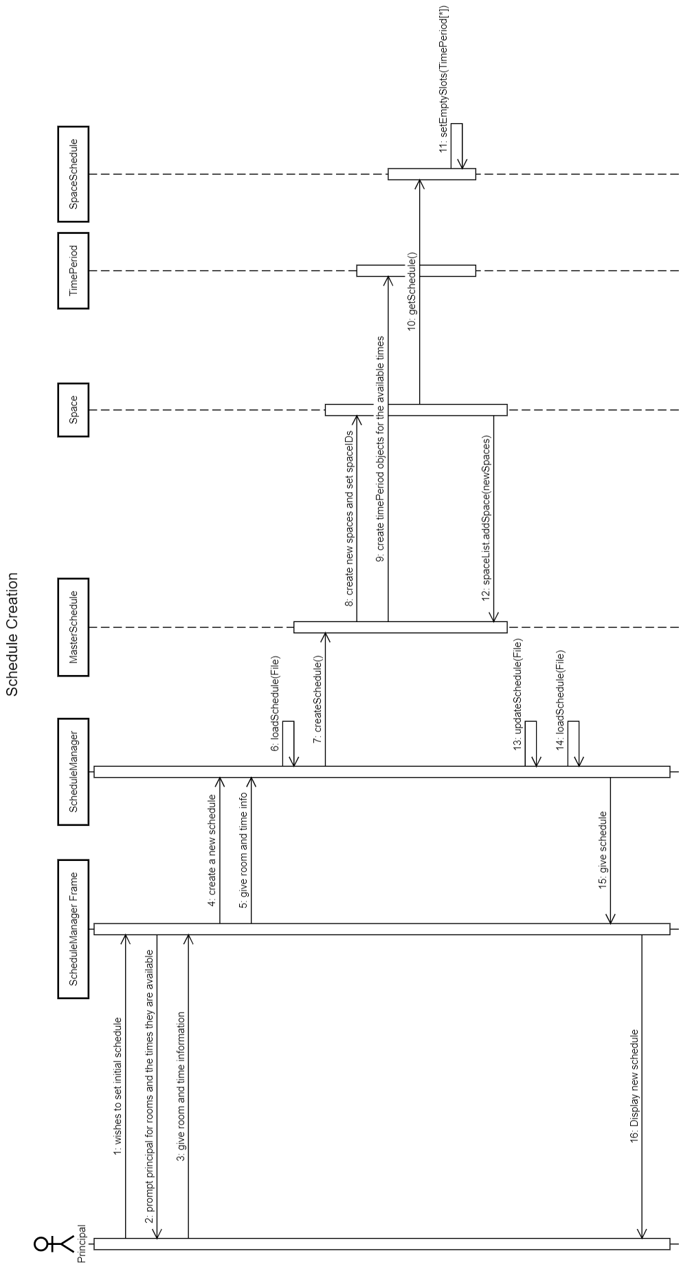

Required Classes

