**Project: 3**

**Serial Transmit of Temperature**

**Course: EN605.715**

**Date: 10/02/2019**

**Principal Investigator: Zach Richard**

**Requirements:**

The requirements we derived for this project were to use a

**Equipment Used:**

* Digilent Zedboard
* various micro USB cables
* any headphones around
* Xilinx Vivado 2017.4
* Ryzen 3900X Development PC running Windows 10

**Data Captured**

50KHz

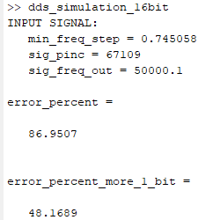

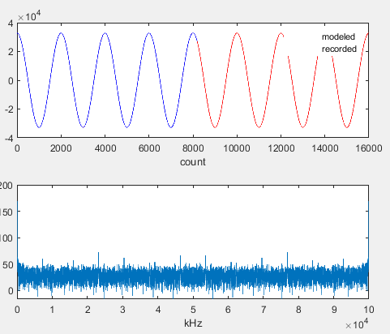

50KHz (cont. 2)

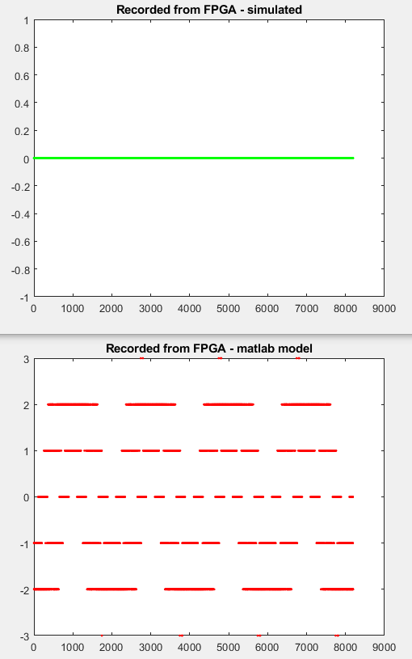

50KHz (cont. 3)

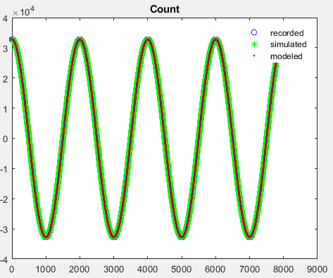

100KHz

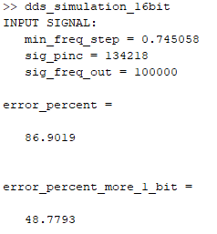

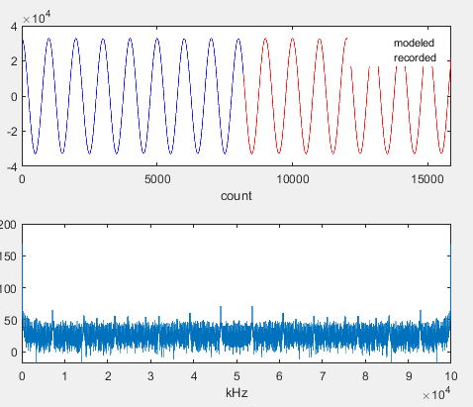

100KHz (cont.)

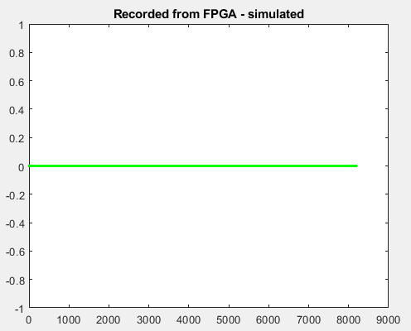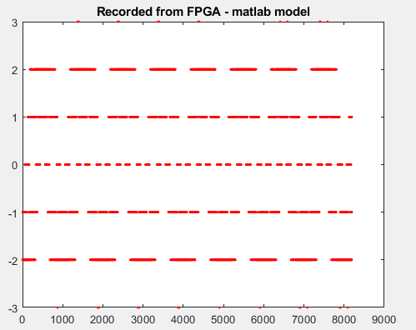

100KHz (cont. 2)

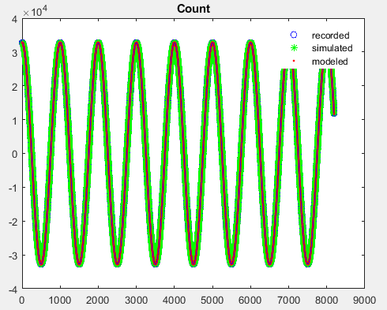

**Summary**

For my design, I used a programmable full-range DDS implementation. Since the matlab simulation does not work as well in full range mode, it is not surprising to me that my error rate is so high. Even so, you can see in both the 50KHz and 100KHz ILA data captures that my sine waves are just about perfect. There is some noise, but this is also to be expected in an implementation without noise shaping. I found this lab to be relatively easy, but it did have a few quirks that took me a while to sort out.