COS30041 – Creating Secure and Scalable Software

Learning Summary Report

S M Ragib Rezwan (103172423)

**Final Portfolio Submission Due**

Pass / Credit/ Distinction / High Distinction Week 14, Mon, 9:00am

**Portfolio Interview Dates**

Distinction / High Distinction: Week 14, TBA

**[Optional, but Strongly Recommended] Tutor’s Feedback on LSR**

Timing of the Feedback process and submissions

|  |  |
| --- | --- |
| **Grade**  **Description** | **Pass / Credit Distinction / High Distinction** |
| LSR only [9.9] | Week 12, Fri (27 May), 18:00 |
| Tutor’s final feedback | Week 13, Wed (1 June), 17:00 |
| Final Portfolio | Week 14, Mon (6 June), 09:00 |

Self-Assessment Details

The following checklists provide an overview of my self-assessment for this unit.

|  |  |  |  |  |
| --- | --- | --- | --- | --- |
|  | Pass (D) | Credit (C) | Distinction (B) | High Distinction (A) |
| Self-Assessment (please tick) |  |  |  | **✓** |

*Self-assessment Statement*

|  |  |
| --- | --- |
|  | Included (please tick) |
| Learning Summary Report | **✓** |
| **All** Pass Tasks are Compete in Doubtfire | **✓** |

*Minimum Pass Checklist*

|  |  |
| --- | --- |
|  | Included (please tick) |
| All Credit Tasks are Complete on Doubtfire | **✓** |

*Minimum Credit Checklist, in addition to Pass Checklist*

|  |  |
| --- | --- |
|  | Included (please tick) |
| Interview booked | **✓** |
| Software proposal is “Complete” | **✓** |
| Your custom-built Enterprise application of your own design meets Distinction criteria and standards | **✓** |
| Software Design doc and Software Test report of your custom-built Enterprise application meet Distinction criteria & standards | **✓** |
| Other pieces (please specify) |  |

*Minimum Distinction Checklist, in addition to Credit Checklist*

|  |  |
| --- | --- |
|  | Included (please tick) |
| HD Research Proposal is “Complete” on Doubtfire | **✓** |
| A Research report and associated pieces (e.g. source code, if any) that meet HD criteria and standards | **✓** |
| Other pieces (please specify) |  |

*Minimum High Distinction Checklist, in addition to Distinction Checklist*

# Declaration

I declare that this portfolio is my individual work. I have not copied from any other student’s work or from any other source except where due acknowledgment is made explicitly in the text, nor has any part of this submission been written for me by another person.

Signature: Ragib

# Portfolio Overview

This portfolio includes work that demonstrates that I have achieved all Unit Learning Outcomes for COS30041 Creating Secure and Scalable Software to a **High Distinction** level.

For instance, in this course I have understood several new interesting things whilst building up from the previous web knowledge I had from cos10011. Back then I had been taught to divide a browser into 4 different languages: Html for the skeleton or structure, css for the colour and design, javascript for performing any action and php for handling the main processing and transferring of data to and from the database. Although it had taught to me how to create a webpage, it was extremely time and code intensive and adding each new webpages usually meant creating new instances of each. Thus it was quite difficult to scale the website.

Thus, when I entered this course and learnt about JavaEE, NetBeans framework, Glassfish, Managedbeans, stateful and stateless beans, Entity classes, DTO and DAOs, I was both stunned and happy. After all, although I needed to learn a new language (Java) to use the framework (which itself took a lot of time), I could easily resolve the previous scalability issues in the website developed! Furthermore, in the last few classes, I had also found out about different inbuilt security features for me to utilize (like regex in 5.2C, file and jdbc realm in 7.1P and 7.2C) with the help of the glassfish server too!

Moreover, all the lectures and tutorials tasks (2.1P, 3.1P, 4.1P, 5.1P, 52C, 6.1P, 7.1P, 7,2C) were to the point and gave me extremely important instructions in terms of setup and development of different websites using the framework itself. Also, they would ask interesting questions regarding the objects, architecture diagrams used, and ways to improve it (2.1P, 3.1P, 4.1P, 5.1P, 5.2C, 6.1P, 7.1P, 7.2C), which would enable to me research and develop useful insights. Thus, I had felt extremely confident in going into D and HD projects (which can be seen in 5.3D and 5.4HD) and coding all by myself.

Unfortunately, that was when I realised that this framework wasn’t as simple as I had previously thought. Each and every time I deviated from the setup instructions given by the tutor in his tutorials and try to implement something new or in a different way, new and strange errors would start popping up. Thus, I would end up constantly going through the Netbeans and Glassfish documentations and “stack Overflow” day and night trying to debug each and every error line by line, trying to make things work.

Sometimes, these errors could be resolved. But most of the times I had been forced to return back to the way things had been set up in tutorial tasks as error was unresolvable without severely altering the framework setup and configuration (like Netbeans missing certain jar files in recent versions, preventing emails from being sent, etc.). This can be seen in the D level task (9.2D) where the final backend process I had ended up with was quite similar to the approach used in tutorial classes, even though the front end was vastly different from the things we had done in this course (as the other variations of the backend hadn’t worked out for the given framework).

But surprisingly, when I tried to set up my HD project for a similar functionality (9.3HD) using .Net framework (in order to compare the two different frameworks), I had been quite surprised. That’s because there were multiple ways to develop web application on .Net, each with their own levels of difficulty. Thus, in the end, by utilizing the concepts I had learnt in this unit, I had not only checked out most of those ways on .Net, but also had been able to pick out the one that stood out the most (which you can see in my 9.3HD).

So, considering all the experiences I had gone through in not only developing my D level project, but also in developing similar web functionality using a different framework in my HD project (and also going through multiple ways of doing it via the new framework) and comparing and contrasting between the two frameworks, (alongside my experience in the entire unit as a whole), I believe I have not only achieved all the Learning outcomes of this unit, but have also surpassed them.

# Reflection

## The most important things I learnt:

The most important thing I have learnt in this unit is not try to “re-invent the wheel” each and every time I face any issue in terms of code and instead to try using inbuilt functionalities provided by the framework to do that instead. Doing so not only helped me complete my work in half the time (for most cases), but had also helped me understand which parts of the codes were being understood properly by the framework and which parts still had issues. Thus it would make it far easier to find and troubleshoot those issues and resolve them (when compared to the alternative).

## The things that helped me most were:

Concept of dividing web application into different layer’s objects like: database layer tables, Data Transport layer Objects, Data Access layer Objects, Business logic layer objects and web pages/ console applications had helped me immensely. Doing so had kept everything modular and thus narrowed down the files I had to go through (as I would already know how the data had been flowing through the system from the starting user side to the ending database table)

## I found the following topics particularly challenging:

For me, I had found jdbc realm quite challenging at first as I had to spend two weeks trying to make it work. In the end I had realised that my problem was actually in the setup where I had mistakenly used a single ”_” instead of using double “_” in stating the connection to the database. Thus the moment I had fixed it, everything had worked like it was supposed to, making me realise how crucial it is in ensuring these small things are correct from the very start (so as not to waste unnecessary time trying to rewrite methods and files that are already correct)

## I found the following topics particularly interesting:

I found SHA encryption aspect and jdbc realm quite interesting. That’s because previously I had learnt that the only way to secure a web application was by securing the input using Regex. But now, not only was I able to set up username and passwords, but I could also encrypt then using SHA. Thus, even if the website’s database gets leaked, the passwords will still have encryption on them and thus hackers will not be able to know what the exact passwords were.

## I feel I learnt these topics, concepts, and/or tools really well:

I believe I have learn the SHA encryption quite well, which you can see in my tutorial tasks (7.2C) where I had used it and also in the D level tasks (9.2D) where I explained which places I can use it and how I would use it in details to further improve my application’s security

## I still need to work on the following areas:

I still believe I need to work further on jdbc realm as I had been stuck on it (due to it’s configuration error) for far too many days and thus had not been able to experience and overcome any other error that may had existed in it (unlike in other tasks where I had been able to face different errors and find ways to overcome them). Furthermore, I had used the tutor’s format in setting up the jdbc realm’s configuration and instead of doing it all by myself. Thus, I may have missed out on other new and strange errors which I would have faced if I had set up everything by myself from scratch (instead of just following the configuration setup blindly).

## My progress in this unit was:

Here, at first my progress was a bit slow as it took me some time to get used to the Java syntax and also get used to my life in Australia as a whole as it’s my first semester abroad and away from my parents. But, once I got used to it, my working speed increased immensely, moving me far ahead of the line shown in the graph. Unfortunately, near the end, I still had to rush to complete my D and HD projects as researching and troubleshooting for them took me far more time than expected.

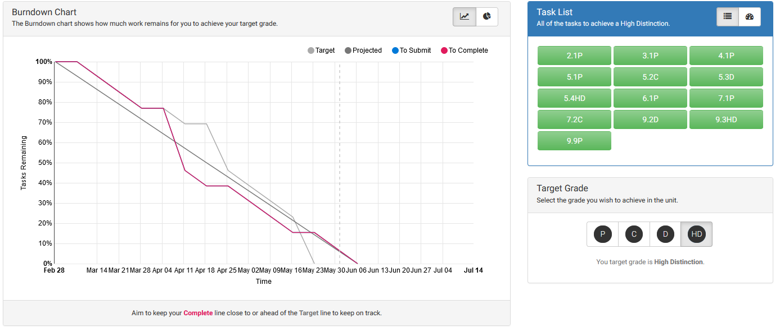

## This unit will help me in the future:

Well, to be honest, I am doing a major on cyber security. So chances of me utilizing this frame work to develop software later on, are quite less. But the SHA encryption, login setups, file and jdbc realm, and other security concepts will be extremely useful for me in the future as they would help me ensure the security aspects of different websites.

## If I did this unit again I would do the following things differently:

## Well, If I did this unit again, I would start working from the very start and not procrastinate. Furthermore I would try to attend all the labs that exist, throughout the week, in order to both resolve my problems and also to listen to everything the different tutors say and advice, instead of just waiting for my own tutorial times. That’s because doing so would help me gain new and interesting perspectives, which are very useful in both my current student life and beyond.