**SWE20001: Managing Software Projects**

**Name:** S M Ragib Rezwan

**ID:** 103172423

**Tutor:** Naveed Ali | 12.30pm Tuesday | EN310

**Is the actual effort within 10% of original estimate?**

Here the answer is yes.

In the previous 63C task, I had come to the conclusion that since the task is similar to add Item, it will also take the same time of 9 hrs and took an hr of leeway time to make it 10 hrs. This was quite beneficial as the Add sales record ended up taking 10hrs instead of expected 9 hrs. That’s because although the rest of the parts took the same time (ie create table taking 2 hrs, Design Backend Logic taking 1 hr, design GUI taking 1 hr), extra 1 hrs was needed for both Testing BackendLogic and GUI *(see in the table below the paragraph)*. That’s because here, more test checklist had been added as it had been used to confirm ISO25010’s Usability’s User Error Protection and testing them on backend and front end took up the extra time. But although it has taken 10 hrs, since that is what had been luckily estimated before (by considering leeway time), it is still within 10% of the original estimate.

|  |  |  |
| --- | --- | --- |
|  | Expected | Actual |
| Create table | 2 | 2 |
| Design Backend Logic | 1 | 1 |
| Test Backend Logic | 3 | **3.5** |
| Design GUI | 1 | 1 |
| Test GUI | 2 | **2.5** |

**Proof of Validity via screenshots:**

* On day-1: Approximately 4hr had been spent on the Add Sales task to finish working on 3 of 13 subtasks.

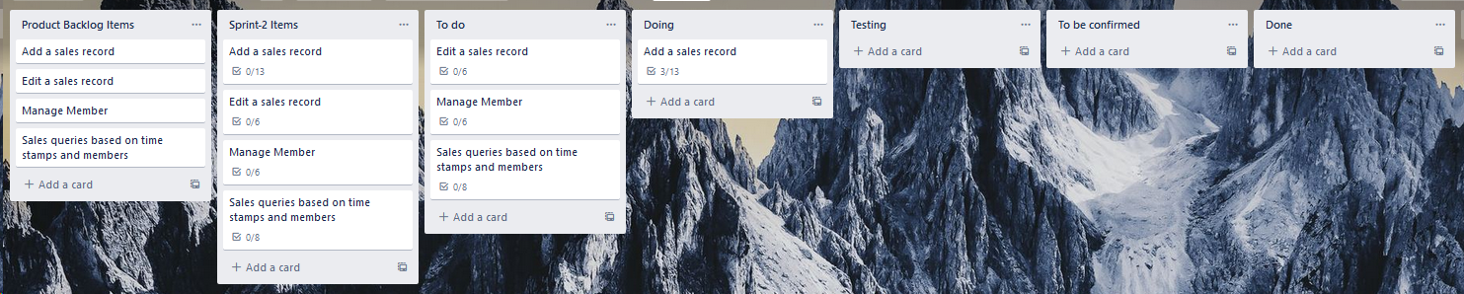

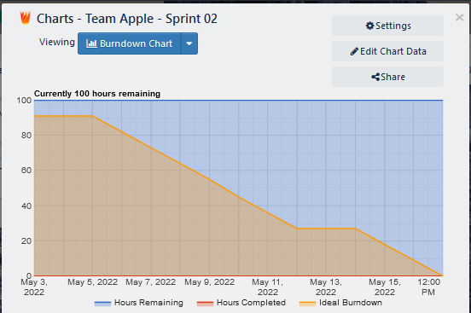

[Burndown chart at start of day 1]

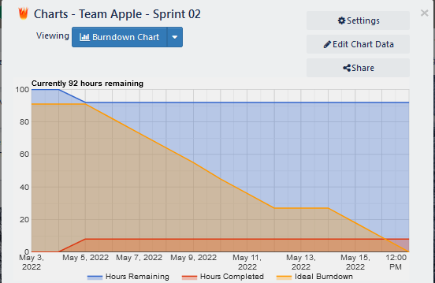

[Burndown chart at start of day 2]

* On day-2: the Remaining 6 hrs had been spent on Add Sales on this day, completing all its subtasks and also finishing up all the Quality testing checklist modules

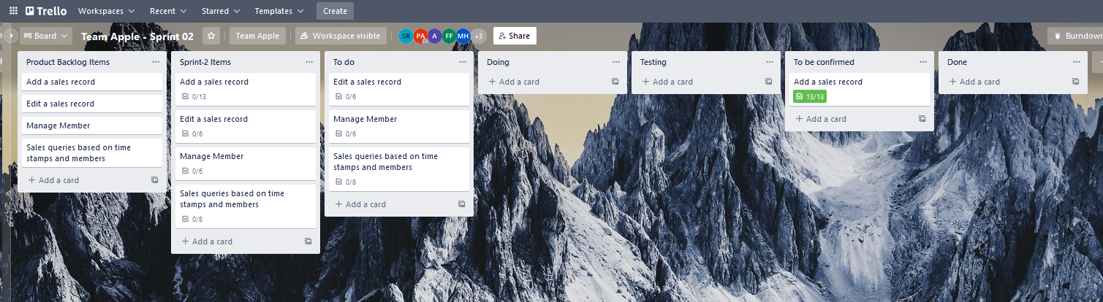



[Burndown chart at start of day 2]

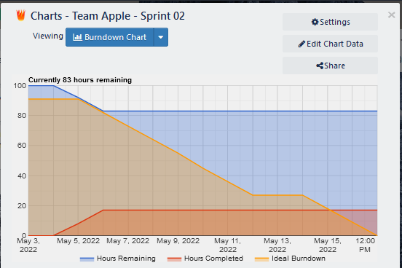

[Burndown chart at start of day 3]

So, cumulative time spent on it over days had been: 4+6 which results in **10** hrs time.