Tutorial: Data Visualisation

Please carefully read the following notes:
- You can provide your answer as an R script, Python Script, Word file, text file (notepad), or a pdf markdown with the code.
- You can use online IDEs to write and execute your code.
- You cannot open your email during the exam (your solution will not be accepted).
- Please separate the question clearly and the answers for each part within the question, for example:
################ Question 1 #####################################
###### Part 1 ########
- For the interpretations, if you want to include them in the script, please include them as a comment.

Question 1:
Part A: Give one issue only in the plot provided below and explain the consequence of this issue.
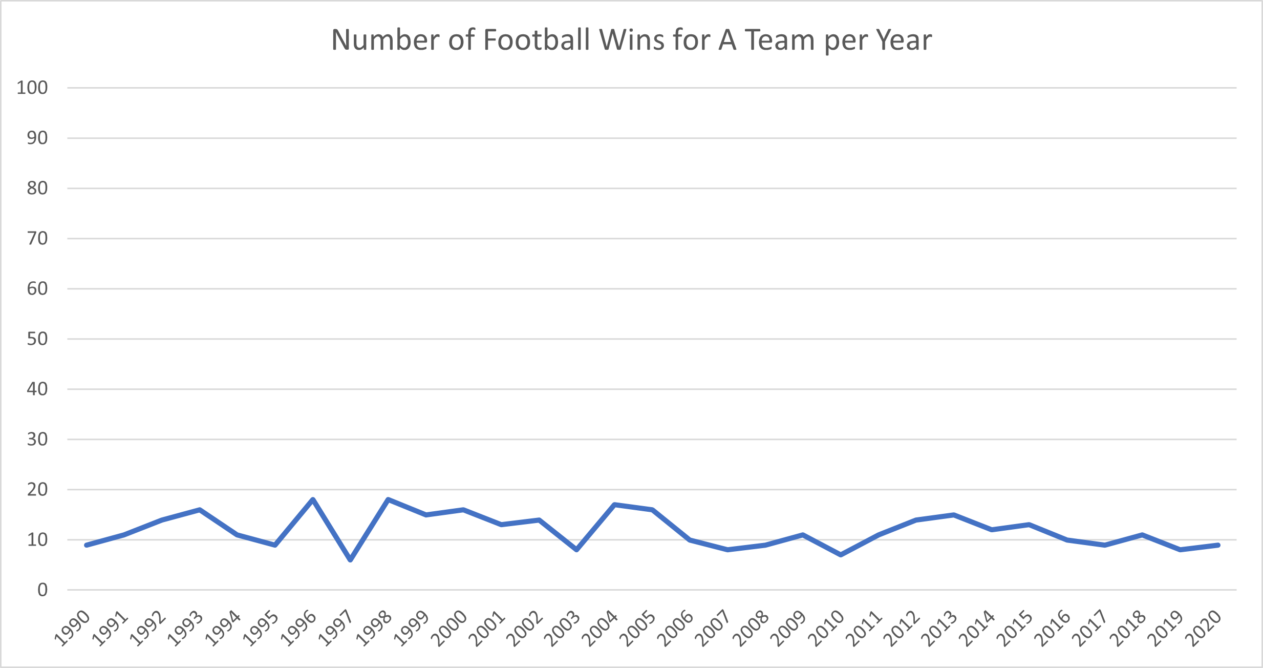

Part B: Give one issue only in the plot provided below and explain the consequence of this issue.
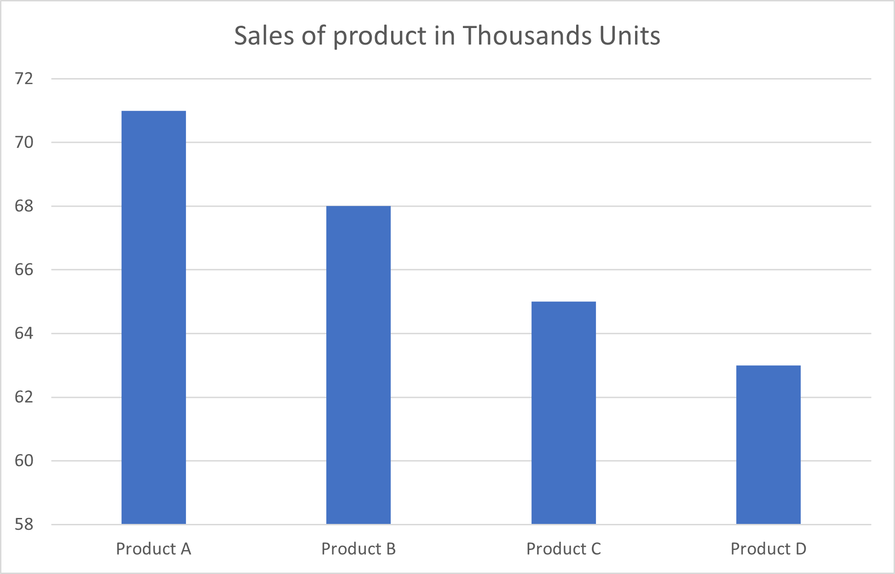

Part C: The following plot has several issues; give two issues only in the graph and the consequences of these issues.

Question 2 (12 points)

You are a data analyst hired by a football club to improve the team's results. One of the issues the manager asked you to analyse is penalties. The club provided you with 410 penalty shots taken by the league's teams in the last ten seasons. Use the dataset in the file "Question 2.csv" and the package of your choice to analyse the following case. The dataset also includes the following variables:

- ID: Unique identification for the shot taken
- Match: Unique ID for the match.
- Goal: Yes/No whether the shot is converted to a goal.
- Position: The position in the goal where the shot is placed. See the attached photo.
- Foot: The foot the player used to convert the penalty shot (right or left foot).

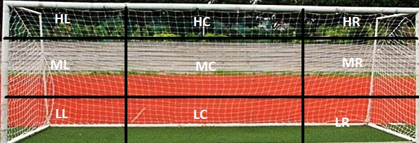

- HL: High Left
- ML: Middle Left
- LL: Low Left
- HC: High Centre
- MC: Middle Centre
- LC: Low Centre
- HR: High Right
- MR: Middle Right
- LR: Low Right

Given this information, you are asked to fulfil the following objectives:
- Produce a visualisation to show which of the nine areas has the best and the area with the worst chance of scoring a goal.
- Produce a visualisation to show which of the three main areas (Left, Middle, Right) has the best chance of scoring a goal and which has the worst chance of scoring.
- Produce a visualisation showing the relationship between the foot used to convert the penalty and the nine areas.
- In no more than 150 words, give briefly a description of your methodology and conclusion for the three visualisations above. What is your recommendation for the team's manager?

Bonus: Use statistical test(s) to provide an exploratory test to confirm the association's results or lack-off between the position/main area and the scoring (2 points).

Question 3: The dataset "Question 3.csv" contains the performance of 1,000 students in three areas (Mathematics, Reading, and Writing). In the dataset, there are other variables for the students' characteristics as follows:
- gender
  - Female
  - Male
- race/ethnicity
  - Group A
  - Group B
  - Group C
  - Group D
  - Group E
- parental level of Education
  - some high school
  - high school
  - associate's degree
  - some college
  - bachelor's degree
  - master's degree
- lunch
  - standard
  - free/reduced
- test preparation course
  - none
  - completed
- math score (out of 100)
- reading score (out of 100)
- writing score (out of 100)
Create visualisations that answer the following:
- Is there a bivariate relationship between the subjects' scores?!
- Is there a potential influence of Parental Level of Education on each subject (you can create a faceted chart or 3 side-by-side charts)?
- Is there a potential influence of lunch on the subject's score (you can create a faceted chart or 3-side-by-side charts)?
Note: Please provide an interpretation for each plot in no more than 30 words.

