ENERGY CLUSTER NORWAY
A Competitiveness and Cluster Strategy Assessment
Final Written Report | Group 1
CENTRAL THESIS
Norway’s strategic challenge is to turn inherited, petroleum-based prosperity and world-class offshore capabilities into created prosperity based on globally competitive energy technologies. Energy Cluster Norway can support this transition by closing the gap between collaboration, demonstration and commercial scale-up.
Scope: Norway’s offshore energy technology cluster, with Energy Cluster Norway as its national Institution for Collaboration.
Microeconomics of Competitiveness | Executive Management MA2 | FH Wien der WKW | WS 26/27
Lecturers: Dr. Clemens Löffler, Dr. Kinga Niemczak

Knispel, Raphael
Mitterlehner, Daniel
Orler, Tim
Schuchnigg, Elias Johannes
Szakasits-Doroszlói, Márton
Župaric, Filip Marko
Date: December 2026

Executive Summary
Energy Cluster Norway (ECN) was launched in August 2026 as a national alliance of three regional cluster organisations with more than 350 members. In this report, we analyse ECN as an Institution for Collaboration (IFC) within Norway’s wider offshore energy technology cluster, drawing on published sources and a written interview with ECN’s CEO.
Norway starts from a strong position but faces a transition challenge. In the Microeconomics of Competitiveness (MOC) framework, it sits in the “high but declining” quadrant: prosperity and labour productivity remain far above the Organisation for Economic Co-operation and Development (OECD) average, while growth was below average between 2014 and 2024. Petroleum still accounted for 57% of goods exports in 2025. The European Innovation Scoreboard (EIS) 2026 shows exceptional collaboration, but much weaker business research and development (R&D), intellectual assets, new-to-market sales and high-tech exports. This points to a gap between knowledge creation and commercial scale-up.
Hywind and Northern Lights illustrate the challenge: strong capabilities and successful demonstrations do not automatically result in commercial scale. We therefore propose “Norway as Europe’s reference location for offshore energy systems in harsh environments” as the national value proposition. The analysis leads to three priorities: convert pilots into first commercial orders, develop a national commercialisation pipeline and help technologies reach international markets. ECN’s contribution should ultimately be assessed through commercial and societal outcomes rather than activity counts.

1. Analytical Framework, Scope and Cluster Boundary
The report applies the Microeconomics of Competitiveness (MOC) framework, in which competitiveness rests on productivity and labour utilisation rather than low wages or a weak currency (Löffler & Niemczak, 2026). It moves from economic performance to the national Diamond, the cluster and strategy (Porter, 2008), and applies Creating Shared Value (CSV) where economic and societal value can both plausibly be created (Porter & Kramer, 2011).
A cluster is a geographic concentration of firms, suppliers and associated institutions in a particular field (Porter, 2008). We define the core cluster as offshore energy technology and services: firms and institutions that design, build, install, operate and decommission energy systems at sea.
Related clusters, including maritime, hydropower, process industry, aquaculture and information and communication technology (ICT), share skills, suppliers and customers with the core. Floating wind, CO₂ storage and offshore electrification are treated as core cluster segments because they share suppliers, vessels, subsea skills and operators (Porter, 2008; Löffler & Niemczak, 2026). Their market structures differ: oil and gas is mature and commercially driven, while carbon capture and storage (CCS) and floating wind still depend on state anchor demand. Exhibit 12 therefore assesses them separately.
ANALYTICAL DISTINCTION
Cluster = interconnected firms, suppliers, universities, research bodies, public institutions, finance and related industries in offshore energy technology.
ECN = one Institution for Collaboration that helps these actors coordinate and upgrade the business environment.
Levels of analysis: Norway (macro and policy context) three regional platforms (Bergen/Vestland, Stavanger/Rogaland, Oslo region) the national cluster and its IFCs.

2. Overall Economic Performance

2.1 Macroeconomic performance
Indicator | Latest evidence | Competitiveness interpretation
Prosperity | Gross domestic product (GDP) per capita approx. USD 91,000 (constant 2021 purchasing power parity [PPP], 2024); growth 2014–2024 approx. 0.9% p.a. vs. 1.8% average (Löffler & Niemczak, 2026). | Very high level, below-average growth: “high but declining”.
Labour productivity | GDP per person employed approx. USD 180,000 (2024), growth approx. 0.8% p.a. vs. 1.1% (Löffler & Niemczak, 2026); USD 100.3 per hour worked in 2025, 3rd in the OECD (OECD average: 66.3) (OECD, 2026). | High level, but the national figure includes the capital-intensive petroleum sector; growth is the weak point.
Labour utilisation | Participation approx. 64% (2020), declining 2010–2020 (Löffler & Niemczak, 2026); unemployment around 4% (International Monetary Fund, 2025). | Tight labour market; declining participation reduces available labour supply, while specialist talent remains scarce.
Growth | Total GDP +1.1%, mainland GDP +1.7% in 2025 (Statistics Norway, 2026); mainland +1.7% projected for 2026 (Ministry of Finance, 2026a). | Moderate expansion, close to trend.
Inflation and currency | Inflation converging towards 2% by 2027; weaker krone (International Monetary Fund, 2025). | A weak currency is not competitiveness (Löffler & Niemczak, 2026).
Fiscal stability | Fund spending 2.7% of fund value in 2026 (fiscal-rule benchmark: 3%), equal to 12.6% of mainland trend GDP (Ministry of Finance, 2026a, 2026b). | Exceptional buffer, but growing dependence on fund transfers.
Trade | Petroleum NOK 1,000bn = 57% of goods exports in 2025 (Norwegian Petroleum, 2026); energy-supplier exports approx. NOK 200bn (Norwegian Energy Partners, 2026). | Strong export engine with concentration risk.
Foreign direct investment (FDI) | Net inflows approx. USD 7.96bn in 2023 (World Bank, n.d.). | Volatile; not a standalone measure.
Exhibit 1. Macroeconomic snapshot of Norway. Course values are approximate readings from the MOC exhibits (Löffler & Niemczak, 2026).
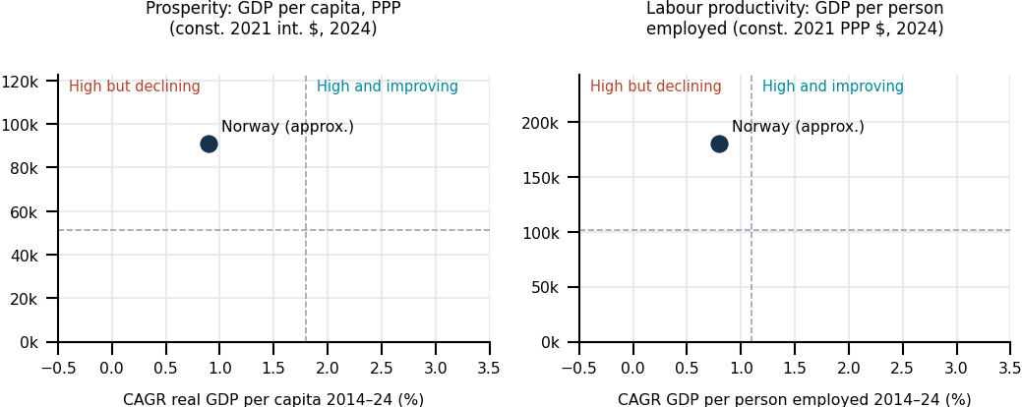
Exhibit 2. Norway in the MOC “prosperity” and “labour productivity” quadrants, 2024
Source: Löffler & Niemczak (2026), MOC course exhibits based on World Bank / ILO data. Norway’s position is read from the original charts and is approximate; dashed lines show the sample averages. CAGR = compound annual growth rate.
Norway therefore has a growth and transition problem rather than a level problem: productivity growth must increasingly come from non-petroleum activities.

2.2 Microeconomic and innovation performance
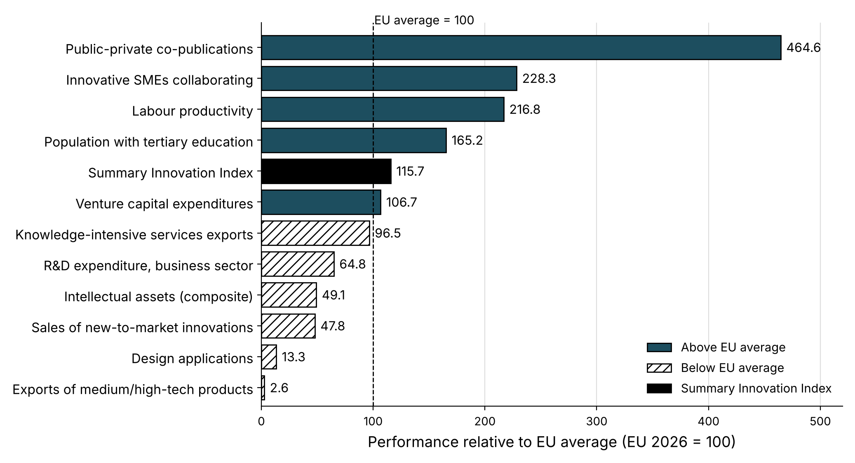
Exhibit 3. Norway in the European Innovation Scoreboard 2026 (selected indicators, EU = 100)
Source: European Commission (2026b), EIS 2026 country profile Norway. Dark bars = above EU average; hatched bars = below; black = Summary Innovation Index. SMEs = small and medium-sized enterprises.
Dimension | Evidence and reading for the cluster (EIS 2026, EU = 100)
Innovation system | Strong Innovator at 115.7% of EU average, rank 10 (−1.5 points vs. 2025) (European Commission, 2026a, 2026b). Norway trails several leading Nordic and European innovation peers.
Linkages | Linkages 236.7% (rank 2). The quantity of collaboration is not the primary constraint; its conversion into commercial outcomes appears more critical.
Firm investment | Business R&D 64.8% (rank 18). Private innovation investment is a relative constraint.
Patents and intellectual property (IP) | Intellectual assets 49.1% (rank 30). The relatively weak intellectual-asset indicators suggest limited conversion of innovation activity into protected commercial assets.
Commercial and trade outcomes | New-to-market sales 47.8% (rank 29); medium/high-tech exports rank 38 of 40. These outcomes are consistent with the proposed commercialisation gap.
Global competitiveness survey | World Economic Forum Global Competitiveness Index (WEF GCI) 2019 (latest edition): rank 17 of 141; institutions 8; social capital 3; regulatory burden 45 (World Economic Forum, 2019). Excellent institutions and trust; regulation perceived as a cost.
Exhibit 4. Microeconomic performance indicators.

2.3 Peer benchmark
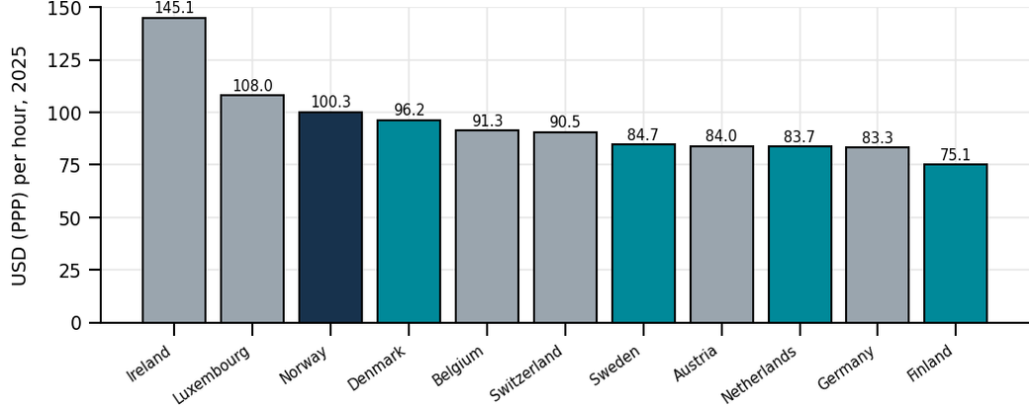
Exhibit 5. GDP per hour worked, selected European OECD economies, 2025
Source: OECD (2026), Productivity Database (GDP per hour worked, USD, constant 2020 PPP; 2025 values are estimates). Norway highlighted; Nordic and Dutch peers in teal. Norway’s figure includes the petroleum sector.
Compared with its peers Sweden, Denmark, Finland and the Netherlands, Norway has higher hourly productivity but lower and declining innovation performance (OECD, 2026; European Commission, 2026a, 2026b). As the national figure includes the petroleum sector, this reinforces the importance of broadening created prosperity beyond petroleum.
EVIDENCE INTERPRETATION
Exceptional collaboration and education, but weak business R&D, IP, new-to-market sales and high-tech exports, combined with below-average productivity growth, suggest a gap between knowledge creation and commercial scale-up.

3. Business Environment and Policy

3.1 Legacy: endowments, culture and institutions
Norway combines substantial natural endowments such as petroleum, hydropower and a long coastline with a small, highly educated population and a strong institutional legacy. It ranks 3rd for social capital and 8th for institutions (World Economic Forum, 2019). High trust and consensus-oriented, tripartite wage bargaining support cooperation and are consistent with the strong linkage indicators shown in Exhibit 3.
At the same time, the state remains a dominant economic actor: it holds 67% of Equinor, the largest operator on the continental shelf (Equinor, 2026). With inherited resources, government tends to become the central economic actor (Löffler & Niemczak, 2026); in Norway this risk is limited by strong governance, but state ownership remains relevant to demand conditions and rivalry within the cluster.

3.2 Geography and regional integration
Through the European Economic Area (EEA), Norway is part of the single market without EU membership. EU competition and state-aid rules apply under the supervision of the European Free Trade Association (EFTA) Surveillance Authority (ESA); the Utsira Nord support scheme, for example, had to be notified to ESA (offshoreWIND.biz, 2026). This provides access to the single market while constraining parts of national industrial policy.
Integration via interconnectors also has costs: NordLink raised average prices and volatility in southern Norway (Bjørndal et al., 2025). Conversely, Northern Lights, a joint venture (JV), stores CO₂ from other European countries (Northern Lights JV, 2026), an example of joint North Sea infrastructure upgrading (Löffler & Niemczak, 2026).

3.3 Macroeconomic policy
- Fiscal policy: petroleum revenues flow into the Government Pension Fund Global; spending follows the expected real return of 3% (2.7% of fund value in 2026) (Ministry of Finance, 2026a, 2026b). This framework has helped Norway manage petroleum revenues without destabilising the broader economy, but growing dependence on fund transfers may reduce pressure for microeconomic reform.
- Monetary policy: Norges Bank targets inflation with a floating krone (International Monetary Fund, 2025); a weaker krone helps exporters but is no substitute for productivity (Löffler & Niemczak, 2026).

3.4 Microeconomic policy choices
Policy area | Current approach (evidence) | Assessment
Competition and privatisation | Statoil/Equinor partially privatised (2001); state retains 67% (Equinor, 2026). | ± Professionally governed, but concentrated buying power.
Education and skills | Tertiary education 165.2% of EU average (European Commission, 2026b). | + Strong; specialist supply lags demand.
Innovation and R&D | Government support of business R&D 84.3%; public-sector R&D 99.6% (European Commission, 2026b). | ± Inputs adequate; outputs lag.
Cluster policy | Norwegian Innovation Clusters programme funds cluster organisations (Innovation Norway, n.d.). | + Mature; should focus more on commercial results.
Demand-side and energy policy | State as anchor investor and demand enabler: Longship/Northern Lights (Equinor, n.d.-b); up to NOK 35bn state aid for one 500 MW floating wind project at Utsira Nord, allocated by competition (offshoreWIND.biz, 2026). | + Creates sophisticated early demand; should not become a permanent subsidy without a credible path to competitiveness.
Regulation | Strict health, safety and environment (HSE) standards; regulatory burden ranked 45th (World Economic Forum, 2019). | ± Standards drive quality; permitting is slow.
Exhibit 6. Assessment of Norway’s microeconomic policy choices (+ supportive, ± mixed, − constraining). Source: own assessment based on the cited sources.

3.5 The national Diamond
Diamond element | Strengths (+) | Weaknesses (−) | Rating
Factor conditions | Highly educated workforce; renewable hydropower; strong institutions and trust; world-class research linkages (European Commission, 2026b; World Economic Forum, 2019). | High labour costs; specialist shortages; grid capacity and price volatility in the south (Bjørndal et al., 2025); slow permitting. | ++
Demand conditions | Strict safety and environmental standards; sophisticated public and corporate buyers. | Small domestic market; new-technology demand concentrated in a few large buyers. | +
Related and supporting industries | Dense supplier, maritime and research networks; organised clusters (Innovation Norway, n.d.). | Regional and programme fragmentation; few large technology firms outside oil and gas. | ++
Context for strategy and rivalry | Open EEA market; rule of law; venture capital available (European Commission, 2026b). | High state ownership (Equinor, 2026); low business R&D and IP; petroleum attracts capital and talent. | ±
Exhibit 7. Norway’s national Diamond. Rating: ++ strong advantage, + advantage, ± mixed, − disadvantage. Source: own assessment.
Norway’s national Diamond is strong on inputs and supporting institutions, but weaker in conditions supporting commercialisation, particularly rivalry, private investment and diversified demand which is consistent with the innovation-output gap in Section 2.

4. From Inherited to Created Prosperity
The course distinguishes inherited prosperity, limited by natural resources, from created prosperity based on productivity (Löffler & Niemczak, 2026). In Norway, petroleum also built advanced capabilities in operator competence, subsea technology and safety, and a large export-oriented supplier industry (Norwegian Energy Partners, 2026).
Inherited prosperity (resource-based) | Created prosperity (productivity-based)
Petroleum and maritime endowments offshore and subsea capability building sophisticated operators, suppliers and research institutions | Technology validation in demanding applications first commercial orders and repeatable solutions international scaling and diversified exports
Exhibit 8. From inherited to created prosperity. Source: own illustration based on Löffler & Niemczak (2026).
The EIS output indicators suggest that important constraints emerge in the later stages of this path (European Commission, 2026b).

5. In-depth Analysis of the Cluster

5.1 History: phases of cluster development
Phase | Period | Key events and capability accumulation
Hydropower and industrialisation | c. 1900–1960s | Electricity-intensive industry, engineering skills and energy governance.
Petroleum capability building | 1969–1980s | Ekofisk (1969); Statoil founded (1972); local-content policies build a domestic supplier base.
Internationalisation and deep-water sophistication | 1990s–2010s | Petroleum Fund (1990); subsea expertise exported; Statoil partially privatised (2001) (Equinor, 2026); Hywind demonstrator (2009).
Low-emission diversification | 2010s–2025 | Hywind Tampen (2022/23) (Equinor, n.d.-a); first CO₂ stored at Northern Lights (2025) (Equinor, n.d.-b); Utsira Nord project areas awarded to two consortia (2025) (Ministry of Energy, 2026).
National IFC integration | 2026 onward | ECN launched at Offshore Northern Seas (ONS) 2026 (Energy Cluster Norway, 2026).
Exhibit 9. Phases of cluster development. Source: own compilation based on the cited sources.
As in the course example of the Australian wine cluster, specialised institutions emerged after the industry had grown (Löffler & Niemczak, 2026); ECN is such an institutional upgrade, not a new cluster.

5.2 The cluster today: actors and regional platforms
The cluster centres on a few large operators, particularly Equinor as both buyer and technology developer, and a broad base of suppliers, research institutes and several hundred SMEs. The state acts as owner, regulator, investor and demand enabler. Three regional platforms form its backbone (Exhibit 10).
Region | Capability base contribution to the national cluster
Bergen / Vestland | Offshore and subsea technology, ocean industries, CO₂ terminal at Øygarden (GCE Ocean Technology, n.d.; Northern Lights JV, 2026) deep technology, supplier development, scale-up.
Stavanger / Rogaland | Operators, petroleum engineering, supplier networks, Utsira Nord (Energy Transition Norway, n.d.; Ministry of Energy, 2026) demand articulation, first-customer pathways.
Oslo / capital region | Headquarters, finance, digitalisation and artificial intelligence (AI) (Energy Valley, 2026) capital, digital capability, internationalisation.
Exhibit 10. Regional platforms of the cluster.

5.3 Cluster map
SPECIALISED SUPPLIERS  Subsea and engineering: Aker Solutions, TechnipFMC, Subsea7  Automation and maritime systems: Kongsberg  Installation vessels, equipment, digital and AI services, SMEs | CORE CLUSTER  Offshore energy technology and services  Oil & gas • Floating and fixed offshore wind • CO₂ transport and storage • Offshore electrification • Decommissioning  Operators: Equinor (67% state-owned), Aker BP, Vår Energi  Flagship assets: Hywind Tampen, Northern Lights | DEMAND AND CUSTOMERS  Operators on the Norwegian Continental Shelf  European emitters buying CO₂ storage (Yara NL, Ørsted, Stockholm Exergi)  Utilities and industrial buyers of power
KNOWLEDGE AND TALENT  Universities: NTNU, UiB, UiS, NHH, UiO  Research institutes: SINTEF, NORCE, IFE  Test sites, e.g. METCentre (Karmøy) |  | RELATED CLUSTERS  Maritime and shipbuilding • Hydropower and transmission (Statkraft, Statnett) • Process industry • Aquaculture • ICT
ENABLING INFRASTRUCTURE  Power grid and interconnectors  Ports and supply bases  CO₂ terminal at Øygarden and offshore storage |  | GOVERNMENT AND REGULATORS  Ministries of Energy and of Trade, Industry and Fisheries  Norwegian Offshore Directorate, Havtil (safety)  Gassnova, Enova, Research Council of Norway
INSTITUTIONS FOR COLLABORATION (IFCs)
Energy Cluster Norway = GCE Ocean Technology (Bergen) + Energy Transition Norway (ETN) (Stavanger) + Energy Valley (Oslo) • Offshore Norge (industry association) • Norwegian Offshore Wind (cluster) • Norwegian Energy Partners – Norwep (export promotion) • Innovation Norway / Norwegian Innovation Clusters programme
Exhibit 11. Map of Norway’s offshore energy technology cluster
Source: own illustration in the format of Porter’s cluster maps (Löffler & Niemczak, 2026; Porter, 2008); actors from Energy Cluster Norway (2026), Energy Transition Norway (n.d.), Energy Valley (2026), Equinor (n.d.-a, n.d.-b, 2026), GCE Ocean Technology (n.d.), Ministry of Energy (2026) and Northern Lights JV (2026). Selection of actors is illustrative, not exhaustive.
ECN is one IFC alongside Offshore Norge, Norwegian Offshore Wind and Norwep. To reduce institutional overlap, ECN should focus on a distinctive role: coordinating a shared national pipeline from industrial need to first order.

5.4 The cluster Diamond and levels of dynamism
Element | Assessment for the cluster | Strength | Trend
Factor conditions | World-class offshore and subsea engineering, test sites and research (linkages rank 2; European Commission, 2026b); scarce specialist talent; grid capacity limits electrification (Bjørndal et al., 2025). | ++ | →
Demand conditions | Very sophisticated for oil and gas; for CCS and floating wind, early deployment depends strongly on public support and anchor demand. Cross-border CCS demand is emerging (Northern Lights JV, 2026); while commercial floating-wind deployment remains dependent on the Utsira Nord state-aid competition (Ministry of Energy, 2026). | + | ↑ CCS / → wind
Related and supporting industries | Maritime, power and process industries allow recombination into new applications; ECN (>350 members) reduces regional fragmentation (Energy Cluster Norway, 2026). | ++ | ↑
Strategy, structure and rivalry | Strong technical rivalry among suppliers, but few, powerful buyers (Equinor 67% state-owned; Equinor, 2026); low business R&D and IP (European Commission, 2026b); scale-ups often remain project-based. | ± | →
Exhibit 12. Cluster Diamond with levels of dynamism. Strength: ++ strong, + good, ± mixed. Trend: ↑ improving, → stable, ↓ weakening. Source: own assessment.
Supporting industries and CCS demand are improving, while rivalry and private investment have not changed. The evidence suggests that a weak link is demand for new technology at commercial scale. Buyer concentration and state-supported projects appear to influence whether demonstrations progress toward commercial deployment.

5.5 ECN integration in practice: insights from its CEO
To complement published sources, we asked ECN’s CEO, Owe Hagesæther, how the integration works in practice. Three points stand out. First, the operating model was built bottom-up: ECN interviewed more than 100 companies on which services to offer and how to finance them, and consulted universities, investors and politicians on a model all parties could support. Second, governance is deliberately balanced: each founding cluster holds one third of the shares and three board seats, while the CEO and management are selected on qualifications, with all three regions represented. Third, services are distributed rather than duplicated: the MIT-based scale-up programme runs in Bergen and Boston, whereas the Technical Committee, which evaluates innovations technically and commercially, is based in Stavanger but open to members nationwide. By the end of 2027, all regional operations are to be integrated into ECN, with offices in Bergen, Stavanger and Oslo; securing the funding model in spring 2027 is the second key milestone. ECN currently judges success by these milestones and by member feedback. This supports our recommendation to add outcome indicators such as pilot-to-order conversion (Exhibit 19).

6. Strategic Issues and Existing Policies
As the cluster is not a single industry, we assess cluster-wide constraints rather than Five Forces (Exhibit 13).
Strategic issue (Diamond element) | Policies in place | Gap
1. Commercialisation gap (rivalry; demand) | R&D support, grants, cluster programme (Innovation Norway, n.d.). | Input-focused; few incentives tied to orders, IP or exports.
2. Buyer concentration (demand) | ETN Technical Committee (Energy Transition Norway, n.d.); state anchor projects (Equinor, n.d.-b). | No transparent route from pilot to procurement.
3. Talent competition (factors) | Strong universities and applied programmes. | Petroleum still pays more; vocational supply lags.
4. Grid and infrastructure (factors) | Statnett grid planning; NVE analyses (offshoreWIND.biz, 2026). | Grid capacity, interconnector politics, slow permitting (Bjørndal et al., 2025).
5. Regional fragmentation (related industries) | ECN; equal ownership and board seats; full integration by end-2027 (Section 5.5). | Funding model (spring 2027) and a shared data model still open.
6. Scale-up and internationalisation (rivalry; demand) | Norwep export promotion; ECN scale-up programmes (Norwegian Energy Partners, 2026). | Export finance and market validation come too late.
7. Dependence on fund transfers (macro context) | Fiscal rule: 3% expected return (Ministry of Finance, 2026b). | No link to microeconomic upgrading.
Exhibit 13. Strategic issues mapped to the Diamond and existing policies. Source: own analysis.
These issues interact: a demonstration without a procurement route uses scarce talent but produces no revenue, IP or export reference.

7. Creating Shared Value
Creating Shared Value means advancing economic and societal value simultaneously through the business model (Porter & Kramer, 2011). Two Norwegian examples illustrate this:
- Yara invested USD 60 million in African ports and roads, strengthening both an agricultural cluster and its own market (Porter & Kramer, 2011).
- Northern Lights sells CO₂ storage as a service, cutting emissions while creating a new export business (Northern Lights JV, 2026).
Domain | Economic value | Societal value
Subsea CCS | Service revenue, supplier growth, subsea IP, exports. | Decarbonisation of hard-to-abate industry.
Floating offshore wind | Engineering, installation and lifecycle services. | Renewable power, energy security, lower regional power prices (offshoreWIND.biz, 2026).
Electrification and asset-focused AI | Equipment, software, system integration, exportable digital services. | Lower emissions, better grid use, energy efficiency.
Exhibit 14. Shared value opportunities in the cluster. Source: own analysis based on Porter & Kramer (2011).

8. National Value Proposition and Cluster Strategy

8.1 Value proposition
A national value proposition combines unique advantages, a regional role and cluster priorities, and states what not to do (Löffler & Niemczak, 2026).
VALUE PROPOSITION
Norway as Europe’s reference location for offshore energy systems in harsh environments: the place where offshore energy technologies are proven, scaled and exported, from oil and gas to floating wind, CO₂ storage and offshore electrification.
Dimension | Content
Unique advantages | Offshore and subsea engineering; harsh-environment operations and safety; complex energy-system integration; trust-based collaboration; stable institutions.
Role in the region and the world | Energy-security partner and CO₂ storage provider for Europe; North Sea test bed for floating wind; exporter of offshore services.
Cluster priorities | Strengthen the core cluster and related clusters rather than unrelated new industries.
What Norway should not do | No subsidy race for mass manufacturing where Norway has no demonstrated cost or scale advantage. Avoid unnecessary regional duplication of test infrastructure. Avoid permanent operating subsidies where projects cannot demonstrate a credible path to competitiveness. Avoid distributing public funding evenly across technology pathways irrespective of demonstrated capabilities and commercial potential.
Exhibit 15. National value proposition. Source: own analysis based on Löffler & Niemczak (2026).

Prioritising without “picking winners”
Sound cluster policy does not pick winners (Löffler & Niemczak, 2026). Our priorities rest on capabilities, not technologies: the state funds shared infrastructure, open challenges and common gates, while the market selects technologies and firms.

8.2 Evidence: two Norwegian pilot-to-scale paths
 | Hywind (floating wind) | Northern Lights (CCS)
Pilot | Demonstrator off Karmøy (2009). | Longship CCS; investment decision 2020 (Equinor, n.d.-b).
Deployment / first customer | Operator-backed deployment: Hywind Tampen powers Equinor’s Snorre and Gullfaks fields (2022/23) (Equinor, n.d.-a). | State-supported Norwegian emitters (Northern Lights JV, 2026).
Next scale step | Utsira Nord: two consortia were awarded project areas in 2025; the subsequent state-aid competition will determine the supported project, with aid capped at NOK 35bn (Ministry of Energy, 2026; offshoreWIND.biz, 2026). | Contracts with emitters in the Netherlands, Denmark and Sweden; phase 2 to raise capacity from 1.5 to at least 5 Mt CO₂/year (Equinor, n.d.-b).
Lesson | Scaling remains policy-dependent: the Utsira Nord terms were revised in 2026 amid concerns about an immature supply chain. (offshoreWIND.biz, 2026). | Anchor customers plus an export market turned a public project into a commercial service.
Exhibit 16. Two pilot-to-scale paths in the cluster. Source: own compilation based on the cited sources.

8.3 Strategic priorities

Priority 1: Convert pilots into first commercial orders
- Introduce a common six-gate process: (1) verified industrial need, (2) capable consortium, (3) technical validation, (4) demonstration, (5) first commercial order, (6) international scale-up.
- Before the demonstration gate, name a lead customer, purchasing criteria and procurement route; measure conversion rather than activity.

Priority 2: Build one national commercialisation pipeline
- Shared portfolio governance, common gates and stop/continue decisions across the three regions, while regional teams keep their industry relationships.
- National challenge roadmaps that define needs without pre-selecting technologies.

Priority 3: Scale successful technologies internationally
- Involve Norwep, export finance and North Sea partners before the first demonstration is complete, following the Northern Lights model.
- Build repeatable products, IP strategies and lifecycle services instead of one-off projects.

9. Policy Recommendations by Actor
Actor | Recommendations
National government | Stage innovation funding against maturity-appropriate milestones, progressing from technical validation toward IP, customer commitment, orders and exports. Use public procurement and state ownership to create transparent first-customer routes through competition-neutral mechanisms consistent with EEA state-aid and procurement rules. Speed up permitting; include distribution effects in interconnector cost-benefit rules (Clean Energy Wire, 2026); keep the fiscal rule while funding shared infrastructure.
Regional government | Align skills strategies with industry demand; plan ports and sites jointly; avoid duplicate test facilities.
Local government | Municipalities such as Øygarden or Haugesund: zoning and land for terminals and supply bases; fast local permitting; housing for specialists; early community involvement.
Private sector | Publish technology needs; commit procurement decision-makers to gate reviews; co-fund demonstrations; adopt shared value strategies (Porter & Kramer, 2011).
Universities and research institutes | Challenge-based research and education; standard IP templates; commercialisation training; industry mobility.
Trade associations | Common standards; aggregated regulatory feedback; market intelligence; precompetitive collaboration.
IFCs (incl. ECN) | Run the national pipeline, gate reviews and shared data model; agree a clear division of roles with other IFCs; measure conversion and exports.
Exhibit 17. Policy recommendations by actor. Source: own analysis.

10. Implementation Roadmap and Scorecard
Phase | Priority actions | Evidence of progress
0–12 months | ECN governance for 2027; challenge map; gate criteria; 2026–2027 portfolio baseline. | Data model, documented gates, baseline conversion data.
12–36 months | Challenge-based calls; cross-regional consortia; lead customers; co-funded demonstrations. | More projects with purchasing criteria and private co-finance.
36–60 months | Scale successful solutions; repeat procurement; target-market partnerships; stop weak projects. | First deployments, repeat orders, export contracts.
Exhibit 18. Implementation roadmap.
Strategic priority | Core indicators
Pilots into orders | Share of projects with named lead buyer; pilot-to-order conversion; time from demonstration to decision.
One national pipeline | Time from need to pilot; cross-regional projects; private funding per unit of public support.
International scale-up | Repeat orders; export revenue; follow-on investment; EIS output indicators (European Commission, 2026b).
Shared value | Verified emission or energy savings; supplier growth; skills development.
Exhibit 19. Scorecard. Targets should be set once the 2026–2027 baseline is available.

Conclusion
Norway is rich, well governed and highly collaborative, but its prosperity and productivity growth are below average, and it trails leading Nordic and European innovation peers.
Hywind and Northern Lights show that technical validation alone is insufficient. Scale-up required an operator-backed deployment pathway for Hywind and anchor customers with cross-border demand for Northern Lights. ECN should establish one national pipeline with shared gates and outcome-based measurement to strengthen Norway’s position as Europe’s reference location for offshore energy systems.

Bibliography
Bjørndal, E., Bjørndal, M., Hovdahl, I., & Tselika, K. (2025). European market integration and price convergence: A panel quantile regression analysis of NordLink (Discussion Paper 2025/19). Norwegian School of Economics (NHH), Department of Business and Management Science. https://ideas.repec.org/p/hhs/nhhfms/2025_019.html
Clean Energy Wire. (2026, May 15). Uneven benefits of German-Norwegian electricity link show need for coordinated policy responses. https://www.cleanenergywire.org/news/uneven-benefits-german-norwegian-electricity-link-show-need-coordinated-policy-responses-report
Energy Cluster Norway. (2026). Official website. https://energyclusternorway.no/
Energy Transition Norway. (n.d.). About and Technical Committee. https://www.energytransitionnorway.no/about
Energy Valley. (2026). Energy Cluster Norway – launched at ONS 2026. https://energyvalley.no/energy-cluster-norway-launched-at-ons-2026/
Equinor. (n.d.-a). Hywind Tampen. https://www.equinor.com/energy/hywind-tampen
Equinor. (n.d.-b). The Northern Lights project. https://www.equinor.com/energy/northern-lights
Equinor. (2026). Our shareholders. https://www.equinor.com/investors/our-shareholders
European Commission. (2026a). European Innovation Scoreboard 2026. https://research-and-innovation.ec.europa.eu/statistics/performance-indicators/european-innovation-scoreboard_en
European Commission. (2026b). European Innovation Scoreboard 2026: Country profile Norway. https://ec.europa.eu/assets/rtd/eis/2026/ec_rtd_eis-country-profile-no.pdf
GCE Ocean Technology. (n.d.). About us. https://www.gceocean.no/about-us
Innovation Norway. (n.d.). Norwegian Innovation Clusters: Programme description. https://nic.innovasjonnorge.no/artikkel/english
International Monetary Fund. (2025). Norway: 2025 Article IV Consultation (Country Report No. 25/248). https://www.imf.org/en/Countries/NOR
Löffler, C., & Niemczak, K. (2026). Microeconomics of Competitiveness: Overview of the course framework [Lecture slides]. FH Wien der WKW.
Ministry of Energy. (2026). Utsira Nord. https://www.regjeringen.no/en/topics/energy/renewable-energy/havvind/utsira-nord/id3052997/
Ministry of Finance. (2026a). Key figures in the Revised National Budget 2026. https://www.regjeringen.no/en/whats-new/key-figures-in-the-revised-national-budget-2026/id3158931/
Ministry of Finance. (2026b). Meld. St. 7 (2025–2026): The Government Pension Fund. https://www.regjeringen.no/no/documents/meld.-st.-7-2025-2026/id3155109/
Northern Lights JV. (2026). Northern Lights has injected first CO₂ from wastewater. https://norlights.com/news/northern-lights-has-injected-first-co%e2%82%82-from-wastewater/
Norwegian Energy Partners. (2026). Norwegian energy supplier industry export statistics. https://www.norwep.com/
Norwegian Petroleum / Ministry of Energy. (2026). Exports of Norwegian oil and gas. https://www.norskpetroleum.no/en/
OECD. (2026). Productivity statistics: GDP per hour worked (USD, constant 2020 PPP) [Data set]. OECD Productivity Database. https://www.oecd.org/en/data/indicators/gdp-per-hour-worked.html
offshoreWIND.biz. (2026, October 9). Norway revises Utsira Nord floating wind support terms. https://www.offshorewind.biz/2026/10/09/norway-revises-utsira-nord-floating-wind-support-terms
Porter, M. E. (2008). On Competition (Updated and expanded ed.). Boston: Harvard Business School Publishing.
Porter, M. E., & Kramer, M. R. (2011). Creating shared value. Harvard Business Review, 89(1/2), 62–77.
Statistics Norway. (2026). National accounts, updated 27 August 2026. https://www.ssb.no/en/nasjonalregnskap-og-konjunkturer/nasjonalregnskap
World Bank. (n.d.). Foreign direct investment, net inflows (BoP, current US$) [Data set]. https://data.worldbank.org/indicator/BX.KLT.DINV.CD.WD
World Economic Forum. (2019). The Global Competitiveness Report 2019: Economy profile Norway. https://www3.weforum.org/docs/WEF_GCI4_2019_Profile_Norway.pdf

O. Hagesæther, CEO of Energy Cluster Norway and GCE Ocean Technology, written interview by e-mail, 25th October 2026. Cited by name with permission.

