Evidence for the Jelly Ocean Hypothesis in the Northwest Atlantic
Nicholas R. Record^{1,*}, Benjamin Tupper¹, Omi Johnson¹, Laura Ganley²
¹Bigelow Laboratory for Ocean Sciences, East Boothbay ME 04544, USA
²New England Aquarium, Boston MA 02110, USA
*corresponding author: nrecord@bigelow.org

Abstract
The Jelly Ocean Hypothesis posits that gelatinous zooplankton populations are increasing worldwide as a result of changing ocean conditions. This hypothesis has been the subject of debate in ocean science. We used time series analyses and a species distribution model to examine data from a 50-year survey of gelatinous zooplankton taxa in the Northeast US Continental Shelf ecosystem. Time series analysis showed statistically significant increases in salps, siphonophores, and coelenterates (scyphozoans) in late summer and early autumn across the entire study region. Boosted regression tree models showed the probability of occurrence across gelatinous taxa were primarily associated with day length, change in day length surface and bottom temperature, and surface oxygen, with some additional taxon-specific associations. These results provide one line of evidence in favor of a long-term rise in gelatinous species. The roughly synchronized increases in these widely diverse taxa suggest that changes in environmental or ecological conditions favor a gelatinous body plan generally.

Introduction
In zooplankton ecology, there has often been a “crustaceocentric” bias: gelatinous species, collectively termed gelata, have been underemphasized as compared to crustaceans (Haddock 2004). In the early 2000s, gelata moved into the spotlight, following conspicuous blooms that damaged fisheries (Kideys et al. 2005), aquaculture (Clinton et al. 2021), energy production (Wang et al. 2023), and recreation (Nunes et al. 2015). In addition to motivating new research on gelata, these events raised the question of whether there was a larger pattern of change.
Emerging from a series of studies was the Jelly Ocean Hypothesis, which posits that gelatinous zooplankton populations are increasing worldwide as a result of changing ocean conditions. Proposed causes are primarily human-driven, including warming [(Gibbons and Richardson 2008); Richardson et al. (2009)], eutrophication, translocation (Kideys et al. 2005), overfishing, bottom trawling (Qiu 2014), pollution, aquaculture, and acidification (Richardson and Gibbons 2008). There is also evidence that shifts toward the dominance of gelata are difficult to reverse because of dynamics like hysteresis (Richardson et al. 2009). The Jelly Ocean Hypothesis echoes a centuries-old concern; the 19th century novelist Jules Verne once predicted that, “crowded with jellyfish, squid, and other devilfish, the oceans will have become huge centers of infection” (Verne 2006). While the term “infection” might be unfair to jellyfish, who simply inhabit the ocean, the potential influence on human industry and recreation makes the question worthy of examination.
Testing the Jelly Ocean Hypothesis requires long time series (>30 years) of gelata abundances in order to compare current levels to historical levels. The sporadic nature of such datasets has left the Jelly Ocean Hypothesis largely unsupported (Condon et al. 2012). In lieu of time series, studies have used qualitative data, such as news reports, to argue that gelata are increasing globally (Brotz et al. 2012). However, it is difficult to distinguish these perceived increases from multi-annual or multi-decadal fluctuations. A recent meta-analysis of time series showed that most perceived increases appear to reflect a ~20 year cyclicity, with a worldwide upswing in the 1990s that coincided with the increase in concern over gelata (Condon et al. 2013), although some notable long-term increases in gelata were not included in the analysis (Atkinson et al. 2004). A metaanalysis of a corpus of research on this topic found flawed citations and misinterpreted conclusions (Sanz-Martin et al. 2016), and at this point, the Jelly Ocean Hypothesis remains an open question.
In some ways, the Jelly Ocean Hypothesis is loosely posed. Gelata are taxonomically very diverse, encompassing multiple phyla. This diversity confounds attempts to quantify increasing trends. The list of species classified under the gelatinous umbrella varies based on the source, and includes taxa with drastic and important differences in their life histories, trophic positions, and ecological roles. For example, pelagic ctenophores are primarily copepod predators, whereas pelagic tunicates graze some of the smallest microbes. Cnidarians and ctenophores are the two most common taxa to group together in analysis, and yet they are phylogenetically very distant (Moroz 2014). Perhaps the only characteristic common to the many gelatinous phyla is a body with a high water content, alternatively expressed as a low carbon:volume ratio. There is no a priori reason to expect that phyla with such striking differences and perhaps only a superficial similarity should be grouped together with respect to their temporal trends.
On the other hand, despite their major differences, there is some evidence that a diverse collection of gelata can vary together (Condon et al. 2013). If so, it is possible that certain conditions can favor the gelatinous body form in general over other strategies that utilize a high carbon:volume ratio (e.g. crustaceans). This position would reframe the Jelly Ocean Hypothesis in trait-based terms: conditions in the ocean ecosystem can shift to benefit the gelatinous body form. The effect would be inclusive of gelata in general, despite differences in phylogeny, trophic position, or other life history traits.
We revisited the Jelly Ocean Hypothesis using a 50-year survey on the Northeast US Continental Shelf. We addressed two main questions: 1) what are the temporal changes in gelata presence; and 2) what are the underlying conditions associated with these changes. We examined three taxonomic groups well-represented in the dataset–siphonophores, salps, and coelenterates (scyphozoans)–to explore the idea that certain conditions can favor the gelatinous body plan in general.

Methods

Survey Data
The Northeast Fisheries Science Center Ecosystem Monitoring (ECOMON) program has collected seasonal zooplankton measurements since 1977 as part of its mission to monitor and assess the Northeast Continental Shelf ecosystem (Figure 1). Sampling includes oblique tows using a 61 cm bongo net fitted with a 333 µm mesh at stratified locations across the shelf. Tows are a minimum of five minutes in duration and sample from the surface to within 5 m of the seabed or to a maximum depth of 200 m. A mechanical flowmeter fitted in the mouth of each net is used to quantify seawater volume sampled. Gelatinous zooplankton are identified into broad taxonomic groups, including siphonophores, ctenophores, salps, and coelenterates. While “coelenterates” is an outdated term, the classification has been consistent over the duration of the survey, and this category represents scyphozoans. The broad groupings, while missing taxonomic detail, have allowed for internal consistency over the duration of the survey. Because of the absence of high taxonomic resolution, or any information on animal size in the samples, we used presence or absence of each taxonomic group in the analysis. We also did not include ctenophores in the analysis because of low representation in the dataset.
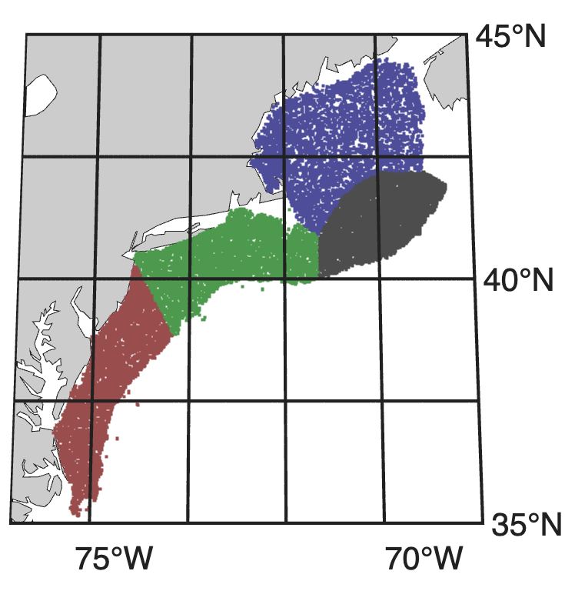
Figure 1. Map of the Northeast US Continental Shelf ecosystem. Points indicate sampling locations colored by the four polygons: Gulf of Maine (blue; 7,847 samples), Georges Bank (grey; 9,803 samples), New York Bight (green; 8,442 samples), and Mid-Atlantic Bight (red; 6,959 samples).

Time series analysis
The ECOMON survey has varied in seasonal frequency over its duration. To correct for seasonal aliasing and spatial bias, we grouped samples by large spatial polygons that represent different habitats and analyzed the time series by month. Polygons include: Gulf of Maine, Georges Bank, New York Bight, and Mid Atlantic Bight (Walsh et al. 2015). We tracked the proportion of samples in a region and in a time period that contained presences, and we tested for statistically significant increases in the proportion of gelata presence over time using a bivariate correlation test against year.

Spatial analysis
To test for environmental associations with the occurrence of gelatinous taxa across the study domain, we developed used a boosted regression tree algorithm for each taxonomic group. We used physical covariates from the Global Ocean Physics Reanalysis (GLORYS) and biogeochemical covariates from the Operational Mercator Ocean biogeochemical global ocean analysis (NEMO) obtained from the Copernicus repository (copernicus.eu). These products provide daily temporal resolution and 1/12 and 1/4 spatial degree resolution, respectively. Physical covariates included: sea surface temperature, sea bottom temperature, sea surface salinity, mixed layer thickness, and surface velocity magnitude. Biogeochemical covariates included: surface chlorophyll a, surface net primary productivity, surface oxygen, surface nitrate, surface phosphate, and surface silicate. We also included bathymetric depth and seabed slope. To determine the best way to represent seasonal dependencies, we conducted a series of experiments using predictors such as month, a rolling seasonality index, and the height and angle of the sun. Models using day length and the time derivative of day length had the strongest performance metrics, so we included those two covariates as well in subsequent analysis.
A common threshold for covariate removal due to cross-correlation is an r-squared value of 0.7. Because removal of covariates leads to information loss and decreased predictive power in tree-based algorithms (Hanberry 2024), we kept all covariates. However, we included this information in our interpretation and conducted additional model runs to test the effect of cross-correlation. Pairs of covariates that crossed this threshold were: bathymetric depth against bathymetric slope (0.71), surface temperature against surface oxygen (0.89), surface temperature against day-length time derivative (0,79), surface chlorophyll-a against net primary productivity (0.81), and surface oxygen against day-length time derivative (0.77). Because of the high correlation between sea surface temperature and surface oxygen, and the physical relationship between the two (water temperature is related to oxygen content), we conducted a second set of runs using subsurface oxygen, taxen from 100 m depth (below the mixed layer), in place of surface oxygen. This change limited the extent of the model domain for these runs.
Boosted regression trees are less prone to overfitting and well suited to data with sharp jumps or thresholds, as is the case for the gelatinous zooplankton data (Elith et al. 2005). We modeled the likelihood of occurrence of each taxon using tidymodels workflows within the R programming language, optimizing the inbuilt area-under-curve (AUC) metric (Fielding and Bell 1997; Kuhn and Wickham 2020). We used a set of hyperparameters optimized in a previous study that used the same dataset and methodology (Johnson et al. 2025); this choice was made following a separate tuning simulation that proved the resulting models highly insensitive to hyperparameters. We used a testing split of 25%, and ran a 25-fold cross-validated model to quantify algorithmic uncertainty around the median output. We used custom-built response curves (Johnson et al. 2025) to interpret associations between model response and variations in environmental covariates (Elith et al. 2005).

Results

Time series analysis
Over almost five decades of measurements, there were consistent patterns of statistically significant increases in the recorded presence of gelatinous taxa (Figure 2, S1). While the survey does not cover every month in every year, there is enough coverage across seasons for consistent patterns to be clear. Out of 144 month-region combinations, 56 (39%) indicate a statistically significant increase (p < 0.05) and zero (0%) indicate a statistically significant decrease. Considering only the months of August-November, 40 of the 48 time series (83%) show a statistically significant increase (Figure 2).
Trend results during other times of year were mixed. On Georges Bank, there were statistically significant increases across the spring months for siphonophores and coelenterates. For the other combinations of taxa, regions, and months, there were no consistent patterns (Figure S1).
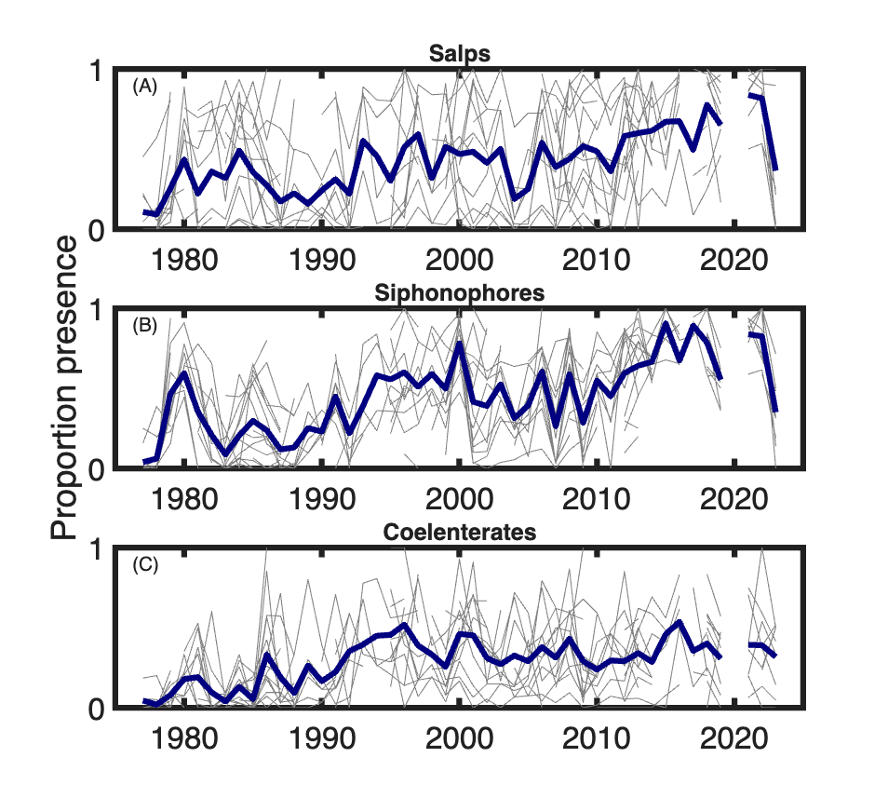
Figure 2. The proportion of presences for each taxon for each month August - November and for each region individually (thin grey lines), and the average of all shown time series (thick lines). Full time series breakdowns are in supplementary figure S1

Spatial analysis
Across the three taxonomic groups, the boosted regression tree distribution model performed well. The coelenterates model had an AUC value of 0.79, an accuracy of 0.77, and an F-score of 0.49. The salps model had an AUC value of 0.93, an accuracy of 0.89, and an F-score of 0.72. The siphonophores model had an AUC value of 0.83, an accuracy of 0.77, and an F-score of 0.63. The model tended to favor specificity over sensitivity over all runs.
Covariate associations broke up approximately into three tiers. The covariates with consistently high contributions across taxa were surface and bottom temperature, surface oxygen, day length, and the change (time derivative) of day length (Table 1). A middle tier of covariates included depth, surface salinity, and surface phosphate. The remaining covariates had consistently low contributions. Comparing across taxa, salps had just three covariates – surface temperature,surface oxygen, and change in day length – contributing the majority, whereas the other two taxa had a more even distribution across covatariates.
We computed the mean response across the ensemble of runs for each covariate (Figure S2-4). Salps had a positive monotonic response to temperature at the surface and at depth, while the other taxa had broad modes of positive temperature response. For salps and siphonophores, and to some degree for coelenterates, the response increased at very low oxygen values. Because of the strong connection between surface oxygen and surface temperature, we ran a series of tests using oxygen at 100 m, below the mixed layer. These patterns persisted. Some of the covariates with smaller contributions showed stable response curves across taxa. The response to phosphate had a single mode that was similar across all three taxa (betwen 0.1 and 0.25 mmol m-3).
Table 1. Covariate contribution (%) by taxonomic group. Values are ordered by average contribution across taxa, from highest to lowest. Values represent the mean of all ensemble runs.
Variable | Salps | Coelenterates | Siphonophores
Day length change (h day-1) | 16 | 12 | 13
Surface temperature (°C) | 21 | 8 | 6
Surface O2 (mmol m-3) | 19 | 6 | 9
Day length (h) | 6 | 13 | 8
Bottom temperature (°C) | 9 | 6 | 11
Depth (m) | 2 | 9 | 12
Surface PO4 (mmol m-3) | 6 | 6 | 6
Surface salinity (psu) | 3 | 6 | 8
Surface Si (mmol m-3) | 2 | 6 | 5
Seabed slope | 2 | 4 | 5
Surface chlorophyll (mg m-3) | 2 | 5 | 4
Surface height (m) | 3 | 4 | 4
Surface NO3 (mmol m-3) | 2 | 5 | 4
Surface net primary productivity (mg m-3 day-1) | 2 | 3 | 2
Surface velocity (m s-1) | 2 | 3 | 2
Mixed layer thickness (m) | 2 | 3 | 2
Model output for the three taxonomic groups had distinct seasonal cycles (Figure 3, S5-7). Salps were absent in the winter and spring, with a strong bloom in the autumn. The bloom was strongest in the Mid-Atlantic Bight, where nearly all samples contained salps, and extended northeast over Georges Bank, while presence remained generally low in the Gulf of Maine. Coelenterates were present year-round in most nearshore areas and generally absent over deeper waters, with minimum occurrence in the winter. Siphonophores had a more northerly range, with higher presence in deeper waters and a notably high presence over the continental slope in autumn.
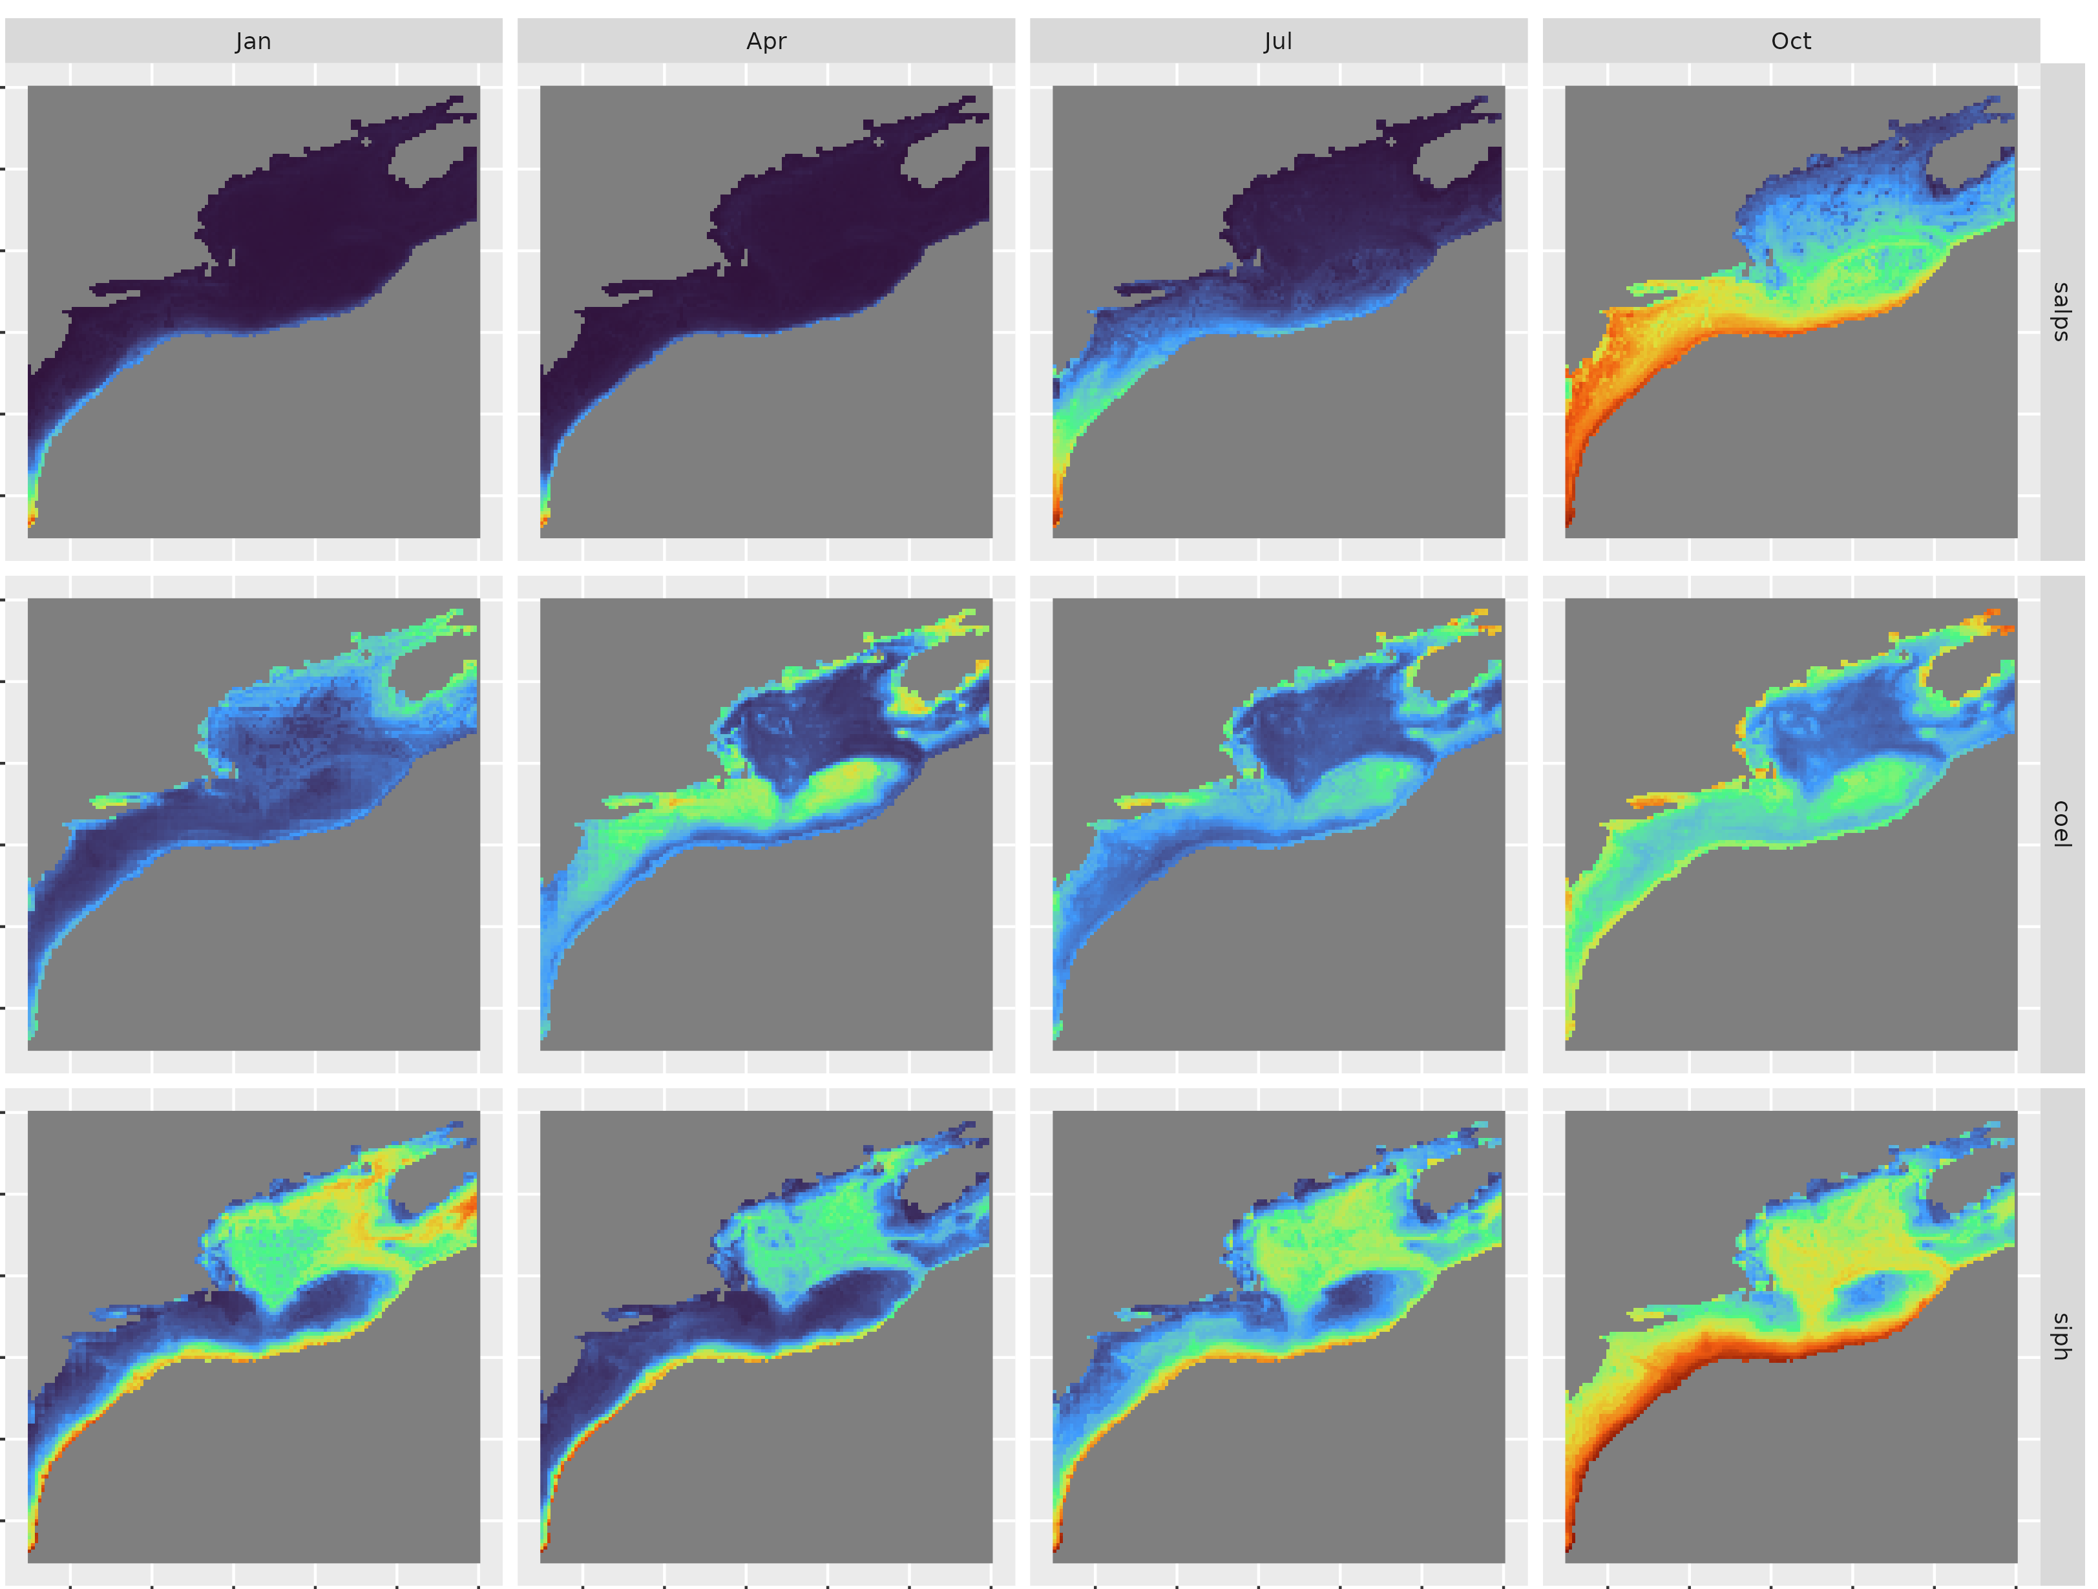
Figure 3. Model response averaged into climatologies for the three gelata taxa over the Northeast US Continental Shelf ecosystem. Example climatologies showing the months of January, April, July, and October (columns)–for salps, coelenterates, and siphonophores (rows). The full climatology for each taxon is in the supplement (Figures S5-S7).

Discussion
Large aggregations of gelata can appear suddenly and often inspire widespread public interest (Record, Tupper, and Pershing 2018). These aggregations have occurred in the Northeast US Continental Shelf ecosystem, prompting the same questions that underlie the Jelly Ocean Hypothesis: Are jellyfish (gelata) increasing, and if so, what is the cause? For this region, we found spatially widespread statistically significant increases in gelata over fifty years, particularly during the late summer and autumn months (August through November). Notably, in the northern regions and in this late seasonal period, salps and siphonophores went from being rare in the early years to being nearly omnipresent in the recent years.
Determing the causal underpinnings of increased gelata is more complicated. The Northeast US Continental Shelf ecosystem has undergone notable oceanographic changes over the past fifty years, some of which are apparent in the gelata time series. There was a decadal shift among copepod species between the 1980s and the 1990s, reverting in the early 2000s, driven by changes in stratification (Pershing and Kemberling 2024). This shift appears in many of the gelata time series as well (Figure 2). While mixed layer thickness did not emerge as a strong covariate in the modeling exercise, these shifts could be represented somewhat by surface temperature or salinity. In the Gulf of Maine in particular, a shift during the 1990s appears across taxa and is particularly pronounced for siphonophores (Figure S1). The region also underwent a decade of extreme rapid warming beginning around 2005 (Pershing et al. 2015). This period does not stand out in particular in the gelata time series, except again among salps in the Gulf of Maine and perhaps Georges Bank (Figure S1). Finally, the region underwent an abrupt shift toward cold, fresh water beginning in autumn 2023 (Record, Pershing, and Rasher 2024). This aligns with the sharp drop in salp and siphonophore presence in fall of 2023. Taken in total, the evidence suggests that changing water masses could drive patterns of gelata, but without finer taxonomic resolution, or size or life stage information, it is difficult to assign causality directly.
One of the main counterarguments against the Jelly Ocean Hypothesis is evidence that there is a 20-year periodicity to jellyfish patterns that, without at least 40 years of measurements, can be misinterpreted as an increase (Condon et al. 2013). This counterargument was supported by a collection of global time series showing troughs in 1950, 1970, 1990, and 2010. The data examined here shows partial alignment with this pattern. Salp and siphonophore time series both had troughs around 1990, and siphonophores had a small trough around 2010. However, both groups also declined shortly after 2020, which would be nearly a decade early for a 20-year cycle. The coelenterate time series did not show evidence of a 20-year cycle. Interpreted together, there could be some longer-period variation, similar to that of the water masses in the region, but this variation was superimposed upon a clear increasing signal.
The species distribution provides some evidence for associations between gelata and changing environmental variables. Salps showed a clear positive response to temperature, which is consistent with the expectation for the dominant species of salps known to inhabit the region – e.g. Salpa spp. and Thalia spp. (Vargas and Madin 2004; Madin et al. 2006). In the Southern Ocean, a long-term increase in salps has been associated with warmer waters and lower productivity (Atkinson et al. 2004). Neither productivity nor chlorophyll stood out as a strong covariate in this modeling exercise, but the positive association with warmer temperatures was notable, as the pattern would have to be consistent across multiple species to emerge.
Coelenterates did not have a monotonic relationship with temperature. This result is not surprising, as some of the most common scyphozoan jellyfish in the range have a subarctic distribution (e.g. Cyanea spp.). The strongest covariates for this taxonomic group were those related to seasonality and bathymetry–i.e. variables without long-term trends. While still significant, the increasing coelenterate trend was less pronounced when compared to the other taxa. A better understanding of the drivers of this trend would probably require a more taxonomically detailed dataset.
Salps and siphonophores, and to some degree coelenterates, had a positive response to very low oxygen values. A test using subsurface oxygen, to account for the relationship between oxygen and temperature, maintained this pattern. Because of their low carbon-to-volume ratio, gelatinous species are often able to survive at oxygen levels that are too low for their competitors or that have a slowing effect on their prey (Purcell et al. 2001). The results here are consistent with that property. One hypothesis for a cross-phylum increase in diverse gelata is that lower oxygen favors a gelatinous body plan.

Conclusion
Our analysis using 50-year survey of the Northeast US Continental Shelf ecosystem showed strong evidence of an increase in occurrence across diverse gelatinous zooplankton taxa. In the context of the still-debated Jelly Ocean Hypothesis, the results contribute one piece of evidence in favor of a long-term rise in gelatinous species. The baseline for this 50-year increase–the 1970s in the Northeast US–is a time and location that represents a highly stressed ocean ecoystem in which many taxa, including fish and mammals, had already been severely depleted. Thus the increase in gelata should not be viewed as compared to a long-term historical level, but rather as compared to a specific, highly-perturbed baseline state.
The roughly synchronized increases in widely diverse gelatinous taxa suggest that changes in environmental or ecological conditions favor a gelatinous body plan generally. While there are a multiplicity of drivers of these changes, one hypothesis worth pursuing is the possibility that low oxygen favors gelatinous species generally. The survey data included broad taxonomic groupings, which limited the analyses and conclusions to some degree. The fact that certain patterns emerged despite this limitation speaks to the persistence of those patterns, as well as to the value of consistent multidecadal surveys.

Supplement
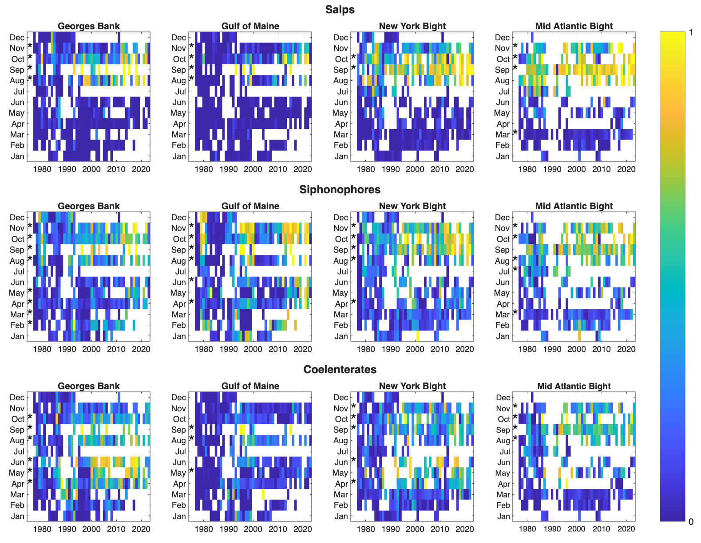
Figure S1. Time series of the proportion of presences of the indicated taxon broken down by month and regional polygon. Yellow indicates a high proportion of presence, while blue indicates a low proportion of presence. Stars indicate a statistically significant (p < 0.05) increase over the duration of the time series.
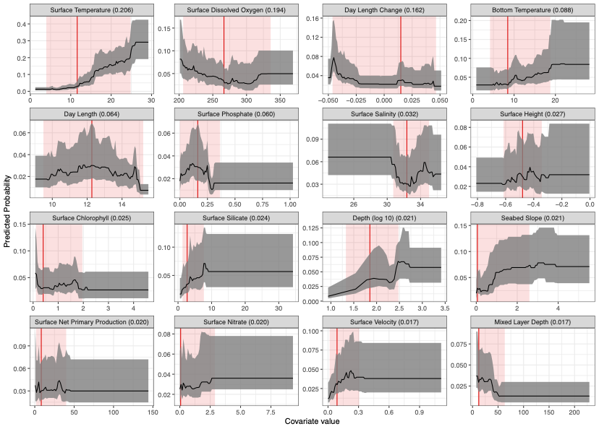
Figure S2. Response curves showing the marginal effects of environmental covariates on salps occurrence probability. Red vertical lines and shaded areas indicate the median valueand 95% interquantile range of the target covariate respectively. Shaded area indicates 95% interquartile range of the response while other covariates are held at their median values. Response curves are ordered from left to right and top to bottom by variable importance. Covariate names and units are detailed in Table T1.
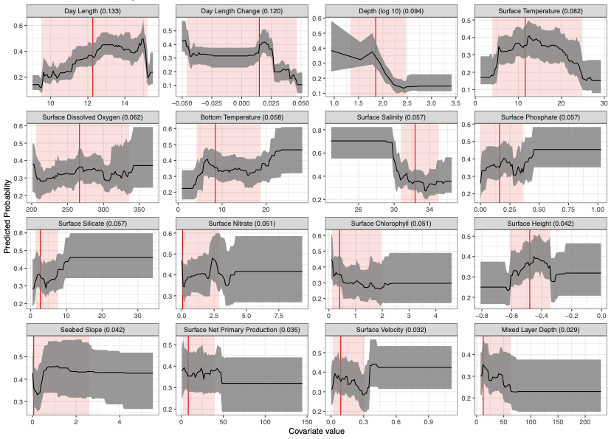
Figure S3. Response curves showing the marginal effects of environmental covariates on coelenterates occurrence probability. Red vertical lines and shaded area indicate the median value and 95% interquantile range of the target covariate. Black lines and shaded area indicate median value and 95% interquantile range and median of model response while all other covariates are held at their median values. Response curves are ordered from left to right,top to bottom by variable importance. Covariate names and units are detailed in Table T1.
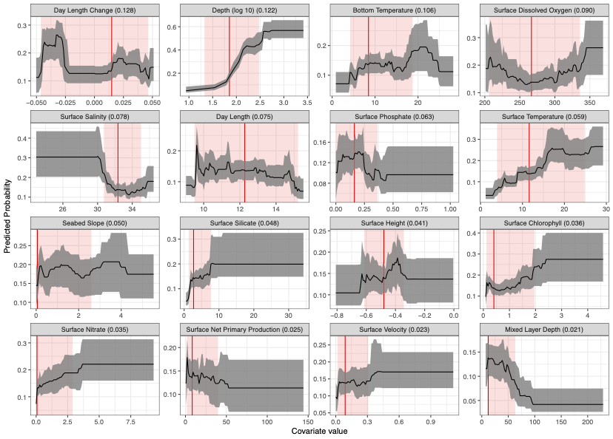
Figure S4. Response curves showing the marginal effects of environmental covariates on siphonophores occurrence probability. Red vertical lines and shaded area indicate the median value and 95% interquantile range of the target covariate. Black lines and shaded area indicate median value and 95% interquantile range and median of model response while all other covariates are held at their median values. Response curves are ordered from left to right,top to bottom by variable importance. Covariate names and units are detailed in Table T1.
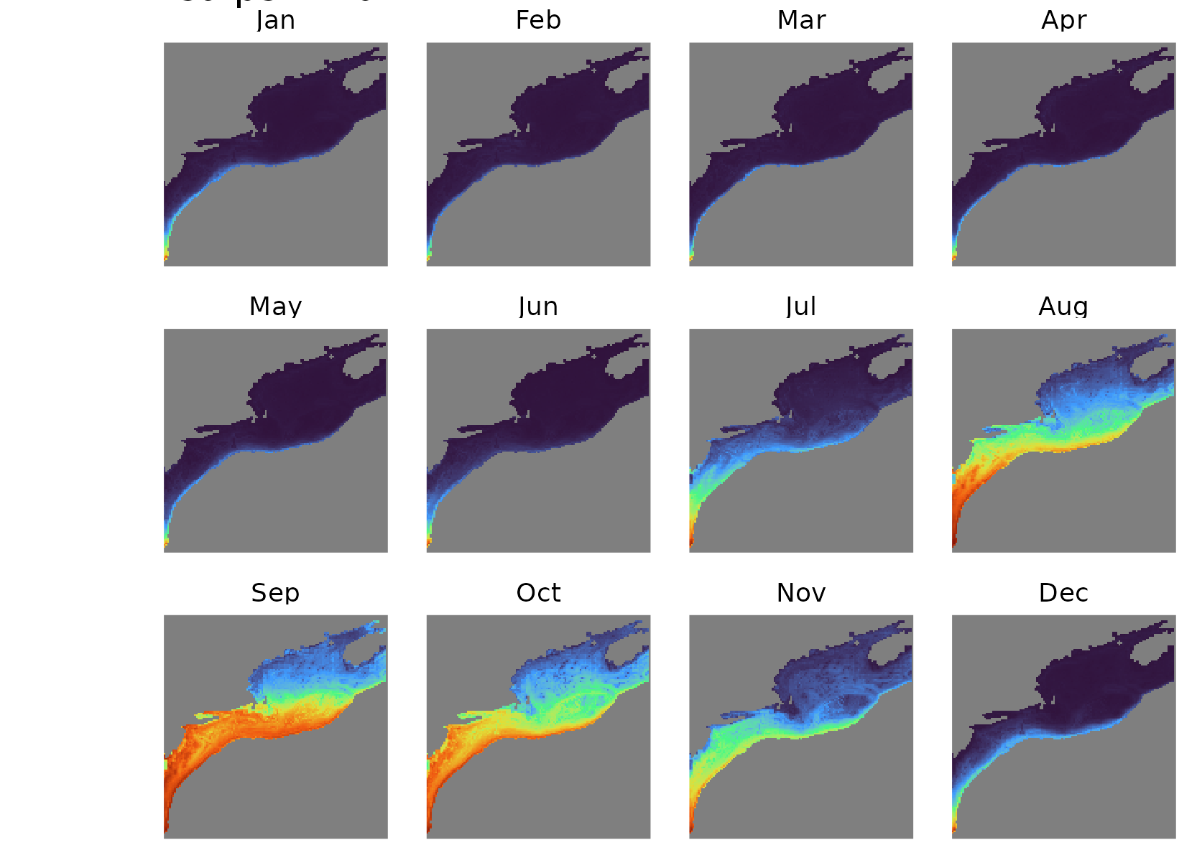
Figure S5. Model response averaged into monthly climatologies for salps over the Northeast US Continental Shelf ecosystem.
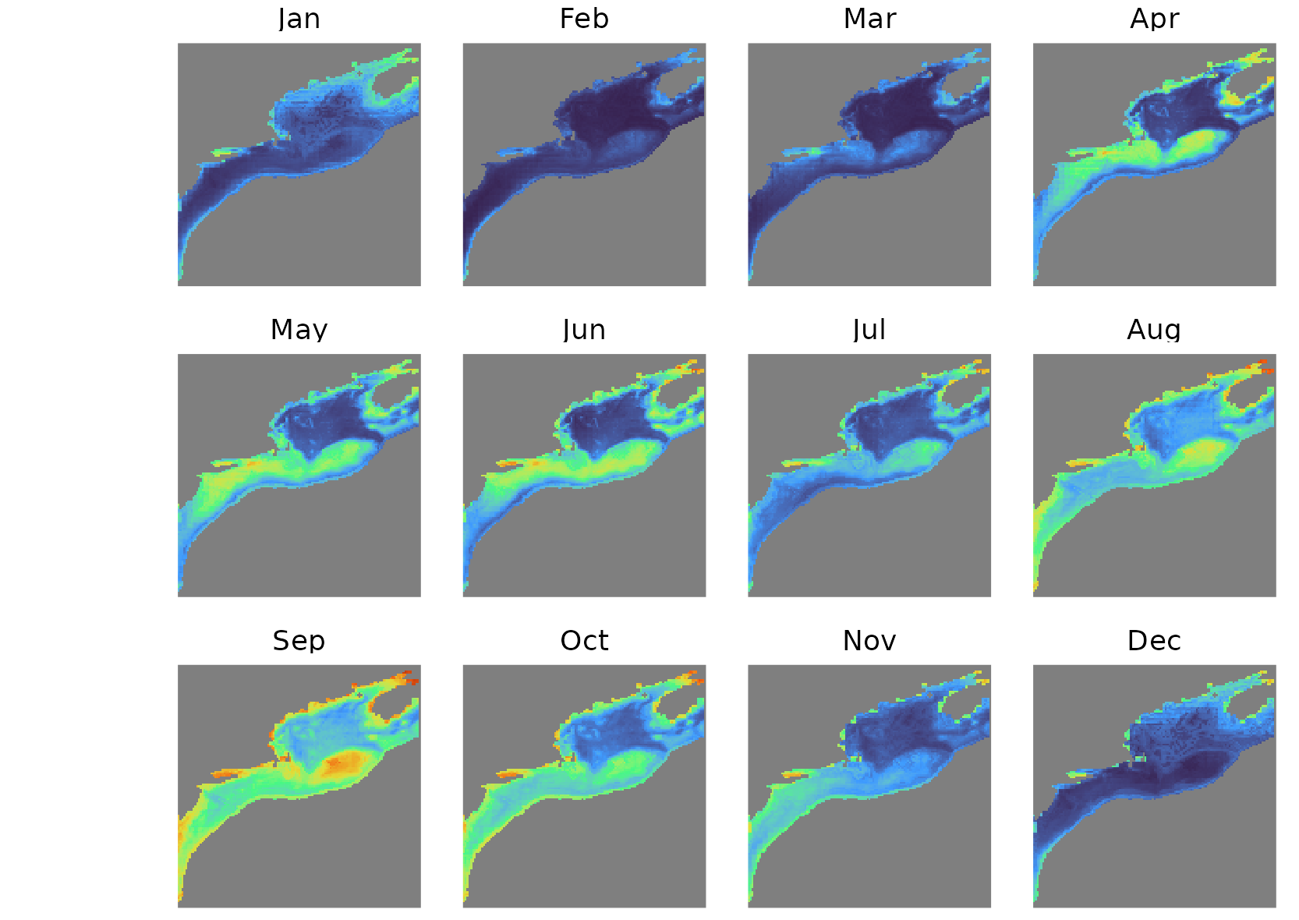
Figure S6. Model response averaged into monthly climatologies for coelenterates over the Northeast US Continental Shelf ecosystem.
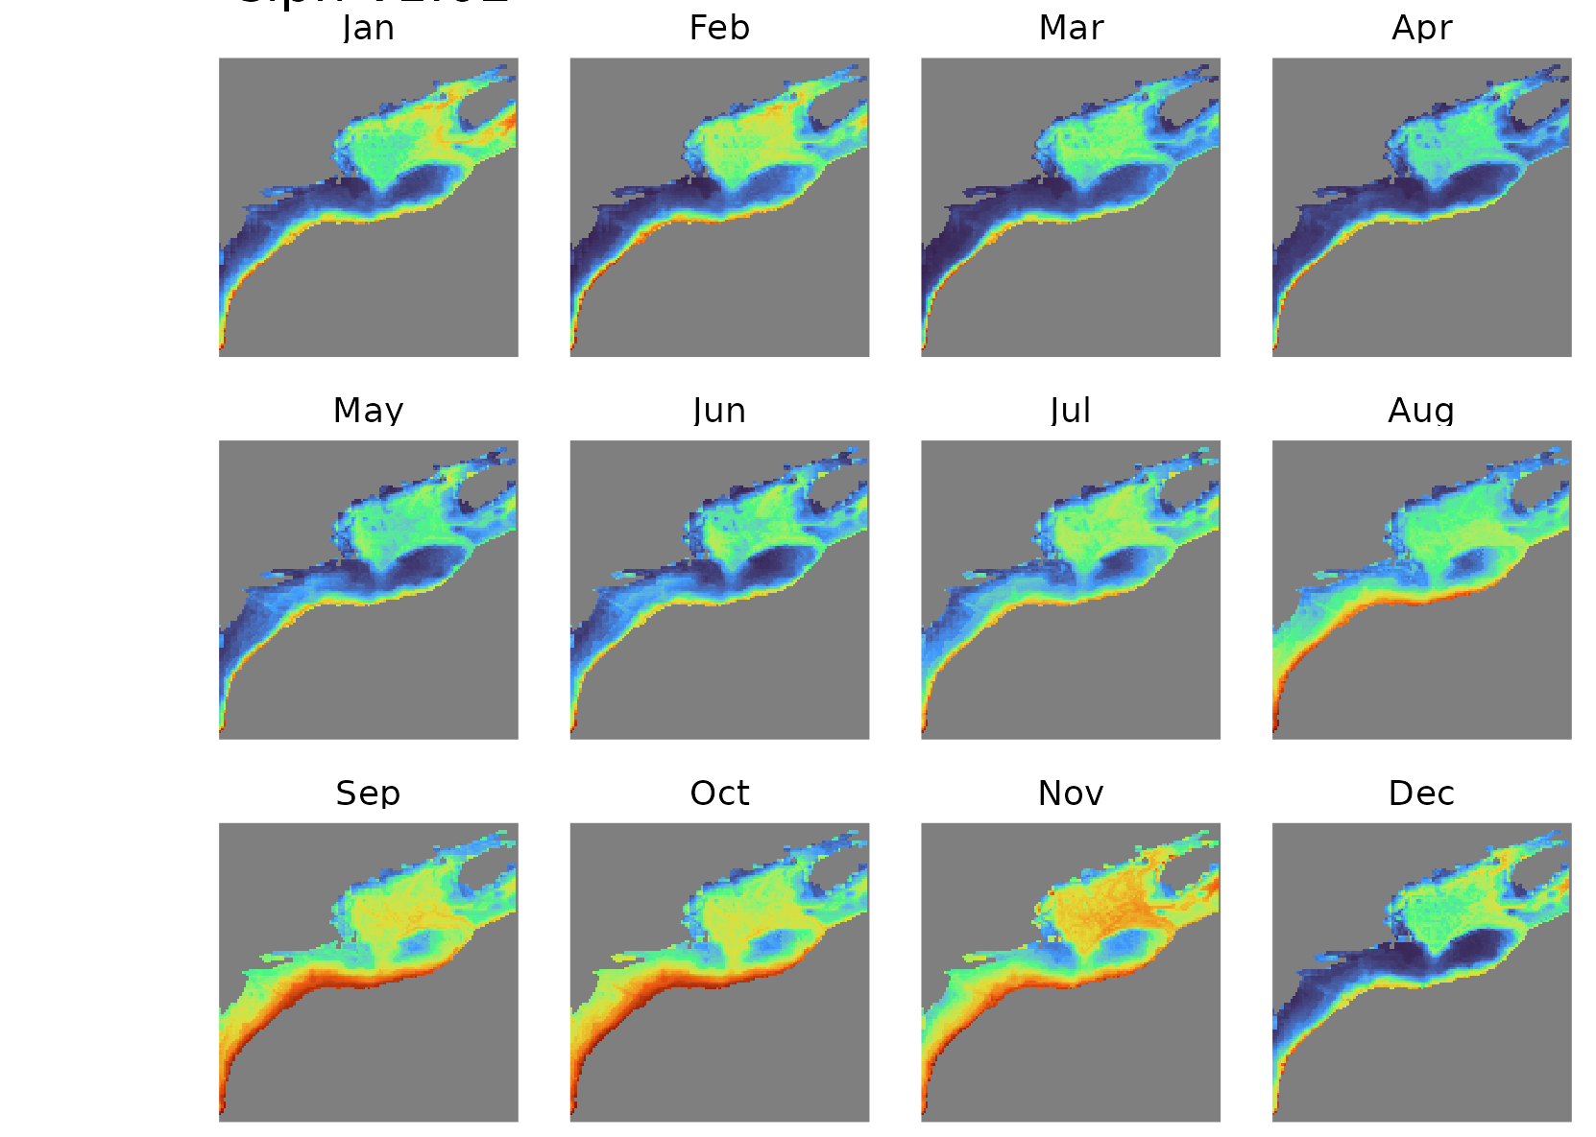
Figure S7. Model response averaged into monthly climatologies for siphonophores over the Northeast US Continental Shelf ecosystem.

References
Atkinson, Angus, Volker Siegel, Evgeny Pakhomov, and Peter Rothery. 2004. “Long-Term Decline in Krill Stock and Increase in Salps Within the Southern Ocean.” Nature 432 (7013): 100–103.
Brotz, Lucas, William WL Cheung, Kristin Kleisner, Evgeny Pakhomov, and Daniel Pauly. 2012. “Increasing Jellyfish Populations: Trends in Large Marine Ecosystems.” In Jellyfish Blooms IV: Interactions with Humans and Fisheries, 3–20. Springer.
Clinton, Morag, David EK Ferrier, Samuel AM Martin, and Andrew S Brierley. 2021. “Impacts of Jellyfish on Marine Cage Aquaculture: An Overview of Existing Knowledge and the Challenges to Finfish Health.” ICES Journal of Marine Science 78 (5): 1557–73.
Condon, Robert H, Carlos M Duarte, Kylie A Pitt, Kelly L Robinson, Cathy H Lucas, Kelly R Sutherland, Hermes W Mianzan, et al. 2013. “Recurrent Jellyfish Blooms Are a Consequence of Global Oscillations.” Proceedings of the National Academy of Sciences 110 (3): 1000–1005.
Condon, Robert H, William M Graham, Carlos M Duarte, Kylie A Pitt, Cathy H Lucas, Steven HD Haddock, Kelly R Sutherland, et al. 2012. “Questioning the Rise of Gelatinous Zooplankton in the World’s Oceans.” Bioscience 62 (2): 160–69.
Elith, Jane, Simon Ferrier, Falk Huettmann, and John Leathwick. 2005. “The Evaluation Strip: A New and Robust Method for Plotting Predicted Responses from Species Distribution Models.” Ecological Modelling 186 (3): 280–89.
Fielding, AH, and JF Bell. 1997. “A Review of Methods for the Assessment of Prediction Errors in Conservation Presence/Absence Models.” Environmental Conservation 24 (1): 38–49.
Gibbons, Mark J, and Anthony J Richardson. 2008. “Patterns of Jellyfish Abundance in the North Atlantic.” In Jellyfish Blooms: Causes, Consequences, and Recent Advances: Proceedings of the Second International Jellyfish Blooms Symposium, Held at the Gold Coast, Queensland, Australia, 24–27 June, 2007, 51–65. Springer.
Haddock, Steven HD. 2004. “A Golden Age of Gelata: Past and Future Research on Planktonic Ctenophores and Cnidarians.” Hydrobiologia 530 (1): 549–56.
Hanberry, Brice B. 2024. “Practical Guide for Retaining Correlated Climate Variables and Unthinned Samples in Species Distribution Modeling, Using Random Forests.” Ecological Informatics 79: 102406.
Johnson, Omi H, Stéphane Plourde, Caroline Lehoux, Camille H Ross, Benjamin Tupper, Christopher D Orphanides, Harvey J Walsh, and Nicholas R Record. 2025. “Suitability of Foraging Habitat for Eubalaena Glacialis Under Future Climate Scenarios in the Northwest Atlantic.” Elem Sci Anth 13 (1): 00044.
Kideys, Ahmet Erkan, Abolchaseem Roohi, Siamak Bagheri, Galina Finenko, and Lyudmila Kamburska. 2005. “Impacts of Invasive Ctenophores on the Fisheries of the Black Sea and Caspian Sea.” Oceanography 18 (2): 76–85.
Kuhn, Max, and Hadley Wickham. 2020. “Tidymodels: A Collection of Packages for Modeling and Machine Learning Using Tidyverse Principles.” Boston, MA, USA.
Madin, Laurence P, P Kremer, PH Wiebe, JE Purcell, EH Horgan, and DA Nemazie. 2006. “Periodic Swarms of the Salp Salpa Aspera in the Slope Water Off the NE United States: Biovolume, Vertical Migration, Grazing, and Vertical Flux.” Deep Sea Research Part I: Oceanographic Research Papers 53 (5): 804–19.
Moroz, Leonid L. 2014. “The Genealogy of Genealogy of Neurons.” Communicative & Integrative Biology 7 (6): e993269.
Nunes, Paulo ALD, Maria L Loureiro, Laia Piñol, Sergio Sastre, Louinord Voltaire, and Antonio Canepa. 2015. “Analyzing Beach Recreationists’ Preferences for the Reduction of Jellyfish Blooms: Economic Results from a Stated-Choice Experiment in Catalonia, Spain.” PloS One 10 (6): e0126681.
Pershing, Andrew J, Michael A Alexander, Christina M Hernandez, Lisa A Kerr, Arnault Le Bris, Katherine E Mills, Janet A Nye, et al. 2015. “Slow Adaptation in the Face of Rapid Warming Leads to Collapse of the Gulf of Maine Cod Fishery.” Science 350 (6262): 809–12.
Pershing, Andrew J, and Adam Kemberling. 2024. “Decadal Comparisons Identify the Drivers of Persistent Changes in the Zooplankton Community Structure in the Northwest Atlantic.” ICES Journal of Marine Science 81 (3): 564–74.
Purcell, Jennifer E, Denise L Breitburg, Mary Beth Decker, William M Graham, Marsh J Youngbluth, and Kevin A Raskoff. 2001. “Pelagic Cnidarians and Ctenophores in Low Dissolved Oxygen Environments: A Review.” Coastal Hypoxia: Consequences for Living Resources and Ecosystems 58: 77–100.
Qiu, Jane. 2014. “Coastal Havoc Boosts Jellies.” Nature 514 (7524): 545.
Record, Nicholas R, Andrew J Pershing, and Douglas B Rasher. 2024. “Early Warning of a Cold Wave in the Gulf of Maine.” Oceanography 37 (3): 6–9.
Record, Nicholas R, Benjamin Tupper, and Andrew J Pershing. 2018. “The Jelly Report: Forecasting Jellyfish Using Email and Social Media.” Anthropocene Coasts 1 (1): 34–43.
Richardson, Anthony J, Andrew Bakun, Graeme C Hays, and Mark J Gibbons. 2009. “The Jellyfish Joyride: Causes, Consequences and Management Responses to a More Gelatinous Future.” Trends in Ecology & Evolution 24 (6): 312–22.
Richardson, Anthony J, and Mark J Gibbons. 2008. “Are Jellyfish Increasing in Response to Ocean Acidification?” Limnology and Oceanography 53 (5): 2040–45.
Sanz-Martin, Marina, Kylie A Pitt, Robert H Condon, Cathy H Lucas, Charles Novaes de Santana, and Carlos M Duarte. 2016. “Flawed Citation Practices Facilitate the Unsubstantiated Perception of a Global Trend Toward Increased Jellyfish Blooms.” Global Ecology and Biogeography 25 (9): 1039–49.
Vargas, Cristian A, and Laurence P Madin. 2004. “Zooplankton Feeding Ecology: Clearance and Ingestion Rates of the Salps Thalia Democratica, Cyclosalpa Affinis and Salpa Cylindrica on Naturally Occurring Particles in the Mid-Atlantic Bight.” Journal of Plankton Research 26 (7): 827–33.
Verne, Jules. 2006. 20,000 Leagues Under the Sea. Vol. 20. Sterling Publishing Company, Inc.
Walsh, Harvey J, David E Richardson, Katrin E Marancik, and Jonathan A Hare. 2015. “Long-Term Changes in the Distributions of Larval and Adult Fish in the Northeast US Shelf Ecosystem.” PLoS One 10 (9): e0137382.
Wang, Xiaocheng, Qingqing Jin, Lu Yang, Chuan Jia, Chunjiang Guan, Haining Wang, and Hao Guo. 2023. “Aggregation Process of Two Disaster-Causing Jellyfish Species, Nemopilema Nomurai and Aurelia Coerulea, at the Intake Area of a Nuclear Power Cooling-Water System in Eastern Liaodong Bay, China.” Frontiers in Marine Science 9: 1098232.

