Support for the Jelly Ocean Hypothesis in the Northwest North Atlantic
Nicholas R. Record, Benjamin Tupper, Omi Johnson
null

Abstract
The Jelly Ocean Hypothesis posits that gelatinous zooplankton populations are increasing worldwide as a result of changing ocean conditions. This hypothesis has been the subject of debate in ocean science. We examined the Northeast US Continental Shelf for increases in the occurence of gelatinous zooplankton taxa using a 50-year survey and a species distribution model. Time series analysis showed statistically significant increases in salps, siphonophores, and coelenterates (scyphozoans) in late summer and early autumn across the entire study region. Species distribution models showed that the drivers of the occurence of gelatinous taxa were XYZ (oxygen?) ETCECT The results form one piece of evidence in favor of a long-term rise in gelatinous species. The roughly synchronized increases in these widly diverse taxa suggest that changes in environmental or ecological conditions favor a gelatinous body plan generally.

Introduction
In the study of zooplankton ecology, there has often been a “crustaceocentric” bias (Haddock 2004). The study of gelatinous species, collectively termed gelata, has been underemphasized as compared to crustaceans. In the early 2000s, gelata moved into the spotlight, following conspicuous blooms that damaged fisheries (Kideys et al. 2005), aquaculture (Clinton et al. 2021), energy production (Wang et al. 2023), and recreation (Nunes et al. 2015). In addition to motivating new research on gelata, these events raised the question of whether there was a larger pattern of change.
Emerging from a series of studies was the Jelly Ocean Hypothesis, which posits that gelatinous zooplankton populations are increasing worldwide as a result of changing ocean conditions, primarily anthropogenic. These studies argued that due a multiplicity of causes, abundance of gelatinous species is growing. Proposed causes are primarily human-driven, including warming (ref), eutrophication, translocation (Kideys et al. 2005), overfishing, bottom trawling (Qui 2014), pollution, aquaculture, and acidification (Richardson and Gibbons 2008). There is also evidence that shifts toward dominance of gelata are difficult to reverse because of dynamics like histeresis (Richardson et al. 2009). The hypothesis echos a concern that has been around for centuries; the 19th century novelist Jules Verne once predicted that, “crowded with jellyfish, squid, and other devilfish, the oceans will have become huge centers of infection” (REF). While the term “infection” might not be fair to jellyfish, who simply inhabit the ocean, the potential influence on human industry and recreation make the question worthy of examination.
Testing the Jelly Ocean Hypothesis requires long time series (>30 years) of gelata abundances in order to compare to historical levels. The shortage of such datasets has left the Jelly Ocean Hypothesis largely unsupported (Condon et al. 2012). In lieu of time series, studies have used qualitative data such as news reports to argue that gelata are increasing globally (Brotz et al. 2012). However, it is difficult to distinguish these perceived increases from multi-annual or multi-decadal fluctuations. A recent meta-analysis of time series showed that most perceived increases appear to reflect a ~20 year cyclicity, with a worldwide upswing in the 1990s, coinciding with the increase in concern over gelata (Condon et al. 2013), although some notable long-term increases in gelata were not included in the analysis (Atkinson et al. 2004). A metaanalysis of a corpus of research on this topic found flawed citations and misinterpreted conclusions (Sanz-Martin et al. 2016), and at this point, the Jelly Ocean Hypothesis remains very much an open question.
In some ways, the Jelly Ocean Hypothesis is loosely posed. Gelata are taxonomically very diverse, encompassing multiple phyla. This diversity confounds attempts to quantify increasing trends. The list of species classified under the gelatinous umbrella varies, and includes taxa with drastic and important differences in their life histories, trophic positions, and ecological roles. For example, pelagic ctenophores are primarily copepod predators, where as pelagic tunicates graze some of the smallest microbes. Cnidarians and ctenophores are the two most common taxa to group together in analysis, and yet they are phylogenetically very distant (Moroz et al. 2014). Perhaps the only characteristic common to the many gelatinous phyla is a body with a high water content, alternatively expressed as a low carbon:volume ratio. There is no a priori reason to expect that phyla with such striking differences and perhaps only a superficial similarity should be grouped together with respect to their temporal trends. Some have suggested that the Jelly Ocean Hypothesis is ill-posed—i.e. which species are increasing, where, and for what reason (Gibbons & Richardson 2013)?
On the other hand, despite their major differences, there is some evidence that a diverse collection of gelata can vary together (Condon et al. 2013). This suggests that certain conditions can occur that favor the gelatinous body form in general, over other strategies that utilize a high carbon:volume ratio (e.g. crustaceans). This reframes the Jelly Ocean Hypothesis in trait-based terms: conditions in the ocean ecosystem can shift to benefit the gelatinous body form. This would be inclusive of gelata in general, despite differences in phylogeny, trophic position, or other life history traits.
We revisited the Jelly Ocean Hypothesis using a 50-year spatial survey on the northwest North Atlantic Shelf. We addressed two main questions: 1) what are the temporal changes in gelata presence; and 2) what are the underlying conditions associated with changes. We examined three taxonomic groups well-represented in the dataset–siphonophores, salps, and coelenterates–to explore the idea that certain conditions can favor the gelatinous body plan in general.

Methods

Survey Data
The Northeast Fisheries Science Center Ecosystem Monitoring (ECOMON) program collects seasonal zooplankton measurements as part of its mission to monitor and assess the Northeast Continental Shelf ecosystem (Figure 1). Sampling includes oblique tows using a 61 cm bongo net fitted with a 333 µm mesh at stratified locations across the shelf (Figure 1). Tows are a minimum of five minutes in duration and sample from the surface to within 5 m of the seabed or to a maximum depth of 200 m. A mechanical flowmeter fitted in the mouth of each net is used to quantify volume sampled. Gelatinous zooplankton are identified into broad taxonomic groups, including siphonophores, ctenophores, salps, and coelenterates (i.e. scyphozoans). The broad grouping, while missing taxonomic detail, has allowed for internal consistency over the duration of the survey. The analysis conducted here uses presence or absence of each taxonomic group.
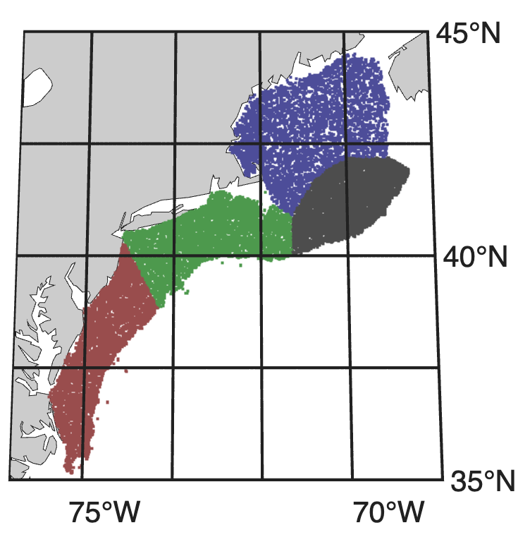
Map of the study region. Points indicate sampling locations colored by the four polygons: Gulf of Maine, Georges Bank, Southern New England, and Mid-Atlantic Bight.

Time series analysis
The ECOMON survey has varied in frequency over its duration. To correct for seasonal aliasing and spatial bias, we followed the common approach of grouping by large spatial polygons that represent different habitats, and analyzed the time series by month. Polygons include: Gulf of Maine, Georges Bank, New York Bight, and Mid Atlantic Bight (Walsh et al. 2015). Because of the low taxonomic resolution of gelatinous taxa and the bulk biomass quantification, we viewed measurements in a presence-absence context, tracking the proportion of samples in a region and in a time period that contain presences. For each month and within each region, we tested for statistically significant increases over time using a bivarite correlation test against year.

Spatial analysis
To test for environmental associations with high or low occurrence of gelatinous taxa across the study domain, we developed a species distribution model for each taxonomic group. We used physical covariates from the Global Ocean Physics Reanalysis (GLORYS) and biogeochemical covariates the Operational Mercator Ocean biogeochemical global ocean analysis (NEMO) obtained from the Copernicus repository (copernicus.eu), which provide daily temporal resolution and 1/12 and quarter-degree resolution respectively. Physical covariates included: sea surface temperature, sea bottom temperature, sea surface salinity, mixed layer thickness, and surface velocity magnitude. Biogeochemical covariates included surface chlorophyll, surface net primary productivity, surface oxygen, surface nitrate, surface phosphate, and surface silicate. We also included day length and the time derivative of day length to represent seasonal dependencies, as well as bathymetric depth and bathymetric slope.
We used a boosted regression tree algorithm to fit the observations to environmental covariates. Boosted regression trees are well suited to variables that have sharp jumps or thresholds (Johnson et al. 2024), as is the case for the presence of gelatinous zooplankton, and is less prone to overfitting in species distribution models (Elith et al., 2008). We modeled each taxon using tidymodels workflows, optimizing the inbuilt area-under-curve (AUC) metric (Fielding and Bell 1997, Kuhn and Wickham, 2020). We used a set of hyperparameters optimized in a previous study that used the same dataset and methodology (Johnson et al. 2024). We used a testing split of 25%, and ran an ensemble of 25 model runs to quantify algorithmic undertainty around the median output. Cross correlation between environmental covariates was used in the interpretation of output, but not in covariate selection because the goal of the model was to explore covariate associations. The resulting response curves were used to interpret associations with environmental covariates.

Results

Time series analysis
Over almost five decades of measurements, there were consistent patterns of statistically significan increases in the recorded presence of gelatinous taxa (Figure 2, S1). While the survey does not cover every month in every year, there is enough coverage across seasons to see consistent patterns. Out of 144 month-region combinations, 56 (39%) indicate a statistically significant increase (p < 0.05) and zero (0%) indicate a statistically significant decrease. In the months August-November, 40 of the 48 time series (83%) show a statistically significant increase (Figure 2). In other words, in late summer and early fall, all taxa show an increase across the entire study region.
The results during other times of year were more mixed. On Georges Bank, there were statistically significant increases across the spring months for siphonophores and coelenterates. For the other taxa, regions, and months, there were some scattered increases but no strong pattern (Figure S1).
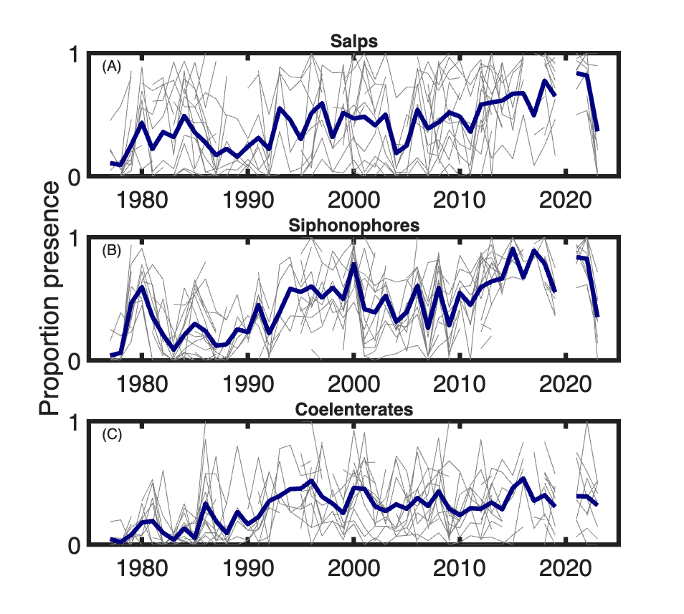
Time series of the proportion of presences of the indicated taxon for the months August - November (grey lines) for all regions, and the average of all shown time series (black lines). Full time series breakdowns are provided in supplementary figure S1

Spatial analysis
For the boosted regression tree distribution model, performance was genearally good across the three taxonomic groups. For coelenterates, the model had an AUC value of 0.79, an accuracy of 0.77, and an F-score of 0.49. For salps, the model had an AUC value of 0.93, an accuracy of 0.89, and an F-score of 0.72. For siphonophores, the model had an AUC value of 0.83, an accuracy of 0.77, and an F-score of 0.63. The model tended to favor specificity over sensitivity over all runs.
A common threshold for covariate cross correlation is an r-squared value of 0.7 (REF). Only a few pairs of covariates met this threshold: bathymetric depth versus bathymetric slope (0.71), surface temperature versus surface oxygen (0.89), surface temperature versus day-length time derivative (0,79), surface chlorophyll and net primary productivity (0.81), and surface oxygen versus day-length time derivative (0.77). Because of the high correlation between sea surface temperature and surface oxygen, and the physical realtionship between the two (water temperature is related to oxyge content), we ran a second set of runs using subsurface oxygen. We used a depth of 50m, which limited the extent of the model domain. [results of these runs]

Discussion
Large aggregations can appear suddenly and often inspire widespread public interest (Record, Tupper, and Pershing 2018). This has happened in the northeast US, prompting the same questions that underly the Jelly Ocean Hypothesis: Are jellyfish (gelata) increasing, and if so, what is the cause? For the region considered in this study, fifty years of measurements provides clear evidence that there is a widespread increase, focused particularly in the autumn months. In some places, and for some taxa, there has been a trend from gelata being rare in samples in the early years of the survey to occurring in nearly all of the samples in the later years of the survey.
The question of cause is more complicated. The northeast US shelf has undergone notable oceanographic changes over the past fifty years, some of which are apparent in the gelata time series. There was a decadal shift among copepod species between the 1980s and the 1990s, driven by stratification (Pershing and Kemberling 2024), which appears in many of the gelata time series (Figure 2). In the Gulf of Maine in particular, a 1990s shift that ends in the early 2000s appears across taxa and is particularly pronounced for siphonophores (Figure S1). The region also underwent a decade of extremely rapid warming beginning around 2005, depending on how it is delineated (Pershing et al. 2015). This period does not stand out in particular, except again among salps in the Gulf of Maine, and perhaps Georges Bank (Figure S1). Finally, the region has also undergone an abrupt shoft toward cold, fresh water beginning in autumn 2023 (Record, Pershing, and Rasher 2024). This is possibly reflected in the sharp drop in salp and siphonophore presence in fall of 2023, which don’t appear to be driven by a sampling bias. Subsequent years of data will help clarify this possibility. Taken in total, the evidence suggests a relationship to the changing water masses of the region, but without finer taxonomic resolution, or size or life stage information, it is difficult to make more direct links.
The species distribution model can be interpreted as providing some evidence for associations with changing environmental variables. In addition to the generally positive response to increasing temperature, the positive response to decreasing oxygen is also notable. [need to be careful here…subsurface]

Supplement
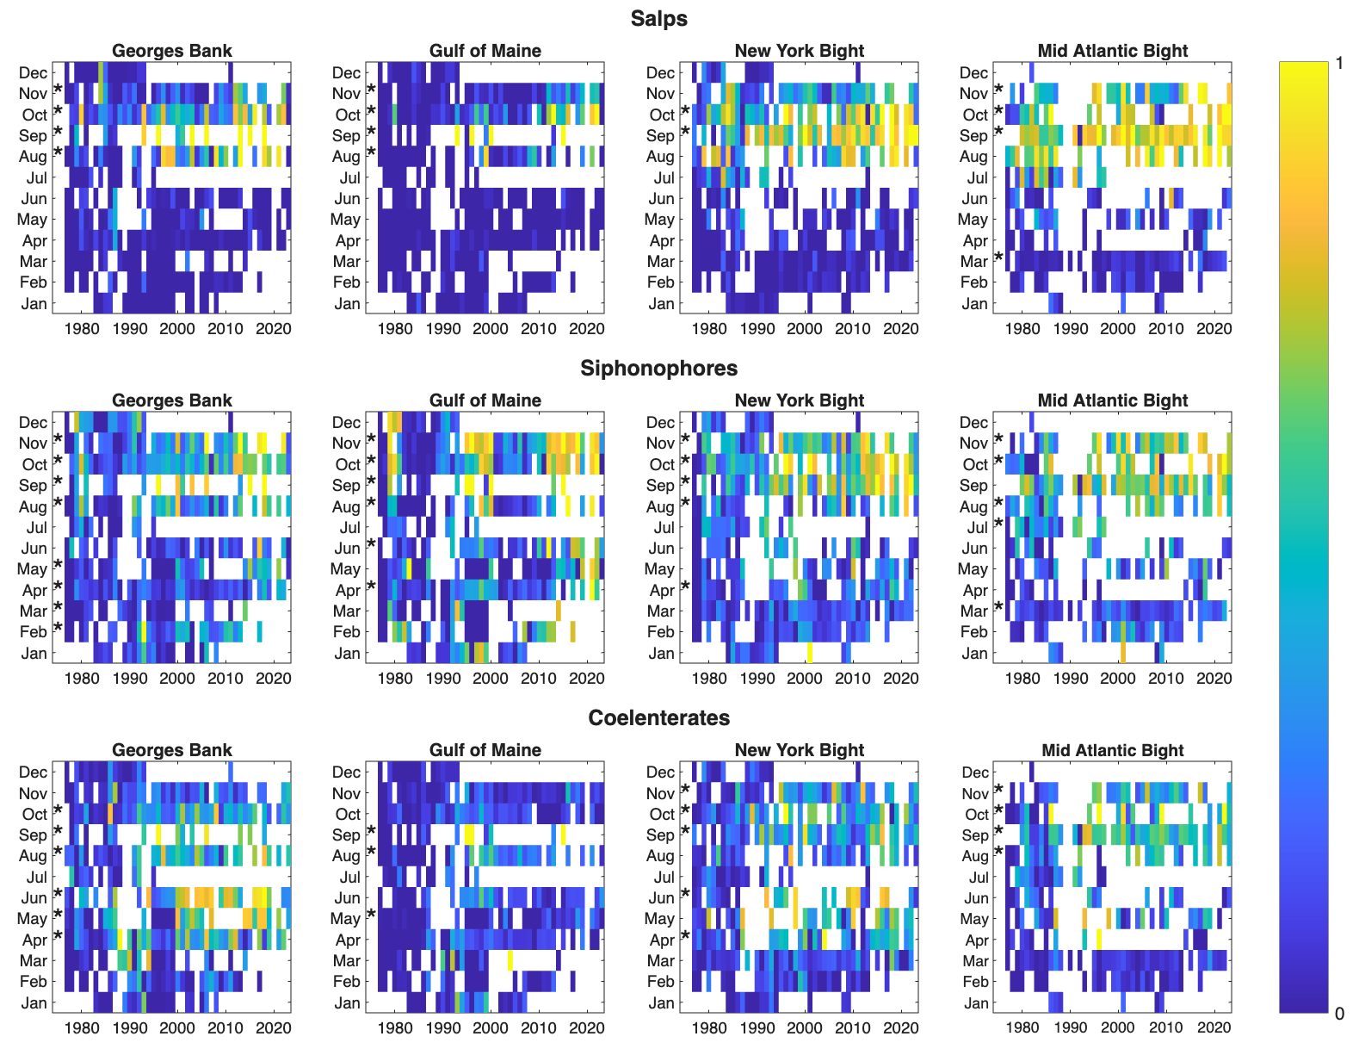
Figure S1. Time series of the proportion of presences of the indicated taxon broken down by month and regional polygon. Stars indicate a statistically significant (p < 0.05) increase over the duration of the time series.

References
Atkinson, Angus, Volker Siegel, Evgeny Pakhomov, and Peter Rothery. 2004. “Long-Term Decline in Krill Stock and Increase in Salps Within the Southern Ocean.” Nature 432 (7013): 100–103.
Brotz, Lucas, William WL Cheung, Kristin Kleisner, Evgeny Pakhomov, and Daniel Pauly. 2012. “Increasing Jellyfish Populations: Trends in Large Marine Ecosystems.” In Jellyfish Blooms IV: Interactions with Humans and Fisheries, 3–20. Springer.
Clinton, Morag, David EK Ferrier, Samuel AM Martin, and Andrew S Brierley. 2021. “Impacts of Jellyfish on Marine Cage Aquaculture: An Overview of Existing Knowledge and the Challenges to Finfish Health.” ICES Journal of Marine Science 78 (5): 1557–73.
Condon, Robert H, Carlos M Duarte, Kylie A Pitt, Kelly L Robinson, Cathy H Lucas, Kelly R Sutherland, Hermes W Mianzan, et al. 2013. “Recurrent Jellyfish Blooms Are a Consequence of Global Oscillations.” Proceedings of the National Academy of Sciences 110 (3): 1000–1005.
Condon, Robert H, William M Graham, Carlos M Duarte, Kylie A Pitt, Cathy H Lucas, Steven HD Haddock, Kelly R Sutherland, et al. 2012. “Questioning the Rise of Gelatinous Zooplankton in the World’s Oceans.” Bioscience 62 (2): 160–69.
Haddock, Steven HD. 2004. “A Golden Age of Gelata: Past and Future Research on Planktonic Ctenophores and Cnidarians.” Hydrobiologia 530 (1): 549–56.
Kideys, Ahmet Erkan, Abolchaseem Roohi, Siamak Bagheri, Galina Finenko, and Lyudmila Kamburska. 2005. “Impacts of Invasive Ctenophores on the Fisheries of the Black Sea and Caspian Sea.” Oceanography 18 (2): 76–85.
Nunes, Paulo ALD, Maria L Loureiro, Laia Piñol, Sergio Sastre, Louinord Voltaire, and Antonio Canepa. 2015. “Analyzing Beach Recreationists’ Preferences for the Reduction of Jellyfish Blooms: Economic Results from a Stated-Choice Experiment in Catalonia, Spain.” PloS One 10 (6): e0126681.
Pershing, Andrew J, Michael A Alexander, Christina M Hernandez, Lisa A Kerr, Arnault Le Bris, Katherine E Mills, Janet A Nye, et al. 2015. “Slow Adaptation in the Face of Rapid Warming Leads to Collapse of the Gulf of Maine Cod Fishery.” Science 350 (6262): 809–12.
Pershing, Andrew J, and Adam Kemberling. 2024. “Decadal Comparisons Identify the Drivers of Persistent Changes in the Zooplankton Community Structure in the Northwest Atlantic.” ICES Journal of Marine Science 81 (3): 564–74.
Record, Nicholas R, Andrew J Pershing, and Douglas B Rasher. 2024. “Early Warning of a Cold Wave in the Gulf of Maine.” Oceanography 37 (3): 6–9.
Record, Nicholas R, Benjamin Tupper, and Andrew J Pershing. 2018. “The Jelly Report: Forecasting Jellyfish Using Email and Social Media.” Anthropocene Coasts 1 (1): 34–43.
Richardson, Anthony J, Andrew Bakun, Graeme C Hays, and Mark J Gibbons. 2009. “The Jellyfish Joyride: Causes, Consequences and Management Responses to a More Gelatinous Future.” Trends in Ecology & Evolution 24 (6): 312–22.
Richardson, Anthony J, and Mark J Gibbons. 2008. “Are Jellyfish Increasing in Response to Ocean Acidification?” Limnology and Oceanography 53 (5): 2040–45.
Sanz-Martin, Marina, Kylie A Pitt, Robert H Condon, Cathy H Lucas, Charles Novaes de Santana, and Carlos M Duarte. 2016. “Flawed Citation Practices Facilitate the Unsubstantiated Perception of a Global Trend Toward Increased Jellyfish Blooms.” Global Ecology and Biogeography 25 (9): 1039–49.
Walsh, Harvey J, David E Richardson, Katrin E Marancik, and Jonathan A Hare. 2015. “Long-Term Changes in the Distributions of Larval and Adult Fish in the Northeast US Shelf Ecosystem.” PLoS One 10 (9): e0137382.
Wang, Xiaocheng, Qingqing Jin, Lu Yang, Chuan Jia, Chunjiang Guan, Haining Wang, and Hao Guo. 2023. “Aggregation Process of Two Disaster-Causing Jellyfish Species, Nemopilema Nomurai and Aurelia Coerulea, at the Intake Area of a Nuclear Power Cooling-Water System in Eastern Liaodong Bay, China.” Frontiers in Marine Science 9: 1098232.

