
Національний технічний університет України
«Київський політехнічний інститут ім. Ігоря Сікорського»

Кафедра цифрових технологій в енергетиці

ЗВІТ
з виконання лабораторної роботи №2
з дисципліни «Декларативне програмування графічних інтерфейсів»
«Вступний приклад розробки WPF-застосунку»
Варіант 20

Виконав: студент групи ТР-33 Чумаченко А.Ю.
Перевірив: доцент, к.ф.-м.н.
Тарнавський Ю.А.
__________________________

Завдання 1
Освоїти основи роботи з XAML та контейнерами компонування
11)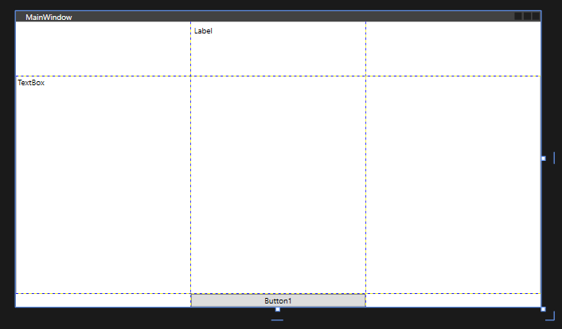
<Window x:Class="lab2.MainWindow"
xmlns="http://schemas.microsoft.com/winfx/2006/xaml/presentation"
xmlns:x="http://schemas.microsoft.com/winfx/2006/xaml"
xmlns:d="http://schemas.microsoft.com/expression/blend/2008"
xmlns:mc="http://schemas.openxmlformats.org/markup-compatibility/2006"
xmlns:local="clr-namespace:lab2"
mc:Ignorable="d"
Title="MainWindow" Height="450" Width="800">
<Grid ShowGridLines="True">
<Grid.RowDefinitions>
<RowDefinition Height="*"></RowDefinition>
<RowDefinition Height="4*"></RowDefinition>
<RowDefinition Height="Auto"></RowDefinition>
</Grid.RowDefinitions>

<Grid.ColumnDefinitions>
<ColumnDefinition Width="*"></ColumnDefinition>
<ColumnDefinition Width="*"></ColumnDefinition>
<ColumnDefinition Width="*"></ColumnDefinition>
</Grid.ColumnDefinitions>

<Label Grid.Row="0" Grid.Column="1">Label</Label>
<TextBox Grid.Row="1" Grid.Column="0" Grid.ColumnSpan="3">TextBox</TextBox>
<Button Grid.Row="2" Grid.Column="1">Button1</Button>
</Grid>
</Window>
15)
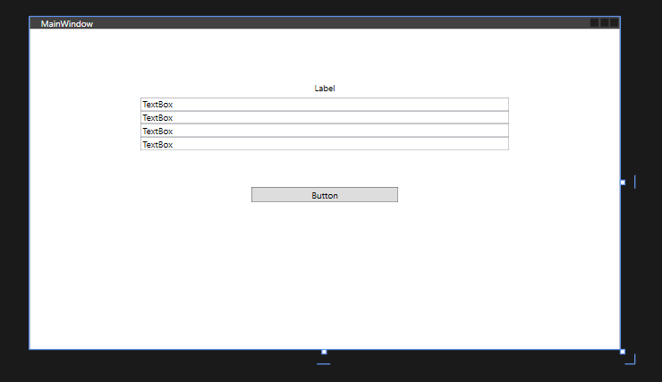
<Window x:Class="lab2.MainWindow"
xmlns="http://schemas.microsoft.com/winfx/2006/xaml/presentation"
xmlns:x="http://schemas.microsoft.com/winfx/2006/xaml"
xmlns:d="http://schemas.microsoft.com/expression/blend/2008"
xmlns:mc="http://schemas.openxmlformats.org/markup-compatibility/2006"
xmlns:local="clr-namespace:lab2"
mc:Ignorable="d"
Title="MainWindow" Height="450" Width="800">
<StackPanel x:Name="stackPanel" HorizontalAlignment ="Center" Width ="500" Height="300">
<Label HorizontalAlignment ="Center">Label</Label>
<TextBox >TextBox</TextBox>
<TextBox>TextBox</TextBox>
<TextBox>TextBox</TextBox>
<TextBox>TextBox</TextBox>

<Button HorizontalAlignment ="Center" Width="200" Margin="0,50,0,0">Button</Button>
</StackPanel>
</Window>
19)
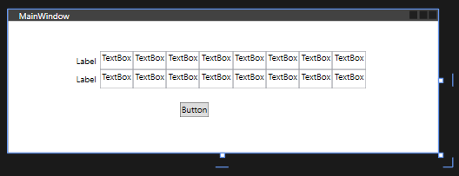
<Window x:Class="lab2.MainWindow"
xmlns="http://schemas.microsoft.com/winfx/2006/xaml/presentation"
xmlns:x="http://schemas.microsoft.com/winfx/2006/xaml"
xmlns:d="http://schemas.microsoft.com/expression/blend/2008"
xmlns:mc="http://schemas.openxmlformats.org/markup-compatibility/2006"
xmlns:local="clr-namespace:lab2"
mc:Ignorable="d"
Title="MainWindow" Height="200" Width="600">
<WrapPanel HorizontalAlignment="Center" Height="100" VerticalAlignment="Center" Width="420" >
<Label HorizontalAlignment ="Center">Label</Label>
<TextBox>TextBox</TextBox>
<TextBox>TextBox</TextBox>
<TextBox>TextBox</TextBox>
<TextBox>TextBox</TextBox>
<TextBox>TextBox</TextBox>
<TextBox>TextBox</TextBox>
<TextBox>TextBox</TextBox>
<TextBox>TextBox</TextBox>
<Label HorizontalAlignment ="Center">Label</Label>
<TextBox>TextBox</TextBox>
<TextBox>TextBox</TextBox>
<TextBox>TextBox</TextBox>
<TextBox>TextBox</TextBox>
<TextBox>TextBox</TextBox>
<TextBox>TextBox</TextBox>
<TextBox>TextBox</TextBox>
<TextBox>TextBox</TextBox>
<Button Content="Button" Margin="150,20,0,0"/>

</WrapPanel>

</Window>

23) 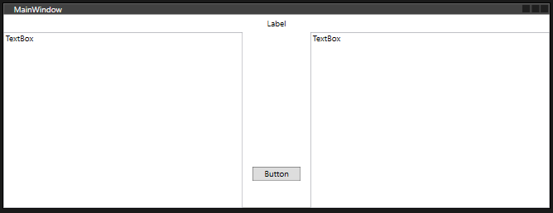
<Window x:Class="lab2.MainWindow"
xmlns="http://schemas.microsoft.com/winfx/2006/xaml/presentation"
xmlns:x="http://schemas.microsoft.com/winfx/2006/xaml"
xmlns:d="http://schemas.microsoft.com/expression/blend/2008"
xmlns:mc="http://schemas.openxmlformats.org/markup-compatibility/2006"
xmlns:local="clr-namespace:lab2"
mc:Ignorable="d"
Title="MainWindow" Height="300" Width="800">
<DockPanel LastChildFill="False">
<Label DockPanel.Dock="Top" HorizontalAlignment ="Center">Label</Label>
<TextBox DockPanel.Dock="Left" Width="350">TextBox</TextBox>
<TextBox DockPanel.Dock="Right" Width="350">TextBox</TextBox>
<Button DockPanel.Dock="Bottom" Margin="0,0,0,40" Height="20" Width="70" >Button</Button>
</DockPanel>

</Window>
27)
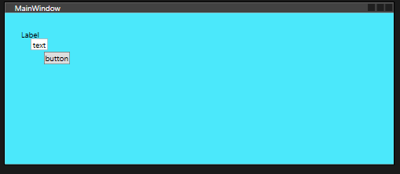
<Window x:Class="lab2.MainWindow"
xmlns="http://schemas.microsoft.com/winfx/2006/xaml/presentation"
xmlns:x="http://schemas.microsoft.com/winfx/2006/xaml"
xmlns:d="http://schemas.microsoft.com/expression/blend/2008"
xmlns:mc="http://schemas.openxmlformats.org/markup-compatibility/2006"
xmlns:local="clr-namespace:lab2"
mc:Ignorable="d"
Title="MainWindow" Height="250" Width="600">
<Canvas Background="#FF4BE8FB">
<Label Canvas.Top="20" Canvas.Left ="20" HorizontalAlignment ="Center">Label</Label>
<TextBox Canvas.Top="40" Canvas.Left ="40">text</TextBox>
<Button Canvas.Top="60" Canvas.Left ="60">button</Button>
</Canvas>

</Window>

Завдання 2
Розробити у WPF інтерфейс текстового редактора
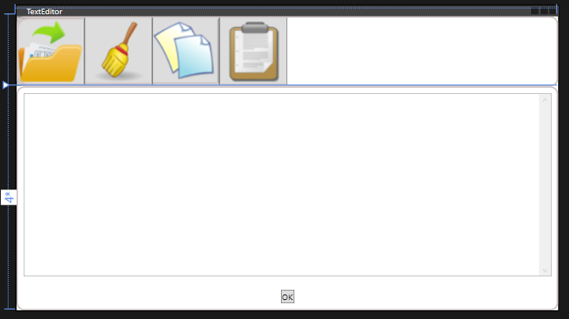
<Window x:Class="lab2.MainWindow"
xmlns="http://schemas.microsoft.com/winfx/2006/xaml/presentation"
xmlns:x="http://schemas.microsoft.com/winfx/2006/xaml"
xmlns:d="http://schemas.microsoft.com/expression/blend/2008"
xmlns:mc="http://schemas.openxmlformats.org/markup-compatibility/2006"
xmlns:local="clr-namespace:lab2"
mc:Ignorable="d"
Title="TextEditor" Height="450" Width="800">
<Grid>
<Grid.RowDefinitions>
<RowDefinition Height="Auto" ></RowDefinition>
<RowDefinition Height="4*"></RowDefinition>
</Grid.RowDefinitions>
<StackPanel Grid.Row="0" Orientation="Horizontal">
<Button Width="100" ToolTip="Відкрити">
<Image Source="/images/1.png"/>
</Button>
<Button Width="100" ToolTip="Стерти">
<Image Source="/images/2.png"/>
</Button>
<Button Width="100" ToolTip="Копіювати">
<Image Source="/images/3.png"/>
</Button>
<Button Width="100" ToolTip="Вставити">
<Image Source="/images/4.png"/>
</Button>
</StackPanel>
<Border Grid.Row="0" BorderBrush="#FFCBBEBE" BorderThickness="2" CornerRadius="10"></Border>
<Border Grid.Row="1" BorderBrush="#FFCBBEBE" BorderThickness="2" CornerRadius="10"></Border>
<Grid Grid.Row="1">
<Grid.RowDefinitions>
<RowDefinition ></RowDefinition>
<RowDefinition Height="Auto"></RowDefinition>
</Grid.RowDefinitions>
<TextBox Grid.Row="0" Margin ="10" VerticalScrollBarVisibility="Visible"></TextBox >
<DockPanel Grid.Row="1" Margin="10">
<Button DockPanel.Dock="Bottom" HorizontalAlignment="Center">
OK
</Button>
</DockPanel>
</Grid>
</Grid>

</Window>

Завдання 3
Розробити дизайн програми із застосуванням пензлів, ресурсів, стилів, тригерів
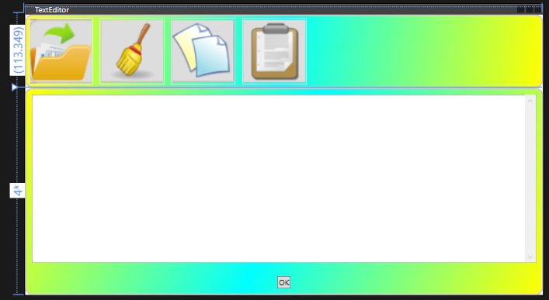
<Window x:Class="lab2.MainWindow"
xmlns="http://schemas.microsoft.com/winfx/2006/xaml/presentation"
xmlns:x="http://schemas.microsoft.com/winfx/2006/xaml"
xmlns:d="http://schemas.microsoft.com/expression/blend/2008"
xmlns:mc="http://schemas.openxmlformats.org/markup-compatibility/2006"
xmlns:local="clr-namespace:lab2"
mc:Ignorable="d"
Title="TextEditor" Height="450" Width="800">
<Window.Resources>
<LinearGradientBrush x:Key="LinearPanelBrush">
<GradientStop Color="Yellow" Offset="0"></GradientStop>
<GradientStop Color="Aqua" Offset="0.5"></GradientStop>
<GradientStop Color="Yellow" Offset="1"></GradientStop>
</LinearGradientBrush>
<Style TargetType="Button">
<Setter Property="Margin" Value="5"></Setter>
<Setter Property="Background" Value="Transparent"></Setter>
<Setter Property="BorderBrush" Value="White"></Setter>
</Style>

</Window.Resources>
<Grid>
<Grid.RowDefinitions>
<RowDefinition Height="Auto" ></RowDefinition>
<RowDefinition Height="4*"></RowDefinition>
</Grid.RowDefinitions>
<Border Background="{StaticResource LinearPanelBrush}" Grid.Row="0" BorderBrush="#FFCBBEBE" BorderThickness="2" CornerRadius="10"></Border>
<StackPanel Grid.Row="0" Orientation="Horizontal">
<Button Width="100" ToolTip="Відкрити">
<Image Source="/images/1.png"/>
</Button>
<Button Width="100" ToolTip="Стерти">
<Image Source="/images/2.png"/>
</Button>
<Button Width="100" ToolTip="Копіювати">
<Image Source="/images/3.png"/>
</Button>
<Button Width="100" ToolTip="Вставити">
<Image Source="/images/4.png"/>
</Button>
</StackPanel>
<Border Background="{StaticResource LinearPanelBrush}" Grid.Row="1" BorderBrush="#FFCBBEBE" BorderThickness="2" CornerRadius="10"></Border>
<Grid Grid.Row="1">
<Grid.RowDefinitions>
<RowDefinition ></RowDefinition>
<RowDefinition Height="Auto"></RowDefinition>
</Grid.RowDefinitions>
<TextBox Grid.Row="0" Margin ="10" VerticalScrollBarVisibility="Visible"></TextBox >
<DockPanel Grid.Row="1" Margin="10">
<Button DockPanel.Dock="Bottom" HorizontalAlignment="Center" Style="{x:Null}">
OK
</Button>
</DockPanel>
</Grid>
</Grid>

</Window>

Завдання 4
Виконати прив'язку команд та елементів
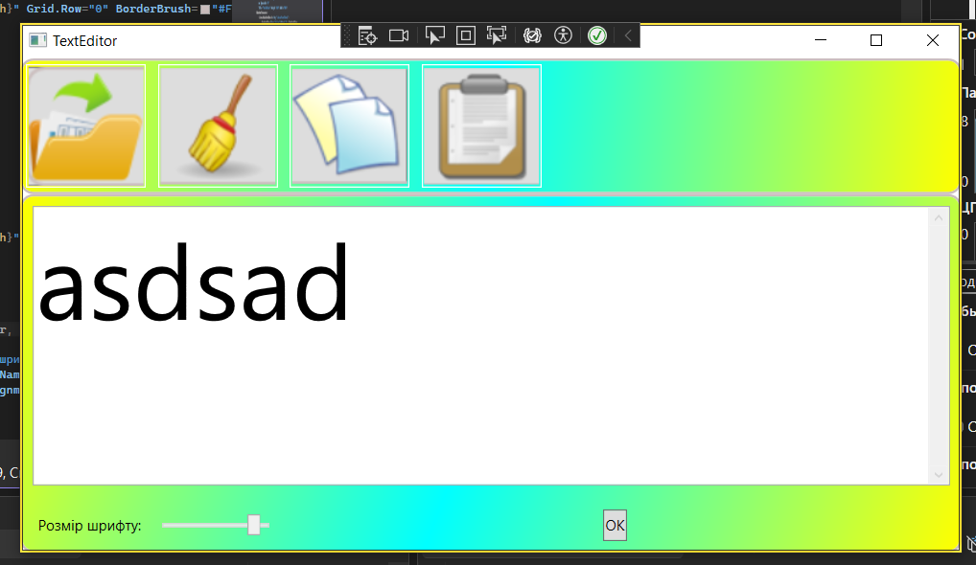
MainWindow.xaml.cs
using System;
using System.Collections.Generic;
using System.Linq;
using System.Text;
using System.Threading.Tasks;
using System.Windows;
using System.Windows.Controls;
using System.Windows.Data;
using System.Windows.Documents;
using System.Windows.Input;
using System.Windows.Media;
using System.Windows.Media.Imaging;
using System.Windows.Navigation;
using System.Windows.Shapes;

namespace lab2
{
/// <summary>
/// Логика взаимодействия для MainWindow.xaml
/// </summary>
public partial class MainWindow : Window
{
public MainWindow()
{
InitializeComponent();

CommandBinding saveCommand = new CommandBinding(
ApplicationCommands.Save,
execute_Save,
canExecute_Save);

CommandBindings.Add(saveCommand);

CommandBinding openCommand = new CommandBinding(
ApplicationCommands.Open,
execute_Open,
canExecute_Open);
CommandBindings.Add(openCommand);

CommandBinding deleteCommand = new CommandBinding(
ApplicationCommands.Delete,
execute_Delete,
canExecute_Delete);
CommandBindings.Add(deleteCommand);
}

void canExecute_Save(object sender, CanExecuteRoutedEventArgs e)
{
if (inputTextBox.Text.Trim().Length > 0) e.CanExecute = true; else e.CanExecute = false;
}
void execute_Save(object sender, ExecutedRoutedEventArgs e)
{
System.IO.File.WriteAllText("d:\\myFile.txt", inputTextBox.Text);
MessageBox.Show("The file was saved!");
}
void canExecute_Open(object sender, CanExecuteRoutedEventArgs e)
{ e.CanExecute = System.IO.File.Exists("d:\\myFile.txt");
}
void execute_Open(object sender, ExecutedRoutedEventArgs e)
{
inputTextBox.Text = System.IO.File.ReadAllText("d:\\myFile.txt");
MessageBox.Show("The file was opened!");
}
void canExecute_Delete(object sender, CanExecuteRoutedEventArgs e)
{
if (inputTextBox.Text.Trim().Length > 0) e.CanExecute = true; else e.CanExecute = false;
}
void execute_Delete(object sender, ExecutedRoutedEventArgs e)
{
inputTextBox.Clear();
MessageBox.Show("The text was deleted!");
}
}
}
MainWindow.xaml
<Window x:Class="lab2.MainWindow"
xmlns="http://schemas.microsoft.com/winfx/2006/xaml/presentation"
xmlns:x="http://schemas.microsoft.com/winfx/2006/xaml"
xmlns:d="http://schemas.microsoft.com/expression/blend/2008"
xmlns:mc="http://schemas.openxmlformats.org/markup-compatibility/2006"
xmlns:local="clr-namespace:lab2"
mc:Ignorable="d"
Title="TextEditor" Height="450" Width="800">
<Window.Resources>
<LinearGradientBrush x:Key="LinearPanelBrush">
<GradientStop Color="Yellow" Offset="0"></GradientStop>
<GradientStop Color="Aqua" Offset="0.5"></GradientStop>
<GradientStop Color="Yellow" Offset="1"></GradientStop>
</LinearGradientBrush>
<Style TargetType="Button">
<Setter Property="Margin" Value="5"></Setter>
<Setter Property="Background" Value="Transparent"></Setter>
<Setter Property="BorderBrush" Value="White"></Setter>
</Style>

</Window.Resources>
<Grid>
<Grid.RowDefinitions>
<RowDefinition Height="Auto" ></RowDefinition>
<RowDefinition Height="4*"></RowDefinition>
</Grid.RowDefinitions>
<Border Background="{StaticResource LinearPanelBrush}" Grid.Row="0" BorderBrush="#FFCBBEBE" BorderThickness="2" CornerRadius="10"></Border>
<StackPanel Grid.Row="0" Orientation="Horizontal" FocusManager.IsFocusScope="True">
<Button Width="100" ToolTip="Відкрити" Command="Open">
<Image Source="/images/1.png"/>
</Button>
<Button Width="100" ToolTip="Стерти" Command="Delete">
<Image Source="/images/2.png"/>
</Button>
<Button Width="100" ToolTip="Копіювати" Command="Copy">
<Image Source="/images/3.png"/>
</Button>
<Button Width="100" ToolTip="Вставити" Command="Paste">
<Image Source="/images/4.png"/>
</Button>
</StackPanel>
<Border Background="{StaticResource LinearPanelBrush}" Grid.Row="1" BorderBrush="#FFCBBEBE" BorderThickness="2" CornerRadius="10"></Border>
<Grid Grid.Row="1">
<Grid.RowDefinitions>
<RowDefinition ></RowDefinition>
<RowDefinition Height="Auto"></RowDefinition>
</Grid.RowDefinitions>
<TextBox x:Name="inputTextBox" FontSize="{Binding ElementName=fontSlider, Path=Value, UpdateSourceTrigger=PropertyChanged}" Grid.Row="0" Margin ="10" VerticalScrollBarVisibility="Visible"></TextBox >
<DockPanel Grid.Row="1" Margin="10">
<Label DockPanel.Dock="Left" Content="Розмір шрифту: " VerticalAlignment="Center"></Label>
<Slider DockPanel.Dock="Left" MinWidth="100" Name="fontSlider" Margin="4" Minimum="12" Maximum="100"></Slider>
<Button ToolTip="Зберегти" Command="Save" DockPanel.Dock="Bottom" HorizontalAlignment="Center" Style="{x:Null}">
OK
</Button>
</DockPanel>
</Grid>
</Grid>

</Window>

URL репозиторію: https://github.com/Bigfloppa12313/WPF-labs/tree/master.

