
Національний технічний університет України
«Київський політехнічний інститут ім. Ігоря Сікорського»

Кафедра цифрових технологій в енергетиці

ЗВІТ
з виконання лабораторної роботи №3
з дисципліни «Декларативне програмування графічних інтерфейсів»
«Творче завдання з розробити застосунку WPF»
Варіант 20

Виконав: студент групи ТР-33 Чумаченко А.Ю.
Перевірив: доцент, к.ф.-м.н.
Тарнавський Ю.А.
__________________________

Завдання 1
Калькулятор. Здійснює базові операції над дійсними числами (додавання, віднімання, множення, ділення).
Виконання:
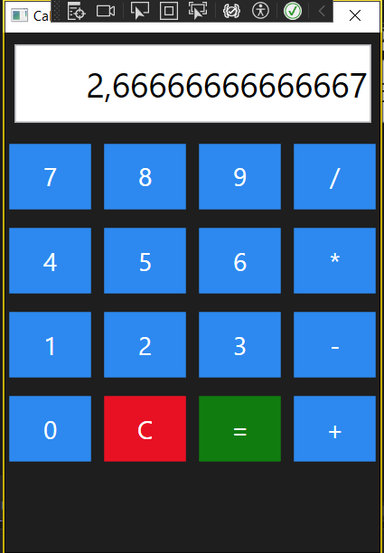
Код:
MainWindow.xaml
<Window x:Class="lab3.MainWindow"
xmlns="http://schemas.microsoft.com/winfx/2006/xaml/presentation"
xmlns:x="http://schemas.microsoft.com/winfx/2006/xaml"
Title="Calculator"
Height="500"
Width="350"
MinHeight="400"
MinWidth="300"
WindowStartupLocation="CenterScreen">

<Window.Resources>

<!-- Стиль кнопок -->
<Style TargetType="Button">
<Setter Property="Margin" Value="5"/>
<Setter Property="FontSize" Value="22"/>
<Setter Property="Background" Value="#2D89EF"/>
<Setter Property="Foreground" Value="White"/>
<Setter Property="BorderBrush" Value="Transparent"/>
<Setter Property="Cursor" Value="Hand"/>
<Setter Property="Height" Value="60"/>
</Style>

<!-- Стиль текстового поля -->
<Style TargetType="TextBox">
<Setter Property="FontSize" Value="30"/>
<Setter Property="Margin" Value="10"/>
<Setter Property="Height" Value="70"/>
<Setter Property="HorizontalContentAlignment" Value="Right"/>
<Setter Property="VerticalContentAlignment" Value="Center"/>
<Setter Property="IsReadOnly" Value="True"/>
</Style>

</Window.Resources>

<Grid Background="#1E1E1E">

<Grid.RowDefinitions>
<RowDefinition Height="Auto"/>
<RowDefinition Height="*"/>
</Grid.RowDefinitions>

<!-- Екран -->
<TextBox Grid.Row="0"
Text="{Binding DisplayText}"/>

<!-- Кнопки -->
<Grid Grid.Row="1">

<Grid.RowDefinitions>
<RowDefinition/>
<RowDefinition/>
<RowDefinition/>
<RowDefinition/>
<RowDefinition/>
</Grid.RowDefinitions>

<Grid.ColumnDefinitions>
<ColumnDefinition/>
<ColumnDefinition/>
<ColumnDefinition/>
<ColumnDefinition/>
</Grid.ColumnDefinitions>

<!-- Ряд 1 -->
<Button Grid.Row="0" Grid.Column="0" Content="7"
Command="{Binding NumberCommand}"
CommandParameter="7"/>

<Button Grid.Row="0" Grid.Column="1" Content="8"
Command="{Binding NumberCommand}"
CommandParameter="8"/>

<Button Grid.Row="0" Grid.Column="2" Content="9"
Command="{Binding NumberCommand}"
CommandParameter="9"/>

<Button Grid.Row="0" Grid.Column="3" Content="/"
Command="{Binding OperationCommand}"
CommandParameter="/"/>

<!-- Ряд 2 -->
<Button Grid.Row="1" Grid.Column="0" Content="4"
Command="{Binding NumberCommand}"
CommandParameter="4"/>

<Button Grid.Row="1" Grid.Column="1" Content="5"
Command="{Binding NumberCommand}"
CommandParameter="5"/>

<Button Grid.Row="1" Grid.Column="2" Content="6"
Command="{Binding NumberCommand}"
CommandParameter="6"/>

<Button Grid.Row="1" Grid.Column="3" Content="*"
Command="{Binding OperationCommand}"
CommandParameter="*"/>

<!-- Ряд 3 -->
<Button Grid.Row="2" Grid.Column="0" Content="1"
Command="{Binding NumberCommand}"
CommandParameter="1"/>

<Button Grid.Row="2" Grid.Column="1" Content="2"
Command="{Binding NumberCommand}"
CommandParameter="2"/>

<Button Grid.Row="2" Grid.Column="2" Content="3"
Command="{Binding NumberCommand}"
CommandParameter="3"/>

<Button Grid.Row="2" Grid.Column="3" Content="-"
Command="{Binding OperationCommand}"
CommandParameter="-"/>

<!-- Ряд 4 -->
<Button Grid.Row="3" Grid.Column="0" Content="0"
Command="{Binding NumberCommand}"
CommandParameter="0"/>

<Button Grid.Row="3" Grid.Column="1" Content="C"
Background="#E81123"
Command="{Binding ClearCommand}"/>

<Button Grid.Row="3" Grid.Column="2" Content="="
Background="#107C10"
Command="{Binding EqualCommand}"/>

<Button Grid.Row="3" Grid.Column="3" Content="+"
Command="{Binding OperationCommand}"
CommandParameter="+"/>

</Grid>

</Grid>
</Window>

MainWindow.xaml.cs
namespace lab3
{
public partial class MainWindow : Window
{
public MainWindow()
{
InitializeComponent();
DataContext = new CalculatorViewModel();
}
}
}
CalculatorViewModel.cs
using lab3;
using System;
using System.Collections.Generic;
using System.ComponentModel;
using System.Linq;
using System.Text;
using System.Threading.Tasks;
using System.Windows.Input;

namespace lab3
{
public class CalculatorViewModel : INotifyPropertyChanged
{
private string displayText = "0";

private double firstNumber;
private string operation;

public string DisplayText
{
get => displayText;
set
{
displayText = value;
OnPropertyChanged(nameof(DisplayText));
}
}

public ICommand NumberCommand { get; }
public ICommand OperationCommand { get; }
public ICommand EqualCommand { get; }
public ICommand ClearCommand { get; }

public CalculatorViewModel()
{
NumberCommand = new RelayCommand(AddNumber);
OperationCommand = new RelayCommand(SetOperation);
EqualCommand = new RelayCommand(Calculate);
ClearCommand = new RelayCommand(Clear);
}

private void AddNumber(object parameter)
{
string number = parameter.ToString();

if (DisplayText == "0")
DisplayText = number;
else
DisplayText += number;
}

private void SetOperation(object parameter)
{
firstNumber = double.Parse(DisplayText);
operation = parameter.ToString();
DisplayText = "0";
}

private void Calculate(object parameter)
{
if (!double.TryParse(DisplayText, out double secondNumber))
{
DisplayText = "Error";
return;
}

double result = 0;

switch (operation)
{
case "+":
result = firstNumber + secondNumber;
break;

case "-":
result = firstNumber - secondNumber;
break;

case "*":
result = firstNumber * secondNumber;
break;

case "/":
if (secondNumber == 0)
{
DisplayText = "Error";
return;
}

result = firstNumber / secondNumber;
break;
}

DisplayText = result.ToString();
}

private void Clear(object parameter)
{
DisplayText = "0";
firstNumber = 0;
operation = "";
}

public event PropertyChangedEventHandler PropertyChanged;

private void OnPropertyChanged(string propertyName)
{
PropertyChanged?.Invoke(this,
new PropertyChangedEventArgs(propertyName));
}
}
}
RelayCommand.cs
using System;
using System.Windows.Input;

namespace lab3
{
public class RelayCommand : ICommand
{
private readonly Action<object> execute;

public RelayCommand(Action<object> execute)
{
this.execute = execute;
}

public event EventHandler CanExecuteChanged;

public bool CanExecute(object parameter)
{
return true;
}

public void Execute(object parameter)
{
execute(parameter);
}
}
}

