GG3: Neural Data Analysis

Dan Logan, DL725
Selwyn College

Abstract

- Introduction
In 2015, KW Latimer et al. published an article on modelling spike trains recorded in the macaque lateral intraparietal (LIP) that challenged the previously widely accepted model. A ‘random dot motion’ task designed to induce clear decision making in the macaque’s parietal cortex was used to produce spike trains measured though extracellular electrophysiology. These spike trains were long thought to reflect a drift-diffusion model, ramping up through the accumulation of evidence over time. In this hypothesis, firing rates in individual trials was assumed to continuously build up over time, with different trials characterised by different drift and diffusion constants. Latimer, however, put forward a stepping model that more accurately described the firing rate behaviour of single trial spike trains. In this revised model, firing rates increase as a single step from min rate to max, with the model characterised by only the step time. The two models are still in debate, as firing rates being determined by a single step would suggest decision making is done elsewhere.
This 4 week project analyses the statistical properties arising from both models. In the final report, Hidden Markov Models (HMMs) containing hidden latents and emission probabilities will be applied to both models to allow us to apply statistical algorithms such as the forward-backwards method to estimate latents. Furthermore, the robustness and model mismatch will be explored to further compare the models.
In this report, however, the findings from the first week of work are outlined, involving the basic understanding of the models and how they have been applied to reproduce experimental data. The behaviour of how firing rate changes over time is visualised, then these rates are then passed through a Poisson process to produce spike rasters. Peri-stimulus time histograms (PSTHs) are explored, showing how the models behave when averaged over may trials. The Fano Factor is then introduced as a way of understanding these trial averaged distributions.
######## Task 1.4 ##########

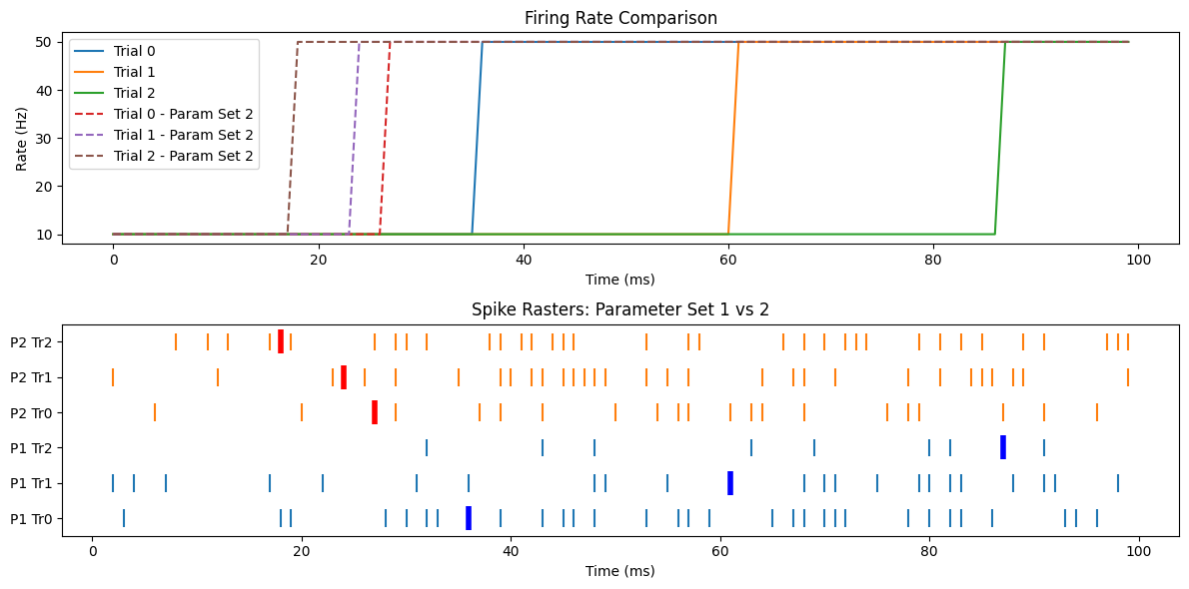

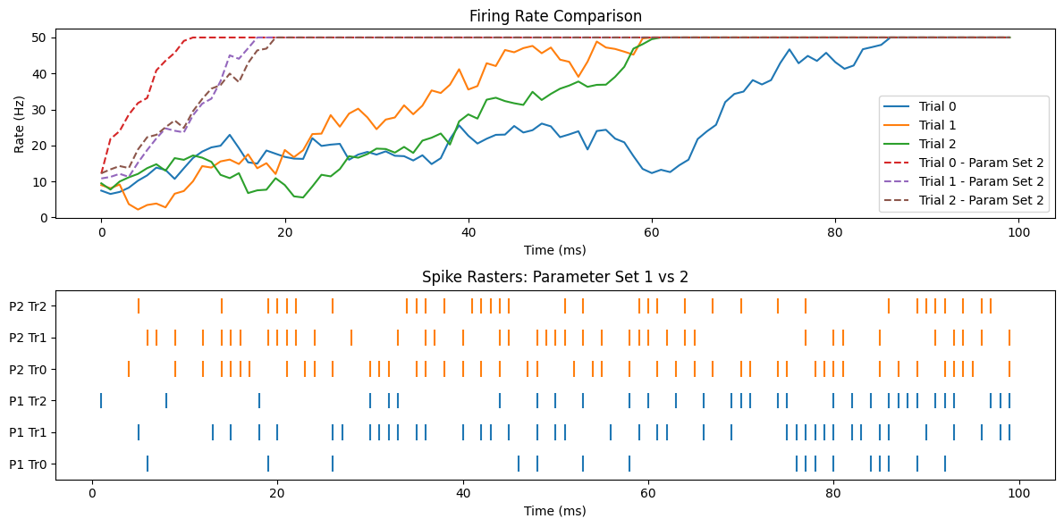
Figure 1: Firing rate and spike raster for step models with m = 25, r = 10 (dotted) and m = 75, r = 10,000 (filled)

Figure 2: Firing rate and spike raster for drift-diffusion model with β = 4, σ = 0.5 (dotted) and β = 0.8, σ = 0.5 (filled)
