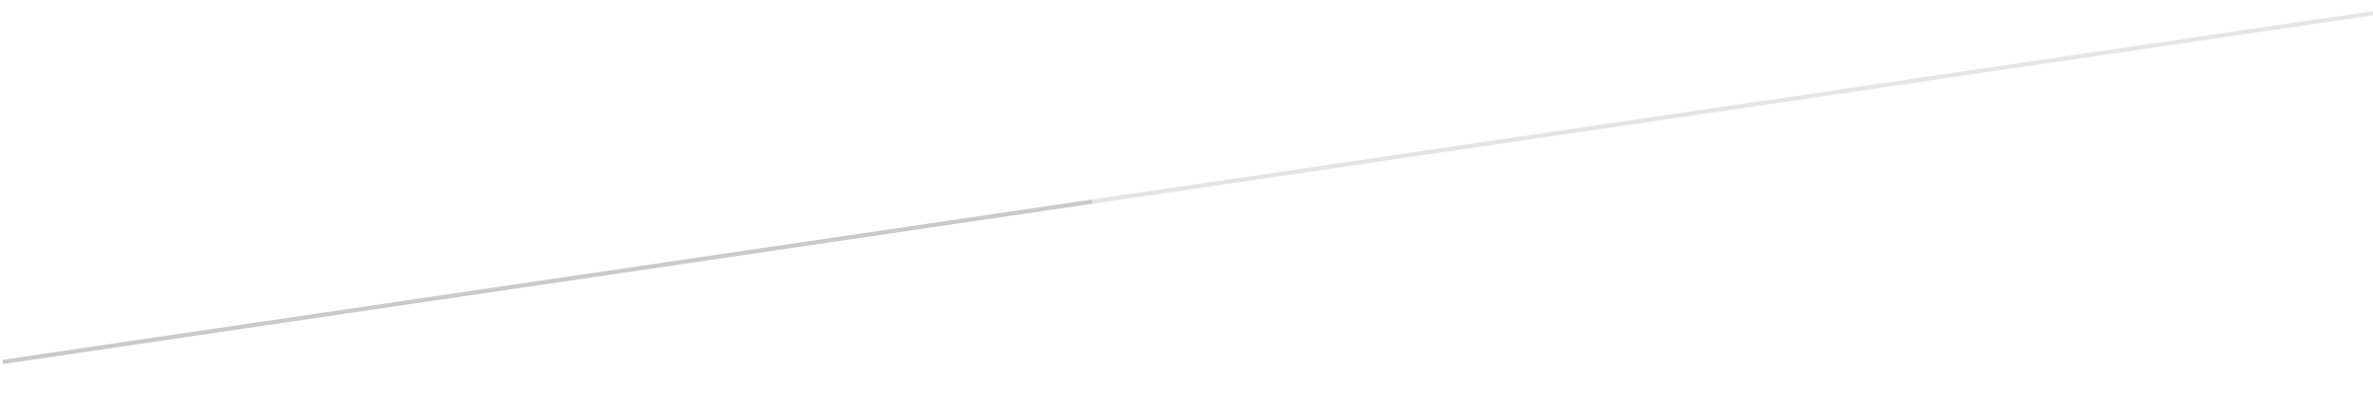

Contents

Introduction and Purpose

Summary of Project

Assumptions

Client/Users

Deliverables

Scope

Approach/Methodology

Timelines

Personnel/HR management

Communications management

# Introduction and Purpose

Many people are always in need of knowing what the weather is outside, at another location, or what it will be in the future. The aim for this project is to create a weather tracking mobile phone application, helping those people who are in need of the information about the weather. Making the application can be achieved through the use of javascript programming, documentation and software tools. The purpose of this, is to gain a better understanding of what has been taught to us in the workshops and lectures; improving on our comprehension of variables, arrays, control structures, objects, functions, sensor use, local storage, web service communication, and software design.

The application itself should be filled with a wide variety of functionality and features including:

* Being able to find the weather for all locations around the world
* Extensive information on the weather (eg. wind speed, humidity, etc.)
* Having a save page of all the locations you have searched
* Showing you your searched location on a map
* Showing the weather in your “Current Location”

# Summary of Project

## Assumptions

This application makes use of the Dark Sky Forecast API. It is assumed that the information that is received from this API is accurate. Also when viewing the weather from the past days it still only displays the temperature and data that was forecast, not the actual temperature of that day, so it is assumed that the actual temperature was the same as the forecast temperature.

## Client/Users

The application is intended for anyone who wishes to see the forecast weather at a particular location for the current day, or the last 30 days. As well as the members of our group, the other stakeholders in this project are Switch Solutions, the companies looking to purchase the app; Bureau of Meteorology (BOM), State Emergency Service (SES), and the Nine Network News, and also any person who may want to use the app.

## Deliverables

The product is an application that allows the user to select any location in the world and instantly receive weather data for the past 30 days. Information displayed includes maximum temperature, minimum temperature, humidity, wind speed and a summary statement. The application will allow the user to add any number of locations to a home page, and receive the weather information by clicking on a particular location. The application should be simple and easy to use, and give the user information quickly.

# Scope

## Approach/Methodology

The approach to finishing this project was done through the use of the applications GitHub, brackets and asana with the help of a couple of other features as well.

GitHub was used mainly for coding; everyone is able to view each other’s code in order to correct, change or add onto it. By viewing each ‘branch’ we could edit the code then sync what was edited and changed. Brackets falls into the same category as GitHub and was mainly used for coding, however, the only difference between the two is that brackets is not accessible online between the group. It is good to use and test out to find the bugs of each coding section and the final result.

Asana was used to stay on top of work and set assignments to each individual. Asana made sure everything was up to date and no one was falling behind schedule.

A feature on Google Chrome is it’s de-bugging system, used to find and solve the bugs in the code. It takes you through each step (or line) of the code and through that, you can pick up exactly where the bug is and what needs to be changed.

Materials Design Lite (MDL) is a library of components that was used to quickly create an elegant design for our web application.

Furthermore, access to a Google Maps API and The Dark Forecast API was a crucial aspect of our web app, allowing users to visualise their locations and actually receive forecast information.

## Timelines

Asana was used to keep track of what tasks need to be completed and what have been completed. It shows whom the tasks are assigned to and you can set timelines for each task as well. An example of this is shown below...

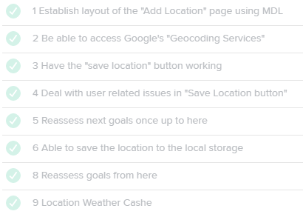

As shown above we tried to get all the basic functions working before reassessing each goal and continuing from there. We did this many times throughout the project to keep up with each task and always reassess what we have done and what we need to do.

We would make a maximum of 5 tasks between each reassessment and then continue our project from there.

The project should be completed by Friday 27 May 2016 in order for it to be ready to present to clients.

# Personnel/HR Management

## Team Members and Responsibilities

Brayden Morrow - 0488018935 - [brmor1@student.monash.edu](mailto:brmor1@student.monash.edu)

Leading app writer, documentation, chairman at meetings.

Jonathan Leibel – 0433720904 - [jglei2@student.monash.edu](mailto:jglei2@student.monash.edu)

Documentation, minutes taker at meetings

Ben Biggs – 0435587977 - [brbig2@student.monash.edu](mailto:brbig2@student.monash.edu)

Documentation, app testing and quality control

Every Thursday we had team meetings to update everyone on the progress, and ensure everybody knew what they needed to do. Bray chaired the meeting, while Jonathan took minutes. Topics discussed included current progress on application and documentation, who should be working on certain parts and when it should be finished by, and any current issues the team were having.

Documents were shared using Google Docs, as it allows everyone to instantly view changes, as well as edit the material themselves if required. Asana was used regularly to update all members of and progress or changes made to the application. Changes to the application were made using GitHub, to ensure that two people were not working on the same part of the application at once.

# Communications Management

The communication between the team was mostly done through Facebook. A group chat was set up between the three members and was used to ensure that each individual knew what needed to be done, to organise group meetings and check up on the status of those tasks as well. Asana also played a massive hand in organising tasks as the system utilises an online tracking system of tasks.Furthermore, much was achieved through the time given after each weekly practical on Thursday. The time allocated in those practical classes for the completion of the assignment was used to check the status of the project and give out certain tasks when needed.