Weather Tracking Application

bray morrow, jonothan leibel, Benjamin biggs

Team 301

MAY 23, 2016

User Guides

Version 1.0.1

**Contents**

Introduction and Purpose 2

Features 3

App Overview 4-7

Known Bugs or Limitation 8

# Introduction and Purpose

This Weather Tracking Application is a simple, user-friendly app that allows people to view the weather forecast for the present day and previous days at their chosen location or current location.

The main **purpose** of this application is to *quickly* inform the user of the current daily weather for specific locations tailored for brief interactions with the user. A secondary purpose for this is to allow users to view the weather *history* for a location and *track* changes in the weather.

This document **includes** a description of the features of this application, the platforms supported, an overview of how to use the various features as well as some known bugs and limitations of this application.

# Features

Features:  
  
This Weather Tracking Application is simple but has a wide range of features. A permanent “Current Location” will appear on the ‘favourites list’ where users can access the weather at their present GPS location. The application allows users to also select any location they please, with the help of a visual aid, chose a nickname for the place and save said location permanently to their ‘favourites’ list. From here users can access the daily minimum and maximum temperature as well as see an icon that would be a summary of the weather for the day for all the locations they have saved. Furthermore users can see a more detailed current daily weather summary including humidity, wind speed and a written summary of the weather as well as maximum and minimum temperatures and the location of a map. Another unique feature from this page is when the slider is moved the weather for the location for the last 29 days can be displayed. Additionally, on this page the user may remove the location from their locations list with the use of the button. Upon returning to this app from the same browser, the user will have all the locations previously saved displayed and the daily weather forecasts previously viewed very quickly as the data is locally stored.

Platform Supported:  
  
As this application is a web app, the *browser* interprets the app not the device. Hence, this will work on all devices including iPhone, Android, Windows Phone and MacBook.

# App Overview

Opening the Application

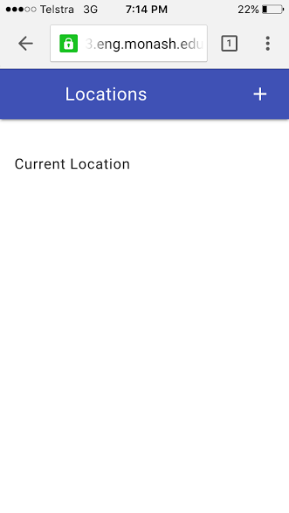

1.0 Upon entering the weather application for the *first* time, a screen like this will appear.

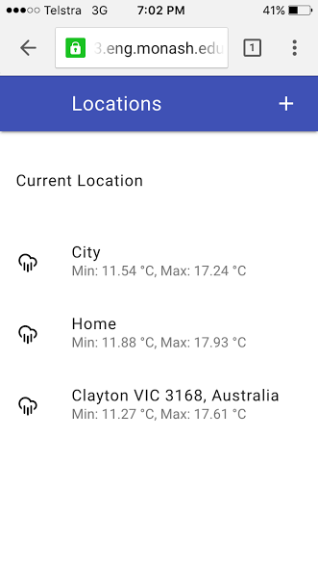

Note: Plus allows user to add a location

1.1 Upon entering the weather application from the *same* browser *after* saving locations, a screen like this will appear.

Add a New Location

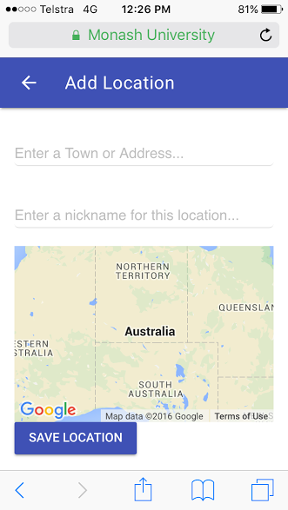

Note: Arrow returns user to home page

2.0 To add a new location, simply click the plus button from the home page and a screen like this will appear.

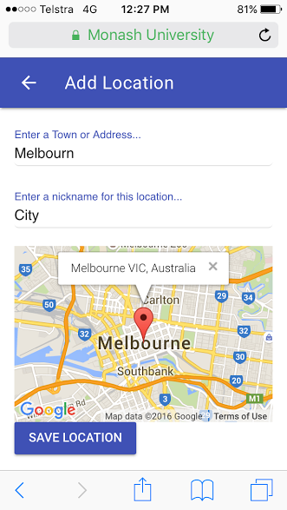

2.1 To find a location start typing in the first text box and the Google Geocoder will find your place. If your location is displayed on the map, you *do not* need to finish typing the address. The second text field is optional. You can assignment a nickname to your chosen location if you please, for instance, ‘City.

2.2 To save this location to your ‘Locations’ list all you need to do is tap the “Save Location” button.

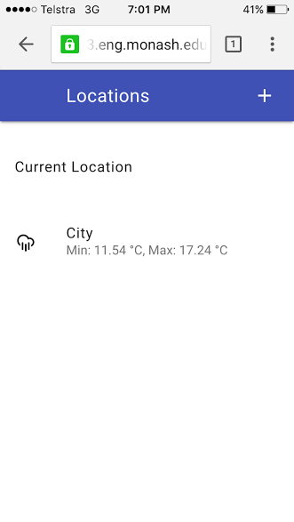

2.3 You will be returned to the Home screen and your location should appear like this. Note that the weather summary has already appeared as well as an icon to quickly display a snapshot of the daily weather forecast.

View Weather at Location

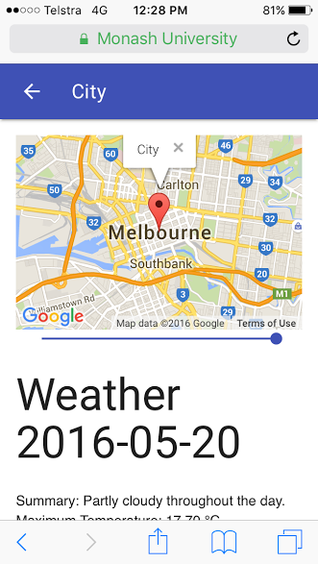

3.0 To view a more detailed summary of the weather at a location, simply click the location from the main page and a screen like this will appear.

Note: The amount the slider moves corresponds to the date

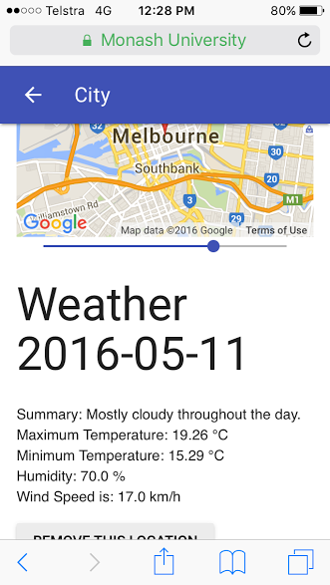

Note: The amount the slider moves corresponds to the date

3.1 The forecast displayed is the daily forecast for today. To display the forecast summary for up to 29 days in the past, simply click and drag the slider until you reach your selected date.

Remove a Location

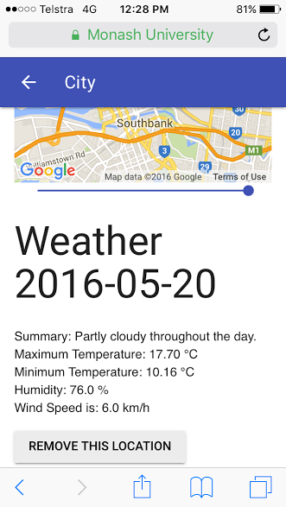

4.0 While viewing a location’s weather you may press the “Remove This Location” button to permanently remove the location from your list.

# 

# Current Location

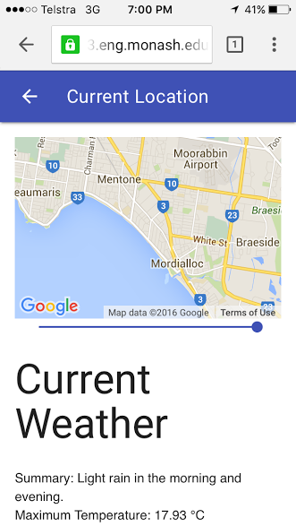

# 5.0 To view weather at your current location, simply click ‘Current Location’ on the main page and a screen like this will appear.

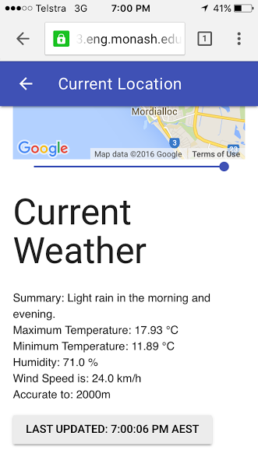

5.1 The content is similar to the View Location page (see Section 3). However, you will be asked for permission to access your current location first. Assuming you accept, the forecast will display with two differences. You will notice how accurate the forecast is and the last time the page was updated in AEST. It should be noted that the slider does still work and your current location updates as you move.

# Known Bugs or Limitation

Bugs:

There are some current bugs, which are not critical or major defects, including the following:

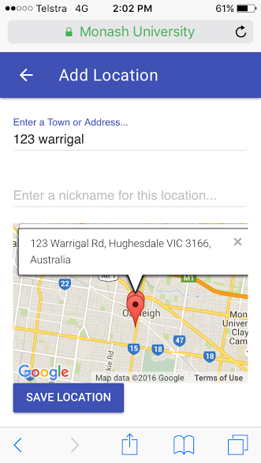

1) While searching for a specific address, a marker is created each time Google finds a new location. For instance, while searching for “123 Warrigal Rd, Hughesdale VIC 3166, Australia”, if they were to make a mistake and type ‘113’initially, two markers would display on the screen as seen below.

2) While searching for a location it always jumps between places all around the world, not locally where the person is. For instance, when searching for “Melbourne VIC, Australia” the map displays ‘Mel BL, Italy’, ‘Melbu, Norway’ and ‘Melbou, Algeria’ along the way. It should just be noted that there may be more than one marker but the information window is correct.

Limitations:

There are some current limitations (however there are a ways to fix these):

1) Using one API Key from forecast.io API. Therefore with many users, the calls limit for the day could be reached quite quickly. A possible solution to this limitation could be purchasing an account with The Dark Sky Forecast to extend the calls allowed per day or just waiting till the next day to request information for this application.

2) The time that the website is updated to displays as AEST. This cannot be changed by the user but could easily be fixed or changed to suit other countries if need be.