**Enhancing the Accuracy of Low-Cost Thermocouple Devices through Deep-wavelet Neural Network Calibration**

**James Julian1, Annastya Bagas Dewantara2, Fitri Wahyuni1**

1Department of Mechanical Engineering, Faculty of Engineering, University of Pembangunan Nasional Veteran Jakarta, Jakarta, Indonesia

21Department of Electrical Engineering, Faculty of Engineering, University of Pembangunan Nasional Veteran Jakarta, Jakarta, Indonesia

|  |  |  |
| --- | --- | --- |
| **Article Info** |  | **ABSTRACT** (10 PT) |
| ***Article history:***  Received month dd, yyyy  Revised month dd, yyyy  Accepted month dd, yyyy |  | An abstract is often presented separate from the article, so it must be able to stand alone. A well-prepared abstract enables the reader to identify the basic content of a document quickly and accurately, to determine its relevance to their interests, and thus to decide whether to read the document in its entirety. The abstract should be informative and completely self-explanatory, provide a clear statement of the problem, the proposed approach or solution, and point out major findings and conclusions. **The Abstract should be 100 to 200 words in length.** References should be avoided, but if essential, then cite the author(s) and year(s). Standard nomenclature should be used, and non-standard or uncommon abbreviations should be avoided, but if essential they must be defined at their first mention in the abstract itself. No literature should be cited. The keyword list provides the opportunity to add 5 to 7 keywords, used by the indexing and abstracting services, in addition to those already present in the title (9 pt). |
| ***Keywords:***  First keyword  Second keyword  Third keyword  Fourth keyword  Fifth keyword |
| *This is an open access article under the* [*CC BY-SA*](https://creativecommons.org/licenses/by-sa/4.0/) *license.* |
| ***Corresponding Author:***  James Julian  Department of Mechanical Engineering, Faculty of Engineering, University of Pembangunan Nasional Veteran Jakarta, Jakarta, Indonesia  Jl. RS Fatmawati, Pondok Labu, Cilandak, Central Jakarta, Indonesian  Email: zames@upnvj.ac.id | | |

1. **INTRODUCTION**

Temperature is a fundamental parameter widely used in industry, manufacturing, and the environment for health. The wide use of these parameters has led to an increasing demand for accurate temperature measurement instruments. This is supported by data obtained from the global market, which estimates that the annual growth of temperature sensors will increase by 4.8% in 2027 [1], and it is estimated that the market of sensors will exceed 10 billion sensors/year in the next ten years [2]. The impact caused by the increased demand is the increase in the price of sensors with high accuracy resulting from the low availability of goods in the market. This has an impact on the increasing use of cheap sensors with low-quality accuracy.

The level of accuracy and reading range of the temperature sensor is influenced by the type of temperature sensor used, the use of thermocouple sensors is often used because of their high reading range capability and low price, rather than thermistors, which have low heat susceptibility and resistance temperature detectors (RTD) which have high prices [3]. The main problem found in thermocouple sensors is the presence of Johnson noise which is created due to thermal gradients at the reference junctions [4] caused by poor insulation, shielding, and temperature stabilization in thermocouple electronic devices, which causes thermal noise in the readings. In addition to the noise created on the thermocouple sensor, other noise created due to electromagnetic interference in electronic circuits and unstable input voltages due to ripple or poor grounding affects the quality of the readings produced [5].

In minimizing the presence of noise, several approaches have been taken, one of which is applying the Kalman filter algorithm to the denoising process [6], however, the process of implementing the Kalman filter is too dependent on the system dynamic model that is set at the beginning and is not effective on data that has high variation [7], an approach using a deep neural network has also been carried out to minimize the amount of noise contained in the thermocouple data and obtain a root mean squared error (RMSE) value of [8] but the presence of noise is still visible in the peak signal area. The use of Fast Fourier transform (FFT) in the denoising process is based on the observed frequency values [9], however, the denoising process using the Fourier transform has limitations in dealing with transient noise and frequency leakage, which are common in non-stationary signals such as sensor data readings. Moving average filter (MAF) is also used to minimize errors in thermocouple sensor readings to measure temperature in internal combustion engines with a maximum error value of 1.5% to 2% peak temperature [10], however, the MAF filtering process has limitations in multiresolution analysis because it treats all component frequencies in the signal evenly and does not respond well to non-stationary signals. The high fluctuation and noise generated by the thermocouple sensor cause conventional data acquisition techniques to be inaccurate and unusable.

In overcoming these problems, this research was conducted to improve the reading quality of the thermocouple sensor by using a deep neural network algorithm combined with the use of wavelet transform as a denoising signal reading method by providing a threshold based on the deviation value of the thermocouple sensor using a computer modeling program. By implementing these two techniques, the identification of the mean absolute error (MAE) and signal-to-noise ratio (SNR) values will be used as basic metrics to determine the performance of the thermocouple sensor reading technique.

1. **METHOD**

Temperature measurements using thermocouple sensors often have low accuracy and precision as well as high noise caused by noise at the reference junction, poor shielding and insulation, unstable input voltage, and the effect of electromagnetic interference on the device module, which causes reliability and data quality using conventional methods has low accuracy and precision. The level of data reliability is inversely proportional to the noise level it has. The lower the deviation, the higher the level of data reliability.

This study aims to improve the quality and reliability of data using a wavelet transform to determine noise reduction and increase the SNR of the input signal using the ANN-based calibration method to obtain the lowest MAE value from the various methods used. Shown in Figure 1. The study began with a calibration process using a temperature-controlled water bath with an adjustable temperature to determine the value of the difference between the temperature readings from the measured sensor and the actual temperature, with repeated measurements made from 20℃ to 73℃ with a sampling frequency of 1 Hz, for five minutes. Data was collected using a 2-wire k-type thermocouple sensor with a probe length of 100mm and a diameter of 5mm made of stainless steel, which was connected to the 32-channel temperature Modbus module. The data is then calibrated using ANN by varying the activation function on the ANN architecture. The best activation function will be used as the activation function in ANN architecture, which will be continued for denoising using wavelet transform.

Figure 1. Research flowchart

**2.2. ANN**

ANN is a computational model system created by mimicking the network pattern of the human brain so that it can recognize patterns and complex relationships in data [11], so the use of ANN in the calibration process using noisy data is suitable for use because of its ability to generalize and recognize outlier data [12]. ANN has an architecture consisting of layers of neurons with nodes connected. Interactions and relationships between each node in each layer have different weight and bias values that can function as regression or classification [13]. ANN performs learning through forward propagation to compute input values from data into initial node neurons to produce the expected output node output through a computational process of adding weight and bias to each neuron node through a specific activation function [14]. The equation form of each neuron node is represented in equation (1), with equation (2) representing the activation function for the weight and bias parameters.

|  |  |  |
| --- | --- | --- |
|  | | (1) |
|  | | (2) |
| L | : Layer | |
| k | : Node input | |
| K | : Total Node input | |
| j | : Node output | |
|  | : Activation Functions | |

The performance test of the ANN uses the MAE shown in equation (3) as the accuracy test performance of the regression model, which is generally used because the model is due to intuitive interpretation of the model [15].

|  |  |  |
| --- | --- | --- |
|  | | (3) |
| M | : Number of samples in batch data | |

The accuracy performance of the ANN model is affected by the given activation function [16], in this calibration process, variations of the activation function are carried out by varying the activation function, namely rectified linear unit (ReLU), exponential linear unit (ELU), gaussian error linear unit (GELU), linear and leaky ReLU. The choice of the ReLU activation function is due to its ability to deal with vanishing gradients [17], ELU is used to prevent dying node neurons, and its robust ability to recognize noisy data [18], Linear is used to find out whether the simplification process can be used to ease model computation. Just like ELU, GELU is used to overcome dying node neurons with lighter computation than ELU, and the asymptotic behavior of GELU provides a more stable training process [19]. Equation simplification for computational process efficiency and prevention of dying node neurons is also found in LeakyReLU [20].

|  |  |
| --- | --- |
|  | (4) |
|  | (5) |
|  | (6) |
|  | (7) |
|  | (8) |

Backward propagation is used to change the weight and bias values for each neuron node in all layers, which is obtained from the loss function error, the difference between the actual value and the predicted value. [21], the mean squared error (MSE) function is used as the loss function in equation (9) instead of MAE because the error distribution of sensor readings has a gaussian distribution and not the Laplacian distribution [22].

|  |  |  |
| --- | --- | --- |
|  | | (9) |
|  | : Cost function mean squared error | |
|  | : Actual value of i-th data | |

Stochastic gradient descent in equations (10)-(13) is used by dividing the total data into certain batches and training ANN on different batches in each iteration with changes in weight and bias values that are set using learning rates to reduce computation time and increase the memory allocation [23].

|  |  |  |
| --- | --- | --- |
|  | | (10) |
|  | | (11) |
|  | | (12) |
|  | | (13) |
|  | : Learning Rate | |
| i | : Iteration | |

**2.3. Wavelet Transform**

Wavelet transform is a mathematical technique for converting data from the time domain into the frequency domain in the form of the frequency domain, and the time domain makes it easier to perform multiresolution analysis than the Fourier transform, which only presents data in the form of the frequency domain [24]. Wavelet transform has more adaptability than Fourier transform in terms of noise suppression. This is because the threshold given to each coefficient is different at each level, which makes the use of Wavelet transform have various implementations [25]–[29].

Discrete Wavelet transform is a wavelet method that is more commonly used than continuous wavelet transform because it has lighter computations and makes it easier to do thresholding at each level [30]. The wavelet transform divides the equation into two coefficients: the detail coefficient and the approximation coefficient, shown in equations (14) and (15).

|  |  |  |
| --- | --- | --- |
|  | | (14) |
|  | | (15) |
|  | : Approximation coefficient at level j and position k | |
|  | : Detail coefficient at level j and position k | |
|  | : Wavelet scaling function at level j and position k at n-data | |
| (n) | : Wavelet function at level j and position k at n-data | |
|  | : Input signal of n-th with length of N | |

The Haar wavelet transform is used because of its ability to perform noise suppression and light computation [31], which is shown in equations (16) and (17).

|  |  |  |
| --- | --- | --- |
|  | | (16) |
|  | | (17) |
|  | : Number of signal input | |

The thresholding calculation in equation (20) is used with VisuShrink based on the deviation value obtained in equations (18) and (19) by treating the global thresholding scheme by treating a single threshold for all wavelet coefficients, which is effective against additive noise that commonly occurs on the sensor [32].

|  |  |  |
| --- | --- | --- |
|  | | (18) |
|  | | (19) |
|  | | (20) |
|  | : Signal deviation | |
|  | : Number of coefficient at level j | |
|  | : Number of level | |
|  | : Universal hresholding | |

Using hard thresholding in equation (21) to filter the signal noise, the signal denoise value is obtained using the inverse discrete wavelet transform in equation (22).

|  |  |  |
| --- | --- | --- |
|  | | (21) |
|  | | (22) |
|  | : Denoise signal | |
|  | : Approximation coefficient at level j and position k after applied thresholding | |
|  | : Detail coefficient at level j and position k after applied thresholding | |

The SNR equation measures the wavelet transform's denoising performance against the equation's actual value (23).

|  |  |
| --- | --- |
|  | (23) |

1. **RESULTS AND DISCUSSION**

**3.1. Kalibrasi data**

The reading data of the thermocouple sensor connected to the module shows different offset variations to the actual temperature, as shown in Figure 2., and shows the presence of evenly distributed noise which shows the exact correlation as Nash et al. related to the presence of noise caused by the cold junction compensator in the amplifier contained in the thermocouple module [33], from the figure, it is kn own that the magnitude of the noise fluctuation is different at low temperature measurements with high temperatures, which is caused by the presence of Jonshon noise making the current flowing from the sensor to the thermocouple module fluctuate due to increased thermal energy and vibrations from the water as a reading environment [34].

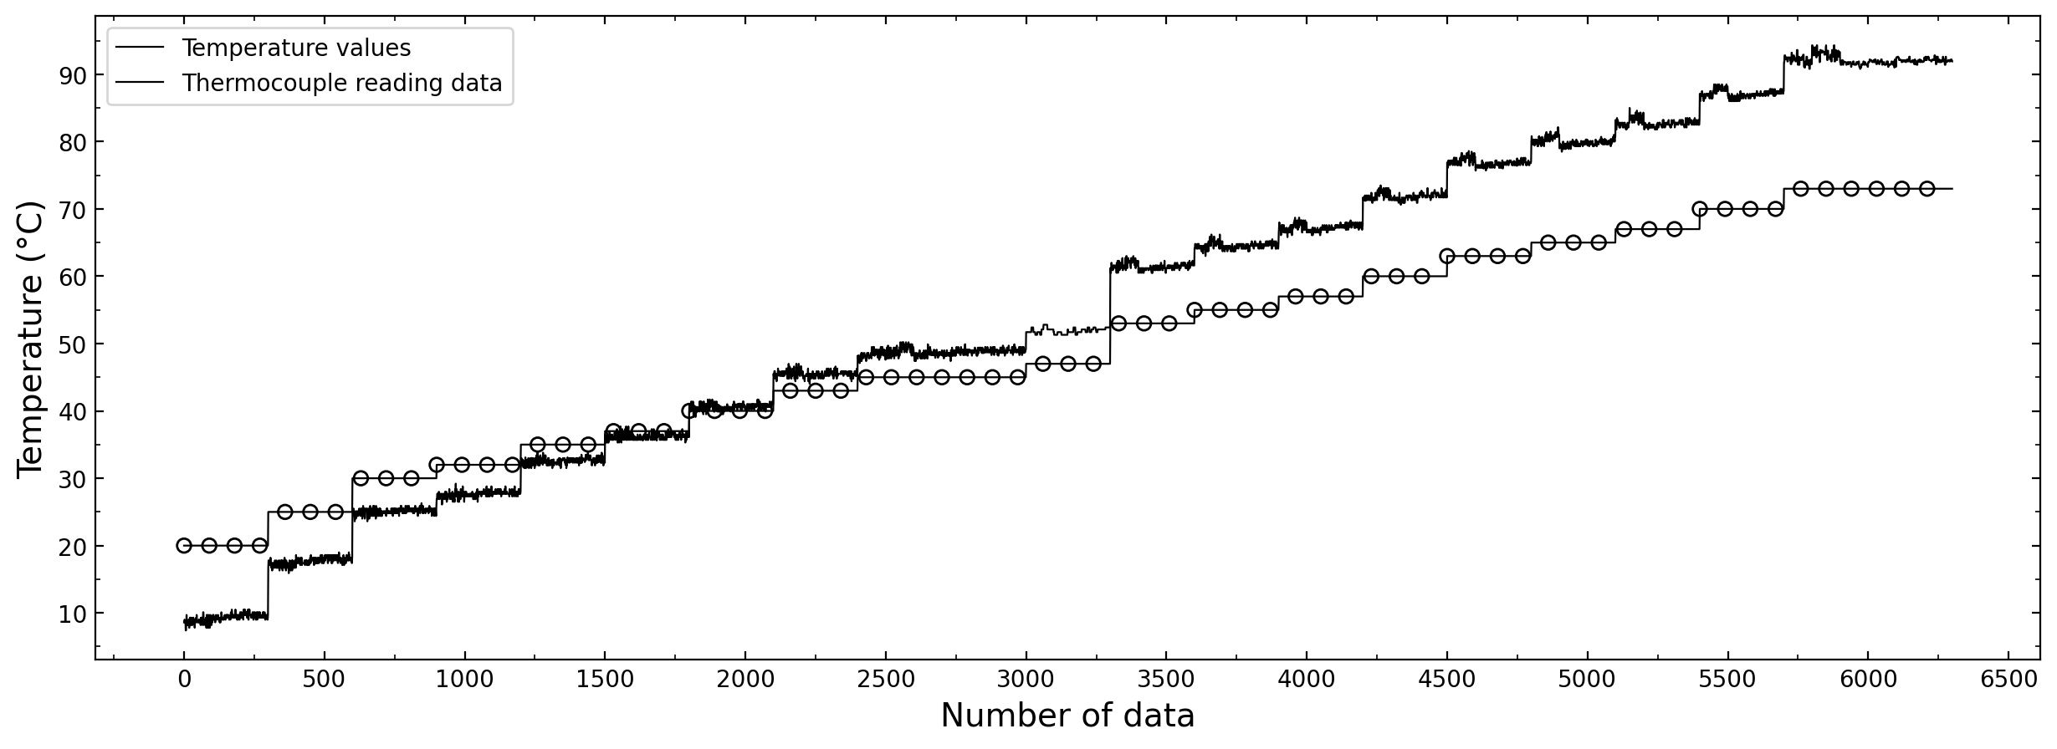

Figure 2. Research flowchart

Deep learning is used to reduce the presence of noise by varying the type of activation function in equations (4)-(8), with a two-layer architecture, eight neuron nodes in the first layer and one neuron node in the output layer with both layers having the same type of activation to be varied. The training process was carried out with an α value of 0.001 and i of 1000 iterations, shown in Figure 3. The ELU activation function has the lowest MAE value and GELU with a faster convergent time than the other four activation functions, showing the same results by Poulinakis et al [35] ELU, as an activation function, has high results when trained on data with high noise.

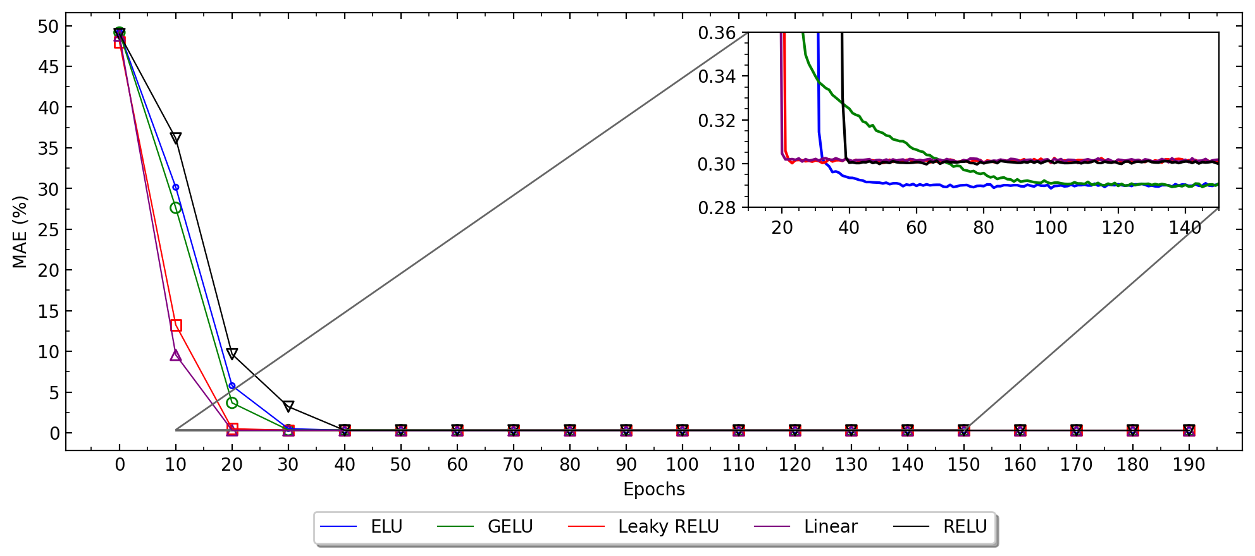

Figure 3. Activation functions MAE comparisons

**3.2. Denoising signal**

Data readings of thermocouple sensors that have been calibrated using deep learning are continued using wavelet transform as a denoising process with a J level value of 6300 and a total N of 6300, with the decomposition results of the wavelet transform shown in Figure 4. Using equations (14)-(17).

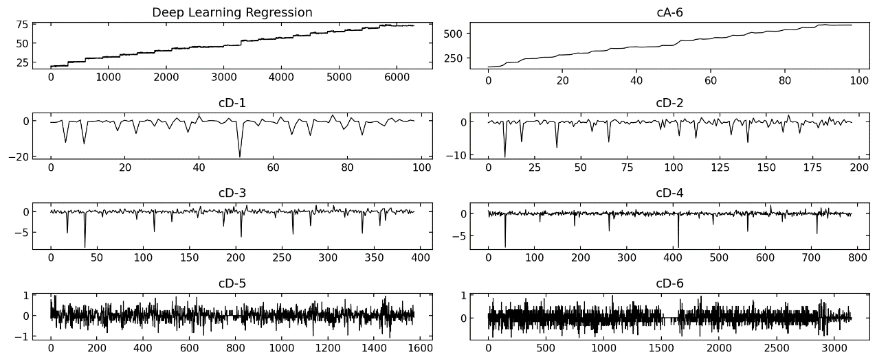

Figure 4. Deep-wavelet denoising process

Melalui implementasi digital signal processing menggunakan Deep-wavelet sebagai metode kalibrasi dan denoising dihasilkan peningkatan akurasi sebesar ___ % dengan nilai MAE dari Deep-wavelet sebsesar __ dengan pengurangurangan jumlah noise sebesar __% dengan nilai SNR dari denoise signal sebesar __ dB yang ditunjukkan pada Figure 5., penggunaan Deep-wavelet ini memiliki MAE yang lebih rendah sebesar __% serta __% SNR lebih besar ketimbang pengukuran yang dilakukan menggunakan National Instrument (NI), yang menjadikan penggunaan low-cost modul thermocouple ini memiliki kualitas dan reabilitas data yang bagus.

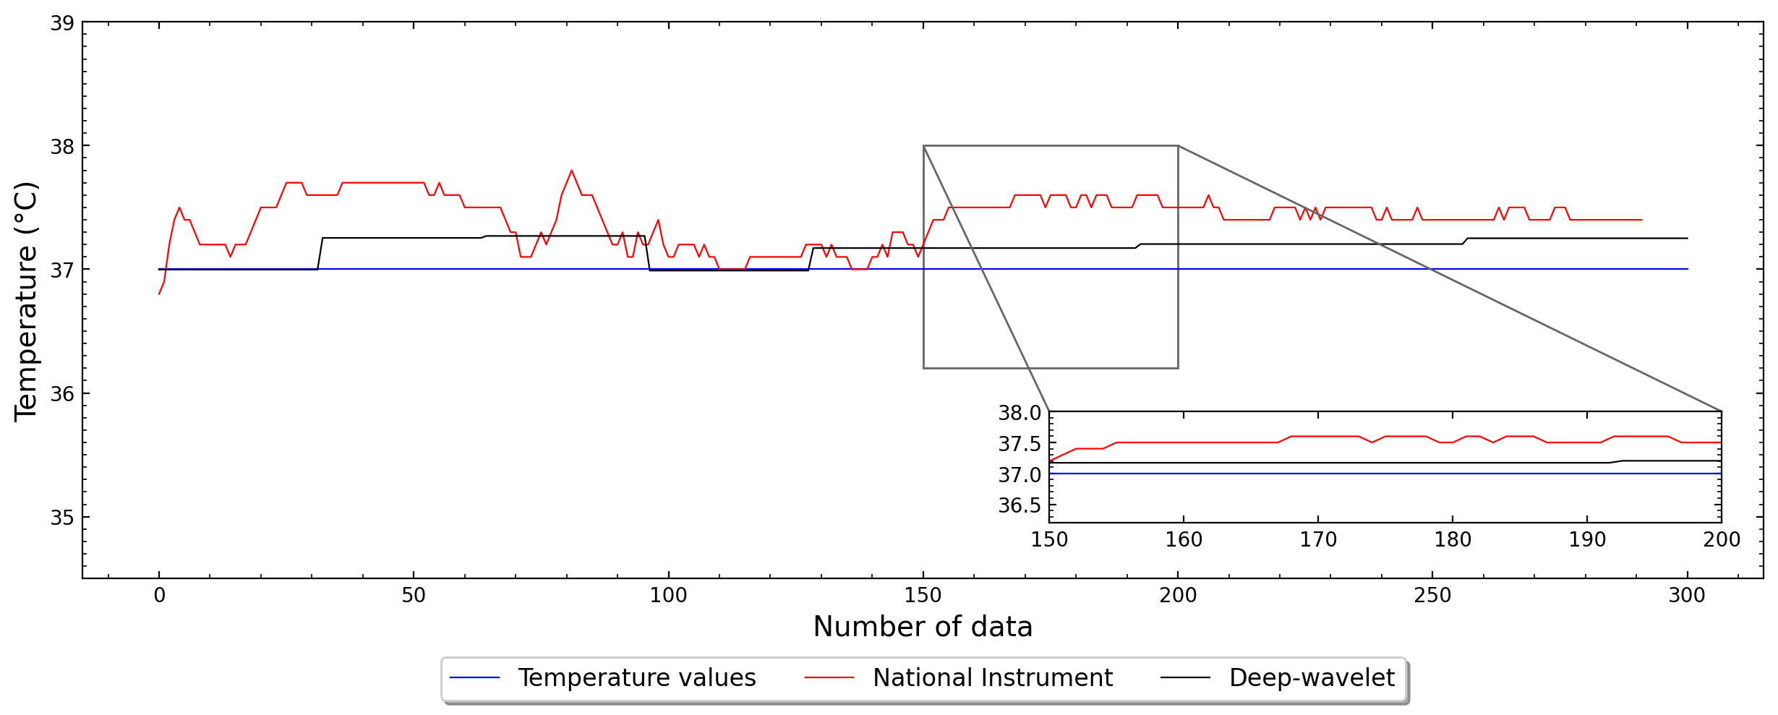

Figure 5. Deep-wavelet results

1. **CONCLUSION**

Pengamnbilan data menggunakan sensor thermocouple pada low-cost devices seringkali terjadi kerusakan kualitas data yang disebabkan akibat pengaruh noise yang ditimbulkan oleh cold conjunction compensator serta johnson noise yang disebabkan akibat buruknya insulas

**REFERENCES**

[1] A. Elyounsi and A. N. Kalashnikov, “Evaluating Suitability of a DS18B20 Temperature Sensor for Use in an Accurate Air Temperature Distribution Measurement Network,” *Engineering Proceedings 2021, Vol. 10, Page 56*, vol. 10, no. 1, p. 56, Nov. 2021, doi: 10.3390/ECSA-8-11277.

[2] R. Bogue, “Towards the trillion sensors market,” *Sensor Review*, vol. 34, no. 2, pp. 137–142, 2014, doi: 10.1108/SR-12-2013-755/FULL/XML.

[3] M. Pandey and G. Mishra, “Types of sensor and their applications, advantages, and disadvantages,” *Advances in Intelligent Systems and Computing*, vol. 814, pp. 791–804, 2019, doi: 10.1007/978-981-13-1501-5_69/COVER.

[4] J. F. Qu, S. P. Benz, H. Rogalla, W. L. Tew, D. R. White, and K. L. Zhou, “Johnson noise thermometry,” *Meas Sci Technol*, vol. 30, no. 11, p. 112001, Sep. 2019, doi: 10.1088/1361-6501/AB3526.

[5] S. B. Barnett, A. G. Swanson, T. Lorimer, and M. Brown, “Electromagnetic Interference Mitigation in a High Voltage Inspection Robot,” *Lecture Notes in Electrical Engineering*, vol. 598 LNEE, pp. 331–341, 2020, doi: 10.1007/978-3-030-31676-1_32/COVER.

[6] R. Septiana, I. Roihan, R. A. Koestoer, and R. A. Koestoer, “Denoising MAX6675 reading using Kalman filter and factorial design,” *International Journal of Electrical and Computer Engineering (IJECE)*, vol. 11, no. 5, pp. 3818–3827, 2021, doi: 10.11591/ijece.v11i5.pp3818-3827.

[7] C. Urrea and R. Agramonte, “Kalman Filter: Historical Overview and Review of Its Use in Robotics 60 Years after Its Creation,” *J Sens*, vol. 2021, 2021, doi: 10.1155/2021/9674015.

[8] J. X. Leon-Medina *et al.*, “Temperature Prediction Using Multivariate Time Series Deep Learning in the Lining of an Electric Arc Furnace for Ferronickel Production,” *Sensors 2021, Vol. 21, Page 6894*, vol. 21, no. 20, p. 6894, Oct. 2021, doi: 10.3390/S21206894.

[9] N. Yilmaz, W. Gill, A. B. Donaldson, and R. E. Lucero, “Problems Encountered in Fluctuating Flame Temperature Measurements by Thermocouple,” *Sensors (Basel)*, vol. 8, no. 12, p. 7882, Dec. 2008, doi: 10.3390/S8127882.

[10] N. Papaioannou, F. Leach, and M. Davy, “Effect of Thermocouple Size on the Measurement of Exhaust Gas Temperature in Internal Combustion Engines,” *SAE Technical Papers*, vol. 2018-September, Sep. 2018, doi: 10.4271/2018-01-1765.

[11] E. Grossi and M. Buscema, “Introduction to artificial neural networks,” *Eur J Gastroenterol Hepatol*, vol. 19, no. 12, pp. 1046–1054, Dec. 2007, doi: 10.1097/MEG.0B013E3282F198A0.

[12] A. E. Ilesanmi and T. O. Ilesanmi, “Methods for image denoising using convolutional neural network: a review,” *Complex and Intelligent Systems*, vol. 7, no. 5, pp. 2179–2198, Oct. 2021, doi: 10.1007/S40747-021-00428-4/FIGURES/13.

[13] N. Yuvaraj, R. A. Raja, N. v. Kousik, P. Johri, and M. J. Diván, “Analysis on the prediction of central line-associated bloodstream infections (CLABSI) using deep neural network classification,” *Computational Intelligence and Its Applications in Healthcare*, pp. 229–244, Jan. 2020, doi: 10.1016/B978-0-12-820604-1.00016-9.

[14] O. A. Montesinos López, A. Montesinos López, and J. Crossa, “Fundamentals of Artificial Neural Networks and Deep Learning,” *Multivariate Statistical Machine Learning Methods for Genomic Prediction*, pp. 379–425, 2022, doi: 10.1007/978-3-030-89010-0_10.

[15] A. de Myttenaere, B. Golden, B. Le Grand, and F. Rossi, “Mean Absolute Percentage Error for regression models,” *Neurocomputing*, vol. 192, pp. 38–48, Jun. 2016, doi: 10.1016/J.NEUCOM.2015.12.114.

[16] K. Biswas, S. Kumar, S. Banerjee, and A. K. Pandey, “EIS - Efficient and Trainable Activation Functions for Better Accuracy and Performance,” *Lecture Notes in Computer Science (including subseries Lecture Notes in Artificial Intelligence and Lecture Notes in Bioinformatics)*, vol. 12892 LNCS, pp. 260–272, 2021, doi: 10.1007/978-3-030-86340-1_21/COVER.

[17] A. Nguyen, K. Pham, D. Ngo, T. Ngo, and L. Pham, “An Analysis of State-of-the-art Activation Functions For Supervised Deep Neural Network,” *Proceedings of 2021 International Conference on System Science and Engineering, ICSSE 2021*, pp. 215–220, Apr. 2021, doi: 10.1109/ICSSE52999.2021.9538437.

[18] D. A. Clevert, T. Unterthiner, and S. Hochreiter, “Fast and Accurate Deep Network Learning by Exponential Linear Units (ELUs),” *4th International Conference on Learning Representations, ICLR 2016 - Conference Track Proceedings*, Nov. 2015, Accessed: Jul. 19, 2023. [Online]. Available: https://arxiv.org/abs/1511.07289v5

[19] D. Hendrycks and K. Gimpel, “Gaussian Error Linear Units (GELUs),” Jun. 2016, Accessed: Jul. 19, 2023. [Online]. Available: https://arxiv.org/abs/1606.08415v5

[20] B. Xu, N. Wang, H. Kong, T. Chen, and M. Li, “Empirical Evaluation of Rectified Activations in Convolutional Network,” May 2015, Accessed: Jul. 19, 2023. [Online]. Available: https://arxiv.org/abs/1505.00853v2

[21] J. C. R. Whittington and R. Bogacz, “Theories of Error Back-Propagation in the Brain,” *Trends Cogn Sci*, vol. 23, no. 3, pp. 235–250, Mar. 2019, doi: 10.1016/J.TICS.2018.12.005.

[22] T. O. Hodson, “Root-mean-square error (RMSE) or mean absolute error (MAE): when to use them or not,” *Geosci Model Dev*, vol. 15, no. 14, pp. 5481–5487, Jul. 2022, doi: 10.5194/GMD-15-5481-2022.

[23] T. Vatanen, T. Raiko, H. Valpola, and Y. LeCun, “Pushing Stochastic Gradient towards Second-Order Methods -- Backpropagation Learning with Transformations in Nonlinearities,” *Lecture Notes in Computer Science (including subseries Lecture Notes in Artificial Intelligence and Lecture Notes in Bioinformatics)*, vol. 8226 LNCS, no. PART 1, pp. 442–449, Jan. 2013, doi: 10.1007/978-3-642-42054-2_55.

[24] S. A. P. Haddad and W. A. Serdijn, “Wavelet versus Fourier Analysis,” *Ultra Low-Power Biomedical Signal Processing*, pp. 33–50, 2009, doi: 10.1007/978-1-4020-9073-8_3.

[25] L. Ramalingappa and A. Manjunatha, “Power quality event classification using complex wavelets phasor models and customized convolution neural network,” *International Journal of Electrical and Computer Engineering (IJECE)*, vol. 12, no. 1, pp. 22–31, Feb. 2022, doi: 10.11591/IJECE.V12I1.PP22-31.

[26] A. B. Channegowda and H. N. Prakash, “Image fusion by discrete wavelet transform for multimodal biometric recognition,” *IAES International Journal of Artificial Intelligence (IJ-AI)*, vol. 11, no. 1, pp. 229–237, Mar. 2022, doi: 10.11591/IJAI.V11.I1.PP229-237.

[27] M. Hamiane and F. Saeed, “SVM Classification of MRI Brain Images for Computer-Assisted Diagnosis,” *International Journal of Electrical and Computer Engineering (IJECE)*, vol. 7, no. 5, pp. 2555–2564, Oct. 2017, doi: 10.11591/IJECE.V7I5.PP2555-2564.

[28] J. Too, A. R. Abdullah, N. M. Saad, M. Ali, H. Musa, and F. K. Elektrik, “A Detail Study of Wavelet Families for EMG Pattern Recognition,” *International Journal of Electrical and Computer Engineering (IJECE)*, vol. 8, no. 6, pp. 4221–4229, Dec. 2018, doi: 10.11591/IJECE.V8I6.PP4221-4229.

[29] L. S, Natraj. K.R, and Rekha. K.R, “Noise and Vibration Reduction in Permanent Magnet Synchronous Motors –A Review,” *International Journal of Electrical and Computer Engineering (IJECE)*, vol. 2, no. 3, pp. 405–416, Apr. 2012, doi: 10.11591/IJECE.V2I3.322.

[30] S. M. Alessio, “Discrete Wavelet Transform (DWT),” pp. 645–714, 2016, doi: 10.1007/978-3-319-25468-5_14.

[31] J. Bhardwaj and A. Nayak, “Haar wavelet transform–based optimal Bayesian method for medical image fusion,” *Med Biol Eng Comput*, vol. 58, no. 10, pp. 2397–2411, Oct. 2020, doi: 10.1007/S11517-020-02209-6/METRICS.

[32] S. Ruikar and D. D. Doye, “Image denoising using wavelet transform,” *ICMET 2010 - 2010 International Conference on Mechanical and Electrical Technology, Proceedings*, pp. 509–515, 2010, doi: 10.1109/ICMET.2010.5598411.

[33] B. Balko and R. L. Berger, “Measurement and computation of thermojunction response times in the submillisecond range,” *Review of Scientific Instruments*, vol. 39, no. 4, pp. 498–503, 1968, doi: 10.1063/1.1683416.

[34] D. R. White *et al.*, “The status of Johnson noise thermometry,” *Metrologia*, vol. 33, no. 4, p. 325, Aug. 1996, doi: 10.1088/0026-1394/33/4/6.

[35] K. Poulinakis, D. Drikakis, I. W. Kokkinakis, and S. M. Spottswood, “Machine-Learning Methods on Noisy and Sparse Data,” *Mathematics 2023, Vol. 11, Page 236*, vol. 11, no. 1, p. 236, Jan. 2023, doi: 10.3390/MATH11010236.

**BIOGRAPHIES OF AUTHORS**

|  |  |
| --- | --- |
|  | **James Julian**     was born in Jakarta on July 18th, 1986. He received his bachelor’s degree in mechanical engineering form Universitas Pancasila in 2012 and obtained his master’s degree form Universitas Indonesia in 2015. Futhermore, he received his Doctor of Engineering degree also form Univeristas Indonesia. Currently he serves as Lecture in Department of Mechanical Engineering, Universitas Pembangunan Nasional Veteran Jakarta (UPNVJ), Indonesia. His research is currently focused on fluid mechanics, machine learning and especially on the application of a plasma actuator on flow control. He is also interested in the application of computational fluid dynamics. He can be contacted at email: [*zames@upnvj.ac.id*](mailto:zames@upnvj.ac.id) |
|  |  |
|  | **Annastya Bagas Dewantara** received the bachelor’s degree in electrical engineering from the University Pembangunan Nasional Veteran Jakarta, Jakarta, Indonesian, was born in Jakarta on December 08th, 2001. His field includes electronics, microcontrollers, and control system. He is salso interested in embedded system, IoT and sensor network. He can be contacted at email: [*annastya.bd@upnvj.ac.id*](mailto:annastya.bd@upnvj.ac.id) |
|  | **Fitri Wahyuni**     was born in Bukit Tinggi on July 2nd, 1985. She completed her Bachelor of Physics education at the Jakarta State University in 2009 and her master’s in mechanical engineering at Gadjah Mada University in 2013. From 2014 to 2019 she worked as a Lecturer in Industrial Engineering, Indraprasta University, PGRI. From 2019 until now he has worked as a Lecturer in Mechanical Engineering at the Veterans National Development University in Jakarta. At present, the area of research that is being developed is Construction Machinery. She can be contacted at email: [*fitriwahyuni@upnvj.ac.id*](mailto:fitriwahyuni@upnvj.ac.id) |