Deep Learning Wavelet Transform Techniques for Gaussian Linear Error Reduction in Cost-Effective Thermocouple Devices

**James Julian1, Annastya Bagas Dewantara2, Fitri Wahyuni1**

1Department of Mechanical Engineering, Faculty of Engineering, University of Pembangunan Nasional Veteran Jakarta, Jakarta, Indonesia

21Department of Electrical Engineering, Faculty of Engineering, University of Pembangunan Nasional Veteran Jakarta, Jakarta, Indonesia

|  |  |  |
| --- | --- | --- |
| **Article Info** |  | **ABSTRACT** (10 PT) |
| ***Article history:***  Received month dd, yyyy  Revised month dd, yyyy  Accepted month dd, yyyy |  | An abstract is often presented separate from the article, so it must be able to stand alone. A well-prepared abstract enables the reader to identify the basic content of a document quickly and accurately, to determine its relevance to their interests, and thus to decide whether to read the document in its entirety. The abstract should be informative and completely self-explanatory, provide a clear statement of the problem, the proposed approach or solution, and point out major findings and conclusions. **The Abstract should be 100 to 200 words in length.** References should be avoided, but if essential, then cite the author(s) and year(s). Standard nomenclature should be used, and non-standard or uncommon abbreviations should be avoided, but if essential they must be defined at their first mention in the abstract itself. No literature should be cited. The keyword list provides the opportunity to add 5 to 7 keywords, used by the indexing and abstracting services, in addition to those already present in the title (9 pt). |
| ***Keywords:***  First keyword  Second keyword  Third keyword  Fourth keyword  Fifth keyword |
| *This is an open access article under the* [*CC BY-SA*](https://creativecommons.org/licenses/by-sa/4.0/) *license.* |
| ***Corresponding Author:***  James Julian  Department of Mechanical Engineering, Faculty of Engineering, University of Pembangunan Nasional Veteran Jakarta, Jakarta, Indonesia  Jl. RS Fatmawati, Pondok Labu, Cilandak, Central Jakarta, Indonesian  Email: zames@upnvj.ac.id | | |

1. **INTRODUCTION (10 PT)**

Temperature merupakan salah satu parameter fundamental yang luas digunakan, dari mulai bidang industry, manufaktur, lingkungan hingga kesehatan. Luasnya penggunaan parameter tersebut menyebabkan peningkatan permintaan terhadap instrument pengukuran suhu akurat semakin meningkat, hal ini didukung oleh data yang diperoleh dari pasar global memperkirakan annual growth dari sensor temperature akan meningkat sebesar 4.8% pada tahun 2027 [1], serta diperkirakan bahwa market dari sensor akan melebihi angka 10 billion sensors/year pada 10 tahun kedepan [2]. Dampak yang disebabkan akibat meningkatnya permintaan adalah menignkatnya harga sensors dengan akurasi tinggi yang diakikabtkan oleh ketersediaan barang di pasar yang masih rendah. Hal ini berimbas pada peningkatan penggunaan sensor murah dengan kualitas akurasi rendah.

Tingkat akurasi serta jangkauan pembacaan sensor temperature dipengaruhi oleh tipe sensor temperature yang digunakan, penggunaan sensor thermocouple seringkali digunakan karena kemampuan jarak jangkauan pembacaan nya yang tinggi serta harganya yang murah, ketimbang thermistor yang memiliki sustepbilitas terhadap panas yang rendah serta resistance temperature detector (RTD) yang memiliki harga tinggi [3]. Permasalahan utama yang terdapat pada sensor thermocouples adalah keberadaan johnson noise yang tercipta akibat thermal gradients pada reference junctions [4] yang disebabkan akibat buruknya insulasi, shielding dan stabilisasi temperature pada perangkat elektronik thermocouple, yang menyebabkan terdapatnya noise thermal pada pembacaan. Selain noise yang tercipta pada sensor thermocouple, noise lain yang tercipta akibat electromagnetic interference interference pada elektronik sirkuit serta tegangan input yang tidak stabil akibat keberadaan ripple atau grounding yang buruk mempengaruhi kualitas pembacaan yang dihasilkan [5].

Dalam meminimalisir keberadaan noise tersebut beberapa pendekatan telah dilakukan salah satunya adalah menerapkan algoritma kalman filter pada proses denoising [6], akan tetapi proses penerapan kalman filter ini terlalu bergantung pada system dynamic model yang ditetapkan di awal serta tidak efektif pada data yang memiliki variasi tinggi [7], pendekatan menggunakan deep neural network juga telah dilakukan untuk meminimalisir jumlah noise yang terdapat pada data thermocouple dan di dapatkan nilai root mean squared error (RMSE) sebesar [8] namun keberadaan noise masih terlihat pada area peak signal, penggunaan fast fourier transform (FFT) dalam proses denoising berdasarkan nilai frekuensi yang di observasi [9], akan tetapi proses denoising menggunakan fourier transform terdapat limitasi yakni limitasi dalam menghadapi transient noise dan frequency leakage yang umum terjadi pada non-stationary signals seperti pembacaan data sensor. Tingginya besar fluktuasi dan noise yang ditimbulkan pada sensor thermocouple menyebabkan teknik data akuisisi konvensial menjadi tidak akurat dan tidak dapat digunakan.

Dalam mengatasi permasalahan tersebut, penelitian ini dilakukan untuk meningkatkan kualitas pembacaan dari sensor thermocouple dengan menggunakan algoritma deep neural network yang dikombinasikan dengan penggunaan wavelet transform (WT) sebagai metode denoising signal pembacaan, melalui kedua teknik tersebut nilai mean absolute error (MAE) serta signal to noise ratio (SNR) akan digunakan sebagai metrics evaluasi dari performa teknik tersebut pada pembacaan suhu temperature menggunakan sensor thermocouple.

1. **METHOD**

Pengukuran temperature menggunakan sensor thermocouple sering kali memiliki akurasi dan presisi yang rendah serta noise yang tinggi yang diakibatkan oleh noise pada reference junction, shielding dan insulasi yang buruk, tegangan input yang tidak stabil serta pengaruh electromagnetic interference pada modul perangkat yang menyebabkan reabilitas dan kualitas data menggunakan metode konvensional memiliki akurasi serta presisi yang rendah. Tingkat reabilitas data berbanding terbalik terhadap tingkat noise yang dimilkiki, semakin rendah besar deviasi maka semakin tinggi tingkat reabilitas data.

Penelitian ini bertujuan untuk meningkatkan kualitas dan reabilitas data menggunakan WT untuk mengetahui pengurangan noise serta meningkatkan signal-noise-ratio (SNR) dari sinyal input dengan menggunakan metode kalibrasi berbasis ANN dengan memvariasikan fungsi aktivasi untuk mengetahi MAE terendah dari variasi fungsi aktivasi yang diberikan. Penelitian dilakukan dengan

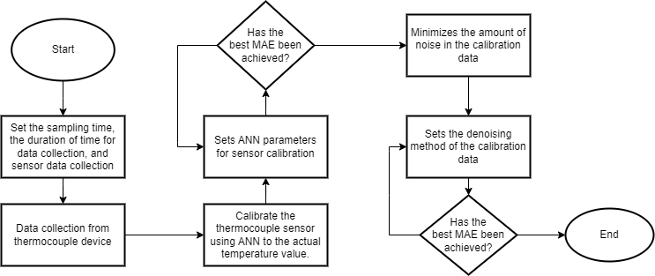

**2.2. Artificial Neural Network (ANN)**

|  |  |  |
| --- | --- | --- |
|  | | (1) |
|  | | (2) |
| L | : Layer | |
| k | : Node input | |
| K | : Total Node input | |
| j | : Node output | |
|  | : Activation Functions | |
|  | | **(3)** |
|  | | **(4)** |
|  | | **(5)** |

**Gaussian activation**

**2.3. Wavelet Transform**

|  |  |  |
| --- | --- | --- |
|  | | **(1)** |
|  | : Layer | |
|  | : Node input | |
|  | : Total Node input | |

|  |  |  |
| --- | --- | --- |
|  | |  |
|  | |  |
|  | |  |
|  | |  |
| **L** | **: Layer** | |
| **k** | **: Node input** | |
| **K** | **: Total Node input** | |
| **j** | **: Node output** | |
|  | **: Activation Functions** | |

|  |  |  |
| --- | --- | --- |
|  | | **(1)** |
|  | | **(2)** |
| **L** | **: Layer** | |
| **k** | **: Node input** | |
| **K** | **: Total Node input** | |
| **j** | **: Node output** | |
|  | **: Activation Functions** | |

|  |  |  |
| --- | --- | --- |
|  | | **(1)** |
|  | | **(2)** |
| **L** | **: Layer** | |
| **k** | **: Node input** | |
| **K** | **: Total Node input** | |
| **j** | **: Node output** | |
|  | **: Activation Functions** | |

1. **RESULTS AND DISCUSSION**

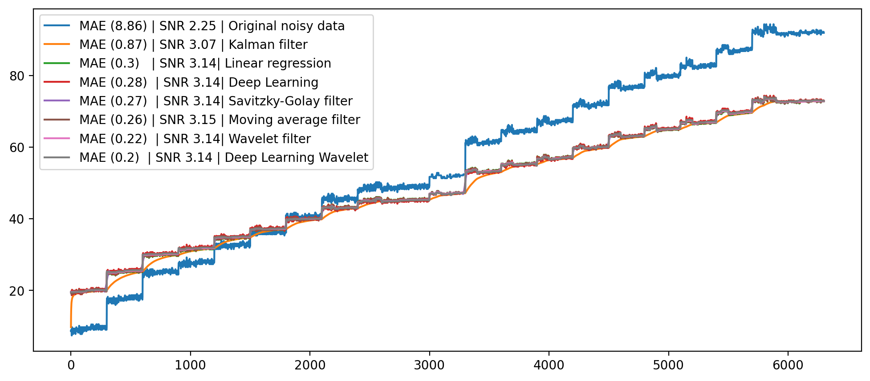

1. **CONCLUSION**

**REFERENCES**

[1] A. Elyounsi and A. N. Kalashnikov, “Evaluating Suitability of a DS18B20 Temperature Sensor for Use in an Accurate Air Temperature Distribution Measurement Network,” *Engineering Proceedings 2021, Vol. 10, Page 56*, vol. 10, no. 1, p. 56, Nov. 2021, doi: 10.3390/ECSA-8-11277.

[2] R. Bogue, “Towards the trillion sensors market,” *Sensor Review*, vol. 34, no. 2, pp. 137–142, 2014, doi: 10.1108/SR-12-2013-755/FULL/XML.

[3] M. Pandey and G. Mishra, “Types of sensor and their applications, advantages, and disadvantages,” *Advances in Intelligent Systems and Computing*, vol. 814, pp. 791–804, 2019, doi: 10.1007/978-981-13-1501-5_69/COVER.

[4] J. F. Qu, S. P. Benz, H. Rogalla, W. L. Tew, D. R. White, and K. L. Zhou, “Johnson noise thermometry,” *Meas Sci Technol*, vol. 30, no. 11, p. 112001, Sep. 2019, doi: 10.1088/1361-6501/AB3526.

[5] S. B. Barnett, A. G. Swanson, T. Lorimer, and M. Brown, “Electromagnetic Interference Mitigation in a High Voltage Inspection Robot,” *Lecture Notes in Electrical Engineering*, vol. 598 LNEE, pp. 331–341, 2020, doi: 10.1007/978-3-030-31676-1_32/COVER.

[6] R. Septiana, I. Roihan, R. A. Koestoer, and R. A. Koestoer, “Denoising MAX6675 reading using Kalman filter and factorial design,” *International Journal of Electrical and Computer Engineering (IJECE)*, vol. 11, no. 5, pp. 3818–3827, 2021, doi: 10.11591/ijece.v11i5.pp3818-3827.

[7] C. Urrea and R. Agramonte, “Kalman Filter: Historical Overview and Review of Its Use in Robotics 60 Years after Its Creation,” *J Sens*, vol. 2021, 2021, doi: 10.1155/2021/9674015.

[8] J. X. Leon-Medina *et al.*, “Temperature Prediction Using Multivariate Time Series Deep Learning in the Lining of an Electric Arc Furnace for Ferronickel Production,” *Sensors 2021, Vol. 21, Page 6894*, vol. 21, no. 20, p. 6894, Oct. 2021, doi: 10.3390/S21206894.

[9] N. Yilmaz, W. Gill, A. B. Donaldson, and R. E. Lucero, “Problems Encountered in Fluctuating Flame Temperature Measurements by Thermocouple,” *Sensors (Basel)*, vol. 8, no. 12, p. 7882, Dec. 2008, doi: 10.3390/S8127882.

**BIOGRAPHIES OF AUTHORS (10 PT)**

**The recommended number of authors is at least 2. One of them as a corresponding author.**

*Please attach clear photo (3x4 cm) and vita. Example of biographies of authors (9 pt):*

|  |  |
| --- | --- |
|  | **James Julian**     was born in Jakarta on July 18th, 1986. He received his bachelor’s degree in mechanical engineering form Universitas Pancasila in 2012 and obtained his master’s degree form Universitas Indonesia in 2015. Futhermore, he received his Doctor of Engineering degree also form Univeristas Indonesia. Currently he serves as Lecture in Department of Mechanical Engineering, Universitas Pembangunan Nasional Veteran Jakarta (UPNVJ), Indonesia. His research is currently focused on fluid mechanics, machine learning and especially on the application of a plasma actuator on flow control. He is also interested in the application of computational fluid dynamics. He can be contacted at email: [*zames@upnvj.ac.id*](mailto:zames@upnvj.ac.id) |
|  | **Annastya Bagas Dewantara** received the bachelor’s degree in electrical engineering from the University Pembangunan Nasional Veteran Jakarta, Jakarta, Indonesian, was born in Jakarta on December 08th, 2001. His field includes electronics, microcontrollers, and control system. He is salso interested in embedded system, IoT and sensor network. He can be contacted at email: [*annastya.bd@upnvj.ac.id*](mailto:annastya.bd@upnvj.ac.id) |
|  | **Fitri Wahyuni**     was born in Bukit Tinggi on July 2nd, 1985. She completed her Bachelor of Physics education at the Jakarta State University in 2009 and her master’s in mechanical engineering at Gadjah Mada University in 2013. From 2014 to 2019 she worked as a Lecturer in Industrial Engineering, Indraprasta University, PGRI. From 2019 until now he has worked as a Lecturer in Mechanical Engineering at the Veterans National Development University in Jakarta. At present, the area of research that is being developed is Construction Machinery. She can be contacted at email: [*fitriwahyuni@upnvj.ac.id*](mailto:fitriwahyuni@upnvj.ac.id) |