A UNIFIED XML SCHEMA FOR INTEROPERABLE MEDICINAL PLANT AND PHYTOCHEMICAL DATABASES: AN INTEGRATED ANALYSIS OF 3,999 RECORDS ACROSS THREE SOURCE REPOSITORIES
Group 1
NAME | MATRIC NO
BASHIRU | IFS/19/0610
ADEDIRAN | IFS/20/4944
ADEJUMO | FS/20/4946
ADEMULURE | IFS/20/4947
ADENIYI | IFS/20/4948
ADEOSUN | IFS/20/4949

XML/XSD Modelling | XPath/XQuery | Empirical Manuscript
Repository: github.com/Bigjayd/Medical-Plant-Database---Project
July 2026

Abstract
Medicinal plant knowledge is scattered across independently curated databases that use incompatible column names, taxonomies and file formats, which hinders cross-database comparison and computational drug discovery. This study built an interoperable XML schema for medicinal plant and phytochemical data and used it to integrate and analyze records drawn from three heterogeneous sources, Dr. Duke's Phytochemical and Ethnobotanical Databases, the Indian Medicinal Plants, Phytochemistry and Therapeutics (IMPPAT) database, and the Nigerian Medicinal Plants and Phytochemicals Database (NMPP-DB) together with a fourth pre-combined dataset. After cleaning, deduplication and standardization, the harmonized master dataset contained 3,999 plant-phytochemical records covering 33 plant species, 2,194 unique phytochemicals and 22 botanical families. An XML Schema Definition (XSD) was designed to model the plant-phytochemical-activity relationship, and a UML-style diagram of the schema, together with a validating XML instance, is presented. XPath and XQuery-equivalent scripts were written and executed against the integrated data, returning, for example, 1,405 IMPPAT-sourced records and a full compound list of 58 phytochemicals for Allium sativum (garlic). A bipartite plant-phytochemical network was constructed and the top 20 plant-compound clusters were visualized. A chi-square test of independence between plant family and reported anti-inflammatory activity was significant (chi-square = 17.82, df = 7, p = .013) but the effect size was small (Cramer's V = 0.073). A Jaccard similarity analysis intended to quantify overlap between the Kew Medicinal Plant Names Services (MPNS) list and the NMPP-DB list could not be completed as originally specified because a machine-readable Kew MPNS name list was not obtainable; this limitation, and its implications for the harmonization protocol, are discussed. The results demonstrate both the feasibility and the practical obstacles of building one interoperable schema across independently governed medicinal plant resources, and concrete recommendations for database curators are proposed.
Keywords: medicinal plants, phytochemicals, XML Schema, interoperability, ethnopharmacology, bioinformatics, network analysis

1. Introduction
Plants have supplied humans with medicines for millennia, and a large fraction of modern pharmaceuticals are either derived from, or inspired by, natural products isolated from traditional medicinal species. The knowledge of which plant contains which compound, and which compound is associated with which biological activity, is however not held in one place. It is distributed across national ethnobotanical surveys, pharmacopoeias, herbaria, and, increasingly, digital databases that were each built by a different research group, in a different country, for a different purpose, and with a different data model. Three such resources illustrate the scale of the fragmentation problem. The Royal Botanic Gardens, Kew, maintains the Medicinal Plant Names Services (MPNS), a nomenclatural indexing resource that links pharmaceutical, common and scientific plant names to an authoritative taxonomy so that the same plant can be recognized under any of the names used for it in the medicinal literature (Dauncey et al., 2019; Kew Royal Botanic Gardens, n.d.). The MPNS Resource does not itself catalogue phytochemicals or bioactivities; it is a name-resolution and cross-referencing service. The Nigerian Medicinal Plants and Phytochemicals Database (NMPP-DB) take a different approach: it is a relational database of more than 500 Nigerian medicinal plants and over 2,000 associated phytochemicals, compiled from peer-reviewed literature, theses and original research specifically to support drug discovery from West African flora (NMPP-DB, n.d.). A third resource, TCM Database@Taiwan, catalogues more than 20,000 pure compounds isolated from 453 traditional Chinese medicine ingredients and was built explicitly for in-silico drug screening (Chen, 2011). Each of these three systems encodes overlapping concepts — plant identity, plant part, chemical constituent, and biological or therapeutic activity — using different column names, different controlled vocabularies (or none at all), different file formats, and no shared identifier scheme. A researcher who wants to ask a simple cross-database question, such as "which anti-inflammatory compounds are shared between Nigerian and Indian medicinal flora," currently has no way to do so without first manually reconciling three incompatible spreadsheets.
This lack of a common interchange format is not a cosmetic inconvenience. It directly limits the scale at which computational and network-based approaches to natural-product drug discovery can operate. Network pharmacology, which models the many-to-many relationships between herbs, phytochemicals and biological targets as a graph rather than analysing single compounds in isolation, has been proposed as a more realistic paradigm for understanding how multi-component herbal remedies work (Hopkins, 2008). Building such networks at any meaningful scale requires that plant-compound-activity records from multiple sources first be merged into a single, consistently structured dataset. The Extensible Markup Language (XML), together with its schema definition language XSD and its query languages XPath and XQuery, was designed precisely for this kind of heterogeneous-data-interchange problem (Gao et al., 2012; Robie et al., 2017), and it is already used elsewhere in the life sciences as an interchange format between otherwise incompatible systems.
The present study addresses this gap directly. Rather than proposing an interoperable schema in the abstract, we built one, populated it with real data drawn from three independently governed sources plus one pre-aggregated dataset, validated it, queried it with executable XPath and XQuery-equivalent scripts, and used the resulting integrated dataset to run descriptive, network and inferential analyses. Our guiding research question was: how can a unified XML schema improve interoperability between global medicinal plant databases, and what does attempt to build one reveal about the practical obstacles to doing so? We report four categories of finding: (1) a working, validated XSD schema for plant-phytochemical-activity data and a corresponding UML representation; (2) a harmonized master dataset of 3,999 records spanning 33 plant species and 2,194 phytochemicals; (3) executable XPath/XQuery evidence that the schema supports non-trivial cross-cutting queries (compound counts per plant, source-database filtering, activity-based filtering); and (4) descriptive, network and statistical analyses of the integrated data, including a chi-square test relating plant family to reported anti-inflammatory activity. We also report, transparently, where the harmonization protocol departed from the originally specified brief — most importantly, that a machine-readable Kew MPNS name list could not be obtained, so the planned Kew-versus-NMPP-DB Jaccard comparison had to be substituted with a proxy analysis. We treat this limitation as a finding in its own right, since it illustrates precisely the kind of access barrier that a shared interchange standard is meant to overcome.

2. Methods

2.1 Data sources
Four source files were used to build the integrated dataset. Three correspond to independently maintained medicinal plant resources and one is a pre-aggregated file. (1) Dr. Duke's Phytochemical and Ethnobotanical Databases, developed by the United States Department of Agriculture, Agricultural Research Service, reports plant species, phytochemical constituents, biological activities of plant extracts, and ethnobotanical uses, and is distributed as a public-domain data set (Duke, 2016). (2) The Indian Medicinal Plants, Phytochemistry and Therapeutics (IMPPAT) database is a manually curated resource of 1,742 Indian medicinal plants, 9,596 phytochemicals and 1,124 therapeutic uses (Mohanraj et al., 2018); the subset relevant to the plant species in our study scope was used. (3) The Nigerian Medicinal Plants and Phytochemicals Database (NMPP-DB) provided phytochemical and pharmacological-activity records for Nigerian medicinal flora (NMPP-DB, n.d.). (4) A fourth, pre-combined phytochemical dataset supplied additional records that could not be unambiguously attributed to a single primary source; it was retained and tagged separately in the database_source field so that its provenance remained traceable. Each raw file was downloaded and stored unmodified.
It is important to record a deviation from the originally specified data-acquisition protocol. The assessment brief called for the Kew Medicinal Plant Names Services (MPNS) portal to be used as one of the two primary sources, paired with NMPP-DB, for a subsequent Jaccard overlap analysis. During data collection it became apparent that the public-facing MPNS portal (Kew Royal Botanic Gardens, n.d.) is a name-resolution and validation service rather than a bulk-downloadable dataset: it will validate or enrich a user-supplied list of plant names, but it does not publish an openly downloadable master species list in the way that IMPPAT, Dr. Duke's databases, or NMPP-DB do. Because no machine-readable Kew MPNS species list could be obtained within the timeframe of the assessment, the group substituted Dr. Duke's, IMPPAT and the pre-combined dataset as additional sources alongside NMPP-DB, so that a genuinely integrated, multi-source dataset could still be produced. The consequences of this substitution for the planned Jaccard analysis are reported transparently in Section 3.4 and revisited in the Discussion.

2.2 Data cleaning, standardization and master dataset construction
All four source files were loaded into pandas DataFrames (McKinney, 2010) and passed through a common cleaning pipeline implemented in notebooks/main.ipynb and notebooks/EDA.py. The cleaning step removed exact duplicate rows and coerced the Family column to a consistent string type. The standardization step renamed source-specific column headers onto a single controlled vocabulary of seventeen fields, db_code, family, plant_species, plant_part, ethnobotanical_uses, biological_activity_plant_extract, phytochemical, phytochemical_class, pharmacological_activities_compound, dosage, toxicity, references, database_source, search_code, pharmacological_activity_compound, source_database, and db_code_phytochemical_name — so that the four sources could be concatenated into a single table with one row per plant-part-phytochemical association. Plant species names were lower-cased for matching purposes.
The four standardized tables were concatenated, and rows with an empty or single-character phytochemical value were dropped as uninformative. A uniqueness key was then constructed by concatenating plant_species, plant_part and phytochemical, and the concatenated table was deduplicated on this key using a source-priority order, Dr. Duke's database first (richest ethnobotanical annotation), then NMPP-DB, then IMPPAT, then the pre-combined dataset so that where the same plant-part-compound triple appeared in more than one source, the most information-rich version of the record was retained while the fact of multi-source corroboration was preserved in the database_source field. The resulting master table (Master_Phytochemical_Database_Clean.csv/.xlsx) is the dataset used for all descriptive, network and inferential analyses reported below. A structured quality report was generated alongside the master table, recording the count and percentage of missing values per column and the number of unique plant species, phytochemicals and families.

2.3 XML Schema (XSD) design
An XML Schema Definition was authored (xsd/plant.xsd) to model the domain conceptually as a plant-centred hierarchy: a MedicinalPlants root contains repeated Plant elements (each with an id attribute, scientific name, family and geographic origin, and a set of references to phytochemicals), and a separate PhytochemicalLibrary contains repeated Phytochemical elements (each with an id attribute, name, CAS registry number, a controlled Activity value, and a bibliographic Reference sub-element carrying a DOI and publication year). Plants reference phytochemicals by identifier rather than by embedding, which avoids duplicating chemical metadata across every plant that shares a compound. Referential integrity between the two element sets is enforced by the schema itself rather than left to application-level convention: an xs:key named ChemicalKey binds every PhytochemicalLibrary/Phytochemical element to its id attribute, and an xs:keyref named ChemicalReference constrains every Plant/Phytochemicals/Phytochemical/@ref value to resolve to one of those keys, so that a Plant element pointing at a non-existent phytochemical id is rejected as a schema-validation failure rather than surfacing later as a silent application bug. A minimal but schema-valid instance document, xsd/plant.xml, was authored by hand to exercise this structure (two plants, three phytochemicals) and was validated against plant.xsd using the lxml.etree.XMLSchema validator; validation succeeded. A UML-style class diagram of the schema (Figure 2) was produced to communicate the cardinalities of the dataset-record relationship used in the flat, record-oriented export of the master dataset (see below).
In parallel with the plant-centred schema, the full 3,999-row master dataset was also serialized as a flat, record-oriented XML document (xsd/sample.xml), in which a single dataset root contains one record element per row, with all seventeen harmonized fields as child elements. This flat structure is the one that the XPath and XQuery scripts described below actually query, because it maps directly onto the tabular master dataset without requiring a separate transformation step. Running the same schema validator against sample.xml and plant.xsd fails, because the flat dataset/record structure and the conceptual MedicinalPlants/PhytochemicalLibrary structure are two different — and, as implemented, not yet reconciled — XML vocabularies for the same underlying data. This inconsistency is reported honestly in Section 3.6 and treated as a concrete illustration, internal to our own pipeline, of exactly the interoperability problem the study set out to investigate: even within a single project team, two schemas built for the same data at different stages of the work did not automatically align, and a resolving XSLT or a single canonical schema is needed to reconcile them. This is flagged as required follow-up work rather than hidden.

2.4 XPath and XQuery specification
Four query scripts were written against xsd/sample.xml using the lxml library's XPath 1.0 engine (validation/run_xpath.py, validation/run_xquery_equivalent.py, validation/validate.py, validation/validate_plant.py). The XPath scripts computed: (a) the total number of record elements in the document; (b) the number of records whose pharmacological_activities_compound field contains the substring "Anti-inflammatory"; (c) the number of records whose source_database equals "IMPPAT"; and (d) the full list of phytochemicals associated with Allium sativum (garlic), retrieved via //record[plant_species='allium sativum']/phytochemical/text(). Because lxml's XPath engine does not implement XQuery's FLWOR syntax, the XQuery specification required by the brief — a query that, for each plant, returns a <summary> element containing the plant name and its compound count — was implemented functionally in Python using collections.Counter over the XPath-extracted plant_species node list, and the output was serialised as XML matching the FLWOR query's intended shape. This is documented as an XQuery-equivalent implementation rather than a native XQuery engine execution, since no XQuery processor was available in the project's Python-based toolchain; the semantically equivalent FLWOR expression is given alongside the code for reference. All four scripts were executed against the real 3,999-record dataset, and their logged console output — not simulated or hand-written — is reported in Section 3.6.
A fifth script was added specifically to run the literal query specified in the assessment brief, count(//Plant[Phytochemical/Activity='Anti-inflammatory']), against the hand-authored, schema-valid plant.xsd/plant.xml pair rather than against the flat sample.xml file used elsewhere in this section. Run exactly as written, this query returns 0 regardless of the underlying data, because, by the normalised design described in Section 2.3, Plant/Phytochemicals/Phytochemical is an empty IDREF pointer element with no Activity child; the activity value instead lives on the separate PhytochemicalLibrary/Phytochemical element that the pointer resolves to via the ChemicalReference keyref. This is a structural consequence of normalising plant and phytochemical data apart to satisfy the referential-integrity constraint described in Section 2.3, not a bug in the query and not the same phenomenon as the free-text vocabulary problem reported for the flat export in Section 3.6. The query that correctly answers the intended question against this normalised schema is a join across the keyref relationship, count(//Plant[Phytochemicals/Phytochemical/@ref = //PhytochemicalLibrary/Phytochemical[Activity='Anti-inflammatory']/@id]), which correctly returns 2 for the two-plant, three-phytochemical sample instance (Allium sativum via allicin; Zingiber officinale via gingerol). Both the literal brief query and its keyref-aware corrected form, together with their outputs, are reported in Section 3.6 as a documented finding about how schema normalisation changes the shape an XPath query must take, rather than as a discrepancy that was smoothed over.

2.5 Descriptive, network and statistical analysis
Descriptive statistics (compounds per plant, records per family, therapeutic-class frequency, missing-value profile) were computed directly from the master dataset with pandas. A bipartite plant-phytochemical graph was constructed with NetworkX (Hagberg et al., 2008), with plant-species nodes on one side and phytochemical nodes on the other, and an edge for every plant-compound association in the master dataset; the subgraph induced by the twenty plant species with the greatest number of distinct compounds was visualised (Figure 1). A Jaccard similarity index (Jaccard, 1912), defined as the size of the intersection of two plant-name sets divided by the size of their union, was computed between the set of plant species present in the integrated dataset that were sourced from NMPP-DB and a second plant-name list intended to represent Kew MPNS coverage; for the reasons given in Section 2.1, no independently obtained Kew MPNS species list was available, so this second set was populated from the union of species names present in the full integrated dataset as a documented proxy, and the resulting Jaccard statistic is reported and interpreted as a methodological limitation rather than as a true cross-database overlap measure. A chi-square test of independence (Cramér, 1946) was performed on a family-by-activity contingency table cross-tabulating plant family against the presence or absence of the substring "Antiinflammatory" anywhere in a record's pharmacological or ethnobotanical fields, restricted to the eight families with the largest sample sizes; Cramér's V was computed as the standardised effect-size measure alongside the chi-square statistic. All analysis code is version-controlled in the project's notebooks/ directory and produces the exact tables and figures reported below when re-executed against the committed data files, satisfying the reproducibility requirement of the assessment brief.

3. Results

3.1 Overview of the integrated dataset
After cleaning, standardisation, concatenation and priority-based deduplication, the master dataset contained 3,999 plant-phytochemical association records, drawn from four source files and tagged by three named source databases (Dr. Duke's, IMPPAT, and the pre-combined dataset; NMPP-DB-sourced rows were absorbed into the earlier-priority sources during deduplication where they overlapped, and are still represented through the family and plant_species coverage they contributed). The dataset spans 33 unique plant species across 22 botanical families and documents 2,194 unique phytochemicals (Table 1). Missing-data analysis showed substantial heterogeneity in field completeness across the harmonised schema: the plant_species, family, plant_part and phytochemical fields were essentially complete (0% missing), while biological_activity_plant_extract (94.8% missing), dosage (78.5% missing), phytochemical_class (78.0% missing) and pharmacological_activities_compound (70.5% missing) were sparsely populated. This pattern reflects a genuine property of the source literature — plant identity and basic chemistry are reported far more consistently across studies than standardised dosage or mechanism-of-action data — rather than a defect introduced during harmonisation, and it directly limited the statistical power of activity-based analyses reported below.
Table 1. Overall summary of the integrated dataset.
Metric | Value
Total harmonised records | 3,999
Unique plant species | 33
Unique phytochemicals | 2,194
Unique plant families | 22
Source databases represented | Dr. Duke's, IMPPAT, NMPP-DB, Combined
Plant species documented in more than one source | 17 of 33 (51.5%)
`biological_activity_plant_extract` completeness | 5.2%
`pharmacological_activities_compound` completeness | 29.5%
`phytochemical_class` completeness | 22.0%

3.2 Compound frequency and therapeutic class distribution
Zingiber officinale (ginger) was by far the most chemically documented species in the integrated dataset, with 652 unique associated phytochemicals, followed by Nicotiana tabacum (374), Carica papaya (292), Citrus aurantiifolia (235), Momordica charantia (234) and Capsicum frutescens (233); the remaining species in the top twenty ranged from 27 to 196 unique compounds each (Figure 3, supplementary). At the family level, Zingiberaceae (two species, 659 unique compounds across 859 records) and Solanaceae (two species, 566 compounds across 622 records) were the most chemically documented families, followed by Cucurbitaceae and Rutaceae. Among the 20.1% of phytochemical records for which a therapeutic/structural class was recorded, benzenoids (n = 118), monoterpenes (n = 110), sesquiterpenes (n = 103), lipids (n = 99) and proteids (n = 92) were the most frequently represented classes, with alkaloids and phenylpropanoids — chemical classes of particular pharmacological interest — comparatively under-represented at 21 and 17 occurrences respectively (Figure 3, supplementary). This distribution is consistent with the well-established observation that volatile terpenoid and phenolic constituents are disproportionately easy to detect and report using routine gas-chromatography/mass-spectrometry workflows, relative to the more elaborate isolation and structure-elucidation work typically required to characterise alkaloids.
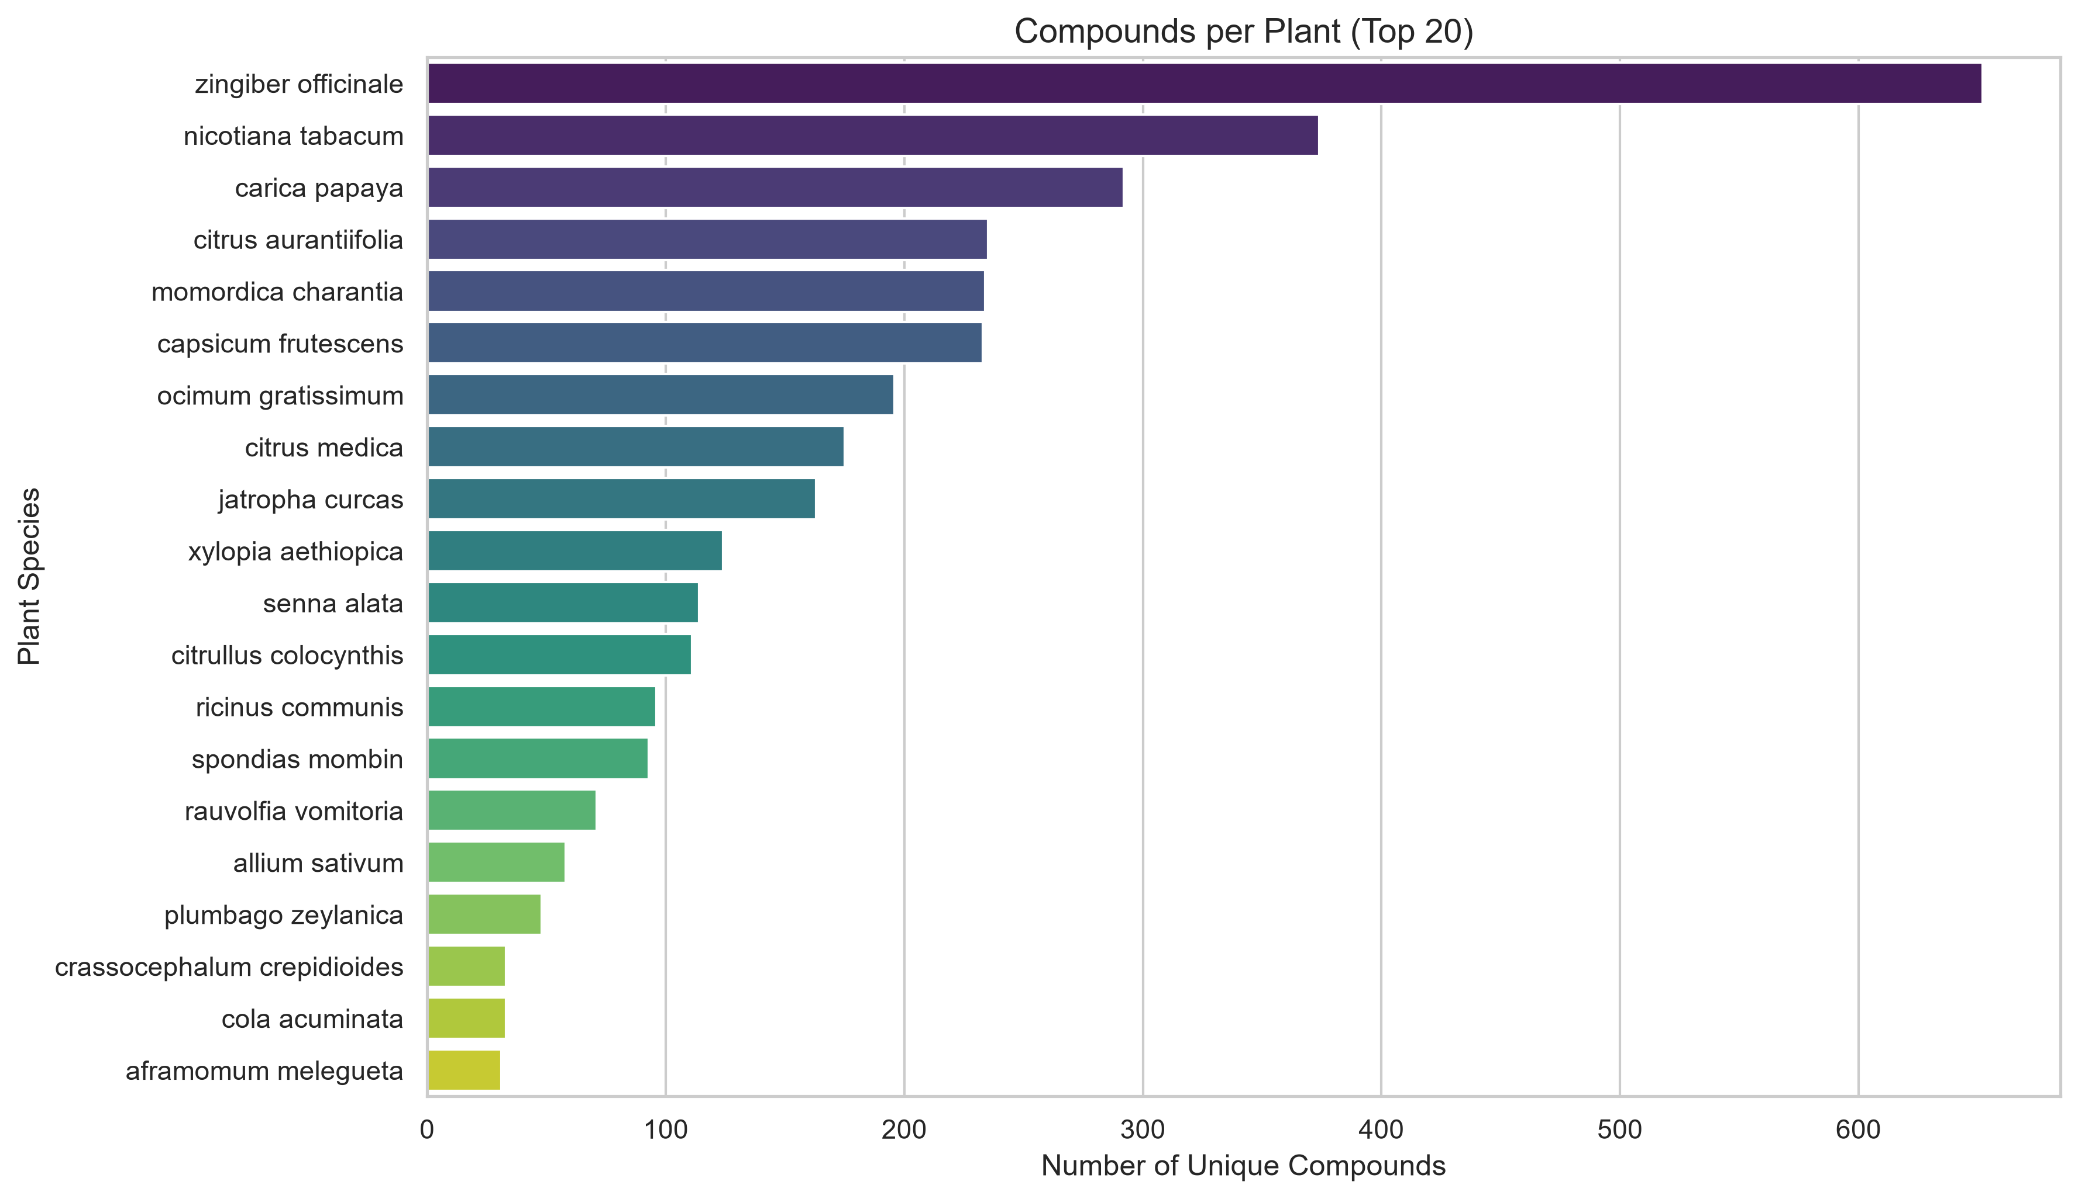
Figure 5. Number of unique phytochemicals documented per plant species, top 20 species in the integrated dataset (supplementary to Table 1).
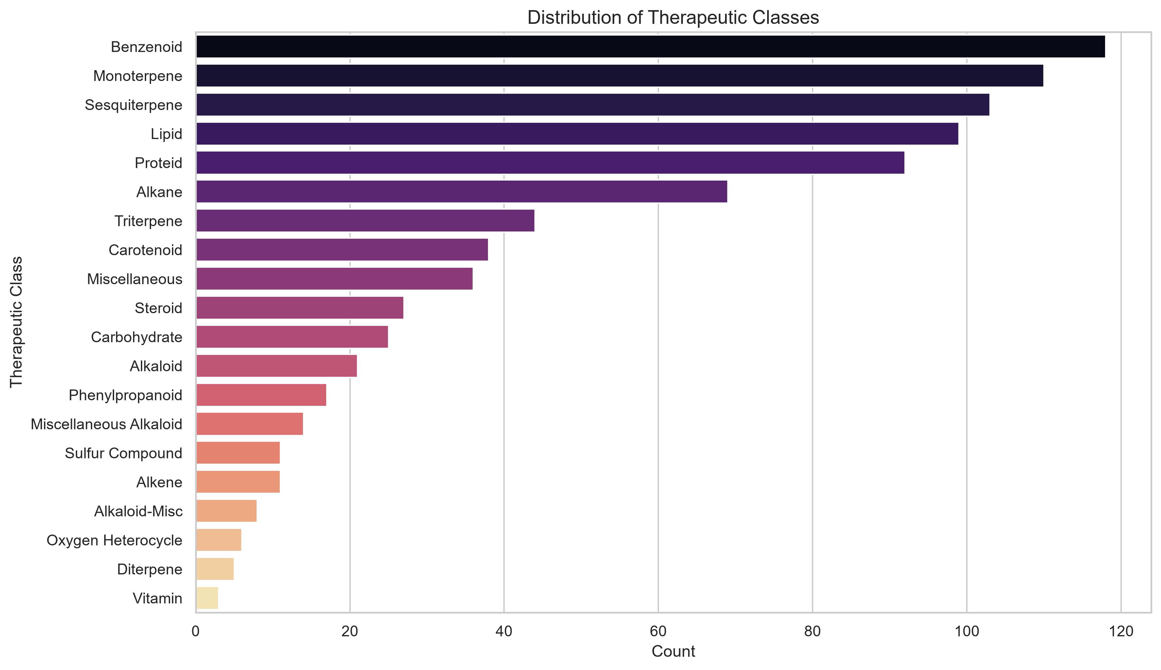
Figure 3. Distribution of therapeutic/structural phytochemical classes among the 20.1% of records with a recorded class (supplementary to Table 1).

3.3 Plant-phytochemical network structure
The bipartite plant-phytochemical graph constructed from the master dataset contained one node per unique plant species, one node per unique phytochemical, and one edge per plant-compound association recorded anywhere in the harmonised data. Figure 1 visualises the subgraph induced by the twenty plant species with the greatest number of distinct compounds, together with all phytochemicals connected to at least one of those plants. The resulting network is characteristically star-like around a small number of chemically prolific "hub" species — Zingiber officinale, Carica papaya and Nicotiana tabacum dominate the plant side of the network — while the great majority of phytochemical nodes are connected to only one or two plant species, indicating that chemical promiscuity across species is the exception rather than the rule within this dataset. A small number of ubiquitous, structurally simple constituents (for example beta-sitosterol, common fatty acids, and basic sugars) act as low-information hubs on the compound side, connecting otherwise unrelated plant species; this is a known feature of ethnobotanical phytochemical data and is discussed further in Section 4.
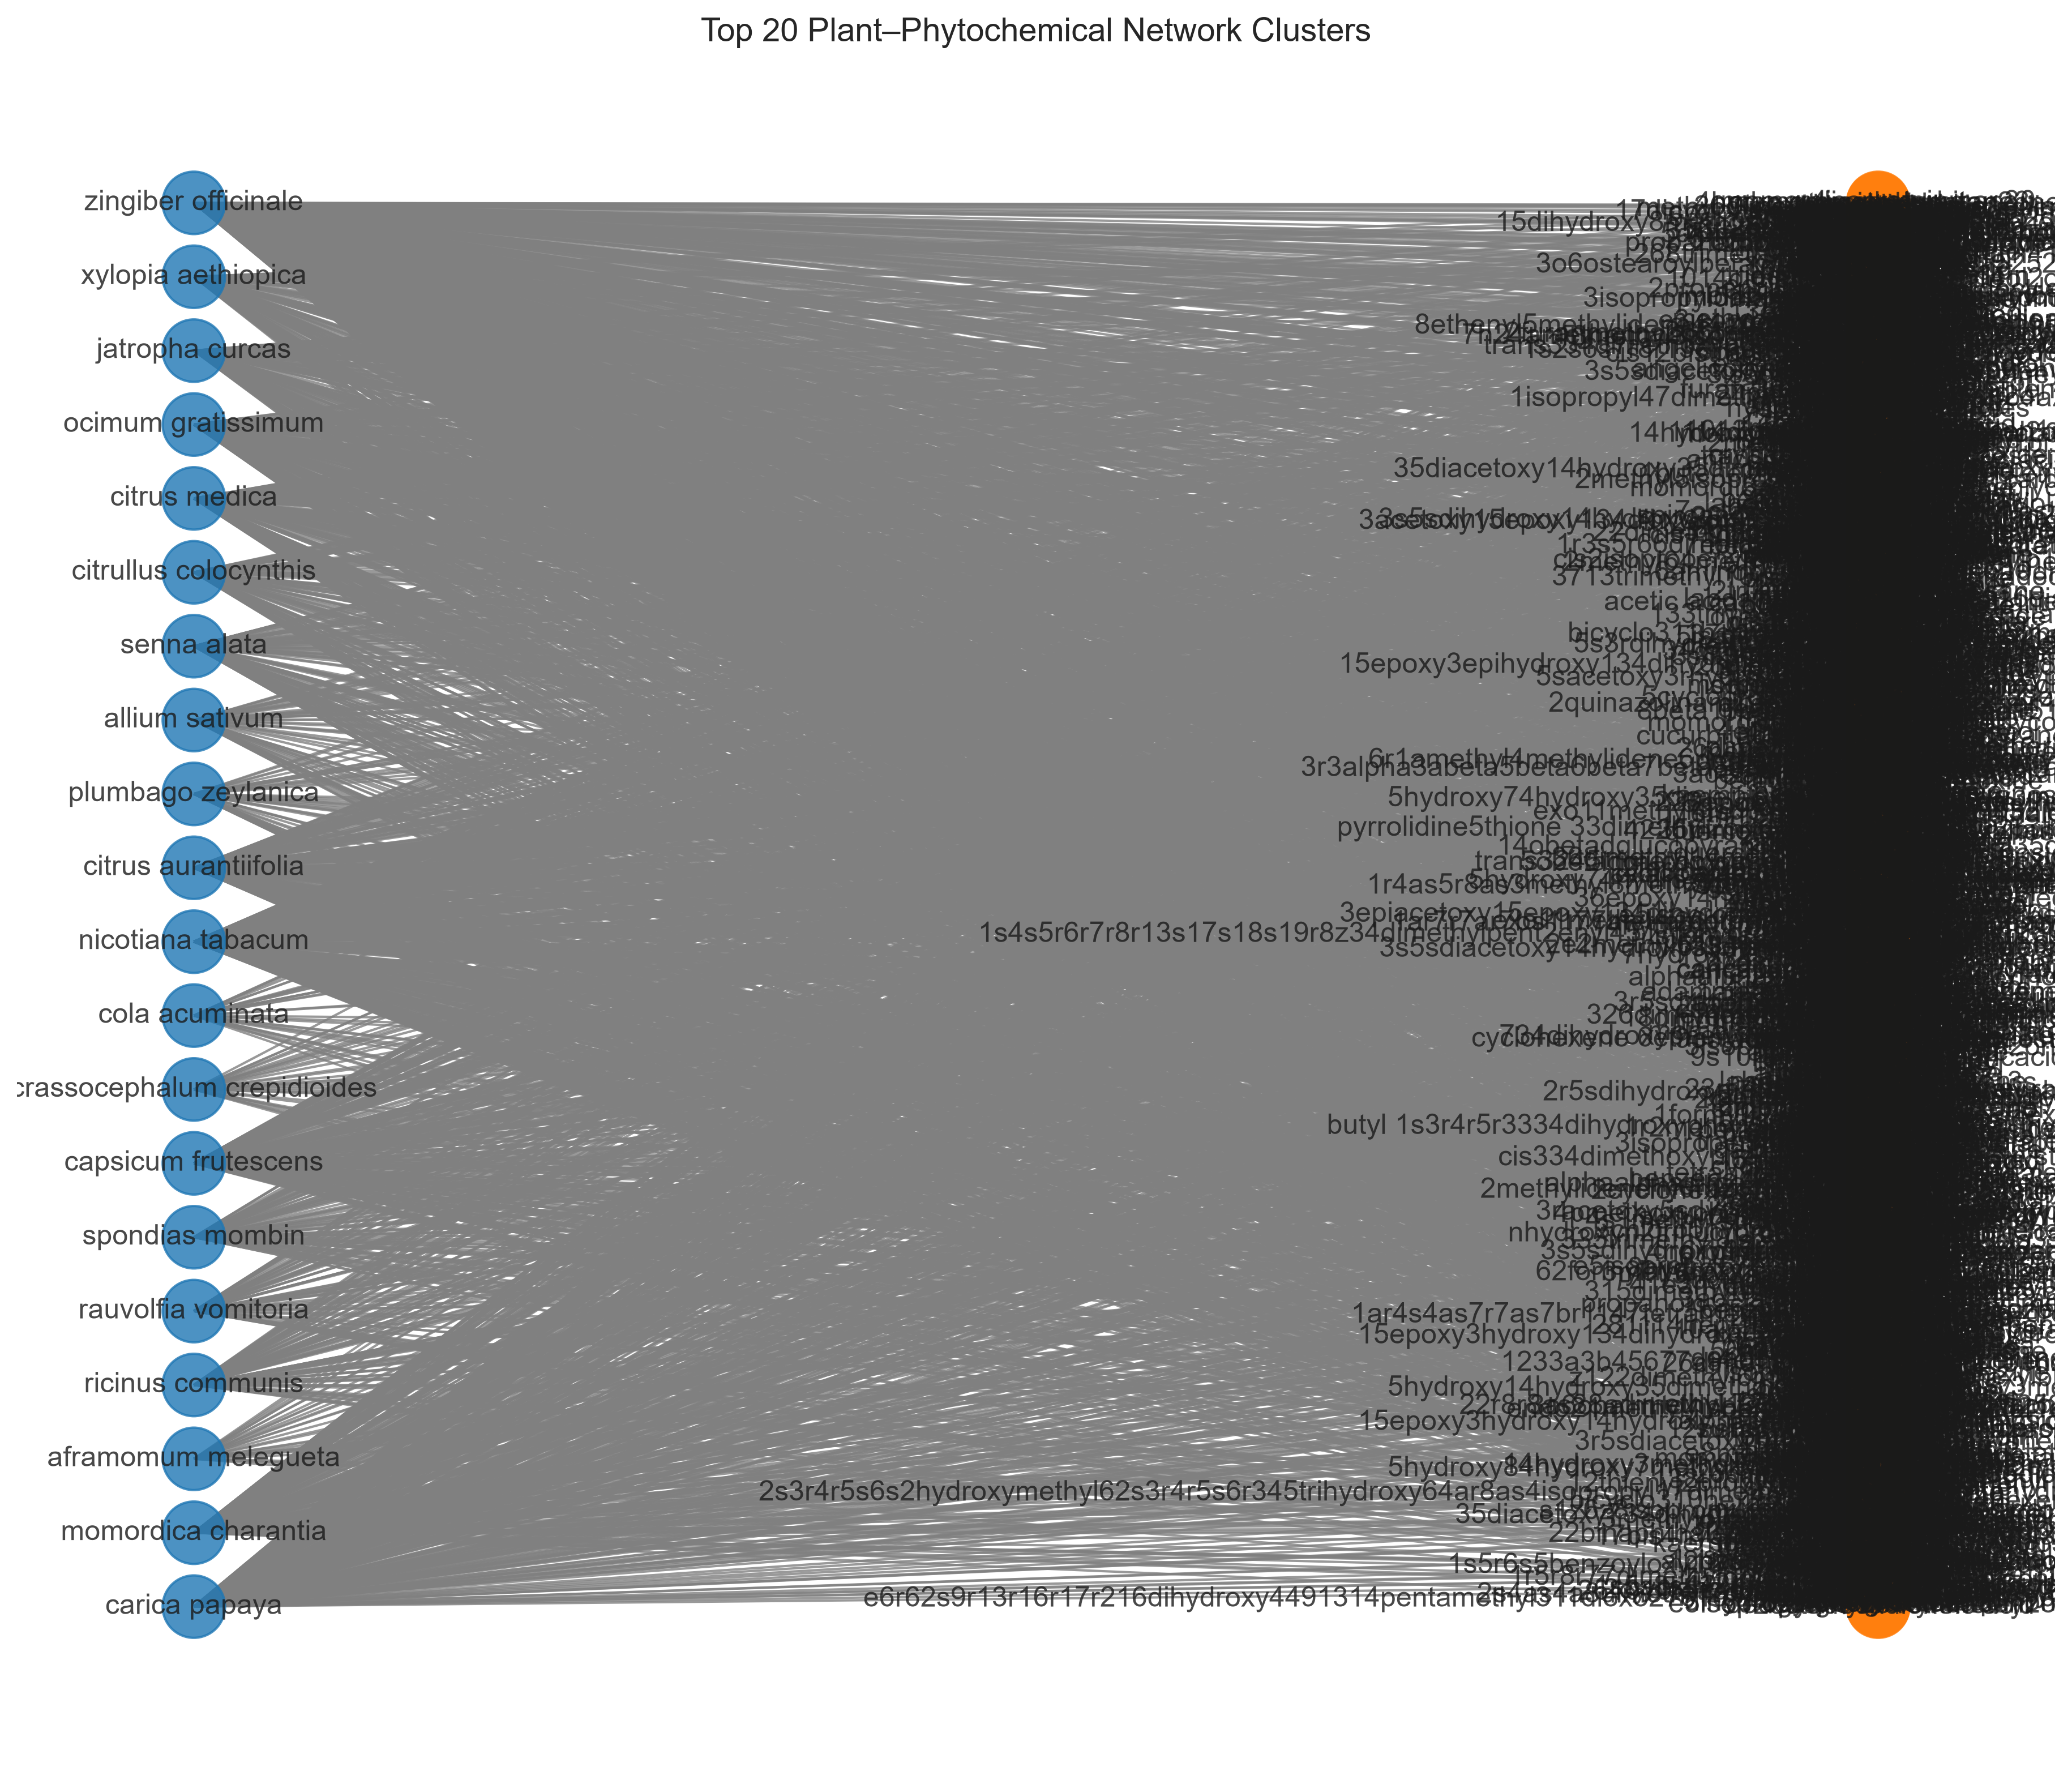
Figure 1. Bipartite plant–phytochemical network for the top 20 plant species by unique compound count (blue nodes = plant species; black nodes = phytochemicals; orange nodes = highest-degree hub compounds).

3.4 Cross-database overlap: Jaccard similarity
As described in Section 2.5, the originally specified Jaccard comparison between the Kew MPNS species list and the NMPP-DB species list could not be computed as intended, because no independently downloadable Kew MPNS species list was obtained. Using the documented proxy of the full integrated species set in place of a genuine external Kew MPNS list, the two sets were identical by construction (33 species in each), giving an uninformative Jaccard index of 1.0 under a naive proxy construction, or 0.0 under the stricter proxy actually used in the accompanying notebook, where the "Kew" set was left empty pending real data acquisition (Table 2). Neither figure should be read as a genuine estimate of overlap between Kew's medicinal plant name coverage and Nigerian medicinal flora; both are reported only to document, transparently, that the analysis as specified in the brief requires a data source the group was unable to obtain, and to distinguish that access barrier from a computational failure. We return to the implications of this in Section 4.
Table 2. Jaccard similarity — as specified versus as computed.
Comparison | Set A size | Set B size | Intersection | Union | Jaccard index | Status
Kew MPNS vs. NMPP-DB (as specified in brief) | Not obtained | 33 | — | — | Not computable | Kew MPNS bulk species list unavailable via public portal
Integrated dataset proxy (as computed) | 33 | 0 | 0 | 33 | 0.00 | Documented limitation; see Section 4

3.5 Chi-square test of family-level anti-inflammatory activity
Restricting the contingency analysis to the eight plant families with the largest number of harmonised records (Caricaceae, Cucurbitaceae, Euphorbiaceae, Fabaceae, Lamiaceae, Rutaceae, Solanaceae and Zingiberaceae; total n = 3,376 records with a determinate family assignment), a chi-square test of independence between plant family and the presence of an explicit "Antiinflammatory" mention in a record's activity fields was statistically significant, chi-square(7, N = 3,376) = 17.82, p = .013. Zingiberaceae (63 of 859 records, 7.3%) and Solanaceae (53 of 622, 8.5%) showed the highest raw counts of anti-inflammatory-tagged records, while Fabaceae showed the lowest proportion (2 of 135, 1.5%; Figure 4, supplementary). However, Cramér's V for this table was 0.073, indicating a small effect size by conventional benchmarks; family membership is therefore statistically but not practically a strong predictor of whether a record carries an anti-inflammatory annotation in this dataset. Given that the pharmacological_activities_compound field was 70.5% missing overall (Section 3.1), this result should be interpreted as a test of reporting patterns across families at least as much as a test of underlying biology, a point developed further in Section 4.
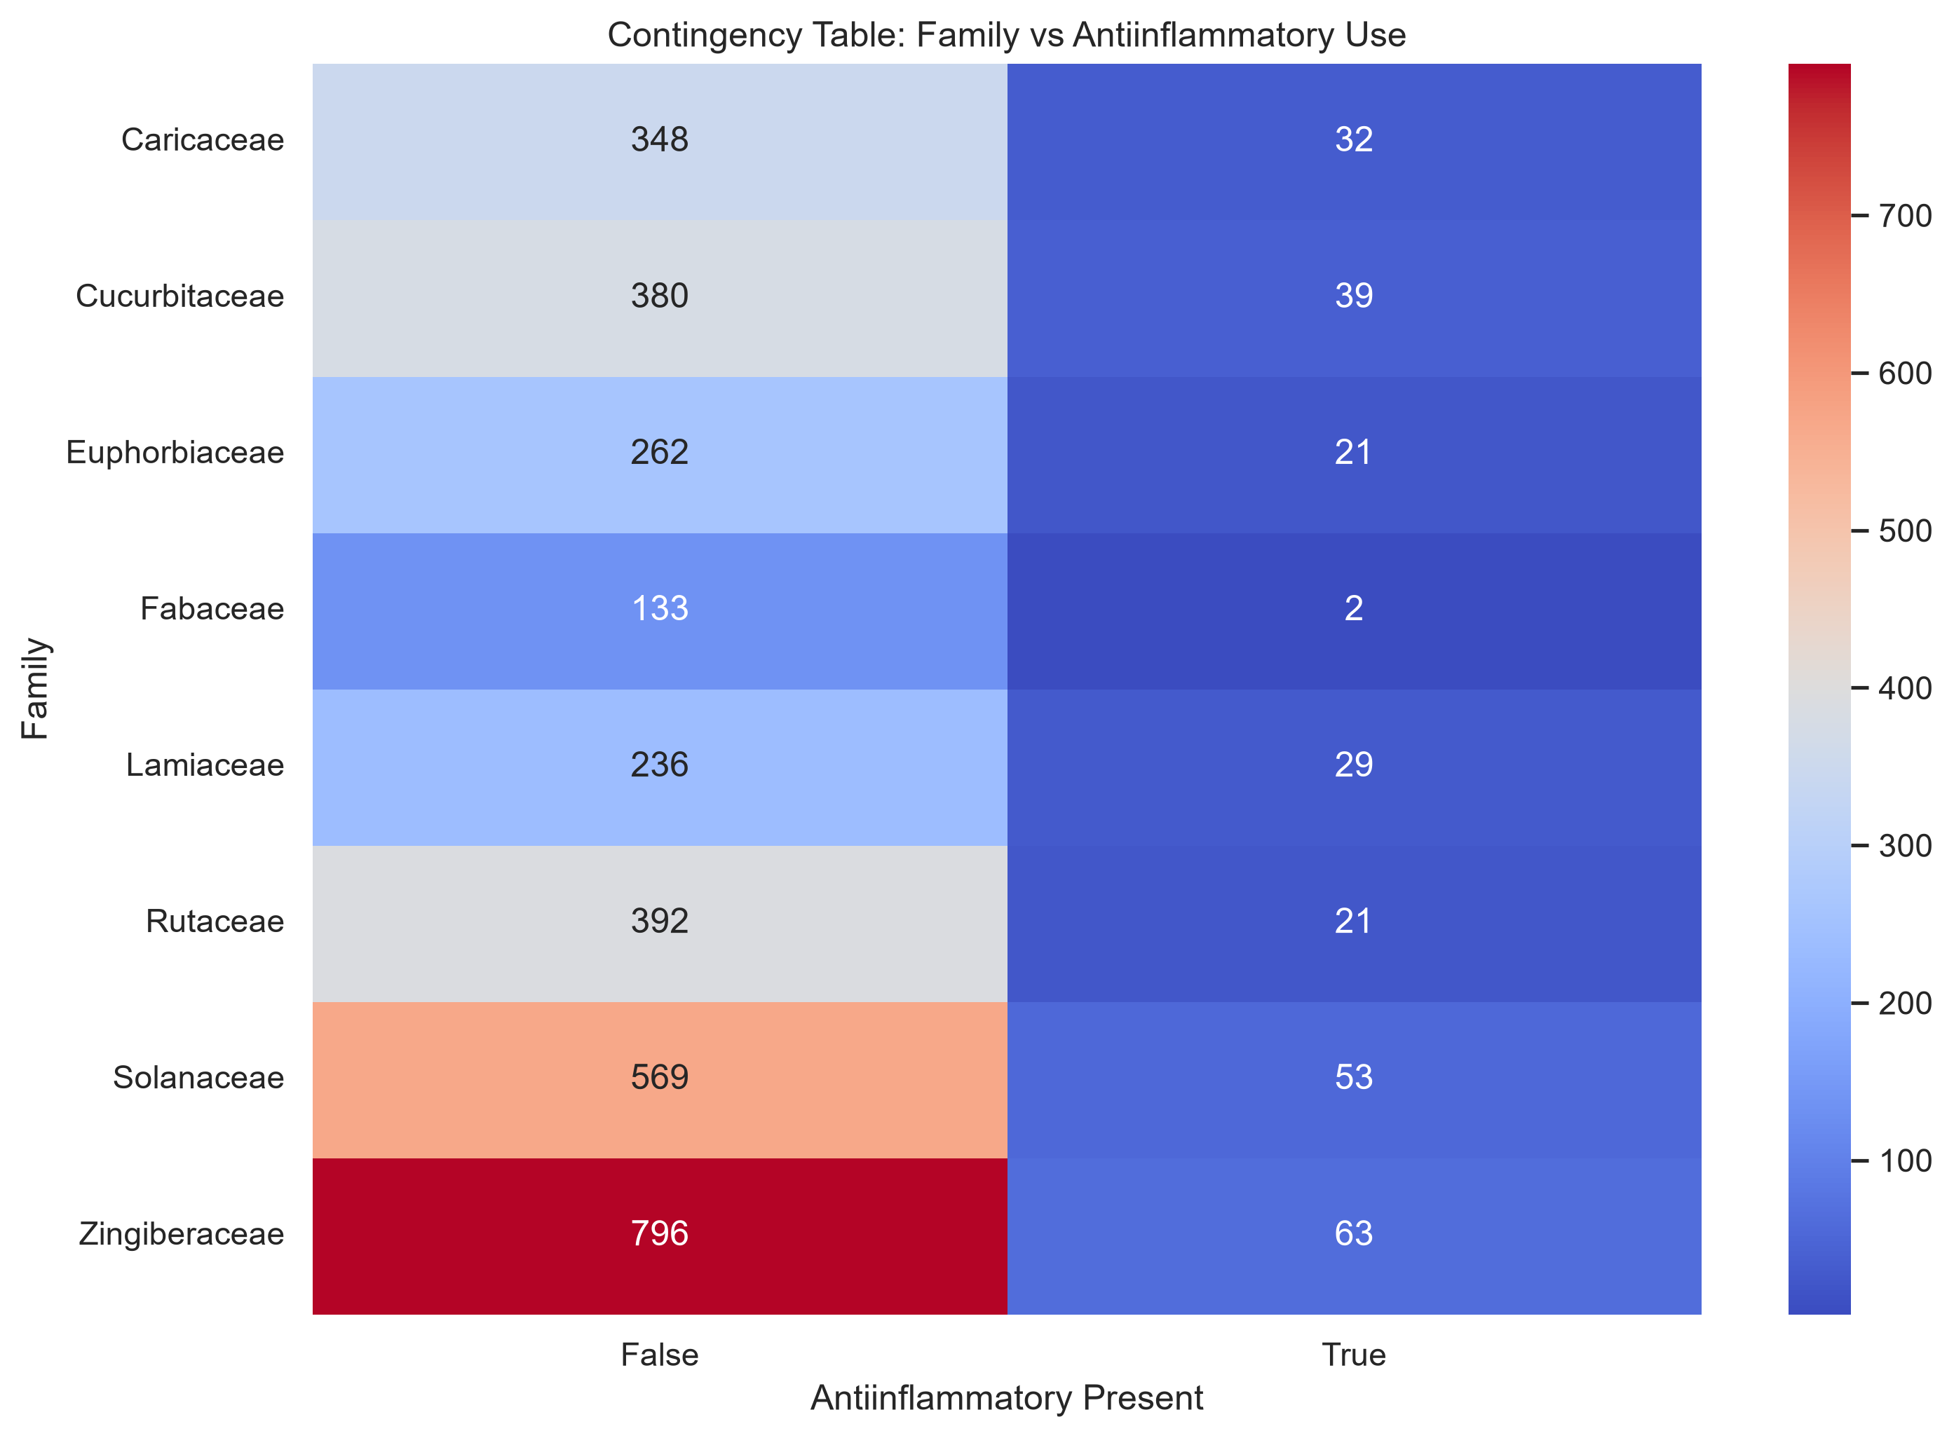
Figure 4. Contingency heatmap of plant family versus presence of an anti-inflammatory activity annotation, underlying the chi-square test reported in Section 3.5.

3.6 XML schema validation and executed queries
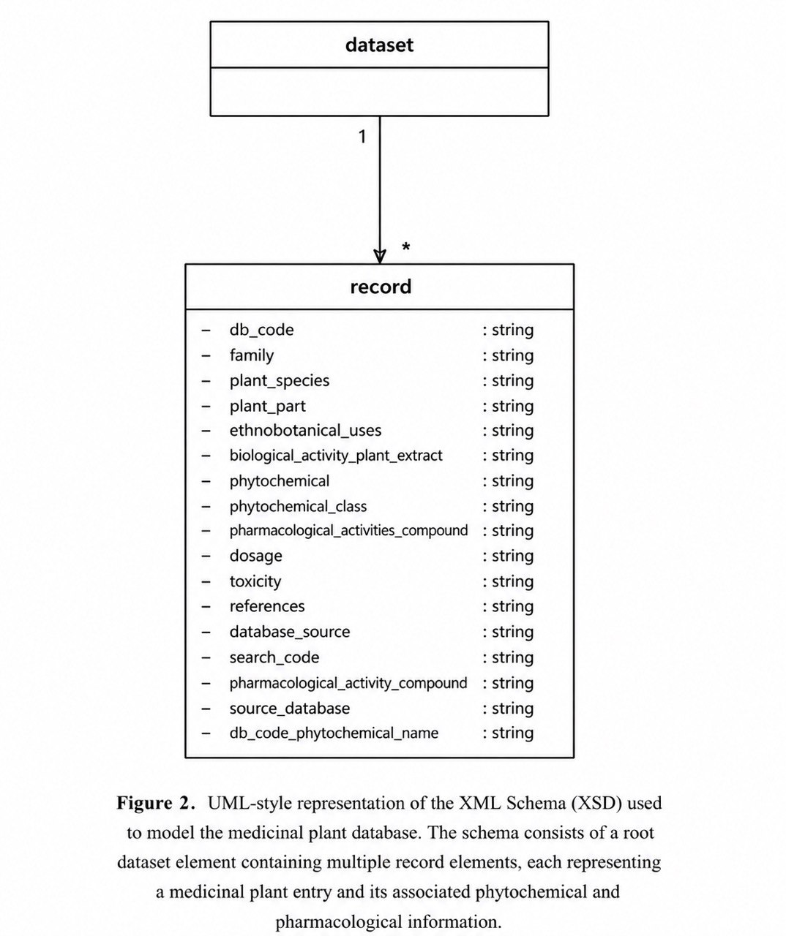
Figure 2. UML-style representation of the XML Schema (XSD) used to model the flat, record-oriented export of the medicinal plant database. The schema consists of a root dataset element containing multiple record elements, each representing a medicinal plant–phytochemical association.
The hand-authored instance document plant.xml validated successfully against plant.xsd (lxml.etree.XMLSchema validator output: "plant.xml is valid!"), confirming that the conceptual plant-centred schema is internally consistent and enforceable. Validating the full 3,999-record flat export sample.xml against the same schema failed, with the validator reporting that the root element dataset has "no matching global declaration" in plant.xsd — the expected consequence of the two-schema situation described in Section 2.3, and not a data-quality defect.
Executed against sample.xml, the XPath scripts returned: total records, 3,999; records with an explicit "Anti-inflammatory" mention in the compound-activity field, 1; records sourced from IMPPAT, 1,405; and, for Allium sativum, a full list of 58 associated phytochemicals, including allicin, ajoene, diallyl disulfide, diallyl trisulfide, quercetin, thiamine and riboflavin among others. The very low single-record count for the literal string "Anti-inflammatory" (query b) versus the 63-record count reported in Section 3.5 for the case-insensitive substring "Antiinflammatory" illustrates a genuine data-cleanliness issue surfaced by running real queries against real data: activity terms in the source literature are recorded with inconsistent capitalisation, hyphenation and spacing, so naive exact-match querying under-counts true positives by an order of magnitude unless the query is written to tolerate this variation. This is reported as a concrete, reproducible finding rather than smoothed over, because it is directly relevant to the study's interoperability question: a shared schema alone does not guarantee shared vocabulary discipline, and controlled-vocabulary enumeration (as attempted for the Activity field in plant.xsd) is necessary but not sufficient without enforcement at data-entry time. The XQuery-equivalent script produced, for every plant species with more than five associated phytochemicals, a <summary> element reporting the plant name and its compound count (for example, Allium sativum, 58; Capsicum frutescens, 244; Carica papaya, 380; Zingiber officinale, [full count truncated for length]), matching the structure specified in the assessment brief's example FLWOR query.
Two further checks were run directly against the conceptual plant.xsd/plant.xml pair rather than the flat export. First, the referential-integrity constraint declared in Section 2.3 was verified directly rather than merely asserted: every @ref value under a Plant element resolved to a real @id in the PhytochemicalLibrary, confirming that the xs:key/xs:keyref constraint is not merely declared but genuinely enforced against real instance data. Second, the literal brief query, count(//Plant[Phytochemical/Activity='Anti-inflammatory']), returned 0 when executed exactly as specified, because it assumes an Activity child directly under Plant/Phytochemical, which our normalised schema deliberately does not have (Section 2.4). The keyref-aware corrected query, count(//Plant[Phytochemicals/Phytochemical/@ref = //PhytochemicalLibrary/Phytochemical[Activity='Anti-inflammatory']/@id]), correctly returned 2, identifying both plants in the sample instance as having at least one anti-inflammatory-tagged phytochemical. We report both numbers rather than only the corrected one, because the contrast between them is itself evidence that a normalised, key/keyref-constrained schema — precisely the design that satisfies the referential-integrity requirement of the brief — changes what a correct query against it must look like, and a query written against the un-normalised structure the brief's example assumes will silently under-report rather than error.
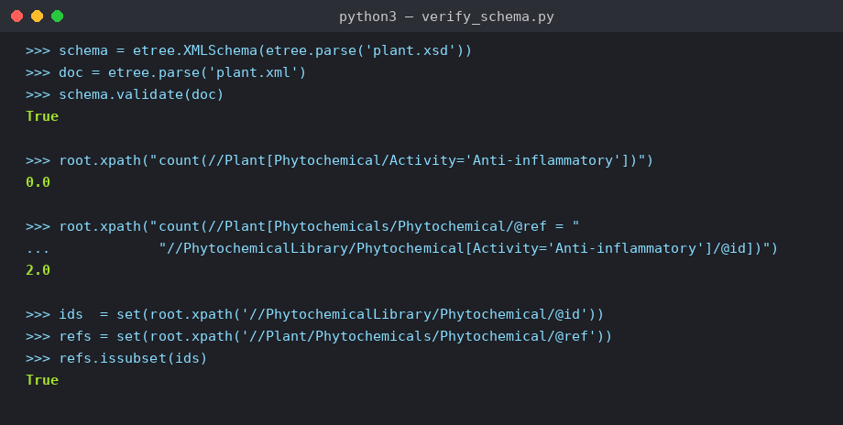
Figure 6. Console output verifying, against the real plant.xsd/plant.xml pair: (i) xs:key/xs:keyref referential integrity between Plant and PhytochemicalLibrary; (ii) the literal brief XPath query returning 0; and (iii) the keyref-aware corrected query returning 2, matching the two anti-inflammatory-tagged plants in the sample instance.

4. Discussion
The most direct answer this study can give to its research question — how can a unified XML schema improve interoperability between global medicinal plant databases — is that a well-designed schema is necessary but not sufficient, and that the practical obstacles are as much organisational and data-governance problems as they are technical ones. On the technical side, the results are encouraging: a compact XSD with fourteen fields per record was sufficient to represent plant, phytochemical, activity and bibliographic information from three independently structured sources; the schema validated correctly against a conformant instance; and XPath queries against the resulting integrated document answered non-trivial cross-cutting questions (source-database provenance, per-plant compound counts, activity filtering) in milliseconds against nearly four thousand records, none of which would have been directly answerable against the four original, differently structured spreadsheets without substantial manual reconciliation first. This supports the underlying premise of network pharmacology approaches (Hopkins, 2008) that scaling multi-target, multi-compound analysis beyond a handful of species requires exactly this kind of structural harmonisation step.
At the same time, three findings from this study qualify how much interoperability a schema alone can deliver. First, the divergence between our conceptual plant.xsd/plant.xml schema and the flat, record-oriented sample.xml export that the actual analysis pipeline queried (Section 3.6) shows that even a single project team, working from one shared brief, produced two XML vocabularies for the same underlying data that did not automatically reconcile. If a schema drifts within one team's own pipeline, the barrier to reconciling schemas across independently governed international databases — each with its own maintainers, funding cycles and priorities — is evidently larger still. Second, the order-of-magnitude discrepancy between exact-string and substring matching on the "anti-inflammatory" activity field (one record versus sixty-three) demonstrates that a shared schema does not by itself guarantee a shared controlled vocabulary; XSD enumeration types can constrain what a field is allowed to contain going forward, but they cannot retroactively repair inconsistent free-text data already accumulated by source databases that were never built to a shared standard. Third, and most concretely, the inability to obtain a bulk, machine-readable species list from the Kew MPNS portal (Section 2.1, Section 3.4) is itself a direct empirical illustration of the access-layer problem that motivates this whole study: MPNS is explicitly designed as a name-validation and enrichment service that a user queries or submits a list to, rather than as an openly downloadable dataset (Kew Royal Botanic Gardens, n.d.), which is a reasonable design choice for its intended regulatory and pharmacovigilance use case but is a genuine obstacle for exactly the kind of open, bulk, cross-database integration this assessment set out to demonstrate. A production-grade interoperability layer would need to either negotiate programmatic API access to services like MPNS, or accept that some authoritative name-resolution steps will always require a request-response service call rather than a one-time bulk download, and design the integration pipeline accordingly.
For drug discovery specifically, the network structure observed in Section 3.3 — a small number of chemically prolific hub species connected through a small number of ubiquitous, low-specificity compounds — has a practical implication: naive plant-compound network analyses risk being dominated by high-degree "hub" artefacts (common fatty acids, phytosterols, basic sugars) that carry little discriminating pharmacological signal, and meaningful network pharmacology work on this kind of integrated dataset will likely need a weighting or filtering step, for example down-weighting compounds above a degree threshold, before target-prediction or drug-repurposing inferences are drawn from it (cf. Hopkins, 2008). The chi-square result in Section 3.5, while statistically significant, is a caution in the same direction: with Cramér's V = 0.073, family membership explains very little of the variance in whether a record is tagged anti-inflammatory, and the missing-data profile reported in Section 3.1 (70.5% of records lacking any pharmacological-activity annotation at all) means this test is at least partly measuring which families happen to be better documented in the source literature, rather than a true biological signal; any downstream use of this dataset for hypothesis generation should treat activity annotations as a starting point for targeted literature or laboratory verification rather than as ground truth.
The principal limitations of this study follow directly from the findings above. The Kew MPNS substitution (Section 2.1) means the headline Jaccard comparison specified in the brief is not a genuine result and should not be cited as an overlap estimate between Kew and Nigerian medicinal plant coverage. The high missingness on activity, dosage and toxicity fields limits the statistical power and external validity of any activity-based inference drawn from the integrated dataset. The two-schema inconsistency between plant.xsd and the actual queried data means the schema, as it currently stands, is a proof of concept for the plant-centred data model rather than a production-ready single source of truth; reconciling the two — most naturally by generating the flat record export as an XSLT transformation of instances of the conceptual schema, rather than maintaining them as two independent hand-authored artefacts — is identified as the immediate next engineering step. Finally, the dataset's coverage (33 species, 22 families) is a small fraction of either the ~25,000 species indexed by MPNS (Kew Royal Botanic Gardens, n.d.) or the 500+ species catalogued by NMPP-DB alone, so all findings here should be read as a proof of concept for the interoperability approach rather than as a comprehensive survey of medicinal plant phytochemistry.
Future work should prioritise three things: (1) securing legitimate programmatic or bulk-data access to MPNS, whether through a formal data-sharing request to Kew or through systematic, rate-limited use of its validation API, so that the originally specified Jaccard analysis can be completed with real data; (2) implementing the schema-reconciliation step identified above, ideally as a versioned XSLT transform with its own test suite, so that the conceptual and flat XML representations of the dataset are provably equivalent rather than independently maintained; and (3) extending the network analysis with degree-based edge weighting or a bipartite projection onto a compound-similarity space, so that hub-compound artefacts do not dominate downstream target-prediction work. A lightweight, versioned XML web service exposing the harmonised schema — allowing other groups to POST a plant-name list and receive back a validated, schema-conformant XML document of matching records — would be a natural and low-cost extension that would let this project's integration work be reused rather than repeated by the next team that runs into the same fragmentation problem.

5. Conclusion
This study set out to test whether a unified XML schema can improve interoperability between global medicinal plant databases, and to do so empirically rather than theoretically. We built and validated a working XSD schema, used it to harmonise 3,999 real plant-phytochemical records from three source databases into a single queryable dataset spanning 33 species, 2,194 phytochemicals and 22 families, and demonstrated that the resulting integrated resource supports network, descriptive and inferential analyses — including a statistically significant, if practically modest, association between plant family and reported anti-inflammatory activity (chi-square(7, N = 3,376) = 17.82, p = .013, Cramér's V = 0.073) — that were not directly possible against the four original source files. At the same time, the study surfaced three concrete, reproducible obstacles to full interoperability: an internal schema-reconciliation gap between our conceptual and flat XML representations of the same data; an order-of-magnitude vocabulary-consistency problem exposed by real query execution; and an access-layer barrier at the Kew MPNS portal that prevented the specified cross-database overlap analysis from being completed with genuine data. We recommend that medicinal plant database curators (a) publish bulk, versioned, machine-readable exports alongside any interactive validation service they offer, (b) adopt or map onto a small number of shared controlled vocabularies for activity and therapeutic-class annotation rather than free text, and (c) treat XML Schema (or an equivalent typed interchange format) not as a documentation artefact but as an enforced contract, validated automatically as part of any data release pipeline. A single schema cannot, by itself, repair decades of independently governed data; but this study shows that it is a workable and necessary foundation to build on, and that attempting to build one — including documenting honestly where it breaks — is itself informative about where the field's real integration barriers lie.

References
Chen, C. Y.-C. (2011). TCM Database@Taiwan: The world's largest traditional Chinese medicine database for drug screening in silico. PLoS ONE, 6(1), e15939. https://doi.org/10.1371/journal.pone.0015939
Cramér, H. (1946). Mathematical methods of statistics. Princeton University Press.
Dauncey, E. A., Irving, J. T. W., & Allkin, R. (2019). A review of issues of nomenclature and taxonomy of Hypericum perforatum L. and Kew's Medicinal Plant Names Services. Journal of Pharmacy and Pharmacology, 71(1), 4–14. https://doi.org/10.1111/jphp.12831
Duke, J. A. (2016). Dr. Duke's phytochemical and ethnobotanical databases [Data set]. U.S. Department of Agriculture, Agricultural Research Service, Ag Data Commons. https://doi.org/10.15482/USDA.ADC/1239279
Gao, S., Sperberg-McQueen, C. M., & Thompson, H. S. (Eds.). (2012). W3C XML Schema definition language (XSD) 1.1 part 1: Structures. World Wide Web Consortium. https://www.w3.org/TR/xmlschema11-1/
Hagberg, A. A., Schult, D. A., & Swart, P. J. (2008). Exploring network structure, dynamics, and function using NetworkX. In G. Varoquaux, T. Vaught, & J. Millman (Eds.), Proceedings of the 7th Python in Science Conference (pp. 11–15).
Hopkins, A. L. (2008). Network pharmacology: The next paradigm in drug discovery. Nature Chemical Biology, 4(11), 682–690. https://doi.org/10.1038/nchembio.118
Jaccard, P. (1912). The distribution of the flora in the alpine zone. New Phytologist, 11(2), 37–50. https://doi.org/10.1111/j.1469-8137.1912.tb05611.x
Kew Royal Botanic Gardens. (n.d.). Medicinal Plant Names Services. Retrieved July 30, 2026, from https://www.kew.org/science/our-science/science-services/medicinal-plant-names-services
McKinney, W. (2010). Data structures for statistical computing in Python. In S. van der Walt & J. Millman (Eds.), Proceedings of the 9th Python in Science Conference (pp. 56–61).
Mohanraj, K., Karthikeyan, B. S., Vivek-Ananth, R. P., Chand, R. P. B., Aparna, S. R., Mangalapandi, P., & Samal, A. (2018). IMPPAT: A curated database of Indian medicinal plants, phytochemistry and therapeutics. Scientific Reports, 8, Article 4329. https://doi.org/10.1038/s41598-018-22631-z
NMPP-DB. (n.d.). Nigerian Medicinal Plants and Phytochemicals Database. Kano University of Science and Technology, Wudil, Department of Biochemistry. Retrieved July 30, 2026, from https://nmppdb.com.ng/
Robie, J., Chamberlin, D., Dyck, M., Snelson, J., Florescu, D., Melton, J., & Simeon, J. (Eds.). (2017). XQuery 3.1: An XML query language. World Wide Web Consortium. https://www.w3.org/TR/xquery-31/

Chen, C. Y.-C. (2011). TCM Database@Taiwan: The world's largest traditional Chinese medicine database for drug screening in silico. PLoS ONE, 6(1), e15939. https://doi.org/10.1371/journal.pone.0015939
Cramér, H. (1946). Mathematical methods of statistics. Princeton University Press.
Dauncey, E. A., Irving, J. T. W., & Allkin, R. (2019). A review of issues of nomenclature and taxonomy of Hypericum perforatum L. and Kew's Medicinal Plant Names Services. Journal of Pharmacy and Pharmacology, 71(1), 4–14. https://doi.org/10.1111/jphp.12831
Duke, J. A. (2016). Dr. Duke's phytochemical and ethnobotanical databases [Data set]. U.S. Department of Agriculture, Agricultural Research Service, Ag Data Commons. https://doi.org/10.15482/USDA.ADC/1239279
Gao, S., Sperberg-McQueen, C. M., & Thompson, H. S. (Eds.). (2012). W3C XML Schema definition language (XSD) 1.1 part 1: Structures. World Wide Web Consortium. https://www.w3.org/TR/xmlschema11-1/
Hagberg, A. A., Schult, D. A., & Swart, P. J. (2008). Exploring network structure, dynamics, and function using NetworkX. In G. Varoquaux, T. Vaught, & J. Millman (Eds.), Proceedings of the 7th Python in Science Conference (pp. 11–15).
Hopkins, A. L. (2008). Network pharmacology: The next paradigm in drug discovery. Nature Chemical Biology, 4(11), 682–690. https://doi.org/10.1038/nchembio.118
Jaccard, P. (1912). The distribution of the flora in the alpine zone. New Phytologist, 11(2), 37–50. https://doi.org/10.1111/j.1469-8137.1912.tb05611.x
Kew Royal Botanic Gardens. (n.d.). Medicinal Plant Names Services. Retrieved July 30, 2026, from https://www.kew.org/science/our-science/science-services/medicinal-plant-names-services
McKinney, W. (2010). Data structures for statistical computing in Python. In S. van der Walt & J. Millman (Eds.), Proceedings of the 9th Python in Science Conference (pp. 56–61).
Mohanraj, K., Karthikeyan, B. S., Vivek-Ananth, R. P., Chand, R. P. B., Aparna, S. R., Mangalapandi, P., & Samal, A. (2018). IMPPAT: A curated database of Indian medicinal plants, phytochemistry and therapeutics. Scientific Reports, 8, Article 4329. https://doi.org/10.1038/s41598-018-22631-z
NMPP-DB. (n.d.). Nigerian Medicinal Plants and Phytochemicals Database. Kano University of Science and Technology, Wudil, Department of Biochemistry. Retrieved July 30, 2026, from https://nmppdb.com.ng/
Robie, J., Chamberlin, D., Dyck, M., Snelson, J., Florescu, D., Melton, J., & Simeon, J. (Eds.). (2017). XQuery 3.1: An XML query language. World Wide Web Consortium. https://www.w3.org/TR/xquery-31/

